Transforming transport & mobility in Scotland: Secondary schools’ challenge
Institute of the Motor Industry & SMTA activity project
Activity project mapped to the Scottish curriculum for excellence.

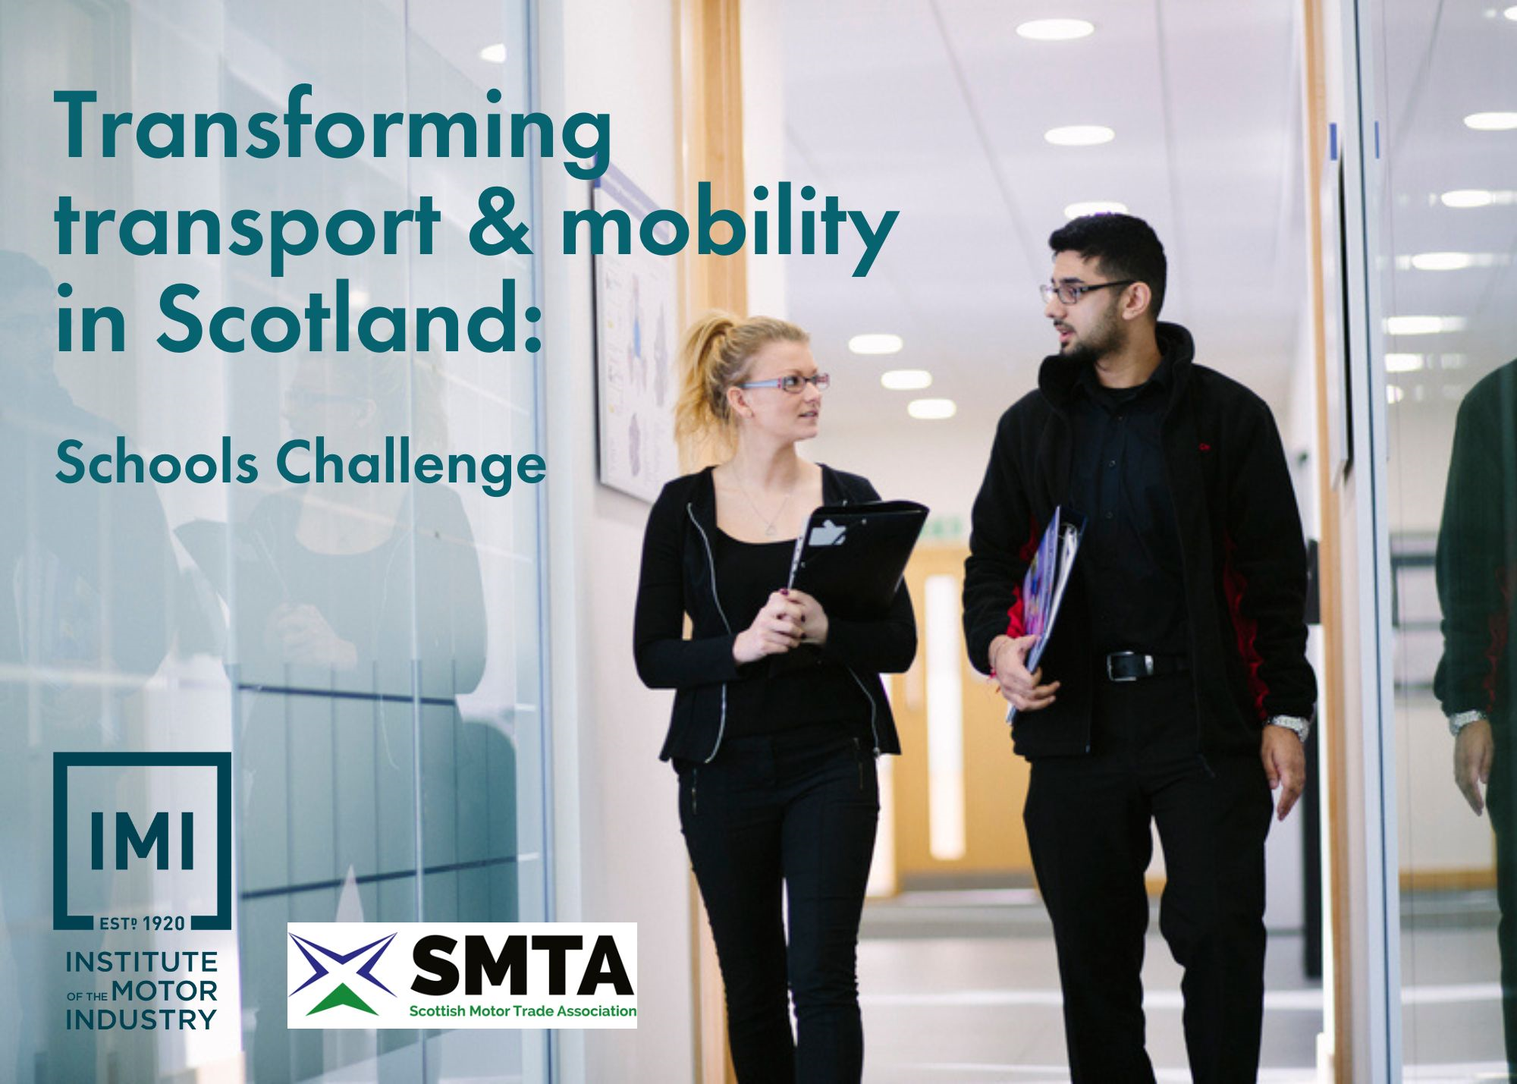

About this challenge

Inspiring and supporting your learners to make well informed decisions about their future and assisting you to embed Careers Education, Information, Advice and Guidance into your school FREE of charge.

This challenge supports young people to start to think about their next steps after school and embeds careers education into the curriculum alongside being mapped to the Scottish curriculum for excellence.

Pupils are asked to undertake 5x key tasks including researching, reimagining, planning and pitching before then looking at the potential career options available using what have just learnt. Based around a sustainability and mobility focus which asks teams to invent a new form of public shared transport to support Scottish mobility.

The challenge also supports pupils in their soft and employability skills by using teamwork, communication and reasoning throughout.

This competition is kindly sponsored by the SMTA.

Curriculum contents

This activity is directly linked to the Scottish Curriculum for Excellence and encompasses the following sections:

1) Expressive arts
- Be creative and express themselves in different ways.
- Experience enjoyment and contribute to other people’s enjoyment through creative and expressive performance and presentation.

2) Religious and moral education
- Develop the skills of reflection, discernment, critical thinking and deciding how to act when making moral decisions.
- Make a positive difference to the world by putting their beliefs and values into action.
- Establish a firm foundation for lifelong learning, further learning and adult life.

3) Health and wellbeing
- Make a successful move to the next stage of education or work.

4) Sciences
- Recognise the role of creativity and inventiveness in the development of the sciences.
- Establish the foundation for more advanced learning and, for some, future careers in the sciences and technologies.
- Express opinions and make decisions on social, moral, ethical, economic and environmental issues based upon sound understanding.

5) Languages
- Develop a secure understanding of how language works and develop their capacity to communicate ideas and information in English and other languages.
- Exercise their intellectual curiosity by questioning, developing their understanding, thinking creatively and critically to synthesise ideas and arguments.
- Communicate, collaborate and build relationships.
- Reflect on and explain my literacy and thinking skills, using feedback to help me improve and sensitively provide useful feedback for others.
- Engage with and create a wide range of texts in different media, taking advantage of the opportunities offered by ICT.

6) Social studies
- Engage in activities which encourage enterprising attitudes.
- Develop an understanding of concepts that encourage enterprise and influence business.
- Establish firm foundations for lifelong learning and for further specialised study and careers.

7) Numeracy
- Appreciate how the imaginative and effective use of technologies can enhance the development of skills and concepts.

8) Technologies
- Awareness of technological developments (Past, Present and Future), including how they work.
- Impact, contribution, and relationship of technologies on business, the economy, politics, and the environment.
- Using digital products and services in a variety of contexts to achieve a purposeful outcome.
- Designing & constructing models/products.
- Representing ideas, concepts and products through a variety of graphic media.

About the IMI

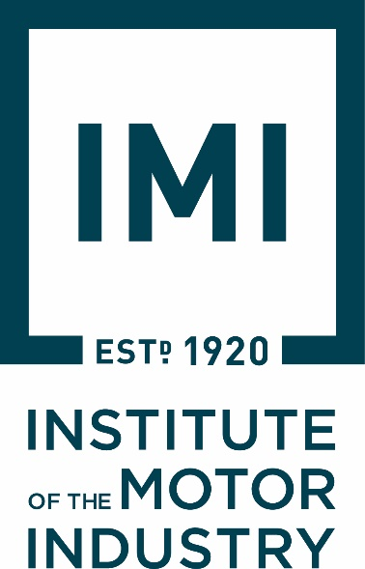
The Institute of The Motor Industry is the professional body for individuals working in the motor industry and the authoritative voice of the retail automotive sector. The IMI’s aim is to ensure that the automotive retail sector has a skilled, competent and professional workforce that is fully equipped to keep pace with the demands of new technology and changing markets. A key part of business for manufacturers and dealers is to encourage the best and brightest people to join their business in a variety of roles.

The automotive industry influences everyone, from delivering goods on time to commuters travelling to work and emergency services being able to respond to a crisis, the motor industry helps to keep the country moving. IMI Autocity is the one-stop-shop for impartial careers information and advice on careers in the Retail Motor Industry. Whether you are an individual looking to start or progress your career, or a teacher or careers advisor who supports others in making their career choices, Autocity is the place to start. With over 200 #MotorCareers to choose from Autocity provides you with all things Automotive!

www.theimi.org.uk/autocity

About the SMTA

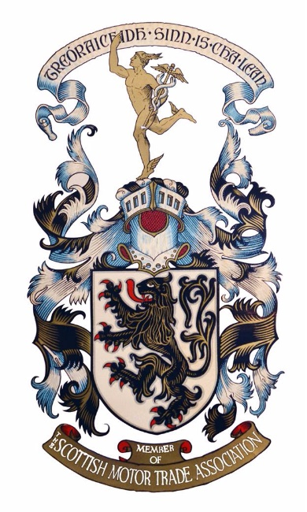
ENCOURAGE, PROMOTE & PROTECT
The SMTA was formed in 1903 to “encourage, promote and protect” the interest of our, at that time, small band of members. To this day that statement remains our reason to exist. Our job is to look after the interests of all our members whether it’s the largest motor group in the country or whether it’s a small MOT station or even just a one-person operation in a remote part of the country.
Our business is your business; we are member owned and member driven and have been ever since our inception way back in 1903. However, from being very much an association in our earlier years which was there to help when things went wrong, we have now become a modern 21st century business, but still owned and driven by our members and their needs.

www.smta.co.uk/about-the-smta/
Activity lesson plan – secondary schools

No. | Topic | Task | Curriculum link
1 | Research | Look back and research into how technology has evolved and what impact it’s made to environment, politics, social mobility, how it will change in the future and their predications for the next 50 years.  Questions:  - How has the automotive sector changed in the last 100 years?  - What are the implications of fossil fuels on our environment?  - How will the 2030 ban on petrol and diesel vehicles affect the automotive market?  - What transport options are currently available and what is coming?  - List the pros and cons of these different types of mobility options.  - How inclusive and accessible are these types of mobility options for those with hidden and physical disabilities in various locations?  - Help to get our started GOV Future of Mobility report, KPMG videos, | Technologies
2 | Reimagine | In teams design a new form of public transport / shared mobility for Scotland. Identify how these would work in different environments such as city centres and the highlands.  Ensure and justify sustainability and equitable mobility to all groups though potential environmental impacts, public transport or shared mobility concepts.  Questions:  - What is there currently on offer?  - What would make people use this new form of mobility above all others?  - What extras would you include to draw people in to use this?  - What fuel system will it use?  - How is your new form of public mobility ethical and environmental?  - How will your mobility solution be used in different environments and terrains in Scotland? | Social studies  Sciences
3 | Plan | Design a marketing and launch campaign to showcase the new form of shared mobility to the public and encourage the community to get involved through financial, ethical, emotional and logical reasons.  Create a campaign, a launch event and brand your new public mobility to the public.  Questions:  - How will you launch this new form of transport to the public?  - Will you have a celebrity endorsement?  - Where will you launch this and how?  - What will it look like and what will it be called?  - Will it have a strapline or slogan?  - Will it have a new brand logo? | Religious & moral education  Numeracy
4 | Pitch | Showcase reel at end of project, option to video pitch or create a TikTok style ad campaign.  Brief:  Use technology to showcase or launch your new form of shared public mobility. This can be in the form of a video, website, TikTok, PowerPoint presentation or word documents.  Share your ideas with the class and create a dragon’s den style or elevator 5 min ‘Pitch’ to sell your ideas. | Expressive arts  Languages
5 | Finding your next future steps | Identify most interesting career route based on those tested during the project and research into the next step options in this.  Questions:  - What skills did you use during the project and what subjects do they align to?  - What role that you tired out in the project did you enjoy the most and why?  - Using www.theIMI.org.uk/autocity research what job role encompasses the things you enjoyed doing.  - What would the next steps be to start this career journey after school?  - What promotion or specialisations could this then take you to?  - Use the IMI skills profiles to see the upcoming job roles and expected salaries. | Health & Wellbeing
+ | Experience of workplaces | Gift the top 5x teams an experience of workplaces to support with their next steps, this could be in the form of  - a virtual tour,  - one day work shadowing  - or a traditional weeklong work experience via SMTA members. | Health & Wellbeing

Pupil activity pack

School name

Year group

Team participants | 1.  2.  3.  4.  5.  6.

Competition brief

We want you to design the vehicle of the future for 2035 with a specific target market in mind. Over the last 100 years cars have come a long way in fact most of the companies you know today would not have existed. We would like you to research and think about what vehicles will look like in the future to support these individuals and help us shape the future of the industry.

Either individually or in teams of 4-6 work together to research, design, market and pitch your new vehicle specifically designed for the Scottish market. Keep in mind your target audience and use your unique selling point (USP) to make your car stand out for the crowd!

Finally send in a copy of your presentation or pitch to careers@theimi.org.uk or post it in, for it to be marked by the panel of industry judges. You and your team may win the top prize of an exciting automotive day out with the IMI and the competition sponsors the SMTA.

The following pages can be used to help you plan out your project!

Within this competition you will be able to try out different career options also during the tasks.

- Task 1: RESEARCH AND DEVELOPMENT understanding your target market with planning and research
- Task 2: ENGINEER problem solving and creating your USP DESIGNER designing your vehicle
- Task 3: MARKETING branding your vehicle with logo and strapline COMMUNIATIONS design the marketing campaign and launch event
- Task 4: SALES produce short video on vehicle – dragons’ den or elevator pitch
- Task 5: Exploring your next steps after school and identifying your skill set
- Options extra: Experiences of the workplace

Task 1: Planning & Research

Job role: Research & Insight

Look back and research into how technology has evolved and what impact it’s made to environment, politics, social mobility, how it will change in the future and their predications for the next 50 years.

Answer the following questions…
Help to get you started GOV Future of Mobility report, KPMG videos, IMI research and insight

How has the automotive sector changed in the last 100 years?

What are the implications of fossil fuels on our environment?

How will the 2035 ban on petrol and diesel vehicles effect the automotive market?

What transport options are currently available and what is coming?

List the pros and cons of these different type of mobility options.
Pros | Cons

How inclusive and accessible are these types of mobility options for those with hidden and physical disabilities in various locations?

Task 2: Problem solving

Job role: Engineer & Designer

In teams design a new form of public transport / shared mobility for Scotland. Identify how these would work in different environments such as city centres and the highlands.

Ensure and justify sustainability and equitable mobility to all groups though potential environmental impacts, public transport or shared mobility concepts.

Questions to answer…

What is there currently on offer?

What would make people use this new form of mobility above all others?

What extras would you include to draw people in to use this?

What fuel system will it use?

How is your new form of public mobility ethical and environmental?

How will your mobility solution be used in different environments and terrains in Scotland?

Task 3: Plan

Job role: Marketing & Communications

Design a marketing and launch campaign to showcase the new form of shared mobility to the public and encourage the community to get involved through financial, ethical, emotional and logical reasons.

Create a campaign, a launch event and brand your new public mobility to the public.

Questions:

How will you launch this new form of transport to the public?

Will you have a celebrity endorsement? If so, who will it be and why have you chosen then to represent your brand?

Where will you launch this and how?

What will it look like and what will it be called? Please sketch your vehicle on a separate piece of paper.

Will it have a strapline or slogan? Create a strapline and/or slogan.

Will it have a new brand logo? Design your logo.

Task 4: Pitch

Job role: Marketing, Communications & Sales

Showcase reel at the end of the project, option to video pitch or create a TikTok style ad campaign.

Use technology to showcase or launch your new form of shared public mobility. This can be in the form of a video, website, TikTok, PowerPoint presentation or word documents.

Share your ideas with the class and create a dragon’s den style or elevator 5 min ‘Pitch’ to sell your ideas.

Send in your entry, email a photo of your design, or record yourself and send a video of you talking about your creation to careers@theimi.org.uk

Storyboard your idea….

Storyboard example…

Task 5: Finding your next steps

Job role: Managing your progression after school.

Identify most interesting career route based on those tested during the project and research into the next step options in this. You can use the IMI skills profiles to see the upcoming job roles and expected salaries to help you. www.theIMI.org.uk/autocity

Questions:

What skills did you use during the project and what subjects do they align to?

Skills… | School subjects….

What role that you tired out in the project did you enjoy the most? | Why?

Using www.theIMI.org.uk/autocity research what job role encompasses the things you enjoyed doing.

What would the next steps be to start this career journey after school?

What promotion or specialisations could this then take you to?

Additional activity of experience of the workplace

Gift the top 5x teams an experience of workplaces to support with their next steps, this could be in the form of:

- a virtual tour via Teams, Zoom or Google meet.
- a half day walk around with a Question & Answer session with staff members throughout the tour.
- one day work shadowing experience.
- or a traditional weeklong work experience via SMTA members.

You can use the Work Experience Guides to support you with this www.autocity.org.uk/index.php/2022/08/12/work-experience-tool-kits-for-organisers-employers-and-pupils/

