Transforming transport & mobility in Scotland: Primary schools’ challenge
Institute of the Motor Industry & SMTA activity project
Activity project mapped to the Scottish curriculum for excellence.

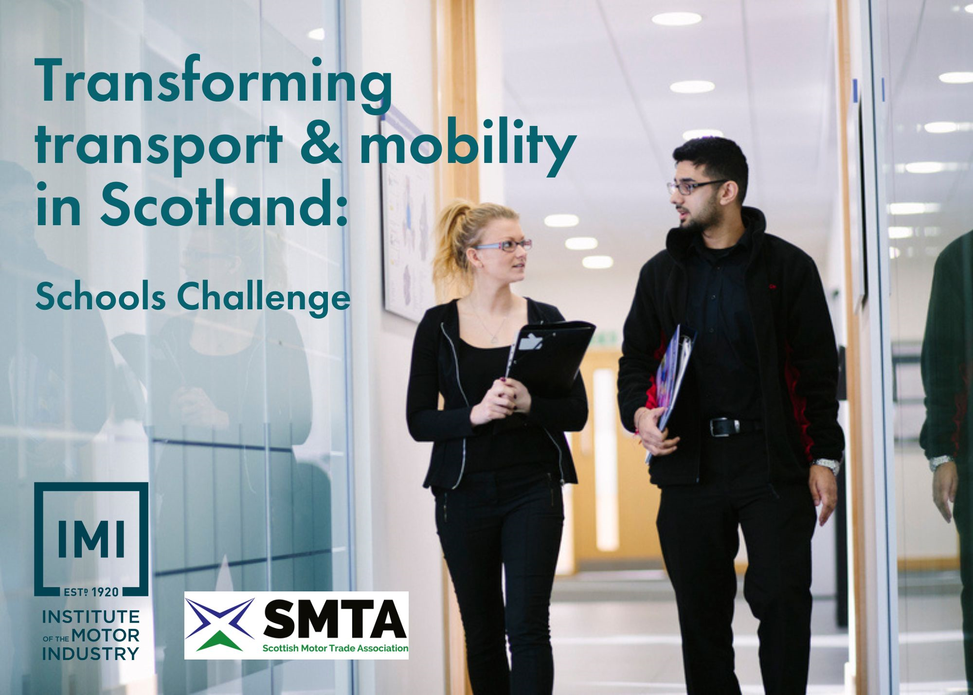

About this challenge

Inspiring and supporting your learners to make well informed decisions about their future and assisting you to embed Careers Education, Information, Advice and Guidance into your school FREE of charge.

This challenge supports young people to start to think about their next steps after school and embeds careers education into the curriculum alongside being mapped to the Scottish curriculum for excellence.

Pupils are asked to undertake 5x key tasks including researching, reimagining, planning and pitching before then looking at the potential career options available using what have just learnt. Based around a sustainability and mobility focus which asks teams to invent a new form of public shared transport to support Scottish mobility.

The challenge also supports pupils in their soft and employability skills by using teamwork, communication and reasoning throughout.

This competition is kindly sponsored by the SMTA.

Curriculum contents

This activity is directly linked to the Scottish Curriculum for Excellence and encompasses the following sections:

1) Expressive arts
- Be creative and express themselves in different ways.
- Experience enjoyment and contribute to other people’s enjoyment through creative and expressive performance and presentation.

2) Religious and moral education
- Develop the skills of reflection, discernment, critical thinking and deciding how to act when making moral decisions.
- Make a positive difference to the world by putting their beliefs and values into action.
- Establish a firm foundation for lifelong learning, further learning and adult life.

3) Health and wellbeing
- Make a successful move to the next stage of education or work.

4) Sciences
- Recognise the role of creativity and inventiveness in the development of the sciences.
- Establish the foundation for more advanced learning and, for some, future careers in the sciences and technologies.
- Express opinions and make decisions on social, moral, ethical, economic and environmental issues based upon sound understanding.

5) Languages
- Develop a secure understanding of how language works and develop their capacity to communicate ideas and information in English and other languages.
- Exercise their intellectual curiosity by questioning, developing their understanding, thinking creatively and critically to synthesise ideas and arguments.
- Communicate, collaborate and build relationships.
- Reflect on and explain my literacy and thinking skills, using feedback to help me improve and sensitively provide useful feedback for others.
- Engage with and create a wide range of texts in different media, taking advantage of the opportunities offered by ICT.

6) Social studies
- Engage in activities which encourage enterprising attitudes.
- Develop an understanding of concepts that encourage enterprise and influence business.
- Establish firm foundations for lifelong learning and for further specialised study and careers.

7) Numeracy
- Appreciate how the imaginative and effective use of technologies can enhance the development of skills and concepts.

8) Technologies
- Awareness of technological developments (Past, Present and Future), including how they work.
- Impact, contribution, and relationship of technologies on business, the economy, politics, and the environment.
- Using digital products and services in a variety of contexts to achieve a purposeful outcome.
- Designing & constructing models/products.
- Representing ideas, concepts and products through a variety of graphic media.

About the IMI

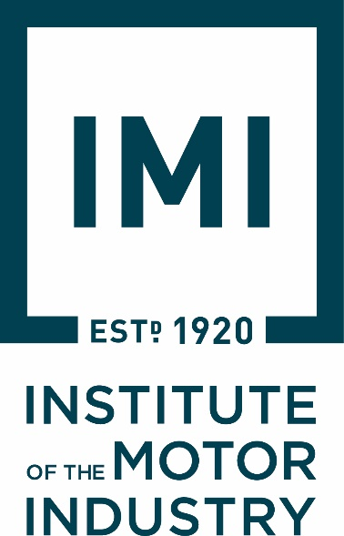
The Institute of The Motor Industry is the professional body for individuals working in the motor industry and the authoritative voice of the retail automotive sector. The IMI’s aim is to ensure that the automotive retail sector has a skilled, competent and professional workforce that is fully equipped to keep pace with the demands of new technology and changing markets. A key part of business for manufacturers and dealers is to encourage the best and brightest people to join their business in a variety of roles.

The automotive industry influences everyone, from delivering goods on time to commuters travelling to work and emergency services being able to respond to a crisis, the motor industry helps to keep the country moving. IMI Autocity is the one-stop-shop for impartial careers information and advice on careers in the Retail Motor Industry. Whether you are an individual looking to start or progress your career, or a teacher or careers advisor who supports others in making their career choices, Autocity is the place to start. With over 200 #MotorCareers to choose from Autocity provides you with all things Automotive!

www.theimi.org.uk/autocity

About the SMTA

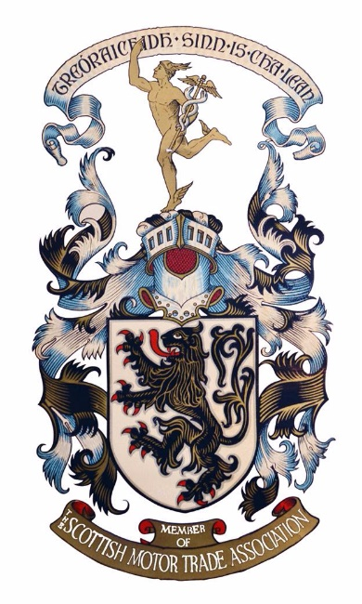
ENCOURAGE, PROMOTE & PROTECT
The SMTA was formed in 1903 to “encourage, promote and protect” the interest of our, at that time, small band of members. To this day that statement remains our reason to exist. Our job is to look after the interests of all our members whether it’s the largest motor group in the country or whether it’s a small MOT station or even just a one-person operation in a remote part of the country.
Our business is your business; we are member owned and member driven and have been ever since our inception way back in 1903. However, from being very much an association in our earlier years which was there to help when things went wrong, we have now become a modern 21st century business, but still owned and driven by our members and their needs.

www.smta.co.uk/about-the-smta/
Activity lesson plan – secondary schools

No. | Topic | Task | Curriculum link
1 | Identifying Scotland’s unique challenges & potential problem-solving solutions | Identifying what may make if difficult to get from A to B in their local area and how they could tackle this with new technology they could invent.  Consider how environmentally friendly and sustainable your new vehicle will be with its new technology also. | Expressive arts  Technologies  Social studies
2 | Design your vehicle using your new technology | Draw your new vehicle to overcome those challenge, highlighting the new technology you have invented and developed to overcome any challenges you identified.  Create a poster to advertise your transport of the future. | Numeracy  Sciences
3 | Name your vehicle, create a logo and a strapline so that it is ready to launch to the market. | Brand your vehicle, create a logo that represents the new technology and create a strapline to see your vehicle on the poster. | Social studies
4 | Pitch your new design | Send in your entry, email a photo of your design or record yourself and send a video of you talking about your creation to careers@theimi.org.uk | Languages
5 | Finding your next future steps | Identify most interesting career route based on those tested during the project and research into the next step options in this.  - Using www.theIMI.org.uk/autocity look at the different jobs open to you when you leave school.  - What would the next steps be to start this career journey after school? | Health & Wellbeing  Religious & moral education
+ | Experience of workplaces | Gift the top 5x teams an experience of workplaces to support with their next steps, this could be in the form of  - a virtual tour,  - one day work shadowing  - via SMTA members.  - Alternatively use the 360 VR films to see inside some different workplaces LINK | Health & Wellbeing

Pupil activity pack

School name

Year group

Your name

Competition brief

We want you to design the vehicle of the future for 2035 with a specific target market in mind. Over the last 100 years cars have come a long way in fact most of the companies you know today would not have existed. We would like you to research and think about what vehicles will look like in the future to support these individuals and help us shape the future of the industry.

Either individually or in teams of 4-6 work together to research, design, market and pitch your new vehicle. Keep in mind your target audience and use your unique selling point (USP) to make your car stand out for the crowd!

Finally send in a copy of your presentation or pitch to careers@theimi.org.uk or post it in, for it to be marked by the panel of industry judges. You and your team may win the top prize of an exciting automotive day out with the IMI and the competition sponsors the SMTA.

The following pages can be used to help you plan out your project!

Within this competition you will be able to try out different career options also during the tasks.

- Task 1: RESEARCH AND DEVELOPMENT identifying challenge you may face and how to overcome them & ENGINEER problem solving and creating your USP
- Task 2: DESIGNER designing your vehicle
- Task 3: MARKETING branding your vehicle with logo and strapline COMMUNIATIONS design the marketing campaign and launch event
- Task 4: SALES showcase your design to your class; you can also produce short video on vehicle – dragons’ den or elevator pitch if you wish
- Task 5: Exploring your next steps after school and identifying your skill set

Activity lesson plan – Primary schools

The automotive industry helps everyone, from delivering food and medicine on time, helping people travel to work and emergency services being able to help in a crisis, the motor industry helps to keep the country moving.
Automotive means everything on the UK roads that we use to transport people and things. This includes cars, lorries, motorbikes, busses, electric scooters, vans, and tractors.
The IMI helps people working in the motor industry and the SMTA look after the interests of all their members whether it’s the largest motor group in the country or whether it’s a small MOT station or even just a one-person operation in a remote part of the country.
Together we have been working hard to prepare the industry for the future, but we have run out of ideas! So, we need your help to create a brand-new vehicle that will be ready for 2035 specifically designed for Scotland.
Can you imagine what type of vehicles will be popular in 2035? What will they look like? How will they run? Will they have some fun things in them that haven’t been invented yet?
Follow the steps below and help us design a vehicle of the future for Scotland.
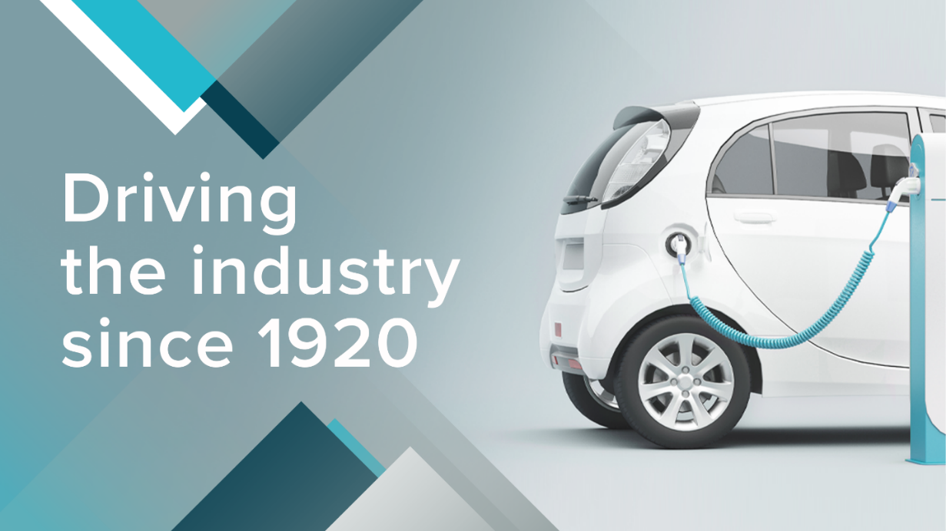

The Competition is kindly sponsored by the SMTA.

STEP 1: What challenges do we face and how can you overcome them.

Think about where you live and what the unique challenge you might face in moving from place to place in Scotland. Write up some key points below.

Now think about some of the new technology you can invent to tackle and overcome some of these challenges with your new vehicle. Consider how the new technology will this affect the envirment in your local area?

The Challenge… | The new Technology to help…

Here are some ideas to get you started…
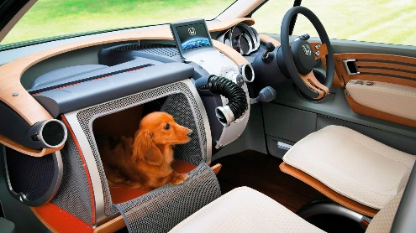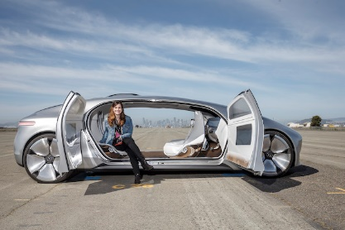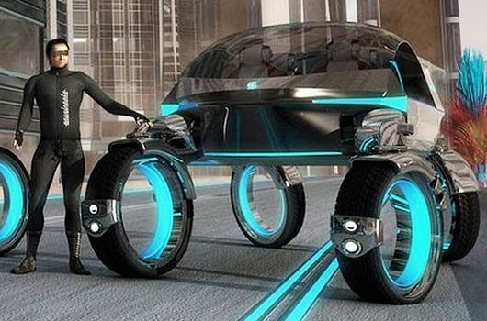

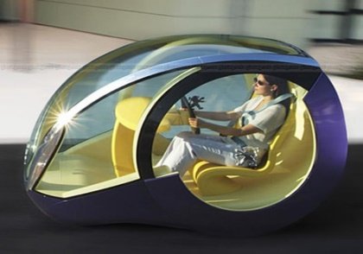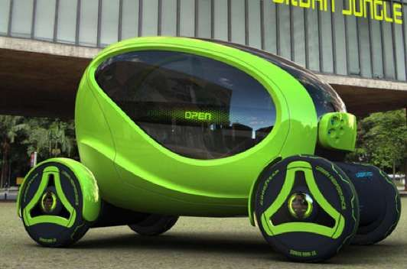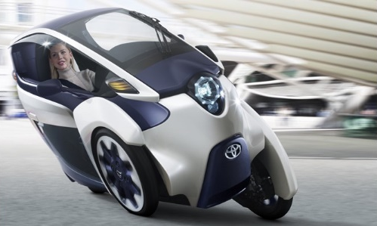

STEP 2: Design
Sketch your new vehicle to overcome those challenge, highlighting the new technology you have invented and developed to overcome any challenges you identified.

Create a poster to advertise your transport of the future.

STEP 3: Branding

Brand your vehicle, create a logo that represents the new technology and create a strapline to see your vehicle on the poster.

Create a logo.

Create a strapline.

Strapline examples for you to complete…

- Every little _________________________
- Just do ____________________________
- Gives you __________________________
- I’m loving __________________________
- Should have gone to _________________

STEP 4: Pitch

Either share your poster design in class, you can record you talking though your ideas or simply send in your entry to careers@theimi.org.uk

STEP 5: Your next steps after school

Using IMI Autocity, explore three possible job roles open to you in the future after you leave school. Watch some of the videos of apprentice talking about their day-to-day work and how they started their journey.

Then complete the table below.

Questions | Job 1 | Job 2 | Job 3
Job role name

What do they do in this job role?

Qualifications I would need to do this job?

I would be paid this much salary to work in this job role. | £ | £ | £
This job role I something I am interested in. | Yes / No / Maybe | Yes / No / Maybe | Yes / No / Maybe
Why are you or why are you not interested in this job role?

