#IWD2022 lesson plan
Challenging Stereotypes
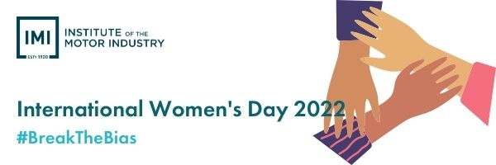

Aims
In this session we will explore the gender stereotypes associated with some career choices, how to overcome these and what different individuals can make to equality.

Learning Outcomes
Pupils will understand the theme of international women’s day 2022, the opportunity to identify the barriers faced by different genders, understand how they can impact #BreakTheBias through personalised pledges and challenge gender stereotypes though real-life case studies.

Resources required:
- Case studies
- Printed pledge cards

Time required: 60 mins

Time | Activity | Resource
10 mins | Introduce IWD2022 and the theme of #BreakTheBias | www.internationalwomensday.com/
15 mins | Independent reading of the case studeos and encourage to make notes or highlight sections.  Allow for some reflection time. | Case studies x3  - Ben Eaton  - Jordan Salt  - Cat Treanor
30mins | Teacher to lead a discussion with the supplied questions to discuss the differences between how each person was treated, why this happened, how they felt and what action they will take to challenge and #BreakTheBias | Questions in lesson plan
5mins | Option for an Additional Activity:  Pupils print and pledge how they will impact #IWD2022 | www.internationalwomensday.com/SelfieCards

Case study 1

Cat Treanor
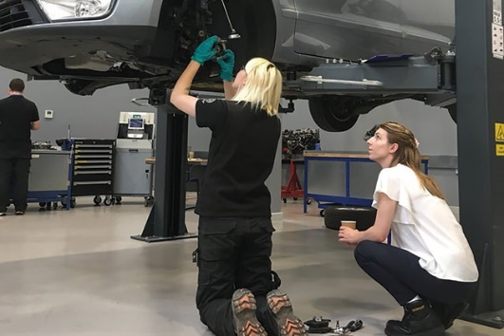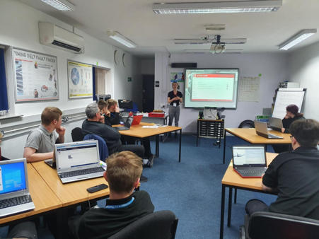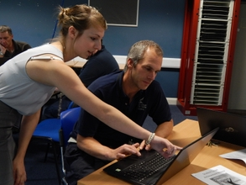

The UK-Electude business development manager shares her passion for the industry, and how she’s fighting stereotypes

What first got you interested in the motor industry?
My school hosted a technology day when I was in Year 7, it was my first taster of revving an engine and checking the oil level. From then on, I couldn’t get the idea out of my head.

But then it became challenging...?
At every stage since then I was told that this was not an informed decision. I had to jump through hoops to show that I had what it takes and that this wasn’t a career choice on a whim.
I decided to do work experience at a local garage. I chose it because I wanted to rule out the idea of being a mechanic – my teachers told me I was aiming low and I listened. This is where I changed brake pads and tyres for the first time, where I got blisters from my oversized steel toe caps, learned how to carry seven cups of tea at once. I started hoping I’d hate it, so I could focus on finding a proper career, but you know what, it was one of the best weeks of my life.

Apprenticeship or university?
Employment, experience, wages and qualifications or debt, lectures and a social-focused environment. University clearly wasn’t for me. Of course it has its place, but it is not the only option. My only wish is that apprenticeships weren’t seen as less worthy, or only for people who couldn’t make the grade.

What apprenticeship did you do and where?
I did a light vehicle Apprenticeship level 2 and 3 at Derby College and Station Garage Belper.

How did your career evolve after your apprenticeship?
The expectation of failure really pushed me to fight harder for what I wanted. After finishing my apprenticeship, I started at VW as a service advisor and, at 21, I became Electude Automotive E-Learning’s UK business development manager. I now deliver keynote speeches in the US, travel all over the UK and represent the company and the industry at events worldwide.

What’s the biggest challenge you’ve faced?
Stereotypes: about women, mechanics, the automotive industry and apprenticeships. I think we can be quite naive about the state of equality in the industry and how women are represented and treated. It can be exhausting feeling like you have to prove yourself to everyone you meet and break down the barriers they have created for you. The events I go to I look more like someone’s lost wife than an industry professional.

Who’s inspired you?
I have met some fantastic people along the way who helped me grow. To name a few: Matt Curtis at Derby College who encouraged me to do my first ever public speaking; David Massie at the IMI, who is infectiously passionate about the Skill Auto Competition and what it can do for young people; and everyone at Electude for helping me as a student and investing in me as a professional.
I respect anyone who will challenge the way things have always been done, who strives for improvement and anyone who sees automotive for what is: an innovative, exciting, ever-changing industry.

Cat Treanor is UK-Electude business development manager, and the 2019 winner of the “Contribution to the IMI Award”.

Case study 2

Jordan Salt
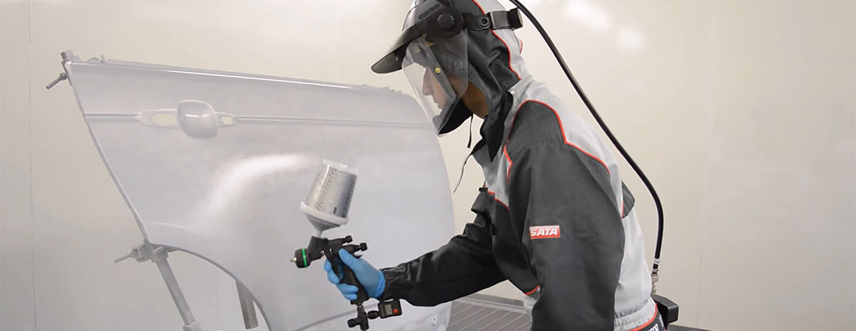

This YouTube star explains how he went from school leaver to Managing Director of his own paint repair business

How did you get into the motor industry?
To be honest, the motor industry wasn’t something I pursued with great gusto initially. I just sort of left school and fell into it. A family member happened to be the manager of a bodyshop at the time and offered me a job. Having just left school, I felt very lucky to have a full-time job offered to me. I took it and I’ve never looked back.

How has your enthusiasm for the industry grown?
The more time I’ve spent in the industry, the more I’ve come to love it. The motor industry is huge and so diverse in its offerings that there’s something for everyone, no matter their background. And there are so many other opportunities that can come from gaining qualifications in repair and paint.

How has your career evolved?
Most people will know me from my YouTube channel Repair and Refinish, along with the accompanying social media pages across Facebook and Instagram. I started the YouTube stuff in 2012 and it has grown from there, gaining a respectable 13,000 subscribers along the way.
My journey through the motor industry has been an interesting one. After getting the job at the workshop and spending a few years on the shop floor, I decided I wanted more, so I went on to complete a basic teaching qualification. Soon after, I was offered a job as a tutor at Chesterfield College, where I was tasked with showing like-minded trainees the bodyshop side of the motor industry. While teaching there, I gained some more teaching qualifications in order to progress within my role.
From there, I went on to develop new paints. Now I’m the Managing Director of paint manufacturing facility Repair and Refinish Coatings Ltd, creating automotive paints and coatings under the MULTI-MIX brand. I also won the IMI Skill Auto award back in 2015.

Is there anything about the motor industry that you think should change?
I would say the salaries. Salary is a big attraction in any job. There is such a skills shortage in the industry at the moment, and revising salaries to offer a little more would go a long way towards addressing that.

What are your plans for the future?
Now that I own my own business, I’m putting all my time and effort into building the brand, with a view to making MULTI-MIX a known brand in every bodyshop in the UK and beyond.

Do you have any regrets?
I wish I’d trained a little more on the vehicle repair side, operating jigs and other repair machinery. I’ve always been interested in the heavyweight side of vehicle repair, but even so, I’m really happy with the skills I’ve gained on the refinishing side.

What words of wisdom would you pass on to those wanting to get into the industry?
Honestly, the best advice I can give is to be open-minded about the huge range of opportunities within the motor trade. The industry is massive and there are so many different avenues available.
Also, if it’s painting cars that you’re interested in and if you have the time and money, try to get as many qualifications as possible and take as many different training courses as you can in order to become skilled in all the different areas of the repair process.

Case study 3

Ben Eaton
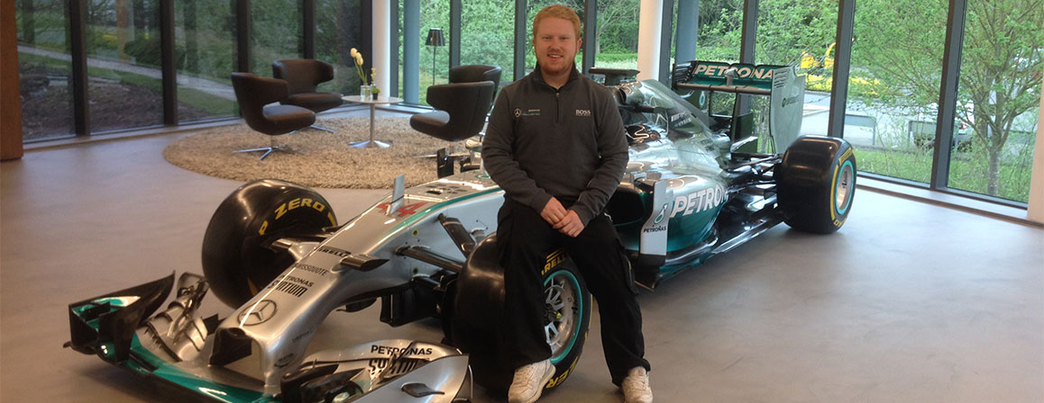

How this young star’s career went from starting grid to pole position (and title-winning glory)

Who or what first got you interested in the motor industry?
I never really looked up to anyone in the industry, but I always had an interest in cars and vehicles growing up. If it had wheels, I wanted a go in it! I also loved all the car programmes on TV, the restoration shows and the overhauling shows and even Pimp My Ride, and when I got towards the end of my time at school, I realised there were lots of jobs available in the motor industry.

How did you decide which career path you wanted to take and how did you set about making it happen?
When I left school at 16, I didn’t want to carry on with classroom studies at college or university. I wanted a more hands-on experience where I could learn a skill and earn money too, so an apprenticeship seemed like the the right way forward for me. After thinking about the interests I had at the time – technology, art and cars – I decided to enrol on a car-painting apprenticeship with BMW at Sytner Sheffield.

How has your career developed so far, and what are your goals for the future?
All of my roles have required I completed my four-year apprenticeship with BMW and was named Apprentice of the Year when I graduated. I then won the National Painter of the Year competition, which lead me to hear about the World Skills competitions.
I became part of Team UK and represented my country at World Skills London 2011, where I won the bronze medal, beating competitors from all over the world. After that success, I joined the Mercedes-AMG Petronas F1 team and painted Michael Schumacher’s car in my first year. Since then, I have gone on to paint Nico Rosberg’s, Valtteri Bottas’s and Lewis Hamilton’s F1 cars. The team has been great – and we’ve won seven world titles!
I’m still enjoying the motorsport side of the industry for now, but who knows what the future may hold and where my career will take me.

Is there anything you would have done differently with the benefit of hindsight?
Looking back, I think I did everything to the best of my ability. I don’t think there was any opportunity I didn’t take, so no, I don’t think I would have done anything differently.

What advice would you give to someone who wants to work in the motor industry?
I would say that if you have a passion for cars or any part of the motor industry, go ahead and check out the different types of apprenticeships and apprenticeship providers out there, as well as relevant courses in further education.

Do you have advice for someone who wants to work in motorsport specifically?
There are so many different roles involved in motorsport, so always check the companies’ websites for job opportunities. You have to go out there to get them – they won’t come to you.

Ben Eaton is a Composite Paint Technician at the Mercedes-AMG Petronas F1 team

Questions and reflections

- What are the barriers they each faced in joining the automotive industry?

- What are the main differences between how Cat, Jordan and Ben were treated?

- How do you think Cat felt?

- How would you break the barriers that Cat faced?

- How can we combat the negative association with some career paths?

- What do you do when you are faced with challenge in your decision making?

- What statement from IWD impacts and speaks to you the most?
- I will help forge a gender-neutral worlds
- I will maintain a gender equal mindset
- I will challenge gender stereotypes, discrimination, and bias
- I will call out gender actions or assumptions
- I will forge positive visibility of women
- I will try to influence others’ beliefs and actions
- I will celebrate women’s achievements
- #BreakTheBias by….

- What could you do differently today to make an impact for #IWD2022?

- How will you personally action this and how what impact will it make?

- Complete this sentence: I will help forge women’s equality by….

