imi Virtual Work experience planner

Student Planner

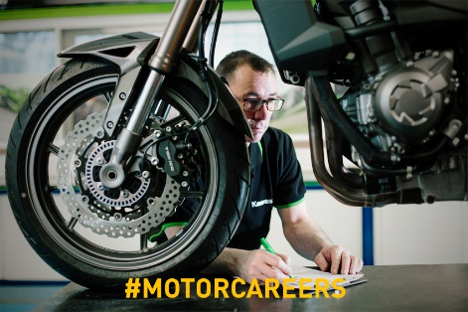
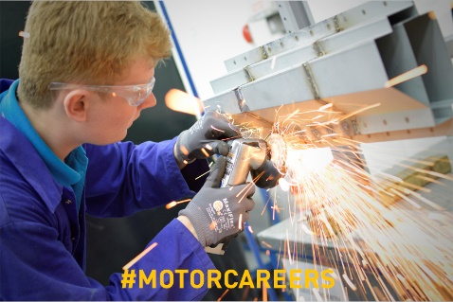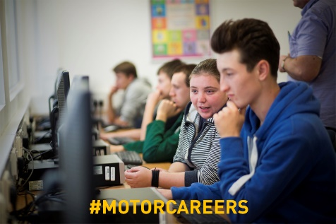

Project Briefs

Customer Journey –
Outline a scenario with a customer, from booking a vehicle in for a service and responding to a customer query letter – conflict resolution

Fault Checking –
Journey of the car through the workshop, what process takes place? Who works on the vehicle? Technology used? Communication with customer? Outcome?

Innovation –
How to change/improve the experience of buying a new car – What is the process from the initial enquiry? How do you find out what the customer wants? Do they get the car straight away?

Product Launch –
A new vehicle is about to launch, plan and design the launch event to gain maximum reach – Who is the intended audience? What is the Unique Selling points of the vehicle? How much will it cost?

Task 1 – Research & Planning
- Decide which project you are going to complete with agreement from your placement mentor.
- Research which departments you will need to work with to get the information you need.
- What other research do you need to complete? Mind map the different aspects of your project and how you are going to get the information you need.

Task 2 - Design
- Design a logo for your brand/vehicle if needed
- Decide on your key features – that you want to include in your customer/car journey or in your designs
- USP – Does your employer have a mission/vision statement? Service agreement? If designing a car or logo, what do you want to be unique and special about it?

Task 3 – Composing
- Have you got all the information you need to complete your project?
- Complete any additional research needed
- Plan and outline your project
- Complete final piece – Have you completed your project brief? Ask peers/mentor to review and feedback for any additional changes.

Task 4 – The presentation
- Prepare your pitch or presentation
- Present all of your ideas to showcase your project and the learning you have completed through your placement.

Task 1 – Planning & Research

Planning

Decide which project you are going to undertake during your virtual work experience placement.
For all of the projects you will need to think about your target market/audience/customer profile. We have provided some examples in the list below, or you can describe your own target audience.

Choose a target market and then research their preferences, lifestyles, hobbies and finances etc. If choosing your own write a description of them below.

Ellie is a 23 year old single young professional living in the London suburbs.
Ellie uses her car to travel the short distance to and from home and the station
for her daily commute. She loves to meet up with her friends at the weekend
for shopping and socialising.

Steve is 48 years old, married with three children. Steve lives in the Midlands and his work regularly takes him all over the UK, driving long distances on motorways. He also often travels to the East coast to visit his parents in their retirement bungalow and in summer enjoys going camping with the family, which includes Dudley the dog.

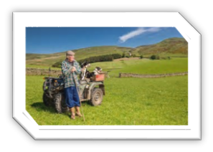
Michael is recently retired from his agricultural job and lives alone. He is 71 years old and lives in a remote part of the Scottish Highlands. From his cottage he has limited direct access to well-maintained roads however he needs to keep his independence and likes to visit his sister and brother in law who live in a nearby town.

Sara and Jamie met while studying at Exeter University and are now in the mid-thirties. They are enthusiastic campaigners for climate change and although they both work from home they do need a vehicle for their monthly visits to their parents and siblings who live in different parts of the country.
Other – describe a target market of your choice…

Our target market is …………………………………….. and we chose this audience because

Research

Research areas
- What departments are in the dealership, what they do and who you need to liaise with to be able to complete your project.
- What processes are already in place, do they work? Can they be improved?
- For vehicle design – what is on the market at the moment? What USP’s would your intended audience want?
Research findings….

What would your target audience WANT in a vehicle? List your ideas below:

Task 2 – Design

Design Your Brand/Vehicle Logo

Experiment with creating some images of a logo you could use and then decide on the
one you like best

Example logo …

Draw your brand logo …

Key Features & Your Unique Selling Point (USP)

Now that you know your target audience you need to come up with some key features and a ‘unique selling point’ that will make them choose to buy your vehicle and not one from a competitor? What do customers come to your dealership over others?

Use your research on the target audience to help you design a unique gadget for your vehicle. Here are some gadget ideas (that actually already exist) to inspire you:

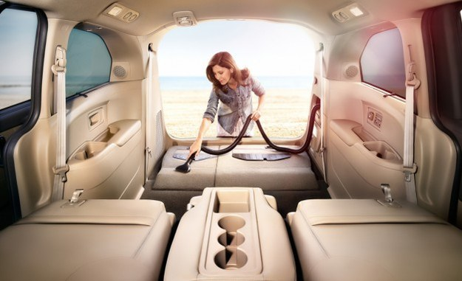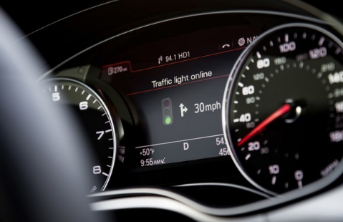

- A built-in vacuum for spontaneous spills and cleaning spells.
- Sensors that learn you’re driving style and can detect when you’re too tired to drive.
- A sunroof that automatically blocks light and lets you see what you want to.
- GPS that automatically analyses traffic and finds the best way around it.
- Cars that recognise traffic light changes and count down until the next green light.
- Brakes and cameras that automatically keep you in the centre of the lane.
- NASA-approved car seats that prevent fatigue on long drives.
- Windows that clean themselves and deflect liquid automatically.
- Heated wiper blades that melt ice and snow to keep everything clear.

What new and exciting key features would you like your car to have?
You should include some of these features when you create an image of your new vehicle

Be innovative by jotting down some Ideas for your USP ….

Task 3 – Composing

Have you got all the information you need to complete your project?

Plan and outline your project
How are you going to present this? Powerpoint presentation? Video? Poster?
Complete final piece – Have you completed your project brief? Ask peers/mentor to review and feedback for any additional changes.

Task 4 – The Presentation

Are you ready?

Now it’s time to get all your ideas and plans together to create a final presentation for your project.

You can complete the project using any of the following formats:
- A PowerPoint presentation
- A written presentation on A4 paper
- A film presenting or ‘pitching’ your ideas including visuals of your design, logo and advertisement
Final feedback from your employer mentor and teacher.

