Automotive Virtual Work Experience Toolkit
Organisers guide

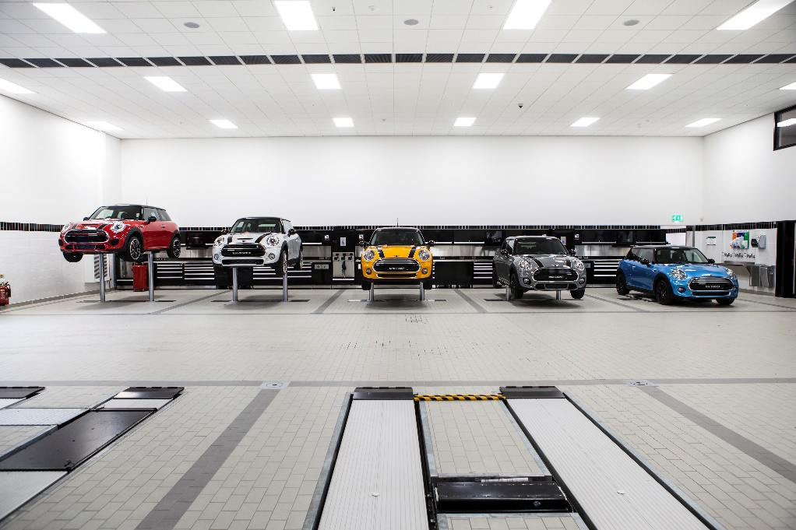

The IMI
The Institute of the Motor Industry is the professional body for individuals working in the motor industry and the authoritative voice of the retail automotive sector. The IMI’s aim is to ensure the automotive retail sector has a skilled, competent and professional workforce that is fully equipped to keep pace with the demands of new technology and changing markets. A key part of business for manufacturers and dealers is to encourage the best and brightest people to join their business in a variety of roles.

Virtual Work Experience Toolkit Overview
Also referred to as online, remote or e-experience, virtual work experience gives students and graduates the opportunity to complete from home, in most cases using nothing but a laptop. Online work experience is open to all and for the majority of opportunities all you need to get involved is access to a computer and a stable internet connection.
Virtual internships share many similarities with traditional, in-person internships but their online nature allows participants to work with organisations across the country, even the globe. They're particularly relevant in these unprecedented times, as they enable students and graduates to gain invaluable work experience and boost their CV in spite of coronavirus restrictions.
Employers are aware that the coronavirus pandemic is robbing students and graduates of the chance to gain face-to-face, real-world work experience and they're working hard to ensure that their virtual opportunities are meaningful and useful for those who take part.

The Virtual Work Experience Toolkit provides enjoyment for work experience placements with the achievement of the maximum learning benefit from the work experience placement. Students will have an insight into the retail motor industry and an ability to make informed decisions about future career options.
You will also receive guidance notes, forms, workbooks and suggestions to ensure that employers and schools have the means to deliver a successful virtual work experience placement in the retail motor industry.
Whether you’re an organiser of work experience, an employer in the sector or a student considering a work experience placement in the retail motor industry, these toolkits contain all you need to ensure a well-planned, meaningful period of work experience or a successful job application.

These guides include:
- The benefits of Virtual work experience
- Information for Virtual work experience organisers
- Information for students
- Information for employers
- Useful templates
- Frequently asked questions

The benefits of Virtual Work Experience

By offering Virtual work experience placements to students, employers can:
- help promote a positive image of the industry
- help promote a positive image of their company locally
- identify potential future employees
- help students develop their knowledge of the industry, so they can make informed choices about what to do in the future
- help improve the work readiness of young people preparing to enter the workforce
- recruit more informed school leavers, who are more likely to stay in the sector because they have a better understanding of the retail motor industry
- make the company more attractive to potential recruits
- help promote the relevance of vocational qualifications within the sector
- meet the company’s social/corporate responsibility policy

And help staff to develop their:
- project management, organisational and planning skills as they operate work experience placements
- coaching skills as they work with students
- communication skills as they prepare assignments or projects related to their department or job role for the student to complete during the course of the placement
- ability to reflect and make amendments to programmes as they review the quality of what happened during the work experience placement

This toolkit provides guidance and practical information on how to deliver a quality and worthwhile virtual work experience placement within the retail motor industry. It has been provided to help students achieve the maximum learning benefit and gain an insight into the retail motor industry and the career options on offer.

Information for Work Experience Organisers

When organised and delivered effectively, virtual work experience can form an important part of a young person’s education and personal development. Many schools and colleges will have their own ways of organising work experience placements, but this toolkit is provided to help promote best practice in virtual work experience placements when delivered in the retail motor industry where physical work experience placements are not possible.

This toolkit can be used to help make sure that students:
- enjoy their virtual work experience placement
- achieve the maximum learning benefit from the virtual work experience placement
- gain an insight into the retail motor industry
- make informed decisions about their future career options.

Guidance
This guide will provide you with guidelines to develop your students own Virtual Work Experience.
On the whole online work experience involves:
- Regular online meetings between student and supervisor or mentor
- Individual project work where the student will focus on one larger project instead of helping with lots of small jobs (as you probably would if you were in an office environment)
- Video tutorials and virtual tours
- Virtual networking sessions and online chats with various members of the organisation to give the student an insight into what different colleagues do
- Training opportunities generally provided via an e-learning platform
- Online socialising events such as team drinks, coffee breaks and quizzes.
We would recommend a 2 week VEX placement. This will provide the student with a good insight into the business and the different roles available. An outline of what the two weeks could look like and resources are available at the end of this guide.
Increasingly the motor industry strives to recruit high-calibre people able to meet the demands of a fast moving, technologically advancing, customer driven industry. These individuals fulfil a variety of job roles not only in the technical field but also in other critical areas where a wide range of skills are required. Skills such as project management, research, finance, insurance, law, human resource management and marketing are all at the core of today’s retail motor industry.

All of the above roles demand a competent, flexible workforce able to adapt to the demands of an industry operating at the leading edge of technology and meeting increasing levels of customer expectation. This work experience toolkit has been produced to assist you in organising a placement in the retail motor industry. There are a diverse number of opportunities for young people to experience working in the industry, either with a small business or a large franchised dealer, in technical and non-technical roles and this toolkit aims to support you in delivering a successful placement.

About the automotive industry
The automotive industry influences everyone, from delivering goods on time to commuters travelling to work and emergency services being able to respond to a crisis, the motor industry helps keep the country moving.

The retail motor industry
The retail motor industry employs around 570,000 people in just under 70,000 companies across the UK. These companies range in size from firms with fewer than 5 employees to large companies with over 500. This variety of businesses sells, maintains and repairs the 38 million vehicles on our roads. The industry can be split into the following sub-sectors:
- Vehicle Fitting (including Fast-Fit and Tyres)
- Vehicle Maintenance and Repair
- Vehicle Body and Paint Operations
- Roadside Assistance and Recovery
- Vehicle Sales
- Vehicle Parts Operations
- Vehicle Rental and Leasing

A great deal of knowledge and competence is required in all of the sub-sectors in order to keep up with technological advances. The development of software packages to manage and control almost every system on a modern vehicle, whether a family car, motorcycle of a 40 tonne articulated truck, require a level of understanding of IT and electronics as well as the more traditional mechanical knowledge.

Commonly, recruitment of young people is through an Apprenticeship lasting three years however some positions such as vehicle sales and rental and leasing require individuals to show a degree of maturity to win the confidence of clients, and, due to insurance reasons, many companies have a minimum age requirement of 21 for these roles.
As well as technicians, fitters and sales staff each sub-sector also offers many opportunities in a variety of non-technical roles including:
- Administration
- Management
- Marketing & Promotion
- Finance
- Insurance
- Human Resources

For more information on all roles and entry routes please see www.autocity.org.uk
The elements of a good virtual work experience placement

- Agree the aims for the virtual work experience placements
- Brief students about the virtual work experience placement
- Use the virtual work experience placement to provide students with a quality learning experience
- Organise debriefing sessions to help students confirm what they have learned.
- Plan virtual Work Experience Placements
- Support students during their virtual work experience placements
- Review and evaluate how virtual work experience placements are organised and managed

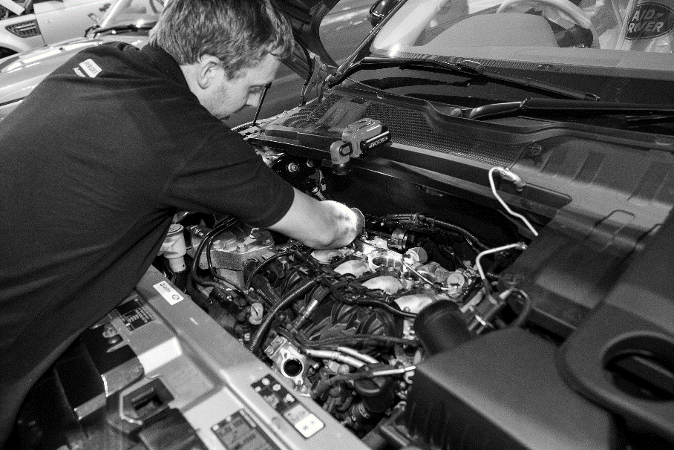

- Agree the aims of the placement
Agree what the virtual work experience placement aims to achieve and identify the expected outcomes e.g. do you want the student to experience different sectors within the retail automotive industry? Or do you want the student to understand how people can develop a career in one area of the industry such as maintenance and repair, where over time employees develop their skills and become Master Technicians or managers?

Virtual Work experience placements help students to:
- Prepare to join the world of work
- Understand how different the world of work is from the world of school
- Understand what is expected of employees
- Understand the responsibilities of employment and what is expected of employees (See the IMI’s Employability Skills Toolkit for more on this)
- Develop their social skills
- Make informed choices about what career routes are available
- Understand what qualifications are required to help them manage and realise their career aspirations
- Put into practice what they have learned in the classroom

Work experience placements should be as realistic as possible, but must be organised within some framework where students do not:
- Work for more than 8 hours a day
- Work for more than 37 hours in a week
- Start work before 0700hrs in the morning
- Finish work after 2000hrs in the evening

By requiring students to work a normal day, which would typically mean working 9am – 5pm (with an hour for lunch plus refreshment breaks) they will grow to understand the difference between the world of school and the world of work. Students should always be encouraged to work longer than a normal school day.

When identifying and planning activities that the students can complete, do not be afraid to give employers permission to manage the activity: ask them what the students could do as they will probably have ideas of their own and want to get actively involved.

- Brief students about the work experience placement
Prior to students actually going out to the employer it is advisable to run briefing sessions for them. These sessions should be designed to bring out into the open any fears or worries they might have about going to an employer and brief them on what is expected of them and what they can expect. During these sessions the opportunity should be taken to:
- Describe what the world of work is like and how it is different from school
- What sort of behaviour is expected of them
- What they must do if they are not able to turn up for work and who they should contact
- Agree any learning objectives
- Explain the purpose of the diary / logbook and how to complete it
- Explain if and when they can expect to be contacted or visited by a teacher
- Identify and common problems that may arise during a placement and explain what a student should do if they have a problem
- Answer any questions and reassure students

As part of this induction type programme it might be useful for the student to meet the employer before the start of the placement (if possible). An informal visit might help make them feel more confident about where they are going / who they are meeting etc.

For more information and suggested activities on the above bullet point please see the IMI’s Employability Skills Toolkit.

- Gatsby Benchmarks

In terms of careers provisions to students, Gatsby Benchmarks 5 (meaningful encounters with employers) & 6 (workplace experiences) Digital experiences must include but not be limited to:
Benchmark 5:
There is evidence that the student actively participated.
Learning outcomes are defined, based on the age and needs of students.
The encounter involves two-way interaction between students and employers/employees.
Benchmark 6:
Learning outcomes are defined, based on the age and needs of students.
Student meets a range of people from the workplace.
There is extensive two-way interaction between the student and employees.
Student must perform a task or produce a piece of work relevant to that workplace and receive feedback on it from the employer.

- Organise debriefing sessions to help students confirm what they have learned
After the Virtual work experience placement is over organise a debriefing session where the student can review what they have experienced. How a debriefing session is organised is up to the school work experience organiser but to give it credibility and a sense of importance, it must be structured and well-organised and be made up of several elements. For example, a well-structured debriefing exercise could include:
- one to one sessions
- group discussions
- presentations
- an event to celebrate success

One to one sessions should be used to help the student confirm what was learned. Teachers will need time to sit down and discuss with the student what happened. To help this process, documents should be provided to record what was discussed and the meeting should take place in comfortable surroundings where interruptions can be avoided. The session can be used to allow the student to present any assignments / project work that was carried out during the work experience placement and agree how it can be used for class work.

Group discussions could be used to encourage a group of students to talk about what happened and what they experienced. You may ask each student to make a short presentation about their work experience placement to other members of the group. They will have to be given guidance on what they should include.

They may want to describe the company, present the results of the project they completed during placements, or simply describe what they did and explain what they have learned. They could be encouraged to prepare a PowerPoint presentation and a set of handouts which may be used towards core skills certification.

None of the activities described are mutually exclusive. You could use one or more of them to help students consolidate what they learned. Opportunities to get the students to organise the activities themselves should not be missed, because these will provide them with opportunities to develop their team building and planning skills.

- Plan virtual work experience placement

You will need to make sure that employers are well briefed about the placement. They will need to know:
- about the calibre of the student attending
- what the student has been learning and what skills they have been developing
- what they are expected to do for the student during the placement

Employers should be encouraged to identify what they can do to help make the virtual work experience placement a worthwhile experience. For example, is the employer able to (virtually) move the student around different parts of the business where they might work in the showroom, back office or in a service and maintenance or accident repair workshop?
The following areas need to be addressed prior to the placement commencing:
- Health and safety checks of the working environment have been conducted and risks have been identified and minimised.
- Where necessary Disclosure Scotland checks have been carried out on employees who will have sustained contact with students during work experience placements (for more guidance on requirements visit www.disclosurescotland.co.uk)
- Employers have checked with their insurance companies that they have sufficient insurance cover in respect to work experience students.
- Assignments / workbooks for students to complete during the work experience placement may need to be developed. These could include investigations into how the company is organised and an analysis of how many other businesses including suppliers the company works with and depends on. An example workbook is available with this toolkit.
- So that employers understand more about the student, if possible it is a good idea to set up interviews, where the student attends an interview in order to secure a work experience placement with the employer.
- You will need to make sure that parents or carers understand what will happen during virtual work experience placements. They will need to be assured that health and safety issues have been covered and need to have an idea about what the students will be doing. They will also have to give their consent, so all the necessary paperwork and procedures will need to be in place.
- Training and briefing sessions for staff on how virtual work experience placements are delivered should be organised so they know exactly what they are required to do. This will give members of the team the opportunity to ask questions on issues that concern them.
- Students will need essential details about the virtual work experience placement. For example, they will need to know:
- who to report to
- Log on/contact information about virtual/online meetings
- the hours of work
- arrangements for lunch & tea breaks
- expectations
- who to contact if they cannot get to work
- school contact details
- emergency contact details for if they have a problem
Some of the information that students need can be included in the forms available within this toolkit. Induction with the placement employer should also cover many of these topics.
- Employers will need to know who to contact if something happens during a virtual work experience placement. You will need to put in place a system for something as simple as a student not turning up/logging in for their placement. The employer should know exactly who to tell and the parents or carers of students should know who to contact if they are not able to attend their placement.

- Support students during their virtual work experience placement
Now that all the plans for the virtual work experience placement have been carried out or put into place, students should be ready to take part in their placements. During this stage, when students are on virtual work experience, they will need to be supported and their work monitored. Therefore, systems will need to be put in place to ensure students receive this support.
- Hold briefing sessions for students before they actually start a virtual work experience placement. These sessions should be designed to bring out into the open any fears they might have about working with an employer and brief them on what is expected of them. The sessions could be used for example to:
- brief the student on what they should do
- agree learning objectives
- agree how the placement will be monitored (visit / telephone call)
- hand out diary, workbooks, assignment or project material
- give out contact details

- Staff responsible for monitoring the placement should identify what sort of tasks the students are doing during the placement in order to make sure they are within the student’s ability or to encourage the employer to give the student more demanding tasks.

- Students should be encouraged to review their own progress and assess what they are learning from the experience. Where possible, the employer should be encouraged to take part in this process.

- Review and evaluate how Virtual work experience placements are organised and managed
It is often recommended that reviews and evaluations of systems and processes be conducted, but sadly this is not always done properly due to lack of time or resources. In this case the review and evaluations should be carried out to identify how the system and processes used to organise and manage virtual work experience placements could be improved. It is up to the school how this is done but the following guidance may be useful:
- Form a small working party charged with managing the review and evaluation and decide who should be involved. This should ideally include students and employers who will be able to advice on issues arising from the virtual work placement. The system of review and evaluations needs to be employer friendly; this means it must not be over bureaucratic or time consuming.

- Decide on the purpose for the review and agree some objectives.

- Decide how the review will be carried out, for example, will people be asked to:
- complete questionnaires (i.e. through Survey Monkey)
- take part in telephone interviews
- take part in face to face interviews
- take part in group discussion

- Decide what areas will be included in the review. The following questions are supplied to help you identify what may be included.
- How effectively were employers briefed prior to the placements?
- Did the employers believe that they provided students with the best possible experience?
- How well were health and safety checks conducted?
- How effective were the workbooks, assignments or projects developed for the students?
- How useful was the dairy / logbook?
- How effective were the systems used to brief parents and carers?
- How effective were the reporting systems used to provide support?
- How effective were the lines of communication between all participants?

- The aim of the review should be to assess if the systems, processes and paperwork used in any of the above areas could be improved.

- Once the areas for improvement have been identifies an action plan will need to be developed, where particular tasks, target dates and deadlines are agreed.

Contact details

A copy of this contact sheet should be retained on file by the work experience organiser and copies given to both the student and the placement provider.

Student
Name |  | Year / Class
Emergency contact
Relationship |  | Mobile no.
Home no |  | Work no

School / College
Work experience organiser
School / College |  | Tel no
Address

Placement provider
Contact |  | Position
Company |  | Tel no
Address

Comments
Note any special requirements or conditions for this student or placement
Health and safety checklist

A copy of this checklist should be retained on file by the work experience organiser.

Placement
Address
Tel no

Insurance
Employers Liability Insurance Certificate
(covering students on work experience)
Public Liability Insurance Certificate
Registration
Placement registered with appropriate authority (HSE or Local Authority)
Health & Safety Policy
Where there are more than 5 employees the placement must have a written Health & Safety Policy.
Health & Safety Law Poster
Health & Safety Law – What you should know poster should be displayed or a leaflet available for the student.
First Aid arrangements | First Aid Box  First Aiders
Fire Precautions | Fire exits / Assembly Points  Fire extinguishers  Appropriate Signs  Alarm
Accident Reporting | Accident Book

Placement Contact: ______________________________________ Signed: ___________________
Work Experience Organiser: _______________________________ Signed: ___________________
Date: __________________________

Virtual Work Experience Checklist
Use the following checklist to help you ensure everything is in place for a good workplace experience.

1 | The role of employers | Yes ✓
 | Employers are well briefed about the programme
 | All legal requirements have been met
 | Employers have identified activities for the students
 | Employers have provided feedback on students’ progress
2 | Good Practice | Yes ✓
 | The experiences are linked to what the students are learning
 | Assignments for students have been identified & designed
 | A diary / logbook for students to complete is available
 | Parents and carers have been briefed
 | Students have been given essential information about their placement
 | Everybody knows what to do if something goes wrong
 | One person has been identified as main contact should something go wrong
3 | Support Systems | Yes
 | A session to brief students about work experience has been arranged
 | Support systems have been identified
 | Student progress is monitored and reviewed
 | Experiences and outcomes are recorded
 | Employers take part in student reviews
4 | Review and evaluation | Yes ✓
 | The systems for managing and organising work experience placements are reviewed & evaluated
 | Materials used to review how work experience placements are managed & organised are in place
 | People have been identified to take part in the review
 | Methods of carrying out the review have been agreed
 | What areas will be included in the review have been agreed
 | An action plan to improve how work experience placements are managed & organised

Virtual Work experience placement Diary – example
Use this form to record the daily tasks and activities you carry out during your work experience placement.
Work experience programme for | John Smith | At | ABC Motors

Day / Date | Morning | Where | Afternoon | Where
Monday 14th June | Induction with Jim Brown, Administration Manager. Was shown (virtually) around dealership and met the people I will work with during my placement. Agreed with Mr Brown my programme for the week and project. | Online meeting | Virtual session with service reception, understanding how the receptionist record details on the computer and pass job cards on to the workshop. Did the task to find out the repair status of the sales car damaged in a crash. | online
Tuesday 15th June | Virtual session with technician servicing a Volvo. Talked through how to check systems on a new car before it went out for delivery to the customer. Chris showed me how to check tyres for wear to make sure they are safe & legal. | Online Workshop | Understanding how to use special equipment to test wiring and found a faulty switch, watch how to fit a new one. | online Workshop
Wednesday 16th June | Virtual session with Bob in the parts department put spare parts into correct bins and used computer to find parts. Project work | Online with the Parts Department | Focus on project for the departments I have learnt about so far | home
Thursday 17th June | Online learning and video tutorials | Training Room | Project work and online team meeting | online
Friday 18th June | Did a challenge with the sales department where I had to find best car for the Smith family. | Online sales department | Got to see what the office does with Steve and then Mr Brown had a chat about my week. Filled in my forms. | online

Virtual Work experience placement diary

Use this form to record the daily tasks and activities you carry out during your work experience placement.

Work experience programme for |  | At

Day / Date | Morning | Where | Afternoon | Where

Virtual Work experience examples and resources

Week 1
Introduction to the business – this could be in the form of a morning team meeting or a pre-recorded session.
House Keeping – Vision and values for the business
Mentor – Allocate a mentor, a point of contact that the student can message, email and call if they need to at any stage.
Project Launch – This can be a topic of your choice or one of our suggestions in the resource section of this guide. Make sure expectations are set for the project and support and resources are available to the student.
Networking sessions – Book in video/online sessions with each department of the business, providing the student with an overview of the roles available and what they entail.
Weekly Check out – either in the form of a team meeting or 121 with mentor, feedback for the week, project update, AOB.
Week 2
Weekly check in – either in the form of a team meeting or 121 – setting the scene and expectations for the week
Video Content – Virtual tours and Apprenticeship journeys are very useful resources in this scenario, where the student is not able to experience the workplace in real life, a virtual tour is the best alternative. Being able to see and talk to employees in the workplace is very powerful.
Online Learning – Does your company have access to an online learning portal that your work experience student can access? Are there any relevant courses you can set them to have an insight into the industry?
Social – Do you have regular meetings, quizzes, drinks with your team? Make sure you include your VEX candidate to show the fun side of the business.
Project – Review progress and final outcome
End of VEX review – What was your students experience like? What did they take from it? Is this now a career they would like to pursue further?
Resources available to you:
Project ideas:
Customer Journey –
Outline a scenario with a customer – conflict resolution?
Fault Checking –
Journey of the car through the workshop?
Innovation –
How to change/improve the experience of buying a new car
Product Launch –
A new vehicle is about to launch, plan and design the launch event to gain maximum reach

Videos available to you:
https://www.youtube.com/watch?v=aZxXpT-iTus
https://vimeo.com/manage/286155018/general
https://vimeo.com/manage/241538368/general Motor Careers
https://vimeo.com/manage/241475335/general Automotive Technology
https://vimeo.com/manage/240720202/general Refinishing
https://vimeo.com/manage/240717078/general Heavy Vehicle
https://vimeo.com/manage/240712429/general Body Repair
https://vimeo.com/manage/215935722/general Vehicle sales
https://vimeo.com/manage/215131960/general business Admin

Online learning Available:
https://tide.theimi.org.uk/learn/courses/343 An introduction to the motor trade
https://tide.theimi.org.uk/learn/courses/371 Light Vehicle layout and design
https://tide.theimi.org.uk/learn/courses/353 Workshop house keeping

For more information please visit www.theimi.org.uk/autocity
Contact us with any questions, queries or feedback on careers@theimi,org.uk

The IMI Careers Team

