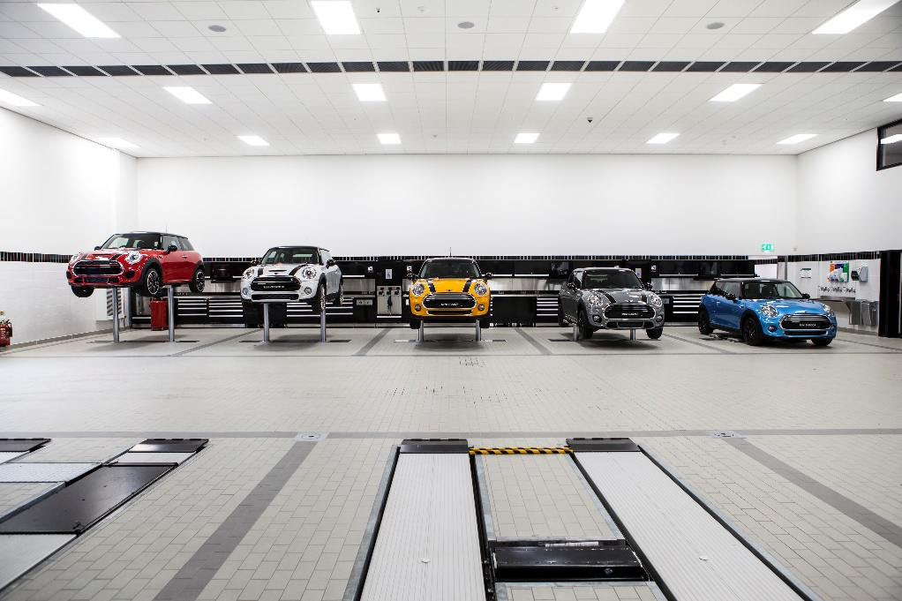
Virtual Work Experience for Students

Also referred to as online, remote or e-experience, virtual work experience gives students and graduates the opportunity to complete from home, in most cases using nothing but a laptop. Online work experience is open to all and for the majority of opportunities all you need to get involved is access to a computer and a stable internet connection.
Virtual internships share many similarities with traditional, in-person internships but their online nature allows participants to work with organisations across the country, even the globe. They're particularly relevant in these unprecedented times, as they enable students and graduates to gain invaluable work experience and boost their CV in spite of coronavirus restrictions.
Employers are aware that the coronavirus pandemic is robbing students and graduates of the chance to gain face-to-face, real-world work experience and they're working hard to ensure that their virtual opportunities are meaningful and useful for those who take part.
In terms of careers provisions to students, Gatsby Benchmarks 5 (meaningful encounters with employers) & 6 (workplace experiences) Digital experiences must include but not be limited to:
Benchmark 5:
There is evidence that the student actively participated.
Learning outcomes are defined, based on the age and needs of students.
The encounter involves two-way interaction between students and employers/employees.
Benchmark 6:
Learning outcomes are defined, based on the age and needs of students.
Student meets a range of people from the workplace.
There is extensive two-way interaction between the student and employees.

Student must perform a task or produce a piece of work relevant to that workplace and receive feedback on it from the employer.
This guide will provide you with guidelines of how to gain your own Virtual Work Experience and expectations.

On the whole online work experience involves:
- Regular online meetings between student and supervisor or mentor
- Individual project work where the student will focus on one larger project instead of helping with lots of small jobs (as you probably would if you were in an office environment)
- Video tutorials and virtual tours
- Virtual networking sessions and online chats with various members of the organisation to give the student an insight into what different colleagues do
- Training opportunities generally provided via an e-learning platform
- Online socialising events such as team drinks, coffee breaks and quizzes.
We would recommend a 2 week VEX placement. This will provide you with a good insight into the business and the different roles available.
What to expect over the two week period:
Week 1
Introduction to the business – this could be in the form of a morning team meeting or a pre-recorded session.
House Keeping – Vision and values for the business
Mentor – Allocate a mentor, a point of contact that the student can message, email and call if they need to at any stage.
Project Launch – This can be a topic of your choice or one of our suggestions in the resource section of this guide. Make sure expectations are set for the project and support and resources are available to the student.
Networking sessions – Book in video/online sessions with each department of the business, providing the student with an overview of the roles available and what they entail.
Weekly Check out – either in the form of a team meeting or 121 with mentor, feedback for the week, project update, AOB.
Week 2
Weekly check in – either in the form of a team meeting or 121 – setting the scene and expectations for the week
Video Content – Virtual tours and Apprenticeship journeys are very useful resources in this scenario, where the student is not able to experience the workplace in real life, a virtual tour is the best alternative. Being able to see and talk to employees in the workplace is very powerful.
Online Learning – Does your company have access to an online learning portal that your work experience student can access? Are there any relevant courses you can set them to have an insight into the industry?
Social – Do you have regular meetings, quizzes, drinks with your team? Make sure you include your VEX candidate to show the fun side of the business.
Project – Review progress and final outcome
End of VEX review – What was your students experience like? What did they take from it? Is this now a career they would like to pursue further?

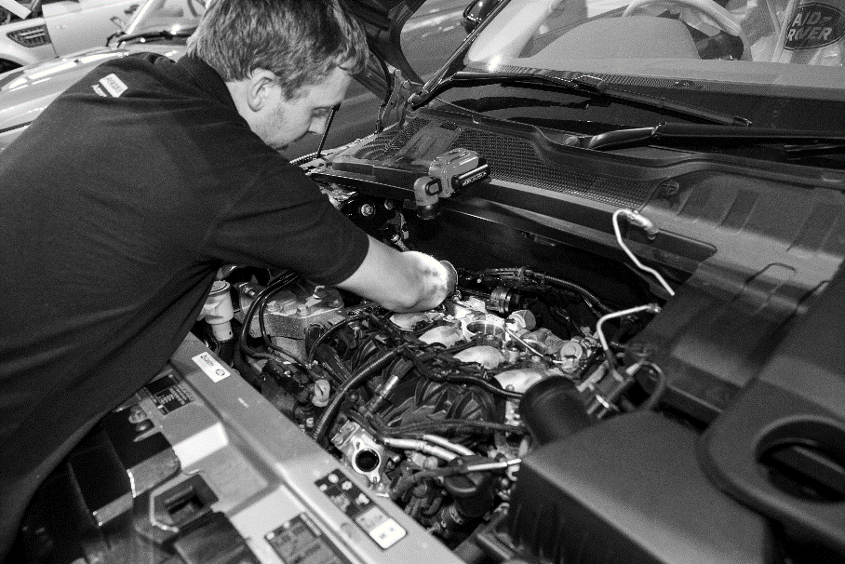

Workbook - Before the placement

- Self-Assessment - aims

Self-assessment – aims

Students name
School
Placement
Date from |  | Date to

To help assess how your own performance has developed you should identify three target areas for improvement during your virtual work experience placement. You will need to agree these with your placement employer to ensure they are appropriate and achievable. To confirm you have completed the stated outcomes you will need to get a supervisor to sign the form to verify them.

Performance Improvement Targets |  | Achieved?  Delete as appropriate
1 |  | Yes / No
2 |  | Yes / No
3 |  | Yes / No

Supervisor confirmation of targets achieved:

_____________________________________________ (signature)

Workbook - During the placement

- Virtual Work experience diary – example
- Virtual Work experience diary – blank
- Workbook
- The Company
- My Company
- Health and safety
- Jobs within the company

Virtual Work experience placement diary – example

Use this form to record the daily tasks and activities you carry out during your virtual work experience placement.

Work experience programme for | John Smith | At | ABC Motors

Day / Date | Morning | Where | Afternoon | Where
Monday 14th June | Induction with Jim Brown, Administration Manager. Was shown (virtually) around dealership and met the people I will work with during my placement. Agreed with Mr Brown my programme for the week and project. | Online meeting | Virtual session with service reception, understanding how the receptionist record details on the computer and pass job cards on to the workshop. Did the task to find out the repair status of the sales car damaged in a crash. | online
Tuesday 15th June | Virtual session with technician servicing a Volvo. Talked through how to check systems on a new car before it went out for delivery to the customer. Chris showed me how to check tyres for wear to make sure they are safe & legal. | Online Workshop | Understanding how to use special equipment to test wiring and found a faulty switch, watch how to fit a new one. | online Workshop
Wednesday 16th June | Virtual session with Bob in the parts department put spare parts into correct bins and used computer to find parts. Project work | Online with the Parts Department | Focus on project for the departments I have learnt about so far | home
Thursday 17th June | Online learning and video tutorials | Training Room | Project work and online team meeting | online
Friday 18th June | Did a challenge with the sales department where I had to find best car for the Smith family. | Online sales department | Got to see what the office does with Steve and then Mr Brown had a chat about my week. Filled in my forms. | online

Virtual Work experience placement diary

Use this form to record the daily tasks and activities you carry out during your work experience placement.

Work experience programme for |  | At

Day / Date | Morning | Where | Afternoon | Where

Work book
Virtual Work Experience allows you to apply the knowledge and skills leaned in the classroom to a real working environment and gain an appreciation of the world of work. Working in the motor industry can offer many exciting and rewarding challenges; this workbook will help you find out about your work experience company and the jobs within it.

- The questions can be done in any order but try to answer all of them
- If you are not sure about any questions, ask for help
- Answer in complete sentences, unless constructing a list, and you can use sketches too
- Use additional material if you can eg photos (ask permission first), brochures, company information sheets etc.

Student name |  | School
Name of business |  | Type of business
Address |  | Private owner
 |  | Partnership
 |  | Dealer group
 |  | Franchise dealership
 |  | Non franchise garage
 |  | Fast fit outlet
 |  | Other
 |  | Public body

If they are a franchised dealership what does this mean? What franchise (s) do they have?

Has the placement more than one site? If so how many and where are they?

Describe the products and / or services they offer

The company

This section encourages you to find out about the company and how it is organised:

- Who owns the company and when was it founded?

- How many people work for the company at your placement location?

- Here is a chart showing the company structure of a typical motor dealership. Draw a similar chart showing the structure of your placement company. Include the names and titles of the heads of each department.

Dealer Principal

Sales Manager
Administration Manager
Parts Manager
Body shop Manager

Service Manager

2 Receptionists
2 Administrators
1 HR Assistant
1 Financial Controller
6 Sales Executives
1 Administrator

1 Body Receptionist
1 Workshop Controller
2 Body Repairers
2 Refinishers
2 Apprentices

2 Parts Operatives
1 Delivery Driver
1 Apprentice
2 Service Reception
1 Workshop Controller
6 Technicians
2 Apprentices
My Organisational Chart

- As part of your induction you should have been given a virtual tour of the workplace. From the list below tick off the departments / areas you have visited:

Reception |  | Showroom |  | Service Workshop
Parts Department |  | MOT Area |  | Carwash / Valet
Toilets |  | Canteen |  | Other
Body Repair Workshop |  | Administration Office

- Describe any areas where you were not allowed to enter and why.

- What hours does the workplace operate?

- When are you expected to start/login/checkin?

- What procedure is there for checking in and out of the workplace?

- When are your breaks?

- Describe what you think about the company e.g. friendly, busy etc.

- What is the dress code at your place of work? What safety clothing or equipment would you be expected to wear?

Health and Safety

Motor vehicle workshops can be dangerous places and it is important you are aware of the systems and procedures in place to protect you and others around you in the workplace.

- What first aid facilities are provided and where are they? Is there a nominated first aider?

- What would you do if you had an accident in the workplace?

- Are there any tools, equipment or substances that you would not allowed to use?

- If you are going to be absent from work, who do you notify and how?

- How do you know when the fire alarm has been raised?

- How many fire extinguishers are in the work area?

- Where is the nearest emergency exit? Where is your assembly point?

- These are just some of the safety signs you may find around the workplace. Fill in what they mean and where they are located in the business.
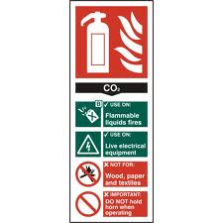

- List at least three safety hazards in the work area e.g. Flammable materials in the Bodyshop

1
2
3

The jobs within the company

It may be useful to arrange to interview someone you have worked with during your placement to help with some of the questions in this section.

- List some of the tasks and duties you are expected to perform on your work experience placement and the skills or knowledge needed to perform them.
Tasks & Duties | Skills / Knowledge Needed
Example: Identify and retrieve replacement parts using parts department computer system | Example: Ability to read and understand diagrams, use correct keys on the computer and follow storage location system to find exact location of part

- What tasks do you enjoy the most and why?

- What don’t you like about the virtual placement and why?

- What qualifications would you need to have to do this job?

- What skills and abilities are needed? E.g. very fit, good with figures etc.

- How are people recruited for this job?

- What training do they receive?

- How long does it normally take to become fully qualified?

- How much could you earn in this job?

- What job opportunities are available in the company at the moment?

Signed:………………………………………….. Date: ………………………………….

Workbook - After the placement

- Review
- Self-Assessment – with employer or organiser
- Self-Assessment – aims

The review
This form will help you look back at your virtual work experience and identify what you learned during the time spent in a workplace environment. Use the workbook you completed during your placement and any assignments or projects you did as a reference to help you complete the questions.

Try to explain how the placement met, or didn’t meet your expectations; how it has helped you understand the world of work in general and how a business operating in the retail motor industry functions.

You may also find it useful to produce a report on your virtual work experience. A report like this should be a story of the time spent with the company: who you met, what you did and what it was like. It should also identify things that you learned and how the skills and knowledge you learned at school were applied in a work situation.

How did the placement meet your expectations?
Were there any areas where your expectations were not met?
How did the work differ from what you expected?
How did being in a workplace compare to being at school?
Did the pre-placement guidance help you understand the work any better?
What support did the workplace give you?
How did you learn how the business operates?
Are there any skills / abilities you feel you’ve improved on since the placement?
Are there any skills / abilities that the placement has shown you need to improve?
How could you sell the virtual work experience you’ve had to a future employer?
Explain how your understanding of how a motor industry business operates has changed.

Describe some of the jobs you were doing?
Which subjects from school helped during your placement and how?
What was good about the job? Why was this good?
What didn’t you like about the job?
Is there any advice you would give someone considering the same placement?
How did you get on with the people who worked there?
What kinds of jobs were there that you didn’t expect / know about?
Would you consider a career in the retail motor industry and why?
If yes, what do you need to do next?

Now you need to write a letter or email of thanks to the employer who provided your virtual work experience placement. Your teacher will help you with the lay-out of the letter and with any spelling or punctuation. Draft your letter first and let your teacher check it before writing the final version.

Self-assessment – with employer or organiser

You should complete the following sections and get them confirmed by asking your supervisor to mark yes or no as appropriate and signing in the right hand column.

Detail a number of tasks which you undertook with limited or no supervision. | Confirmed by supervisor?  Yes / No  Supervisor’s signature
Give an example of when you dealt effectively with an unexpected situation and responded to it in a positive manner. | Confirmed by supervisor?  Yes / No  Supervisor’s signature
Give an example of when you had to think for yourself and use your initiative. | Confirmed by supervisor?  Yes / No  Supervisor’s signature
Give a time when you asked for advice or help from others. | Confirmed by supervisor?  Yes / No  Supervisor’s signature
Give a time when you volunteered opinions or gave advice to others. | Confirmed by supervisor?  Yes / No  Supervisor’s signature
Give an example which shows how you worked well and co-operated with others. | Confirmed by supervisor?  Yes / No  Supervisor’s signature

Self-assessment – aims

Now look back at the targets you set. Have you achieved them?

Targets |  | Achieved?
1 |  | Yes / No
2 |  | Yes / No
3 |  | Yes / No

Supervisor confirmation of targets achieved (or not):

_______________________________________________________ (signature)

_______________________________________________________ (print name)

_________________________________ (date)

Resources available to you:
Project ideas:
Customer Journey –
Outline a scenario with a customer – conflict resolution?
Fault Checking –
Journey of the car through the workshop?
Innovation –
How to change/improve the experience of buying a new car
Product Launch –
A new vehicle is about to launch, plan and design the launch event to gain maximum reach

Videos available to you:
https://www.youtube.com/watch?v=aZxXpT-iTus
https://vimeo.com/manage/286155018/general
https://vimeo.com/manage/241538368/general Motor Careers
https://vimeo.com/manage/241475335/general Automotive Technology
https://vimeo.com/manage/240720202/general Refinishing
https://vimeo.com/manage/240717078/general Heavy Vehicle
https://vimeo.com/manage/240712429/general Body Repair
https://vimeo.com/manage/215935722/general Vehicle sales
https://vimeo.com/manage/215131960/general business Admin

Online learning Available:
https://tide.theimi.org.uk/learn/courses/343 An introduction to the motor trade
https://tide.theimi.org.uk/learn/courses/371 Light Vehicle layout and design
https://tide.theimi.org.uk/learn/courses/353 Workshop house keeping

If you need any further support or advice please contact the careers team careers@theimi.org.uk

