IMI Life Skills lesson plan

Topic: Budgeting

Context: Drag Racing

This exercise allows the student to “play” with variable factors, to achieve the best result possible when designing their own drag racing vehicle. It will also introduce them to ideas of trade off and value for money.

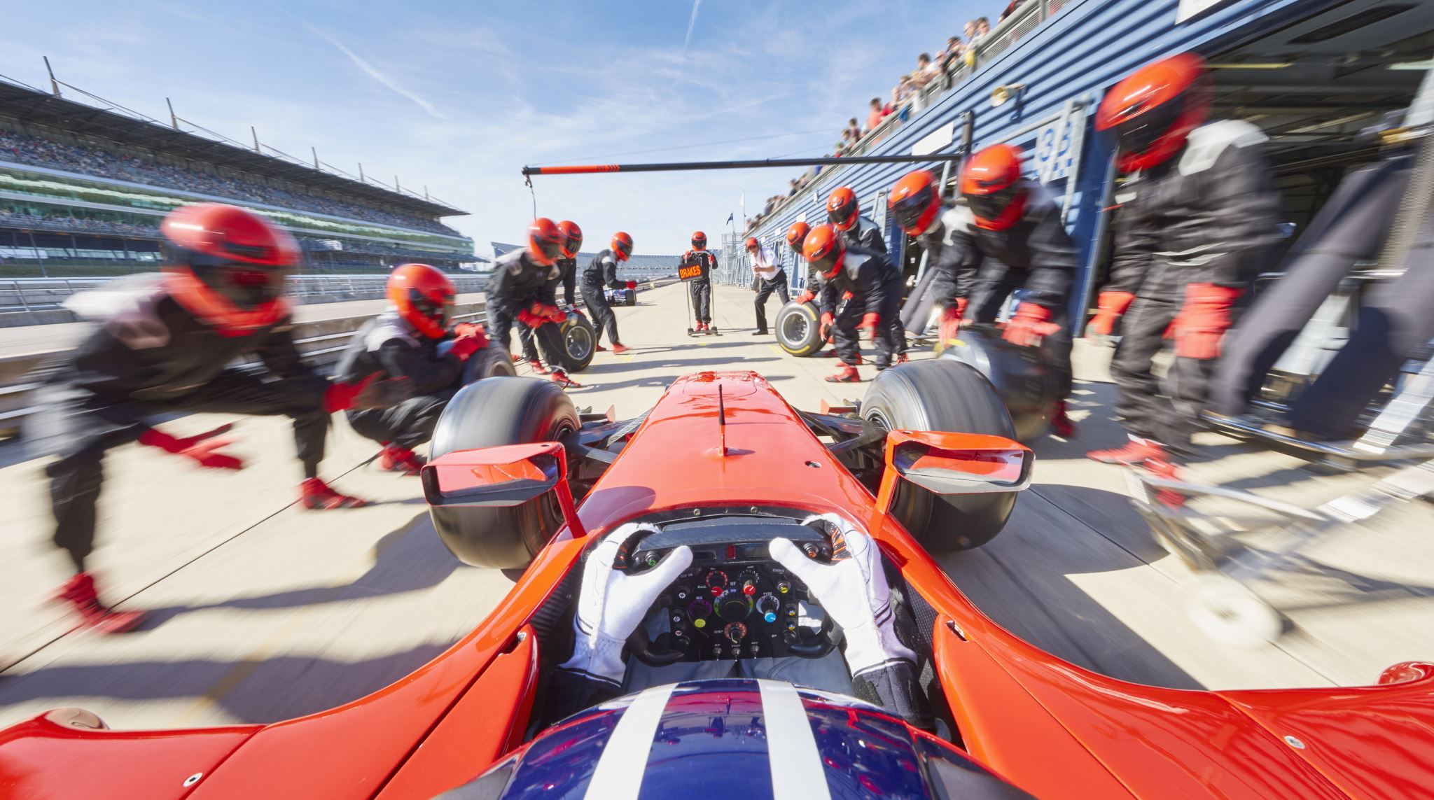

IMI Life skills lesson plan

Topic: Budgeting

Context: Drag Racing

**Learning Objectives:**

This exercise allows the student to “play” with variable factors, to achieve the best result possible. It should introduce them to ideas of trade off and value for money.

**Task**

You have been asked to design and build a drag racing car at the world-famous Santa Pod raceway. You have been given a specific budget to spend (£10,000) and you have several options available to choose from to build and develop a specification for the car. You need to have all seven parts to ensure the car will race properly plus one compulsory part (the parachute) at a fixed cost.

You will not have enough budget to always buy the best parts, so you will have to make a judgement and look at the relative value of each part. Each part has an associated financial value and point’s total. Your objective is to achieve the highest number of points within budget. Use your budgeting skills and weigh up the relative values of the parts, thinking about trade off and value for money.

Budget is £10,000…..what is the maximum number of points you can achieve?

**Teachers note**

Students are given the opportunity to “spec” their drag racer. They will need to appreciate that they won’t be able to purchase the most expensive part for each of the categories so they are asked to think about the relationships between varying factors in the car’s set up and how changing one factor may have an implication to the car. They will also be able to make value judgements about which parts offer best value for money. To enthuse the students in this area, there are links to Santa Pod raceway and other drag racing sites that might be used to contextualise the exercise. This topic could also link into other lessons as part of the curriculum.

**Support materials**

A table has been developed that offers students the opportunity to spend a budget of £10,000 on various parts. The spend is weighted to quality and the higher quality items attract the higher number of points. This affords the student the opportunity to look at the cost implications of certain purchases and their relative values and to look at alternatives.

**Drag Racing parts table.**

|  |  |  |  |  |  |  |
| --- | --- | --- | --- | --- | --- | --- |
| **Part** | **High** | | **Medium** | | **Low** | |
| **Cost** | **Points** | **Cost** | **Points** | **Cost** | **Points** |
| Engine | £2500 | 10 | £1500 | 7 | £1000 | 5 |
| Body | £1000 | 10 | £750 | 5 | £400 | 5 |
| Suspension | £1000 | 10 | £750 | 7 | £200 | 3 |
| Wheels | £800 | 10 | £600 | 8 | £300 | 3 |
| Tyres (four) | £1800 | 10 | £1200 | 7 | £800 | 4 |
| Weight reduction kit | £2000 | 10 | £1500 | 7 | £1000 | 5 |
| Supercharger | £1500 | 10 | £1200 | 7 | £1000 | 5 |
| Fuel | £2500 | 10 | £2000 | 7 | £1500 | 4 |
| Parachute (fixed cost) | £300 | - | £300 | - | £300 | - |

Pupil work sheet

Drag racing and budgeting.

**Learning Objectives:**

This exercise allows the student to “play” with variable factors, to achieve the best result possible. It should introduce them to ideas of trade off and value for money.

**Task**

You have been asked to design and build a drag racing car at the world-famous Santa Pod raceway. You have been given a specific budget to spend and you have several options available to choose to build and develop a specification for the car. You need to have all seven parts to ensure the car will race properly plus one compulsory part (the parachute) at a fixed cost.

You will not have enough budget to always buy the best parts, so you will have to make a judgement and look at the relative value of each part. Each part has an associated financial value and point’s total. Your objective is to achieve the highest number of points within budget.

Budget is £10,000…..what is the maximum number of points you can achieve?

**Drag Racing parts table.**

|  |  |  |  |  |  |  |
| --- | --- | --- | --- | --- | --- | --- |
| **Part** | **High** | | **Medium** | | **Low** | |
| **Cost** | **Points** | **Cost** | **Points** | **Cost** | **Points** |
| Engine | £2500 | 10 | £1500 | 7 | £1000 | 5 |
| Body | £1000 | 10 | £750 | 5 | £400 | 5 |
| Suspension | £1000 | 10 | £750 | 7 | £200 | 3 |
| Wheels | £800 | 10 | £600 | 8 | £300 | 3 |
| Tyres (four) | £1800 | 10 | £1200 | 7 | £800 | 4 |
| Weight reduction kit | £2000 | 10 | £1500 | 7 | £1000 | 5 |
| Supercharger | £1500 | 10 | £1200 | 7 | £1000 | 5 |
| Fuel | £2500 | 10 | £2000 | 7 | £1500 | 4 |
| Parachute (fixed cost) | £300 | - | £300 | - | £300 | - |

