Car sales Cleudo
Lesson plan guide

Title | Car Sales Executive Cluedo
Aims | For learners to have an understanding of what a car salespersons’ role involves.  To explain ‘selling cycles’ to learners
Outcomes | For each learner to better understand how important it is for a sales person to have the following set of skills:  - be able to read, understand, sort, process information, work as part of a team and be able to communicate effectively.  Learners will also understand the ‘selling cycle’
Resources | - Employer from the automotive sales sector if possible  - Customer sheets  - Evaluation sheets  - Car feature sheets  - Feature ad benefit sheets  - Winners’ prizes
Time Required | 50mins
Introduction | 5mins | Introduce session and outline what learners will go away with  Ask learners to identify ground rules for the session
Activity 1 | 10mins | What a sales person does:  - Introductions  - Hands up who likes reading / writing?  - Go round the room – what’s your favourite subject?  - Does anyone know a car sales executive? Or anyone ion the motor trade?  - What qualities do you think a care sales executive needs?  - Lead conversation towards good communication, reading, writing and maths  - Today we are going to show you how the English you learn in the classroom is used in the role of a car sales executive  The Selling Cycle:  Talk through the selling cycle including features and benefits:  - Contacting  - Questioning / listening to the customers’ needs and wants  - ‘Close’ the sale, secure decision of the customer to buy  - Handover vehicle professionally  - Follow up to endure customer satisfaction
Activity 2 | 10mins | - Talk through with learners what makes a good sales executive and a bad sales executive  - An additional option for this activity is to role play examples of a good and bad sales exec i.e. bad sales exec talks about how fast /sporty/cool the car is to an older person who will not drive more than 2 miles at a weekend, good sales person establishes a rapport and finds out what the person wants before selling them an appropriate vehicle.  - Watch the short video on sales advisor roles http://www.autocity.org.uk/world-of-work?job=18
Activity 3 | 10mins | Feature and Benefits  - Divide the class into teams  - Hand out the customer profiles and vehicle data sheets to the teams  OR  - If possible take the learners outside to examine 3 cars  - Working in teams examine the customer profiles and the data sheets of the vehicles available  - On the sheets complete a list of features and benefits your customer would consider important
Activity 4 | 10mins | The teams then try to sell the cars to their customers or the other learners in a role play format and to enthusiastically present those features and benefits to secure a sale.
Conclusion | 5mins | Add up the marks form the evaluation sheets and compare the scores.  Group discussion on what they have found out and learnt.  Ask learners if there are any questions and check understanding.

Example : Martins Mondeo

Features | Benefits
Automatic gearbox | Only needs one foot to drive and easier in traffic
Hatchback – folding seats | Lots of luggage space
Voice control | Safety and also a very good gadget
Smart modern design | Looks professional
Cruise control | Less likely to speed and makes long journeys easier
High speed wipers | Safety feature, good if you drive a lot ion the rain
Sophisticated airbags | Safety and peace of mind
Heated front screen | Safety and very convenient so can get out quickly in cold mornings

Other possible vehicles could include…

Features | Benefits
4 wheel drive | Good for off-roading
Tow bar | For towing things
Good size boot | For dog, golf clubs, scuba gear
Built in sat nav | Good for those who travel a lot
Light steering | Makes parking and manoeuvring easier
Parking sensors | Makes parking easier
Alloy wheels | Looks good and you can’t lose them like hubcaps
CD/MPS player | Can plug in ipod or mp3 player into the car
Heated seats | Great in cold weather
Convertible | Looks good and great in summer
Diesel | More economical on long journeys

Your car specification sheet

Team name
Group
Name of customer
Name and make of chosen vehicle

Features | Benefits

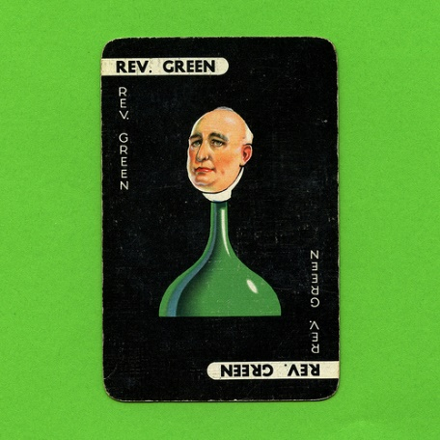

Farmer Green

Team name
Group

Your customer is Farmer Green
- Owns a large successful farm
- Married with 3 young children
- Tows trailers occasionally
- Likes lots of gadgets
- Likes to take his dog for walks in the countryside
- Takes family on holiday in England in the car

Feature | Benefits

The newly wed Whites

Team name
Group

Your customers are the newly wed Whites
- Just moved into a new home
- Don’t use the car a lot
- Commute into the city
- Very aware of the environment
- Very aware of safety
- Keen on driving into the country side for walks

Feature | Benefits

Miss Scarlet

Team name
Group

Your customer is Miss Scarlet
- 24 year old, single with no children
- Recently graduated from university and is replaying student loan
- Living in the city and parking is difficult
- Just started a permanent job
- Likes to take her dog out for walks in the countryside
- Always likes to look good
- Currently drives a 10 year old basic model car

Feature | Benefits

Professor Plumb

Team name
Group

Your customer is Professor Plumb
- Married, family grown up and living away from home
- Uses car for business with high mileage
- Commutes into the city and uses the phone a lot
- Needs to look professional
- Likes lots of gadgets
- Keen on scuba diving at weekends and carries a lot of equipment for that
- Concerned about safety

Feature | Benefits

