BUSINESS & ENTERPRISE COMPETITION

A UK wide competition for schools and colleges to work in teams to design, brand and launch their very own vehicle

The automotive industry influences everyone, from delivering goods on time to commuters travelling to work and emergency services being able to respond to a crisis. The motor industry helps to keep the country moving.

The Business & Enterprise competition will focus and improve students’ skills such as teamwork, communication, leadership, employability and life skills. Roles within the teams could include Project Managers, Sales and Marketing Executives, Researchers and Designers.

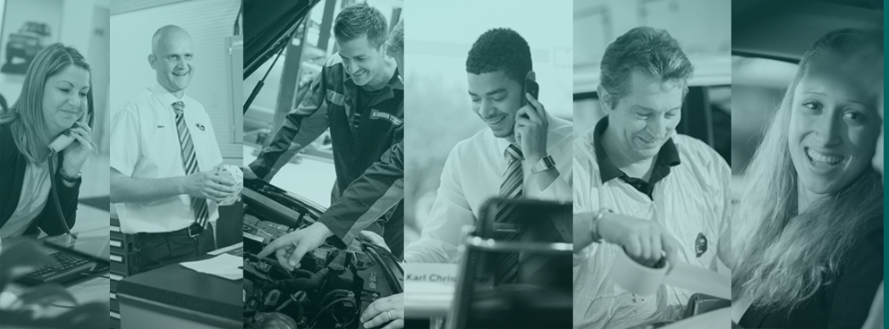

About The Institute of the Motor Industry (IMI)

The Institute of The Motor Industry is the professional body for individuals working in the motor industry and the authoritative voice of the retail automotive sector. The IMI’s aim is to ensure that the automotive retail sector has a skilled, competent and professional workforce that is fully equipped to keep pace with the demands of new technology and changing markets. A key part of business for manufacturers and dealers is to encourage the best and brightest people to join their business in a variety of roles.

www.autocity.org.uk is the IMI’s one-stop-shop for impartial careers information and advice on careers in the Retail Motor Industry. Whether you are an individual looking to start or progress your career, or a parent, teacher or careers advisor who supports others in making their career choices, Autocity is the place to start. With over 150 #MotorCareers to choose from Autocity provides you with all things Automotive!

Sponsored by Sytner Group

Sytner Group represents 20 of the world's most desirable car manufacturers in over 100 dealerships across the UK. Last year Sytner sold over 135,000 cars and serviced a further 230,000 Cars.
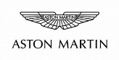
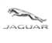
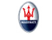
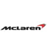
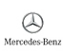
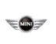
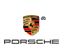
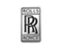
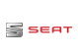
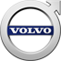
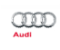
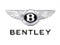
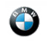
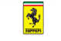
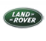
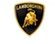
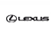
Founded by British Touring Car Champion Frank Sytner and his brother Alan in 1968, Sytner Group celebrates a one team spirit and strives to follow Frank's uncompromising driving style by offering an uncompromised customer experience. In 2002 Sytner joined the Penske Motor Group who shared the Sytner passion for motorsport. CEO, Roger Penske, being the founder of Penske Racing, the most famous race team on a worldwide basis, featuring in the NASCAR and Indy Racing series as well as Formula 1 in the 1970’s.

Sytner recognises that unparalleled customer service can only be achieved by attracting, motivating and retaining the very best team members. With this in mind, Sytner puts their employees at the heart of everything they do by providing an outstanding working environment and exciting careers opportunities. Sytner are immensely proud to have been voted, by their employees, the Sunday Times No. 1 Best Big Company to Work for 2017 and have been in the top 5 for the last 8 years. In addition, for the 5th consecutive year, Sytner have also attained the highly prized 3 star accreditation for outstanding levels of employee engagement.

Sytner Group are committed to developing talent and building careers, working in partnership with the biggest car manufacturers in the world, leading training providers and industry specialists to offer comprehensive ‘on the job’ apprentice and trainee programmes. This offers future Sytner stars a progressive and consistently successful investment in their career and personal development.

Sytner welcome Apprentices and Trainees into a wide range of business areas to kick start their career, these areas include:

- Technicians
- Sales Executives
- Service Advisors
- Parts Advisors
- Administration

Due to success and demand for the Sytner Group apprentice and trainee programmes they look to support the most proactive students who are prepared to go that extra and most innovative mile to secure themselves a fantastic career opportunity.

To find out more about the Sytner Apprenticeship and Trainee Programme: https://careers.sytner.co.uk/

THE COMPETITION

In teams (4-6 students) you are asked to design, brand and launch a new vehicle to the market …

The CEO of Sytner has decided they are going to launch a new vehicle to the market and they need your help to design, brand and launch a new vehicle!

In your team you will need to cover the roles of Researcher, Designer, Sales, Marketing and Project Manager to decide, design and create a unique and imaginative vehicle. Just follow the plan to create a concept and strategy that will appeal to your chosen target audience.

TASK 1

Firstly, decide on your target market – who are you going to sell the vehicle to?

PROJECT MANAGERS -
  - Choose from one of those listed OR
  - Decide on your own target market and describe them, their likes and how they would use a vehicle
  - Name your new vehicle and the reason behind it
RESEARCHERS -
  - What does your target market want in a new vehicle?
  - What is already available out there for them?

TASK 2

Time to get creative!

DESIGNERS -
  - Design the logo for your vehicle
  - Decide on your vehicle’s key features – these should be innovative and relevant to your target market
  - Your new vehicle needs a USP (unique selling point) to make your audience want to buy your vehicle and not one from your competitors – make sure you include this in your design and explain why they would want this
  - Draw a picture of your vehicle and point out its key features and USP

TASK 3

Now you need to plan the launch of your new vehicle

MARKETING –
  - Decide on a strapline for your new vehicle
  - Create an advertising poster for your vehicle
  - Tell us about your marketing campaign – Will you have a celebrity endorse it? Will there be a special limited edition of the vehicle available? Will there be a bonus/offer if you buy the vehicle first?
  - Describe your launch event

TASK 4

You are now ready for ‘The Big Pitch’...

SALES -
  - Film yourselves doing an ‘elevator pitch’ OR
  - Create a presentation using your ideas and drawings to show your concept (PowerPoint, Google Docs etc)

Once your new vehicle is finalised, your design can be entered into a competition, where the winning team (accompanied by teachers, tutors or parents) will be invited to attend a celebratory winners’ day with the Institute of the Motor Industry (IMI) and Sytner Careers. Previous winners have been invited to attend winners’ days at Mercedes-Benz World and the Jaguar Land Rover Experience Centre.

In addition the most innovative and exciting designs will be featured on www.autocity.org.uk

Please email your completed entry to careers@theimi.org.uk or send by post to The Careers Team, Institute of the Motor Industry, Fanshaws, Brickendon, Hertford, Hertfordshire SG13 8PQ by Friday 20th July 2021.

GOOD LUCK!
Jo, Rikki, Libby & Zoe
Careers & Student Team - Institute of the Motor Industry
Thanks to the competition sponsor:
