AUTOMOTIVE WORK EXPERIENCE TOOLKIT

Employer Guide

Sponsored by:

Content

Overview | During The Placement
Benefits Of Work Experience | Post Placement
Employer Guidance | Work Experience Placement Diary
Preparing For The Work Experience | Frequently Asked Questions

The IMI

The Institute of the Motor Industry is the professional body for individuals working in the motor industry and the authoritative voice of the retail automotive sector. The IMI’s aim is to ensure the automotive retail sector has a skilled, competent and professional workforce that is fully equipped to keep pace with the demands of new technology and changing markets. A key part of business for manufacturers and dealers is to encourage the best and brightest people to join their business in a variety of roles.

Sponsored by Sytner Careers

Sytner Group is the leading retailer of prestige vehicles in the UK and they are just as passionate about their people as they are about their customers and the cars they sell. Sytner are immensely proud to have been voted, by their employees, the Sunday Times No. 1 Best Big Company to Work for 2017 and have been in the top 5 for the last 8 years. In addition, for the 5th consecutive year, Sytner have also attained the highly prized 3 star accreditation for outstanding levels of employee engagement.

Contact Us

If you have any questions of feedback please contact us on careers@theimi.org.uk

Work Experience Toolkit Overview

The Work Experience Toolkit provides enjoyment for work experience placements with the achievement of the maximum learning benefit from the work experience placement. Students will have an insight into the retail motor industry and an ability to make informed decisions about future career options.

You will also receive guidance notes, forms, workbooks and suggestions to ensure that employers and schools have the means to deliver a successful work experience placement in the retail motor industry.
Whether you’re an organiser of work experience, an employer in the sector or a student considering a work experience placement in the retail motor industry, these toolkits contain all you need to ensure a well-planned, meaningful period of work experience or a successful job application.

These guides include:

- The benefits of work experience
- Information for work experience organisers
- Information for students
- Information for employers
- Useful templates
- Frequently asked questions

The Benefits of Work Experience

By offering work experience placements to students, employers can:

- help promote a positive image of the industry
- help promote a positive image of their company locally
- identify potential future employees
- help students develop their knowledge of the industry, so they can make informed choices about what to do in the future
- help improve the work readiness of young people preparing to enter the workforce
- recruit more informed school leavers, who are more likely to stay in the sector because they have a better understanding of the retail motor industry
- make the company more attractive to potential recruits
- help promote the relevance of vocational qualifications within the sector
- meet the company’s social/corporate responsibility policy

And help staff to develop their:

- project management, organisational and planning skills as they operate work experience placements
- coaching skills as they work with students
- communication skills as they prepare assignments or projects related to their department or job role for the student to complete during the course of the placement
- ability to reflect and make amendments to programmes as they review the quality of what happened during the work experience placement

This toolkit provides guidance and practical information on how to deliver a quality and worthwhile work experience placement within the retail motor industry. It has been provided to help students achieve the maximum learning benefit and gain an insight into the retail motor industry and the career options on offer.

Employer Guidance

Work experience provides employers with an opportunity to promote a positive image of the industry and gives them the perfect stage on which to test young people who can be viewed as potential future employees. By building links with local schools and colleges employers can help improve the work readiness of young people about to enter the workforce and recruit informed school leavers who better understand the skill requirements and environment of the retail motor industry.

A well-organised work experience replacement helps promote the relevance of vocational qualifications within our sector and the need for ongoing training as part of an employee’s career development. Employees themselves can also benefit through the process of managing and operating the work experience placement allowing them scope to develop management and coaching skills. Existing staff could develop assignments or projects related to their department or job role for the student to complete during the course of the placement. These should encourage the student to communicate with staff and carry out research.

What you can offer as an employer will obviously depend on the size, structure and nature of your business and the range of opportunities you have. You should also however consider how much time and resources can be devoted to the work experience, which departments, positions and tasks are suitable for a young person, health and safety implications and any disruption to the normal daily routine.

However, by providing a well-planned, well-organised work experience for the student you will not only have helped them acquire the right skills and attitudes for the world of work but raised the profile of the retail motor industry as an attractive career option and perhaps dispelled a few inaccurate stereotypical views.

This guidance note and the associated documentation aims to assist you with the organisation, planning and management of a work experience placement. In providing a constructive and rewarding experience for participants not only will they themselves benefit from their time with you, but it will also promote a positive image of your company and our industry in general, to potential employees and customers. By developing this toolkit the Institute of the Motor Industry (IMI) hopes to encourage a better understanding of the wide variety and nature of the roles within the automotive sector and the career opportunities it offers.

From a practical point of view the toolkit provides you with guidance and information on work experience provision by way of notes, checklists and suggested work schedules which can be adapted to fit your environment ensuring a rounded experience to the student.

A Work Experience Agreement is drawn up prior to commencement of the work experience placement and an attendance certificate issued on completion. Samples are included in the organiser section of the toolkit, however, individual schools and colleges may choose to use their own documentation. Your school / college contact will advise you of any forms they require to be used.

The work experience activity itself can be divided into:
- Preparation prior to the placement
- Learning experiences provided during the placement
- Review on completion of the placement

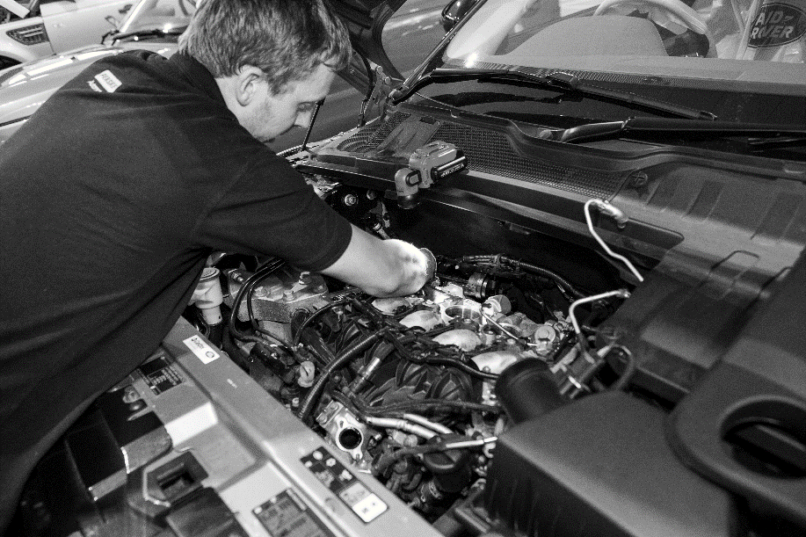

Preparing for the Work Experience

- You need to clearly identify who will supervise students during their time with you and who will deputise in the event of their absence. Supervisors should be aware that young people will require more supervision than adults.

- Prepare a scheme of work activities and ensure relevant departments are aware of their involvement. It is worth remembering that students should have the opportunity to make choices and decisions for themselves. Consider how these activities may allow them to do things for themselves and how it might link to the student’s school work. This and any learning objectives should be agreed with the work experience organiser and may include:

  - Understanding the purpose of the job or task and its relationship to the overall work of the company
  - Meeting appropriate standards of working behaviour such as timekeeping, dress code and conduct
  - Identifying the importance of good health, safety and welfare practices

- Whenever possible invite the student to visit prior to the placement commencing. Research has shown that a pre-placement visit to discuss the nature and range of work builds the student’s confidence and they performed better during the placement. It may be possible to complete an induction into the workplace at this time and introduce the student to key personnel they will be involved with. Further details of what should be included in an induction are included in the next section entitled ‘During the Placement’.

- Complete the work experience agreement and pre-placement checklist with the school / college personnel.

- Carry out a risk assessment of all areas where the student will be working.

During the Placement

- Provide an induction into the workplace. As well as general information on the company and what it does the following topics should be included:

- Health and safety risks and any precautions / rules which are in place
- Student responsibilities towards health and safety
- Identify any specific areas and tasks which are prohibited
- PPE (if applicable)
- Emergency procedures
- Hours of work / breaks etc.

It may also prove useful to remind students of key health and safety points during the placement. This could be integrated into the work activity by asking them to produce a risk assessment for a particular task. An example induction programme is available within this toolkit.

- Endorse the student’s record of learning activities in their daily log sheets / work diary. The student should be encouraged, within reason, to seek out opportunities to do things themselves and to try out new activities. The enterprise projects included in this toolkit are provided to assist with developing the interpersonal skills of the individual and creating a better understanding of the world of work by encouraging them to undertake investigations of how your business operates.

- Provide experience of doing real work in a real job. This is key to the success of the work placement. Students should experience actually working with or around vehicles because this is often why they will have selected this type of work experience in the first place, because of a love for cars, trucks or motorcycles. A variety of related jobs should be arranged to provide an overview of what your business does. The suggested work plan diary demonstrates how the week could be split up between departments however this will depend on many factors such as the size and structure of the organisation and availability of resources to allow a placement in a particular department.

- Work experience can be given an ‘enterprise’ dimension if employers set a challenge for the student to investigate and report on during the placement. This requires the student to use initiative and creativity to generate ideas in response to a realistic business problem. They should also be encouraged to develop their personal and social skills and time spent in areas dealing directly with staff or customers may be appropriate e.g. parts counter.

- On the last day of the placement, interview the student to find out how they felt about the experience and if they had met any objectives or outcomes set. This should give the opportunity to discuss any areas which may not have gone as well as planned and how they could be improved.

Post Placement

- The departmental supervisor should complete a short report recording the overall performance of the student during the placement within their department. The report should identify areas of work undertaken and comment on attitudes and personal qualities demonstrated. Any examples of using their initiative and positive comments on the student’s suitability for employment are particularly useful. Where the student has worked in several areas each department’s report can then either be fed back to the organiser or compiled into a single report showing the overall performance of the student throughout the duration of their placement.

- Review the work experience placement with department supervisors to highlight any areas of concern and allow for suggestions of how future placements could be improved. This process can help the personal development of members of staff by allowing them some degree of control and creativity within their involvement with work placement students.

- Feedback to employees any positive comments from the student regarding their placement.

- Discuss with the school / college how you may be able to assist them in other areas. By offering support you not only help young people prepare for the transition to work but also enhance the image of your business in the community. Examples of how you can get involved are:

Work Shadowing – students ‘shadow’ employees going about their normal activities. This allows close observation of jobs which for reasons of security, safety or complexity cannot be undertaken as part of a work experience placement.

Placement Visits – group guided tours of your workplace. This can be for students, teachers or both.

Mock Interviews – giving students experience of job interviews.

Company Briefing – various people speak about their different roles within your business.

Mentoring – where an individual student meets on a regular basis with an employee to enhance their motivation, knowledge and skills.

Teacher Placement – allows the teacher to identify the possibilities for learning within the workplace and gain an appreciation of the types of work carried out.

Work Experience Placement Diary – Example

Use this form to record the daily tasks and activities you carry out during your work experience placement.

Work experience programme for | John Smith | At | ABC Motors

Day / Date | Morning | Where | Afternoon | Where
Monday 14th June | Induction with Jim Brown, Administration Manager. Was shown around dealership and met the people I will work with during my placement. Issued with overalls and boots. Agreed with Mr Brown my programme for the week. | Office | Went to service reception and helped the receptionist record details on the computer and passed job cards on to the workshop. Did the task to find out the repair status of the sales car damaged in a crash. | Reception
Tuesday 15th June | Worked with technician servicing a Volvo. Helped check systems on a new car before it went out for delivery to the customer. Chris showed me how to check tyres for wear to make sure they are safe & legal. | Service Workshop | Helps Chris to find a fault with a car that had no heater fan. Used special equipment to test wiring and found a faulty switch, fitted a new one. Helped John do an MOT on a Fiesta. | Service Workshop
Wednesday 16th June | Helped Bob in the parts department put spare parts into correct bins and used computer to find parts. Did exercise set by Mr Brown to get parts ready for delivery van. | Parts Department | Built display and put up posters for new oil promotion. Served mechanics at workshop counter. | Parts Department
Thursday 17th June | Went to training show on new car with sales department. Unpacked new car sales displays and posters. | Training Room | Set up new promotion in showroom. Put up posters and displays in windows. Helped move cars in from transporter and clean them. | Showroom
Friday 18th June | Did a challenge in sales department where I had to find best car for the Smith family. | Showroom & Office | Got to see what the office does with Steve and then Mr Brown had a chat about my week. Filled in my forms. | Office

Work Experience Placement Diary

Use this form to record the daily tasks and activities you carry out during your work experience placement.

Work experience programme for |  | At

Day / Date | Morning | Where | Afternoon | Where

Frequently Asked Questions about Work Experience Placements

What will I do on my work experience?
You will gain an understanding of the world of work and the skills, abilities and attitudes you will require to be successful in the workplace and how these relate to your school work. You will experience what it is like to be employed in the retail motor industry and, depending on the size and type of company, the range of jobs available. You may work with people in technical roles repairing vehicles in the workshops, assisting service advisors and receptionists dealing with customers, providing admin back up to ensure the garage runs smoothly, or supporting the sales and parts departments. A work experience placement can provide an insight into what a job in the motor industry is like and help you to make informed decisions about our future.

Will I attend at the same times as when I am at school?
The hours you attend work experience will be agreed with the employer and your placement organiser. However, for you to gain a real insight into the world of work and experience the daily routine, you should expect your working day to be the same as the people you will be working beside.
What if I find this isn’t the job I want to do?
Then you have learned something from the experience and will be able to rethink your career plans. Even if you find that a job in the motor industry is not what you expected, you will have gained a valuable understanding of what the world of work is like. Things like team work, communication, good timekeeping and appearance are important in any job and every work experience placement provides the opportunity to see why these matter, helping you prepare for the career you eventually decide is right for you.
Will potential employers recognise my work experience?
Yes. Employers realise the benefit of work experience and are more likely to recruit someone who has attended a work experience placement. You may be given a certificate recognising a successful placement and you should ensure that details of your placement are added to your CV. Many work experience placements can lead to an offer of a job.

Where can I find information on degree courses and university work placements?
The IMI has launched a new Graduate and Undergraduate section on our Jobs Platform, where applicants can now search for degree-level opportunities, internships and gap-year placements alongside apprenticeship vacancies: www.imijobs.org.uk

How can I prepare my students for work experience in the motor industry?
Included in the toolkit is a section for your students with guidance and information to ensure they are well prepared for their work experience in our industry.

I already have information for organising my placements. How will this toolkit help me?
The Automotive Work Experience Toolkit has been designed specifically for work experience within the automotive sector, providing guidance and information on how to ensure your students gain the best experience in our industry. The toolkit includes all the necessary forms and documents to help you set up and manage an automotive work experience placement. It also provides your students and the employers you work with tasks and projects which will help them structure their time in the workplace highlighting the range of skills and abilities needed by the retail motor industry.
Employers in my area are reluctant to get involved. What can I do?
Many smaller employers in our sector find it difficult to organise and manage the work experience placement and therefore find it easier not to become involved. By providing them with guidance on how to go about it, with a structured programme they can work to and pre-prepared documentation you can make the process as straightforward as possible. Hopefully this will ensure that a hassle free, enjoyable and high quality work experience placement is provided. Once on board employers can be encouraged to participate in other activities such as school visits/talks, teacher placements, mock interviews etc - strengthening relationships with their local schools and the local community.

Can I download/print the forms?
All the documents are in pdf format and available for you to download and print.

For more information please visit www.theimi.org.uk/autocity

Contact us with any questions, queries or feedback on careers@theimi.org.uk

The IMI Careers Team

