Design a vehicle for your future
The automotive industry helps everyone, from delivering food and medicine on time, helping people travel to work and emergency services being able to help in a crisis, the motor industry helps to keep the country moving.
Automotive means everything on the UK roads that we use to transport people and things. This includes cars, lorries, motorbikes, busses, electric scooters, vans, and tractors.
The IMI helps people working in the motor industry and Sytner Group are Europe’s largest automotive retailer.
Together we have been working hard to prepare the industry for the future, but we have run out of ideas! So, we need your help to create a brand-new vehicle that will be ready for 2030.
Can you imagine what type of vehicles will be popular in 2030? What will they look like? How will they run? Will they have some fun things in them that haven’t been invented yet?
Follow the steps below and help us design a vehicle of the future.
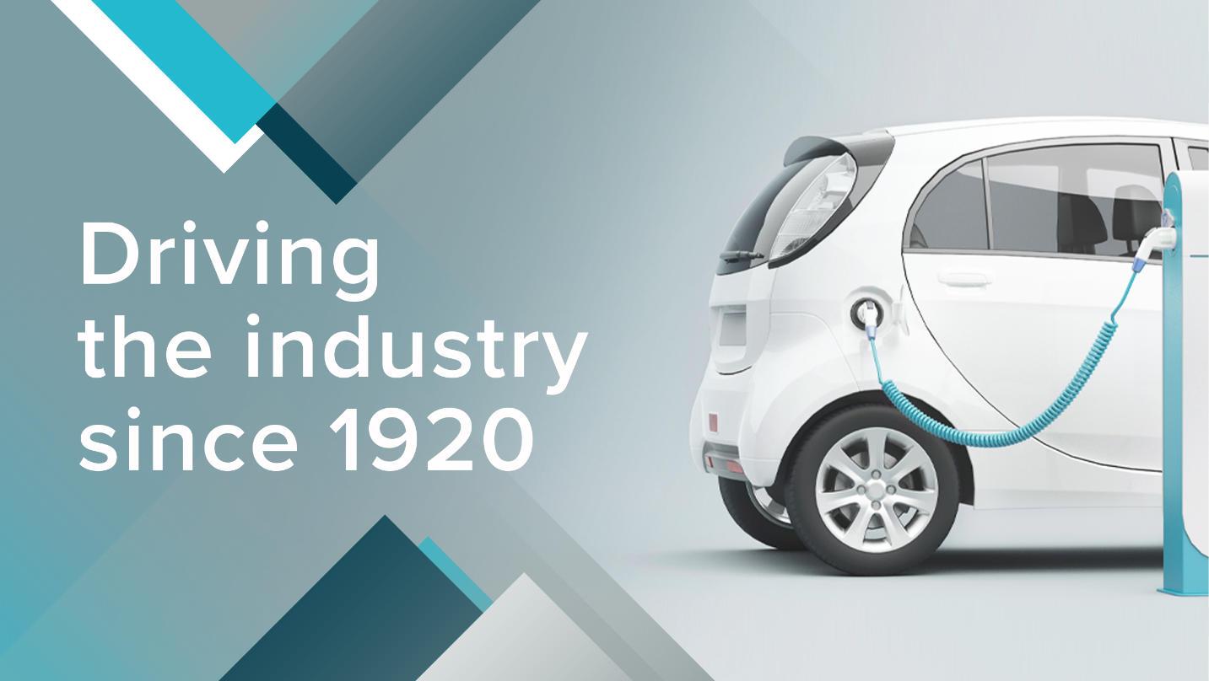
Competition sponsored by:
STEP 1:
Think of 3 new things you would like your vehicle to have. Remember you are looking into the future so it could be anything we have lots of time to invent things.

Her are some ideas to get you started…
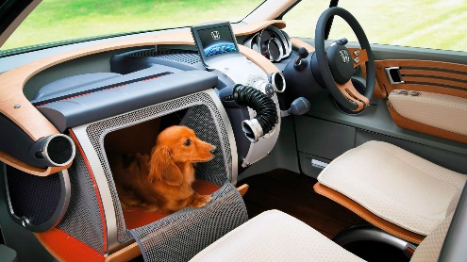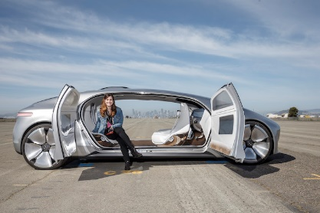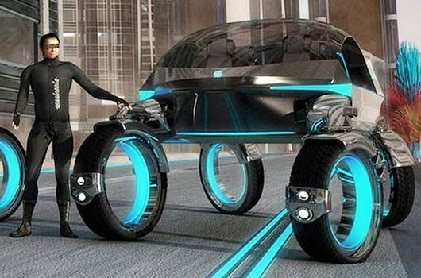

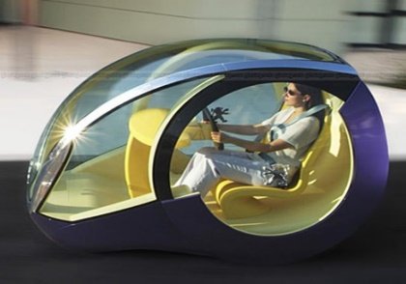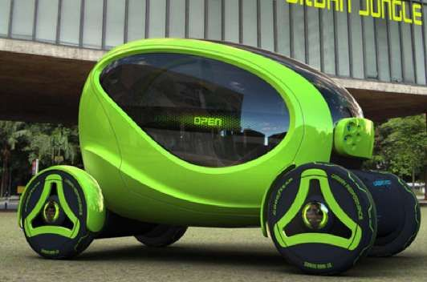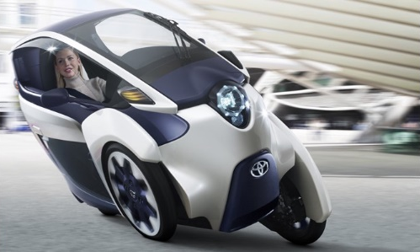
STEP 2:
What will you name your new transport? Put some Ideas in the box below.

What name have you chosen?

STEP 3:
Please draw a picture of your transport and label some of its special features:

STEP 4:
Create a logo and show us what it will look like:

STEP 5:
Now it’s time to put everything together and show us your big ideas. Create a poster to advertise your transport of the future.
You can use a separate piece of paper of you want to paint, colour in your design, or need some more space to show your vehicle.
.

You’ve done a great job, thank you!

On behalf of the IMI, Sytner Group and the future, thank you for an amazing design. You have shown creativity, inventiveness, marketing skills and brand awareness. You have also given us a great design and ideas on what the next best vehicle will be. We are sure you will all go far and look forward to seeing these vehicles in real life in 2030!

Now submit your designs to careers@theimi.org.uk

If you would like to know more about jobs in the automotive industry then please visit: www.autocity.org.uk

