BUSINESS & ENTERPRISE COMPETITION

Student Planner

Sponsored by Sytner

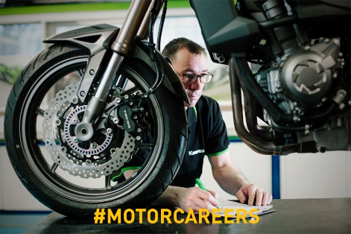
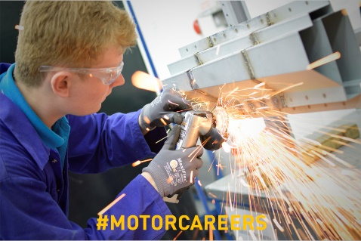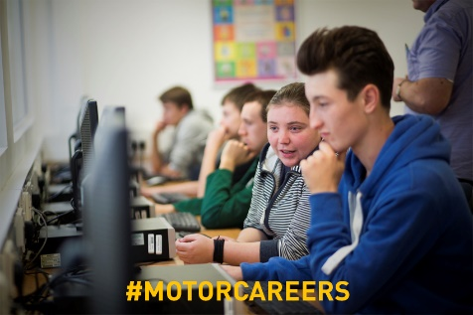

Team name:

Team participants: | 1  2  3  4  5  6

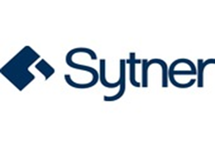

Competition Brief

The CEO of Sytner has decided they are going to launch a new vehicle to the market and they need your help to design, brand and market a new vehicle. In teams of 4-6 you will need to:

Task 1 – Research & Planning
- Decide who you will be selling the vehicle to – choose a target market from the list OR describe your own audience, their likes and how they would use a vehicle
- Explore what is currently available to your target audience in existing vehicles?
- Think about what they would want in a new vehicle
- Name your new vehicle and the reason behind it
Task 2 - Design
- Design a logo for your brand/vehicle
- Decide on your vehicle’s key features – these should be innovative and relevant to your target market
- Your new vehicle needs a USP (unique selling point) to make your audience want to buy your vehicle and not one from your competitors – make sure you include this in your design and explain why they would want this
- Create an image of your vehicle, highlighting its key features and USP
Task 3 – Brand & Launch
- Decide on a marketing strapline for your vehicle
- Create an advertising poster for your vehicle
- Plan and describe a launch event
- Tell us about your marketing campaign – how will you launch the new vehicle to the market? Will you have a celebrity endorse it? Will there be any special offers or a limited edition?
Task 4 – The Big Pitch
- Prepare your pitch or presentation
- Present all of your ideas to showcase your new product – you could either film yourselves doing an ‘elevator pitch’ OR create a PowerPoint/Google Docs presentation

Finally send in a copy of your presentation or pitch to careers@theimi.org.uk for it to be marked by the panel of industry judges. You and your team may win the top prize of an exciting automotive day out with the IMI and the competition sponsors Sytner!

The following pages can be used to help you plan out your project!

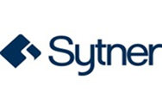

Task 1 – Planning & Research

Planning

In your group decide which target market you are going to design, brand and launch your vehicle to from the list below, or you can describe your own target audience.

Choose a target market and then research their preferences, lifestyles, hobbies and finances etc. If choosing your own write a description of them below. Include what your target market would be looking for in a new vehicle and what would appeal to them.

Ellie is a 23 year old single young professional living in the London suburbs.
Ellie uses her car to travel the short distance to and from home and the station
for her daily commute. She loves to meet up with her friends at the weekend
for shopping and socialising.

Steve is 48 years old, married with three children. Steve lives in the Midlands and his work regularly takes him all over the UK, driving long distances on motorways. He also often travels to the East coast to visit his parents in their retirement bungalow and in summer enjoys going camping with the family, which includes Dudley the dog.

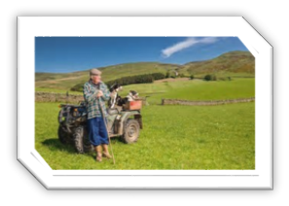
Michael is recently retired from his agricultural job and lives alone. He is 71 years old and lives in a remote part of the Scottish Highlands. From his cottage he has limited direct access to well-maintained roads however he needs to keep his independence and likes to visit his sister and brother in law who live in a nearby town.

Sara and Jamie met while studying at Exeter University and are now in the mid-thirties. They are enthusiastic campaigners for climate change and although they both work from home they do need a vehicle for their monthly visits to their parents and siblings who live in different parts of the country.
Other – describe a target market of your choice…

Our target market is …………………………………….. and we chose this audience because

Research

Research the types of vehicles already available to your chosen target audience.
- What are the good bits and what could be improved?
- What parts of the vehicle would appeal and are unique to that audience?
- Why would all of these things appeal to that audience?
Research findings….

What would your target audience WANT in a vehicle? List your ideas below:

Name Your Vehicle

What will you name your vehicle and why?

Now it’s time to start designing your vehicle for your chosen audience!

Task 2 – Design

Design Your Brand/Vehicle Logo

Experiment with creating some images of a logo you could use and then decide on the
one you like best

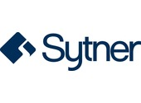
Example logo …

Draw your brand logo …

Key Features & Your Unique Selling Point (USP)

Now that you know your target audience you need to come up with some key features and a ‘unique selling point’ that will make them choose to buy your vehicle and not one from a competitor.

Use your research on the target audience to help you design a unique gadget for your vehicle. Here are some gadget ideas (that actually already exist) to inspire you:

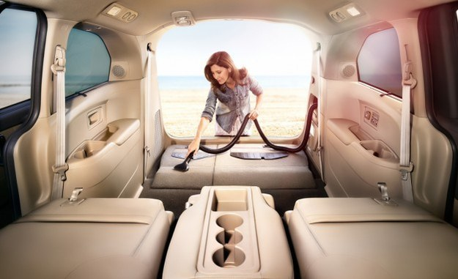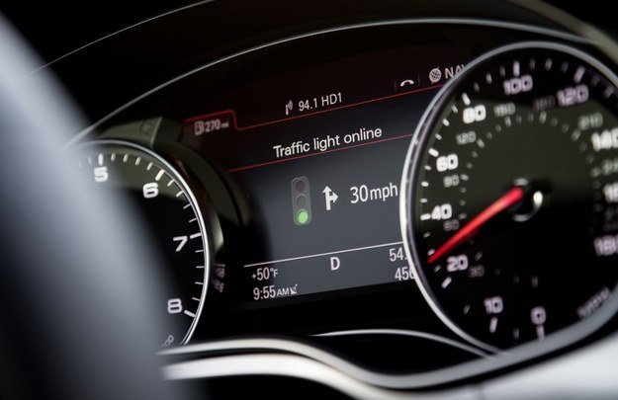

- A built-in vacuum for spontaneous spills and cleaning spells.
- Sensors that learn you’re driving style and can detect when you’re too tired to drive.
- A sunroof that automatically blocks light and lets you see what you want to.
- GPS that automatically analyses traffic and finds the best way around it.
- Cars that recognise traffic light changes and count down until the next green light.
- Brakes and cameras that automatically keep you in the centre of the lane.
- NASA-approved car seats that prevent fatigue on long drives.
- Windows that clean themselves and deflect liquid automatically.
- Heated wiper blades that melt ice and snow to keep everything clear.

What new and exciting key features would you like your car to have?
You should include some of these features when you create an image of your new vehicle

Be innovative by jotting down some Ideas for your USP ….

Finally explain your vehicle’s chosen USP, remembering your target audience …

Design Your Vehicle
Please create an image of the new vehicle

Use this space to be creative and pencil in some initial ideas
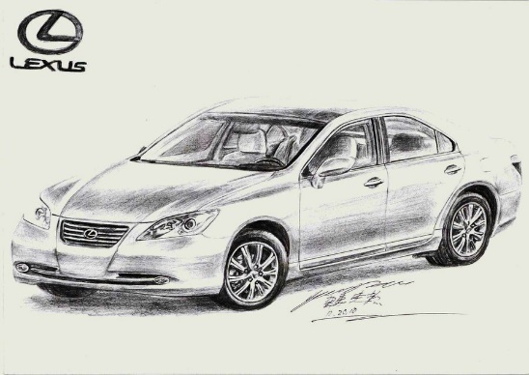

Show a final image of your new vehicle … remember to highlight the key features and USP

Congratulations you have successfully designed your vehicle!

Task 3 – Brand & Launch

Decide on a marketing strapline for your vehicle

Now that you have decided who your target audience is and what your vehicle will look like, you need to decide how you will promote your vehicle. If you don’t promote your vehicle then no one will know you have created it.

Before launching a new product you will need to think of a marketing strapline for promoting your vehicle and the image you would like to portray. Can you guess where these ones are from?
- ‘Every little helps’
- ‘Because you’re worth it’
- ‘Just do it’
Now it’s time to come up with a marketing strapline for your new car. Jot down some words you like and try and piece them together.

Marketing strapline ideas…

Final strapline…

Create an advertising poster for your vehicle

You will want to promote your new vehicle to the general public and an advertising poster is a great way of doing this.

How and where will you advertise your new vehicle?

What your advertising poster may look like …

Plan your media campaign and product launch event

Devise a promotional plan by creating a media campaign to launch the vehicle onto the market:
- Which media platforms would you use to sell your product?
- Would you have a celebrity endorsement?
- Will there be a limited edition or special offer for the launch?
- Describe your launch event – when, where, what, who?
Tell us how you plan to launch the new vehicle onto the market …

Your product is ready for the big launch … now to focus on ‘selling’ your vehicle!

Task 4 – The Big Pitch

Are you ready?

Now it’s time to get all your ideas and plans together to create a final presentation for your new vehicle.

You can enter the competition using any of the following formats:
- A PowerPoint presentation
- A written presentation on A4 paper
- A film of your team presenting or ‘pitching’ your ideas including visuals of your design, logo and advertisement
COMPETITION CHECKLIST | DONE
Choose your target audience
Research into existing vehicles
What would your target audience want/need?
Name your vehicle
What does the brand name stand for?
Design a logo
Highlight key features
Describe the USP
Create an image of your vehicle
Decide on a marketing strapline
Create an advertising poster
Plan a media campaign
Include a launch event
Prepare your big pitch
Present your new vehicle to a panel of experts

Please send your entries by email to careers@theimi.org.uk or post to The Careers Team, Institute of the Motor Industry, Fanshaws, Brickendon, Hertford, Hertfordshire SG13 8PQ by Friday 20th July 2018.

GOOD LUCK!

Jo, Sam, Libby & Zoe
Careers & Student Team - Institute of the Motor Industry
Thanks to the competition sponsor:

