ICT - LESSON PLANS

Teacher Pack

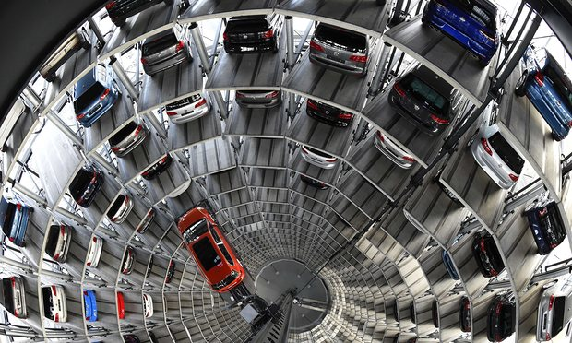

Content

Thank you for downloading our FREE ICT course. This pack includes: 12 lesson plans.

- Full lesson plans
- Resources
- Maximum 60 minutes per lesson
- Mapped to National Curriculum (England) Key Stage 3 & 4 computing programmes of study
Please add/remove/change tasks activities and resources if required for student differentiation and time restrictions.

Introduction  About The IMI and IMI Autocity | Lesson 7  Microsoft Excel
Notes:  Curriculum Content | Lesson 8  Microsoft Outlook Basic
Lesson 1  Understanding Hardware and Software | Lesson 9  Microsoft Outlook Advanced
Lesson 2  Technology & Safety | Lesson 10  Microsoft PowerPoint
Lesson 3  Online Reputation | Lesson 11  Microsoft PowerPoint Advanced
Lesson 4  Microsoft Word Basic | Lesson 12  Presentation of PowerPoint
Lesson 5  Microsoft Word Advanced | Additional Information:  Student Feedback
Lesson 6
Microsoft Excel

Lesson Titles and Resource Reference Numbers

Lesson 1 - Understanding Hardware and Software | Ref. no.
Lesson plan 1 | 001
Task 1 – External Hardware handout | 002
Task 1 – Internal Hardware handout | 003
Task 2 – Hardware / Software handout | 004
Lesson 2 - Technology & Safety
Lesson plan 2 | 005
Task 1 – Comprehension & Class discussion | 006
Task 2 – Inappropriate comments handout | 007
Task 3 – Group activity | 008
Lesson 3 – Online Reputation
Lesson plan 3 | 008
Task 1 – Reading activity | 009
Lesson 4 – Microsoft Word
Lesson plan 4 | 010
Task 1 – Create a cover letter | 011
Lesson 5 – Microsoft Word
Lesson plan 5 | 012
Task 1 – Edit document | 013
Lesson 6 & 7 – Microsoft Excel
Lesson plan 6 & 7 | 014
Task 1 – Create a price list | 015
Lesson 8 – Microsoft Outlook
Lesson plan 8 | 016
Task 1 – Create and send an email | 017
Lesson 9 – Microsoft Outlook Further
Lesson plan 9 | 018
Task 1 – Send a meeting request | 019
Task 2 – Create and save a task | 020
Task 3 – Save and create a new contact | 021
Lesson 10 – Microsoft Power Point
Lesson plan 10 | 022
Task 1 – Create and save a presentation | 023
Lesson 11 – Microsoft PowerPoint Further
Lesson plan 12 | 024
Task 1 – Edit a presentation and save it | 025
Lesson 12 – The Presentation
Lesson plan 14 | 026
Task 1 – Present their PowerPoint | 027
Rules_Automotive Family Fortunes | A
Automotive Family Fortunes_Questions | B
Automotive Family Fortunes_Slides | C
Course Feedback Form_Student | D

Lesson plan KEY |  | Prizes
Resources | Dark blue underlined text | End of lesson 8 = YES  (1 prize)  End of lesson 17 = YES (2 prizes)
Teacher information | Bold or non-bold red text
(T) | Teacher/Tutor’s role
(ALL) | Students’ role  (Individual, group or whole class is indicated)
Monitor: | Teacher/Tutor to monitor student  progress and offer support

Introduction
The automotive industry influences everyone, from delivering goods on time to commuters travelling to work and emerging services being able to respond to crisis, the motor industry helps keep the country moving.

About The IMI
The Institute of The Motor Industry is the professional body for individuals working in the motor industry and the authoritative voice of the retail automotive sector. The IMI’s aim is to ensure that the automotive retail sector has a skilled, competent and professional workforce that is fully equipped to keep pace with the demands of new technology and changing markets. A key part of business for manufacturers and dealers is to encourage the best and brightest people to join their business in a variety of roles.

www.theimi.org.uk/autocity

IMI Autocity is the one-stop-shop for impartial careers information and advice on careers in the Retail Motor Industry. Whether you are an individual looking to start or progress your career, or a teacher or careers advisor who supports others in making their career choices, Autocity is the place to start. With over 150 #MotorCareers to choose from Autocity provides you with all things Automotive!
NOTES

Curriculum content

Please note: The following points are not covered on the ICT Lessons.

Candidates should be able to:
- design, use and evaluate computational abstractions that model the state and behaviour of real-world problems and physical systems

- understand several key algorithms that reflect computational thinking [for example, ones for sorting and searching]; use logical reasoning to compare the utility of alternative algorithms for the same problem

- use two or more programming languages, at least one of which is textual, to solve a variety of computational problems; make appropriate use of data structures [for example, lists, tables or arrays]; design and develop modular programs that use procedures or functions

- understand simple Boolean logic [for example, AND, OR and NOT] and some of its uses in circuits and programming; understand how numbers can be represented in binary, and be able to carry out simple operations on binary numbers [for example, binary addition, and conversion between binary and decimal]

- understand how instructions are stored and executed within a computer system; understand how data of various types (including text, sounds and pictures) can be represented and manipulated digitally, in the form of binary digits

- create, re-use, revise and re-purpose digital artefacts for a given audience, with attention to trustworthiness, design and usability

LESSON 1: ICT

Understanding Hardware & Software

Learning objectives:
- Know the difference between hardware and software.
- Understand what hardware and software are found in a home computer.
- Be able to label hardware and software correctly.

Key words and phrases:
Hardware Software

Resources:
Student hand outs
001 | Lesson plan 1 | 003 | Task 2 – Internal hardware handout
002 | Task 1 – External hardware handout | 004 | Task 3 - Hardware / Software handout

Teacher’s resources
A | External Hardware handout | B | Internal hardware handout
C | Hardware / software handout | D | PowerPoint Presentation

Pre-class preparation:

Task 1: Print one external hardware handout per student

Task 2: Print one internal hardware handout per student

Task 3: Print one hardware / software handout per student

Lesson begins…
02

Course ice breaker

Automotive Family Fortunes

Explain the rules if necessary (See Resource A Rules Automotive Family Fortunes)

- They will be split into two teams for this game (same teams over the 17 lessons)
- The winning team will receive a prize in the final lesson
- Show example question and scoring on slides
- Check everyone knows how to play

Start the game:

Divide the class into two teams, ask the first player from each team to come to the front desk – and ask them both the first question.

We asked 100 people…

- Name an animal that would not fit into a Smart Car … |  | - What are the most popular car colours in the UK?
Elephant  Lion  Hippo  Giraffe  Mouse | 43% said…  18%  16%  14%  9% | Silver  Black  Blue  Red  White | 41% said…  17%  16%  15%  11%
- What are the most crashed cars in the UK? |  | - What are the most popular cars of all time in the UK?
Renault Clio  Ford Fiesta  Alfa 147  Porsche Boxster  BMW Convertible | 38% said…  20%  18%  15%  9% | Ford Fiesta  Ford Escort  Vauxhall Astra  Ford Cortina  Vauxhall Corsa | 45% said…  28%  12%  8%  7%
- Name 5 of the most reliable cars … |  | - Name 5 of the most unreliable cars …
Honda  Toyota  Lexus  Suzuki  Subaru | 36% said…  30%  21%  9%  4% | Land Rover  BMW  Porsche  Volvo  Mercedes | 39% said…  22%  16%  14%  9%

Lesson objective/aims:

(T) Using the PowerPoint presentation explain the learning objectives.

Discuss what hardware is – both internal and external.

Task 1:
02

(T) Ask students if they can name each piece of external hardware in the picture

(ALL) Students give their answers.

(T) Show them the slide with other examples of external hardware.

Then,

(T) Hand out the external hardware worksheet and ask the students to fill it in.

(ALL) Students discuss their answers and fill in the sheet of missing answers

Task 2:

(T) Explain internal hardware using the PowerPoint presentation.

(ALL) Students to discuss with teacher
02
(T) Hand out the internal hardware worksheet and ask the students to fill it in

(ALL) Work with a partner to check and improve your work

(T) Ensure learners are happy with their knowledge internal and external components.

02

Task 3

(T) Discuss what software is.

(ALL) Discuss the different examples of software and their functions.

(T) Give the students the software handout and ask them to complete it.

(ALL) Swap / Review your work with a partner – how many did you get right?

(T) Ensure learners are happy with both internal and external hardware and the software components of a computer.

Lesson ends
02

HANDOUT 002: External Hardware Task 1

Label as many pieces of hardware as you can on this picture:

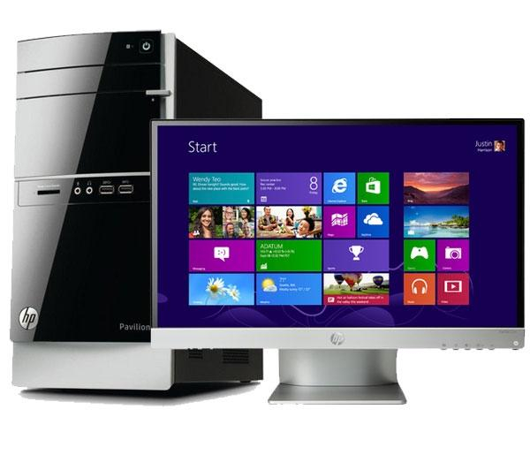
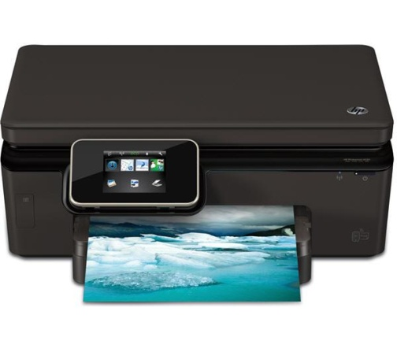

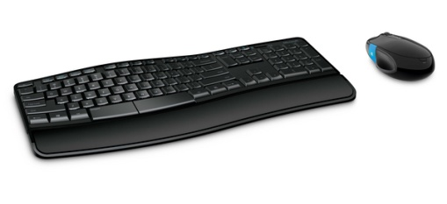
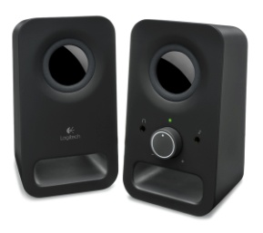
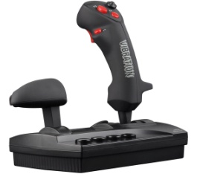
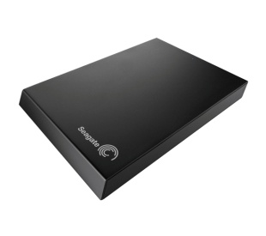
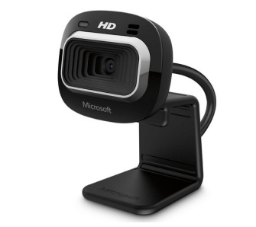
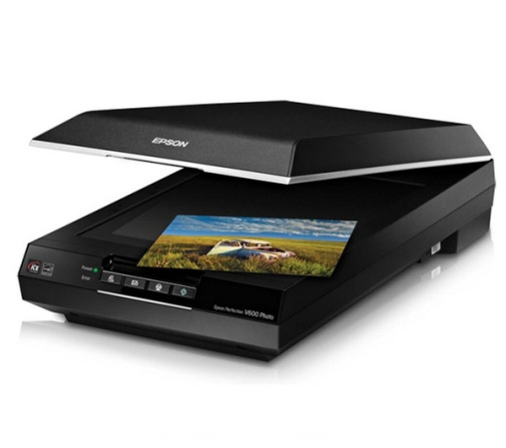
HANDOUT 003: Internal Hardware Task 2

Label as many pieces of hardware as you can on this picture:

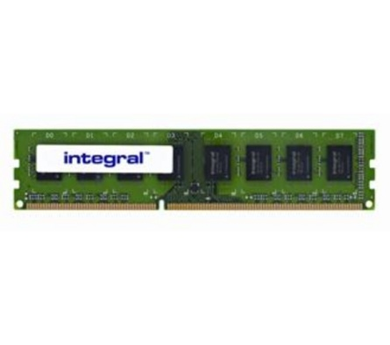
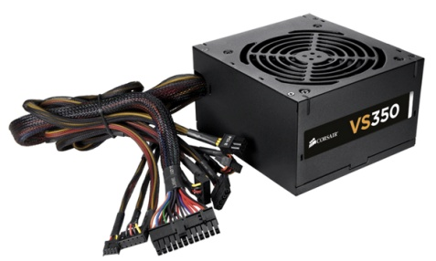
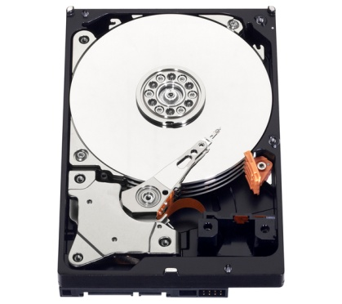
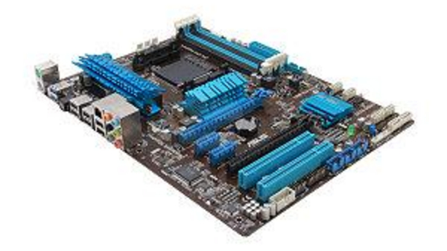
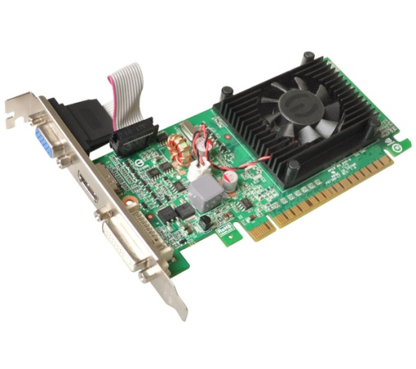

HANDOUT 004: Hardware or Software Task 3
Hardware | Software

Graphics Card | Speakers
Microsoft Paint | Keyboard
Windows 8 | Driving Test Theory CDROM
Adobe Photoshop | Webcam
Microphone | Monitor
Windows Media Player | RAM
Power Supply | CPU
Sim City Game | Hard Disc Drive
Norton Anti-Virus | Microsoft Outlook
Assassin’s Creed 3 Download | Microsoft Word
LESSON 2: ICT

Technology & Safety

Learning objectives:
- Know how to use technology safely.
- Understand how to protect your online identity and privacy.
- Be able to recognise inappropriate content and know how to report it.

Key words and phrases:

Privacy | Identity Theft | Respect | Secure
Responsibility | Protect | Inappropriate Comments

Resources:

Student hand outs
005 | Lesson plan 2 | 006 | Task 1: Online Conversation Task
007 | Task 2: Inappropriate Comments work sheet | 008 | Task 3: Identity Theft Worksheets

Misc.
Computers / Laptops | Post-it notes (green, red, orange or yellow)
Pens

Teacher’s resources
A | Automotive Family Fortunes Questions | B | Automotive Family Fortunes Slides

Pre-class preparation:

Task 1: Print handout

Task 2: Print handout

Task 3: Print handout

Lesson begins…
02

Starter Activity

Go to https://www.typingclub.com/typing-qwerty-en.html and practice your typing skills. Keep note of where you left off so as you can start at that point next lesson!

______________________________________________________________________________________

(T) Explain the objectives.

02
(T) Discuss how teenagers could encounter issues online
04
(ALL) Discuss issues when using a computer and how safe/unsafe it can be

(T) Using the PowerPoint (Lesson 2 ICT) presentation discuss Cyberbullying / dealing with cyberbullying

(ALL) Discuss ‘speaking with people online’ and what you would do if you suspect someone isn’t who they say they are – Use the links to read about real life situations that have occurred!
Task 1:

(ALL) Read the online messaging conversation on the handout and answer the questions

(ALL) Go through the answers and discuss – Look at the You don’t know!!!
04
02

(T) Explain the information on the ‘inappropriate content’ slide

(ALL) Discuss what is inappropriate and why. Has it ever happened to you?

Task 2

(T) Hand out the worksheets to the students

(ALL) Circle which comments you would find inappropriate if you saw them on Social Media

(ALL) Reflect on your answers with the class
02

(T) Discuss identity theft using the slides –

Task 3:
02

(T) Spilt the class into groups - Hand out the Task 3 handout on Privacy & Identity Theft

(ALL) In your groups take 4 minutes to discuss and fill in the sheet of 10 things you should never give out online.

(T) Ask each group to share their answers with the class and to jot down any answers they may have missed.
Hand out sheet – ‘What other things could happen if you give out your personal information online?’

(ALL) In the same groups – take 4 minutes to discuss and fill in the handout.
Again, share your answers with the class and fil in any answers you may have missed.

(T) Discuss Viruses and the damage they can cause using the slides

02

Feedback to teacher

(T) Ask students if they feel the learning objective & aims have been met using Post-its.
Explain what the colours mean and give an example.

Give out Post-its. Green = YES Red = NO Amber OR Yellow = not sure

Ask students to give their reasons.

(ALL) Hold up a Post-it and volunteer reasons.

(T) Collect in Post-its held up/count no. of each colour and keep a written record.

Lesson ends
02
03

HANDOUT 006: Lesson 2: Technology & Safety

Online Conversation Task 1

Read the following online conversation then answer the questions:

Chris: Hey you’re friends with Amy right? Saw you on her Facebook friends, are you in her class?

Sarah: Yeah, where do you know her from?

Chris: She lives near me, are you going Corn Exchange on Friday with her?

Sarah: Might do, dunno. You in our year? Which school?

Chris: Yeah, am at all boys
Sarah: So you’ve got a free house? Cool. Party?! ;)
Chris: Maybe ;), they go away a lot. Do yours?
Chris: No, must be a different form – think my brother does. He’s away with our parents this week.
Sarah: Bugger! Lol. do you know Tim Peters?
Pretend you are Sarah:

QUESTION | ANSWER
What is the name of the person you are speaking to?
What year are they in?
How do they know you?

What school are they at?

Where do they live?

Are they male or female?
Do they have a family?

What would you reply to their last question?

HANDOUT 007: Inappropriate Comments Task 2

Circle which comments you would find inappropriate if you saw them on Facebook or Twitter:

Just hit a cyclist on way to work, oh well.
Shut up you idiot!

This is my video of my friend hitting a puppy, isn’t it funny?

All Welsh people are dumb.

I don’t talk to people from Scotland because I can’t understand them.

I wish I was Irish, the English are boring.
Some people are really annoying!
I’m not racist, I just don’t like people from China.
All French people eat frogs and snails.
HANDOUT 008: Privacy & Identity Theft Task 3
1.

2.

3.

4.

5.

6.

7.

8.

9.

10.

Work in groups and list 10 things you should never give out online.

Apart from Identity Theft, what other things could happen if you give out your personal information online?
1.

2.

3.

4.

5.

LESSON 3: ICT

Online Reputation

Learning objectives:
- Know what your online reputation is.
- Understand why it is important to protect your online reputation.
- Be able to manage online accounts safely, securely and appropriately.

Key words and phrases:
Internet | Reputation | Upload | Online
Facebook | Twitter | Sexting | Texting

Resources:
Student hand outs
009 | Lesson plan 3 | 010 | Task 1 Future You
011 | Case Study

Teacher’s resources
A | Automotive Family Fortunes Slides | B | Automotive Family Fortunes Questions

Websites
NONE

Misc.
Post-it notes (green, red, orange or yellow) | Blue Tack
Smart board & Flip chart paper | Blank paper and marker pens

Pre-class preparation:

Task 1: Print 010 Future You Task 1
Print 011 case study

Task 2: Research what a Dealer Principle is using - http://www.autocity.org.uk/world-of-work

Lesson begins…
02

Starter Activity

Automotive Family Fortunes (4-5 minutes)

Use Resources: Automotive Family Fortunes_Slides AND Automotive Family Fortunes Questions
Explain the rules if necessary (See Resource A Rules Automotive Family Fortunes)

- They will be split into two teams for this game (same teams over the 17 lessons).
- The winning team will receive a prize in the final lesson.
- Show example question and scoring on slides:
- Check everyone knows how to play.

Start the game:
Divide the class into two teams, ask the first player from each team to come to the front desk – and ask them both the first question.

- Name 5 past and present Top Gear presenters … |  | - Name the most popular, past and present, Top Gear presenter …
Jeremy Clarkson  Richard Hammond  James May  Chris Evans  Matt Le Blanc | 43% said…  28%  12%  11%  6% | Jeremy Clarkson  Richard Hammond  James May  Matt Le Blanc  Chris Evans | 39% said…  31%  15%  9%  6%
- Name the oldest, past and present, Top Gear presenter … |  | - Name the youngest, past and present, Top Gear presenter …
Jeremy Clarkson (55)  James May (53)  Chris Evans (49)  Matt Le Blanc (48)  Richard Hammond (46) | 34% said…  33%  30%  2%  1% | Richard Hammond (46)  Matt Le Blanc (48)  Chris Evans (49)  James May (53)  Jeremy Clarkson (55) | 46% said…  43%  6%  3%  2%
- Name 5 of their most favourite cars featured on Top Gear … |  | - Name 5 supercars …
Lamborghini  Ferrari  Audi  BMW  Alfa Romeo | 28% said…  26%  24%  15%  7% | Bugatti  Ferrari  Aston Martin  Lamborghini  Porsche | 24% said…  22%  21%  19%  14%

_______________________________________________________________________

Lesson objective/aims:

(T) Explain the objectives.

Task 1:
02
(T) Using the power point slides, discuss your online reputation and why is it important to have a positive

Hand out the Future you handout
(ALL) Read the future you story on the handout – fill in the sheet answering online or offline to the comments.

(T) Bask students to read out their answers in class and discuss the reason for choosing their answer – discuss the repercussions of seeing posts online using the PowerPoint presentation.

(ALL) Case study – Read the case study about Kent youth PCC Paris Brown investigated over tweets.

(T) Continue through the PowerPoint presentation discussing the importance of having a positive online reputation and posting pictures online.

(ALL) Class discussion on - What is safe to post online?

IF THERE IS TIME:

Task 2:

(T) Research what a Dealer Principle is using - http://www.autocity.org.uk

Feedback to teacher

(T) Ask students if they feel the learning objective & aims have been met using Post-its.
Explain what the colours mean and give an example.

Give out Post-its. Green = YES Red = NO Amber OR Yellow = not sure

Ask students to give their reasons.

(ALL) Hold up a Post-it and volunteer reasons.

(T) Collect in Post-its held up/count no. of each colour and keep a written record.

Lesson ends
02

HANDOUT 010: Future You Task 1

You are now 40 years old, married and have 2 children. You own 4 car dealerships and are a respected member of your local Institute of the Motor Industry, Membership Association.

A local reporter is writing an article on you and decides to dig around online to see what he can find out about you when you were younger.

If you had posted any of the things below online the reporter will be able to find them and will use them in his article, which all your friends and family will see.

Knowing this, which of the following would you post online and which would you keep off the internet?

Information | Online or Offline?
A picture of you coming out of a party, drunk and wearing only underwear.

A picture of you and your friends at your university graduation.

A video of you singing karaoke in a nightclub in Ibiza.

A post where you have written that you think all people of a certain nationality shouldn’t be allowed in the UK.

A video of your dog.

A picture of you with your parents

A picture of you swearing at the camera.
HANDOUT 011: Case Study

Kent youth PCC Paris Brown investigated over tweets

(www.bbc.co.uk )
Paris Brown, an apprentice with Swale Borough Council, is due to begin the PCC job in the summer
Comments posted on Twitter by Britain's first youth police and crime commissioner are being investigated for possible criminal offences.

Paris Brown, 17, posted what could have been considered racist and anti-gay tweets from the ages of 14 to 16.

She was appointed to the £15,000-a-year post last week by Kent PCC Ann Barnes, who said she would stand by her.

Kent Police said it was investigating the circumstances to determine whether any offences had been committed.

The force said it had received on Monday a number of complaints about statements posted on social media.

Earlier, the teenager was urged to resign from the post. Two Kent MPs - Laura Sandys and Damian Collins - said Paris should step down.

Labour's home affairs select committee chairman Keith Vaz said he believed her views were "incompatible with holding office but at the end of the day it is a matter for the police and crime commissioner to decide".

The teenager, from Sheerness, made a tearful apology for the tweets after the Mail on Sunday reported she had boasted about her sex life, drug taking and drinking on her account @vilulabelle on the social networking website.

She said: "I deeply apologise for any offence caused by my use of inappropriate language and for any inference of inappropriate views.

"I am not homophobic, racist or violent and am against the taking of drugs.

"If I'm guilty of anything it's showing off and wildly exaggerating on Twitter and I am very ashamed of myself."
The Twitter page has since been removed.

Ms Barnes, 67, who is paying £5,000 of Paris's salary from her own pay, said her tweets or Facebook page were not vetted when she was offered the job.

"Perhaps that is a lesson for the future," she said. "We went through a perfectly normal recruitment process. We had her vetted by the force and nobody normally looks through anybody's Twitter feed."
Ms Barnes added: "A lot of young people use them and say the most horrible things. They don't even think about what they are saying and I think this is what's happened with Paris."

She said the teenager was one of 164 applicants for the job and was the best one and a "confident and articulate woman".

Paris, who is currently an apprentice at Swale Borough Council, is due to begin the one-year PCC post in July or August.

Paris resigned 2 days after this new story came out.

http://www.bbc.co.uk/news/uk-england-22083032

LESSON 4: ICT

Microsoft Word – The Basics

Learning objectives:
- Know what Microsoft Word is.
- Understand what documents can be created in Microsoft Word.
- Be able to create documents and use basic functions

Key words and phrases:
Internet | Reputation | Upload | Online
Facebook | Twitter | Sexting | Texting

Resources:
Student hand outs
012 | Lesson plan 4 | 013 | Task 1 Write a letter
014 | Example Letter

Teacher’s resources
A | Automotive Family Fortunes Slides | B | Automotive Family Fortunes Questions

Misc.
Post-it notes (green, red, orange or yellow) | Computers
Printer

Pre-class preparation:

Task 1:

Lesson begins…
02

Starter Activity

Go to https://www.typingclub.com/typing-qwerty-en.html and practice your typing skills. Keep note of where you left off so as you can start at that point next lesson!

____________________________________________________________________

Lesson objective/aims:

(T) Explain the objectives.

Task 1:
02

(T) Explain to the students what Microsoft word is and why you would use it.
04

(T) Demonstrate the look and layout of Microsoft word, to include;

(ALL) Turn on your computers and open Microsoft Word.

(T) Handout the Activity sheet and the example of a letter.
Ensure students are comfortable using

Feedback to teacher

(T) Ask students if they feel the learning objective & aims have been met using Post-its.
Explain what the colours mean and give an example.

Give out Post-its. Green = YES Red = NO Amber OR Yellow = not sure

Ask students to give their reasons.

(ALL) Hold up a Post-it and volunteer reasons.

(T) Collect in Post-its held up/count no. of each colour and keep a written record.

Lesson ends
02

HANDOUT 013: Microsoft Word

Type a Covering Letter

You are going to write a letter to a local company applying for an apprenticeship that you have seen them advertising.

Go to http://jobs.theimi.org.uk/ and search for an apprenticeship. Pick one vacancy that you are going to apply for.

Open Microsoft Word by clicking on the icon that looks like this:
(Yours might be 2007 or another year)

Letters should have certain information in them:
- Your address
- Your contact phone number and email address
- The company’s address
- The date
- The name of the person you are writing to or, if you do not know the name, put ‘Dear Sir or Madam’.
- The main section of the letter states why you are writing. In this case it will include the position that you want to apply for, where you saw it advertised and why you think you’d be good at the job
- Finish the letter with ‘Yours sincerely’ (or ‘Yours faithfully’ if your letter is address to ‘Dear Sir or Madam’ and your full name.

Now try writing a letter

In Microsoft Word with all these things in it, an example is on the next page.

HANDOUT 014: Microsoft Word

Amy Beech
123 Road Avenue
Townland
Countyland
AB1 2CD
Contact no: 01234 567890
Email: Amy.Beech@email.co.uk

Motors Ltd
1 Road Way
Townland
Countyland
AB1 3EF

1st September 2020

Dear Sir / Madam,

I would like to apply for the apprenticeship vacancy of Light Vehicle Maintenance and Repair Technician that I saw advertised on the IMI Jobs Website.

I have always been interested in fixing cars and would like to turn this hobby into a career. I can work as part of a team and have been volunteering at my local go-kart track at weekends.

I look forward to hearing from you.

Yours sincerely,

Amy Beech

Notes on using Microsoft Word:

Make sure that all the writing is in the same font.

To change the font; select all the writing on the page and left click on the font box in the bar along the top, you can then select a different font by left clicking on it.

Change to font to Arial now using this box, then use the box next to it to make sure all your writing is the same size (12):

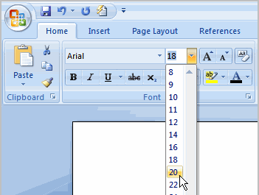

To make your address appear on the right hand side of the page you need to type it in normally, then select the writing you want to move and use the ‘alignment’ buttons on the right of the text box.

You can also use these to make sure the company’s address is aligned to the left hand side of the page.

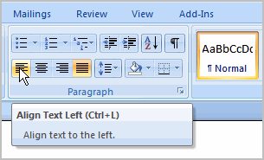

Once you have written your letter make sure you have no spelling mistakes by doing a spell check (you should do this on any document you create). Click ‘Review’ at the top of the page and then the first icon, Spelling and Grammar:

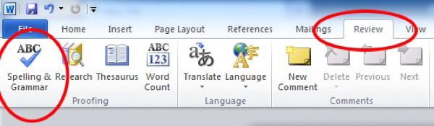

A box will appear that will change any words you have spelt wrong – remember do not just accept what it tells you, it might be changing the word. Make sure you read it carefully and think what you want to say.

You now need to save your document. Click the Windows Icon (or File), and select ‘Save As’ and ‘Word Document’:

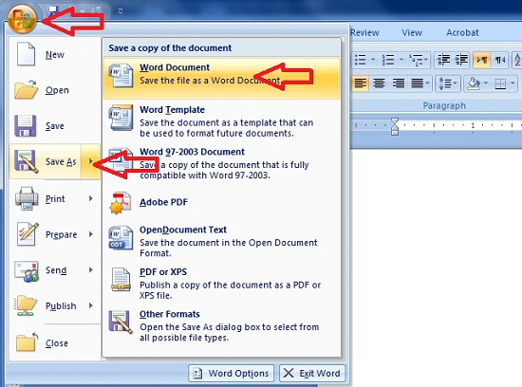

You can then select where you want to save the document (ask your teacher) and what to call it:

Now you need to make sure the letter prints properly. Go back to the Word document that is your letter and select the Windows Icon again, and hover your mouse over ‘Print’, the select ‘Print Preview’:

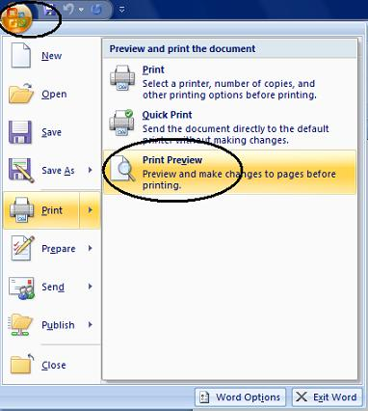

Once you have clicked Print Preview you will see your letter displayed in a preview screen:

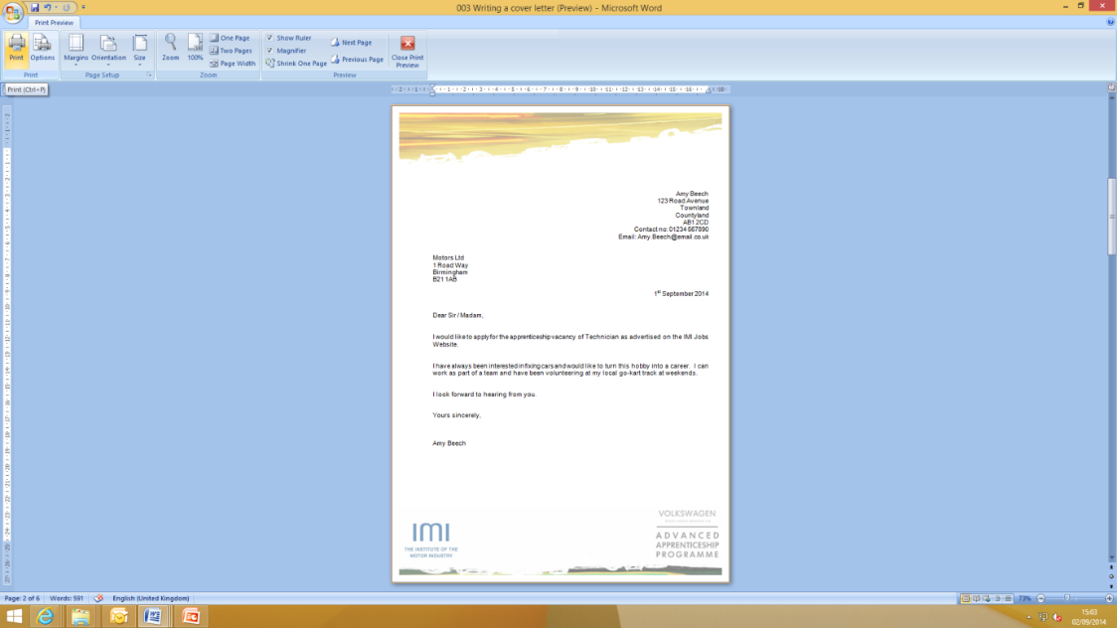
If you are happy with how your letter looks then press print in the top left corner.

When the print box comes up check that the right printer is selected (ask your teacher) and press ok.

Check your printed letter, if it is on more than one page, does not look right or has bits missing you need to change it in Microsoft Word, save it and re-print it.

LESSON 5: Microsoft Word

Document to Edit

Learning objectives:
- Know how to edit a Microsoft Word document
- Understand what you can display in a Microsoft Word document
- Be able to edit documents and add additional information into them

Key words and phrases:
Internet | Reputation | Upload | Online
Facebook | Twitter | Sexting | Texting

Resources:
Student hand outs
015 | Lesson plan 5 | 016 | Task 1 – Saved Letter

Teacher’s resources
A | Automotive Family Fortunes Slides | B | Automotive Family Fortunes Questions

Websites
https://www.typingclub.com/typing-qwerty-en.html

Misc.
Post-it notes (green, red, orange or yellow) | Computers / Laptops
Printer | Email

Pre-class preparation:

Task 1: Save the letter and picture into a central location so as the learner have access from their computers.

Lesson begins…
02

Starter Activity

Go to https://www.typingclub.com/typing-qwerty-en.html and practice your typing skills. Keep note of where you left off so as you can start at that point next lesson!
_________________________________________________________________________________

(T) Lesson objective/aims:

(T) Explain the objectives.

(T) Ask the students why they would need to edit documents

Task 1:
02

(T) Ask the students to open the letter – saved in a central location. Demonstrate how to open the letter using the overhead projector.

(ALL) Open the letter and save it into your files

(T) Direct Students to carry out the following tasks on the letter:
Add a picture of a Ford Focus air filter top the letter
Demonstrate to the students how you would do this by using an overhead projector.

(ALL) Insert the picture - saved in a central location.
Save the letter so as not to lose any of your work.

(ALL) Print the document

IF THERE IS TIME:

Task 2:

(T) Write a cover letter that you can send to potential employers in a letter or email format.

Feedback to teacher

(T) Ask students if they feel the learning objective & aims have been met using Post-its.
Explain what the colours mean and give an example.

Give out Post-its. Green = YES Red = NO Amber OR Yellow = not sure

Ask students to give their reasons.

(ALL) Hold up a Post-it and volunteer reasons.

(T) Collect in Post-its held up/count no. of each colour and keep a written record.

Lesson ends
02
HANDOUT 016: Document to edit

Document to Edit

123 Garage
The Road
The Town
AB1 1AB
01234 567890

Bob’s Parts
1 Road
Town
BA1 1AB

1st September 2020

Dear Bob,

I am trying to find an air filter for a Ford Focus. Please can you let me know if you have any?

Many Thanks

A. Garage

LESSON 6 & 7: ICT

Microsoft Excel

Learning objectives:
- Know what Microsoft Excel is
- Understand what documents can be created in Microsoft Excel
- Be able to create spreadsheets and use basic functions

Key words and phrases:
Column | Spreadsheet | Cells | Currency
VAT | Sum | Formulas

Resources:
Student hand outs
017 | Lesson Plan 6 & 7 | 018 | Task 1 Create a Spreadsheet
019 | Notes - How to Create a Spreadsheet

Teacher’s resources
A | Automotive Family Fortunes Slides | B | Automotive Family Fortunes Questions

Websites
http://jobs.theimi.org.uk/

Misc.
Post-it notes (green, red, orange or yellow) | Computers / Laptops
Power Point

Pre-class preparation:

Task 1: Print resource 016

Lesson begins…
02

Starter Activity

Automotive Family Fortunes (4-5 minutes)
Use Resources: Automotive Family Fortunes Slides AND Automotive Family Fortunes Questions

Explain the rules if necessary (See Resource A Rules Automotive Family Fortunes)

- They will be split into two teams for this game (same teams over the 17 lessons).
- The winning team will receive a prize in the final lesson.
- Show example question and scoring on slides:
- Check everyone knows how to play.

Start the game:

Divide the class into two teams, ask the first player from each team to come to the front desk – and ask them both the first question.

- Name 5 of the top selling motorbikes … |  |  | - Name 5 major motorbike race circuits in the UK …
Yamaha MT-09 Tracer  Honda CBF 125 M  BMW R 1200 S  BMW S1000 RR  Honda CBR 125 R | 35% said…  25%  18%  13%  9% |  | Brands Hatch (South West)  Silverstone (East Midlands)  Oulton Park (North West)  Donnington Park (East Midlands)  Anglesey (North Wales) |  | 36% said…  31%  16%  14%  3%
- Name 5 common reasons for motorbike accidents in the UK … |  |  | - Name 5 of the most famous motorcycle racing World Champions …
Bends on country roads  Collisions at junctions  Collisions while overtaking  Loss of control  Road surface conditions | 43% said…  28%  15%  8%  6% |  | Valentino Rossi  Jorge Lorenzo  Marc Marquez  Danni Pedrosa  Bradley Smith |  | 48% said…  20%  17%  9%  6%
- Name 5 commonly replaced parts on a motorbike (due to wear and tear) … |  |  | - Name 5 commonly modified motorbike parts …
Tyres  Brake pads  Oil filter  Air filter  Bulbs | 37% said…  30%  13%  12%  8% |  | Exhausts  Brake pads  Mirrors  Windscreens  Crash protection |  | 32% said…  24%  18%  16%  10%
- Name 5 job roles related to motorbikes |  |  |  | - Name 5 popular motorbike colours
Service/Parts advisor  Motorcycle technician  Motorcycle sales executive  Ignition component engineer  Mechanical / Restoration engineer |  | 35% said…  31%  23%  8%  3% |  | Black  Silver  Blue  Red  White | 38% said…  23%  17%  15%  7%

- Name 4 cars from a TV programme … |  | - Name 5 films featuring cars …
Batmobile  Kit (Knight Rider)  The Mystery Machine  Transformers | 38% said…  22%  21%  19% | Fast and Furious  Transformers  Chitty Chitty Bang Bang  The Italian Job  Gone in 60 secs | 27% said…  22%  19%  17%  15%
- Name 5 commonly misspelt car names … |  | - Name 5 car manufacturers that often advertise on TV …
Lamborghini  Ferrari  Subaru  Porsche  Mitsubishi | 46% said…  29%  10%  8%  7% | Renault  Toyota  Volkswagen  Peugeot  Citroen | 34% said…  28%  20%  17%  5%
- Name 5 car manufacturers … |  | - Name 5 companies that offer car insurance …
BMW  Ford  Audi  Volkswagen  Vauxhall | 32% said…  28%  20%  12%  8% | Direct Line  Aviva  Tesco  Churchill  LV | 39% said…  26%  18%  10%  7%

__________________________________________________________________________________________

Lesson objective/aims:

(T) Explain the objectives

(T) Discuss Microsoft Excel and what you would use it for.
Task 1:
02

(T) Each student is to create a price list on an excel spreadsheet
04

(ALL) Go to http://jobs.theimi.org.uk/ and search for an apprenticeship, pick one that interesteds you and apply for it.

(T) Ask the students to open a blank Microsoft Exel spreadsheet.

Discuss: Price lists should have certain information in them and so should pice lists;
- Spreadsheet title
- Colum titles
- Names of each part you are listing
- Amount in currency that each part costs (Trade Price)
- How much the VAT on each part is (%)
- How much you sell each part for (Retail Price)
Task 2:
02

(ALL) Create a price list in Microsoft Work with the following information in it:

Spreadsheet Title in Box 1A
Column Titles in Row 2: Part, Trade Price, VAT Amount, Retail Price
Put the following parts in Column A:
- Exhaust
- Wing Mirror
- Radiator
- Tyre
- Battery
- Headlight Bulb
- Windscreen Wiper

(T) Demonstrate how to make the box size bigger / smaller so as you can read all the words in each column.

(ALL) Put the following prices in the Trade Price column:
- Exhaust 40
- Wing Mirror 25
- Radiator 100
- Tyre 33
- Battery 27
- Headlight Bulb 2.50
- Windscreen Wiper 21.75

(T) Demonstrate to the learners how to change the numbers into currency using £ signs.
(ALL) Change the numbers you have just inserted into currency using the £ sign.

Then;

(T) Explain and demonstrate how to calculate the VAT value using the appropriate formula.

(ALL) Calculate the VAT for each of the items by using the appropriate formula.

- All formula’s in Excel start with the equals symbol =
- Then add the cell that you want to apply the formula to, in this case B3
- Then select the multiply symbol on your keyboard – this will show as *
- Now type 0.2 and hit enter and the box should display the VAT amount of £8.00, you will still be able to see the formula in the top bar once the £8 is displayed.

(T) Demonstrate how to copy a formula from one cell to another;

To use the same formula on each price in this column you do not need to type it into each box, put your mouse arrow over the bottom right hand corner of cell C3 that shows the answer to your last formula (you can see a little box in the corner of the cell). Your arrow will change to a cross, when it does this left click and pull the box down until it covers all the cells you want the formula applied to.

(ALL) Copy the formula from the first cell so as to calculate the VAT for each item.

(ALL) Now you must calculate the retail price for each item.

(T) Demonstrate to the students how to calculate the Retail Price –
- Start the formula as it always has to be with =
- Now type the name of the cell with the trade price, B3 and the add symbol + then the cell with the VAT amount, C3.
- Click enter
- Copy the formula down the row

(ALL) You will now need to save your spread sheet – before doing this you need to edit the heading;
- Select cells A1 to D1, then we are going to merge the cells – this means turning them into one big cell.

Feedback to teacher

(T) Ask students if they feel the learning objective & aims have been met using Post-its.
Explain what the colours mean and give an example.

Give out Post-its. Green = YES Red = NO Amber OR Yellow = not sure

Ask students to give their reasons.

(ALL) Hold up a Post-it and volunteer reasons.

(T) Collect in Post-its held up/count no. of each colour and keep a written record.

Lesson ends
02

HANDOUT 016: Production Methods

Now try creating a price list in Microsoft Work with the following information in it:

Spreadsheet Title in Box 1A

Column Titles in Row 2: Part, Trade Price, VAT Amount, Retail Price

Put the following parts in Column A:
- Exhaust
- Wing Mirror
- Radiator
- Tyre
- Battery
- Headlight Bulb
- Windscreen Wiper

Make sure that you can read all of the words in each column by making the columns wider, put the mouse arrow over the line between two columns until you see the symbol below then left-click and drag until the column is the right size:

Put the following prices in the Trade Price column:
- Exhaust 40
- Wing Mirror 25
- Radiator 100
- Tyre 33
- Battery 27
- Headlight Bulb 2.50
- Windscreen Wiper 12.75

To make these numbers appear as pounds we need to turn them into currency.
Highlight the cells that have the numbers in by clicking on the top box and dragging the mouse down until they are all highlighted:

Then select the currency button at the top – it looks like notes and coins:

All the prices should now appear in this format: £40.00

To calculate the VAT amount we can use a formula. Formulas are the reason that Excel is used so much when any calculations need to be made to sets of numbers; the spreadsheet does it for you!
In this case we will need to work out 20% of the Trade Price, to do this you need to multiply the trade price by 0.2.

All formula’s in Excel start with the equals symbol =

Then add the cell that you want to apply the formula to, in this case B3

Then select the multiply symbol on your keyboard – this will show as *

Now type 0.2 and hit enter and the box should display the VAT amount of £8.00, you will still be able to see the formula in the top bar once the £8 is displayed:

To use the same formula on each price in this column you do not need to type it into each box, put your mouse arrow over the bottom right hand corner of cell C3 that shows the answer to your last formula (you can see a little box in the corner of the cell). Your arrow will change to a cross, when it does this left click and pull the box down until it covers all the cells you want the formula applied to:

When you let go of the mouse the correct VAT amounts should show in each cell:

Are yours correct? If not go back and work through the formula again.

To calculate the Retail Prices we are going to use another formula. This time we need to add together the Trade Price with it’s VAT and this will give the retail price.

Make sure you have clicked in the square where you want the answer to be, in this case D3

Start the formula as it always has to be with =

Now type the name of the cell with the trade price, B3and the add symbol + then the cell with the VAT amount, C3. As you do this the cells you are selected will be outlined in different colours:

Hit enter and the total should be shown:

Repeat the process to copy the formula down into all of the cells where you need to calculate the retail price. Does your spreadsheet look like this:

If not go back and start the formula process again.

Now you need to save your spreadsheet. Select the Windows icon, or File, and Save As, then select Excel Workbook:

You will then need to follow your teacher’s directions to save your spreadsheet in the right place.
The name of your Spreadsheet is not very easily read so we are going to edit Row 1 to make it look more like a heading.

Select cells A1 to D1, then we are going to merge the cells – this means turning them into one big cell:

Once you have clicked ‘Merge & Centre’ the heading should move into the middle of your table, leave the cell selected and make the text bold so it stands out:

You now need to put the list of parts into alphabetical order so it is easier to find what you are looking for – this might not seem important here but if you have 100 rows of parts you might find it useful.
To do this you need to select the column that you want to Sort, you do this by clicking on the ‘A’ button at the very top of the column:

You will then need to select the ‘Sort & Filter’ button from the right hand side of the top toolbar, and select ‘Sort A – Z’:

When you select this the spreadsheet will ask you if you want to expand your selection (so that all the prices stay in line with the parts) or continue with current selection (which will just change the order of the part names and leave the prices where they are).

You need to Expand the Selection as you want to keep all the right prices with the right part:

Click ‘Sort’, does your sheet now look like this:

If not go back to the beginning of the process to filter the Part names A-Z and try again. Once it looks like this save your document by clicking the blue disk circled above.

You now need to print your spreadsheet, select the windows icon, or file, and Print, then select Print Preview – it is always a good idea to preview your print, especially when using Excel to make sure that it all shows on one page:

How do you think it looks in the Print Preview? Is it clear and easy to read? With spreadsheets it is often easier to read if the gridlines between all the cells are shown when it is printed.

To do this select Page Setup while still in the Print Preview:

Then the Sheet tab and tick the box marked Gridlines:

Then click ok and it should now look like this:

If you are happy with how it is shown, click Print and check that the correct printer is selected (check with your teacher), then select ‘ok’.

Make sure your name is on your work and hand in to your teacher.

LESSON 8: ICT

Creating an Email

Learning objectives:
- Know what Microsoft Outlook is
- Understand what Microsoft Outlook can do.
- Be able to create emails, tasks and use basic functions

Key words and phrases:
Outlook | Inbox | Sent Items | Email
Sent | Junk E-Mail | Attachment | Forward
Reply | Deleted Items | Address Book

Resources:
Student hand outs
019 | Lesson Plan 8 | 020 | Task 2 – Create an email
021 | Notes – Creating an email

Teacher’s resources
A | Automotive Family Fortunes Slides | B | Automotive Family Fortunes Questions

Misc.
Post-it notes (green, red, orange or yellow) | Computer / Laptops

Pre-class preparation:

Task 1: Print handout 020: Market research

Lesson begins…
02

Starter Activity

Automotive Family Fortunes

Explain the rules if necessary (See Resource A Rules Automotive Family Fortunes)

- They will be split into two teams for this game (same teams over the 17 lessons).
- The winning team will receive a prize in the final lesson.
- Show example question and scoring on slides:
- Check everyone knows how to play.

Start the game:

Divide the class into two teams, ask the first player from each team to come to the front desk – and ask them both the first question.

- Name 5 of the most expensive cars in the world … |  | - Name 5 car manufacturers beginning with the letter ‘m’ …
Bugatti Veyron  Lamborghini  Ferrari  Pagani Zonda  Aston Martin | 41% said…  17%  16%  15%  11% | Maserati  Mercedes Benz  Mazda  Mini  Mitsubishi | 39% said…  26%  18%  10%  7%
- Name 5 car manufacturers beginning with the letter ‘s’ … |  | - Name 5 German car manufacturers …
Saab  Subaru  Skoda  Seat  Smart | 38% said…  20%  18%  15%  9% | Audi  Mercedes Benz  BMW  Volkswagen  Porsche | 41% said…  17%  16%  15%  11%
- Name 5 car manufacturers whose logo features an animal … |  | - Name 5 car manufacturers whose logos are completely silver …
Ferrari (horse)  Porsche (horse)  Lamborghini (bull)  Jaguar  Alfa Romeo (dragon) | 40% said…  27%  13%  11%  9% | Audi  Mercedes Benz  Renault  Toyota  Honda | 36% said…  22%  20%  13%  9%

__________________________________________________________________________________________

Lesson objective/aims:

(T) Explain the objectives.

(T) Discuss why you would use Microsoft Outlook

(ALL) List some day to day reasons you might use Microsoft Outlook.

(T) Discuss and demonstrate the day to day uses of Outlook.

Task 1:
02

(ALL) Go to http://jobs.theimi.org.uk and search for an apprenticeship. Pick one vacancy that you are going to apply for.

Demonstrate to the learners how to search on IMI Auto Jobs for an apprenticeship.
Once you have found the apprenticeship you would like to apply for you need to ensure your cover letter (which is your email) and CV skills match the skills required to do the position.

Task 2

(T) Ask the learners to write an email in application for the apprenticeship they would like to apply for.

Take the learners through step for step on how to send an email, attach a CV and send the email.

(ALL) Use your notes to bring you through the process of writing, sending and attaching to an email.
Tips;
- Ensure the font is the same size and type throughout
- Us the spell check tool to ensure you have no spelling mistakes in your email
- Ensure you have the email address correct

Feedback to teacher

(T) Ask students if they feel the learning objective & aims have been met using Post-its.
Explain what the colours mean and give an example.

Give out Post-its. Green = YES Red = NO Amber OR Yellow = not sure

Ask students to give their reasons.

(ALL) Hold up a Post-it and volunteer reasons.

(T) Collect in Post-its held up/count no. of each colour and keep a written record.

Lesson ends
02

HANDOUT 020: Market Research

You are going to write an email to a local company applying for an apprenticeship that you have seen them advertising.

Go to http://jobs.theimi.org.uk and search for an apprenticeship. Pick one vacancy that you are going to apply for.
Open Microsoft Outlook by clicking on the icon that looks like this:
(Yours might be another year)

When you are applying for a job, the email is your cover letter and should always have certain things in:

- The email address of the person you are sending it to
- Your email address to send a copy of the email to
- A Subject
- It should be addressed to the correct person, if you do not know the name, put ‘Dear Sir or Madam’.
- The main section of the email will state why you are writing. In this case it will include the position that you want to apply for, where you saw it advertised and why you think you’d be good at the job
- Finish the letter with ‘Yours sincerely’ (or ‘Yours faithfully’ if your letter was address to ‘Dear Sir or Madam’) and your full name.
- Your CV will need to be attached to the email

When you open Microsoft Outlook you will need to create a new email:

Put the email address in of the person you want to send the email to (in this case the one your teacher has given you).

You then want to put your own email address into the ‘CC’ line, this stands for Carbon Copy and sends a copy of the email to yourself so you remember what you have applied for.

You also have the option of sending an email to someone ‘BCC’, this means Blind Carbon Copy and means that the person you send the email to cannot see that you also sent a copy to the BCC person.

You must always put a subject into an email; most companies have systems set up that will reject any email that comes in without a subject as ‘Junk’ or ‘Spam’, so to make sure your email gets through always put something in the subject box.

This can be very simple and straight forward, in this case: ‘Application for Vacancy’ is all that is needed.

You then need to write your email, you MUST write something in the main body of the email or, again, many companies Spam filters will reject it. Plus – it looks strange, if an employer receives an email with a CV attached but nothing written in the email how do they know why you have sent your CV?

The email is not very different to the cover letter that you created in Word except you do not need to put any postal addresses or the date at the top.

Do not think that because it is an email it can be informal; this is still you applying for an apprenticeship, or job role, and your first contact with an employer. If it’s badly written they will just delete it.

Now write your email.

Did yours look like this?

Make sure that all the writing is in the same font. To change the font; select all the writing on the page and left click on the font box in the bar along the top, you can then select a different font by left clicking on it.

Change to font to Arial now using this box, then use the box next to it to make sure all your writing is the same size (12):

Once you have written your email make sure you have no spelling mistakes by doing a spell check (you should do this on any email you create). Click ‘Spelling’ on the top menu:

A box will appear that will change any words you have spelt wrong – remember do not just accept what it tells you, it might be changing the word. Make sure you read it carefully and think what you want to say.

You now need to attach your CV to the email, using the file your teacher tells you, select the paper clip icon:

This will open a box and you need to find the file you are attaching then click insert:

The attachment will now show on your email:

Read over your email again and make sure you are happy with everything.

If you are, click Send.

LESSON 9: ICT

Creating a Meeting, Task & Contact

Learning objectives:
- Know what Microsoft Outlook is
- Understand what Microsoft Outlook can do.
- Be able to create tasks and calendar appointments

Key words and phrases:
Outlook | Inbox | Sent Items | Email
Sent | Junk E-Mail | Attachment | Forward
Reply | Deleted Items | Address Book

Resources:
Student hand outs
022 | Handout: Creating a meeting | 023 | Handout: Creating a task
024 | Handout: Creating a contact | 025

Teacher’s resources
B | Automotive Family Fortunes_Slides | C | Automotive Family Fortunes_Questions

Misc.
Post-it notes (green, red, orange or yellow) | Blue Tack
Smart board & Flip chart paper | Blank paper and marker pens

Pre-class preparation:

Task 1: Print handout 022: Creating a meeting

Task 2: Print handout 023: Creating a task

Task 3: Print handout 024: Creating a contact

Lesson begins…
02

Starter Activity

Automotive Family Fortunes (4-5 minutes)

Use Resources: Automotive Family Fortunes_Slides AND Automotive Family Fortunes Questions

Automotive Family Fortunes

Explain the rules if necessary (See Resource A Rules Automotive Family Fortunes)

- They will be split into two teams for this game (same teams over the 17 lessons).
- The winning team will receive a prize in the final lesson.
- Show example question and scoring on slides:
- Check everyone knows how to play.

Start the game:

Divide the class into two teams, ask the first player from each team to come to the front desk – and ask them both the first question.

__________________________________________________________________________________________

Lesson objective/aims:

(T) Explain the objectives.

Discuss what else Microsoft Outlook can be used for in an office environment (diary, meetings manager and contacts database)

Meetings: where you can create and invite people to meetings, check other people’s calendars and manage your time.
You can also use it to create a task list or save contacts.

(ALL) List some reasons why you may use Microsoft Outlook in an office

Task 1:
02

(ALL) Go to Microsoft Outlook and use their handout to bring you through the process of creating a meeting in outlook

Task 2:
02

(ALL) Go to Microsoft Outlook and use their handout to bring you through the process of creating a task in outlook

Task 3:

(ALL) Go to Microsoft Outlook and use their handout to bring you through the process of creating a contact in outlook

Feedback to teacher

(T) Ask students if they feel the learning objective & aims have been met using Post-its.
Explain what the colours mean and give an example.

Give out Post-its. Green = YES Red = NO Amber OR Yellow = not sure

Ask students to give their reasons.

(ALL) Hold up a Post-it and volunteer reasons.

(T) Collect in Post-its held up/count no. of each colour and keep a written record.

Lesson ends
02

HANDOUT 022: Creating a Meeting

You are going to create a meeting between you and your teacher to discuss your Career Options.
Open Microsoft Outlook by clicking on the icon that looks like this:
(Yours might be 2007 or another year)

You will be using the Microsoft Excel calendar and it is important to fill in all the fields that it asks you for.

Go to your calendar in Microsoft Outlook by selecting the Calendar icon on the left hand menu:

You can view your calendar a day, week or month at a time.

Select ‘New’ from the top menu bar (circled above) and this will open a new calendar event:

You now need to fill in the details of your meeting. First you need to put the subject and location:

You then need to put the correct day and time, set your meeting for tomorrow at 2pm by using the drop down boxes:

You will then need to write a brief description to tell the other person what your meeting is about.

You need to do this every time, even if they already know as if you were planning a meeting for in a few months’ time they may have forgotten what it was about by then!

Now Spell-check what you have written using the blue tick on the menu bar (circled).

If you are happy with what you have written you need to invite the people that you want at the meeting. Click ‘Invite Attendees’:

This will open a box similar to when you add an email address:

Write the email address of the person to send it to in this line (your teacher will give you this) and check the meeting again to check everything is right:

If you are happy, click send.

HANDOUT 023: Creating a task

You are going to create a task on Microsoft Outlook. A task list is like a to-do list, it helps you remember everything you need to do for work and mark it as complete when you have finished.
Open Microsoft Outlook by clicking on the icon that looks like this:
(Yours might be 2007 or another year)

Then go to the Tasks section of Outlook:

Your task list will be blank at the moment, you need to select ‘New’ from the menu:

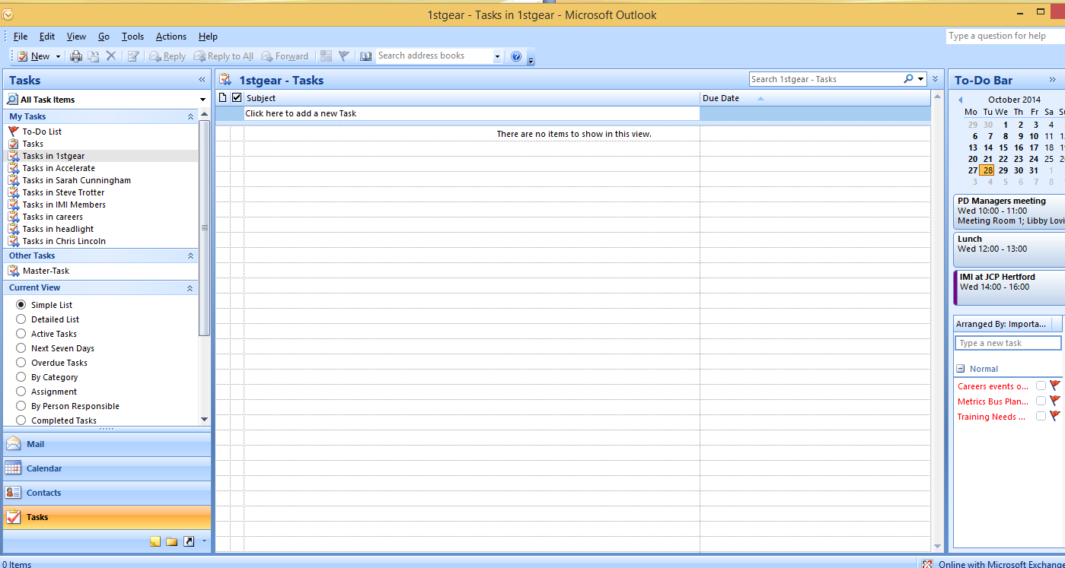

Select ‘New’ from the top menu bar (circled above) and this will open a new task:

You now need to fill in the details of your task. First you need to put the subject:

You then need to put the Start Date (the date that you plan to start the task), and the Due Date (the date you need to finish the task by).

Put that start date as tomorrow and the due date as 2 weeks after that using the drop down buttons:

You will see that you can change the ‘Status’ of the task, see what option you have by clicking on the drop down menu and select the most appropriate status for your task.

Set the Priority of the task to ‘High’:

Set a reminder for your task for 5 days before it is due at 10am using the drop down buttons:

Now put a brief description of what you need to do in the box; this is your task list so you do not have to write it formally.

You can now click ‘Save & Close’:

The task will now appear in your Outlook Task List:

Once you have completed the task you can tick the box to the left of it and it will draw a line through it to show it is complete:

HANDOUT 023: Creating a contact

You are going to create a contact on Microsoft Outlook. Your Contacts are like your phone book, you can save people’s emails, phone numbers and addresses that you might want for work.
Open Microsoft Outlook by clicking on the icon that looks like this:
(Yours might be another year)

Then go to the Contacts section of Outlook:

Your contact list will be blank at the moment, you need to select ‘New’ from the menu:

Select ‘New’ from the top menu bar (circled above) and this will open a new contact:

You now need to fill in the details of your contact.

Fill this one in for yourself, you will notice as you start to fill in different information the contact card starts to fill them in as well (make up the information you do not have):

You can add a picture of your contact if you like by clicking on the picture square (circled above).

You can also add notes into the contact, for example how you met them or what you discussed:

When you are happy with the record click ‘Save & Close’ circled above.

Your contact will now appear in your contacts list:

Now add another contact to the list with a different surname and see how they are saved.
LESSON 10: ICT

Microsoft PowerPoint

Learning objectives:
- Know: what Microsoft PowerPoint is
- Understand: what Microsoft PowerPoint can create and be used for
- Be able to: create a Presentation based on a researched subject

Resources:
Student hand outs
026 | Handout: Creating a presentation | 027
028

Teacher’s resources
B | Automotive Family Fortunes_Slides | C | Automotive Family Fortunes_Questions

Misc.
COMPUTERS | Post-it notes (green, red, orange or yellow)
Smart board & Flip chart paper | Blue Tack, blank paper and marker pens

Pre-class preparation:

Task 1: access to computers

Task 2: printout Handout 026 creating a presentation

Lesson begins…
02

Starter Activity

Go to https://www.typingclub.com/typing-qwerty-en.html and practice your typing skills. Keep note of where you left off so as you can start at that point next lesson!
_________________________________________________________________________________________
Lesson objective/aims:

(T) Explain the objectives.

Task 1:
02

(T) Discuss the number of job roles available in the retail automotive industry (150), that they can be found on www.theimi.org.uk/autocity and that today they are going to develop a 5 min presentation on a job role they did not know existed

(ALL) Discuss different job roles they know exist and list on the board

Visit the www.theimi.org.uk/autocity website and find a job role they are interested in they did not know about before today

Task 2:
02

(T) Go to PowerPoint and use their handout to bring you through the process of creating a presentation

Feedback to teacher

(T) Ask students if they feel the learning objective & aims have been met using Post-its.
Explain what the colours mean and give an example.

Give out Post-its. Green = YES Red = NO Amber OR Yellow = not sure

Ask students to give their reasons.

(ALL) Hold up a Post-it and volunteer reasons.

(T) Collect in Post-its held up/count no. of each colour and keep a written record.

Lesson end
02
HANDOUT 026: Creating a Presentation

You are going to create a 5 minute presentation to describe an automotive job role that you did not know existed.

Go to www.autocity.org.uk and decide which job role you are going to do your presentation on, then research it and find out some basic information that you will include in your slidesOpen Microsoft
Open PowerPoint by clicking on the icon that looks like this:
(Yours might be another year)

You can then start to put your information in the slides.

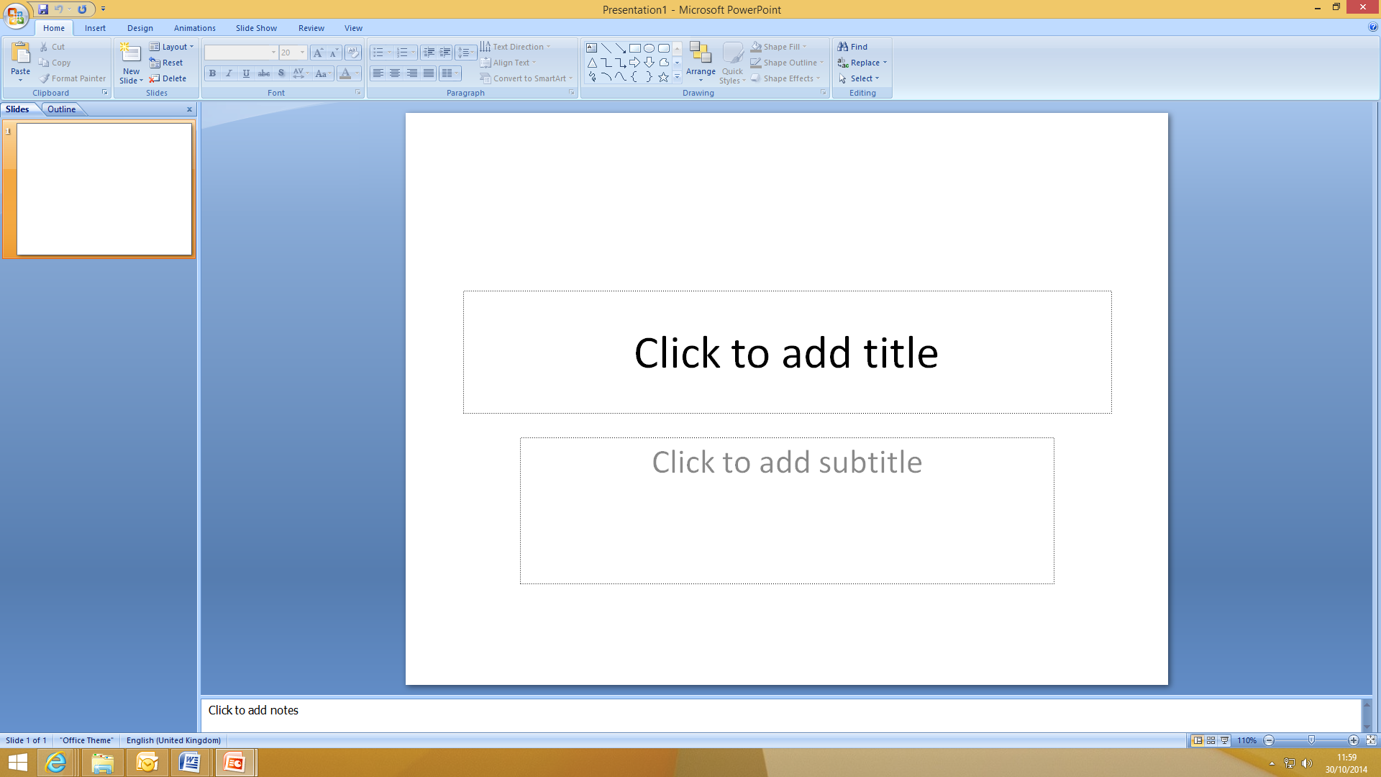

Follow the instructions to add a title and subtitle into your presentation:

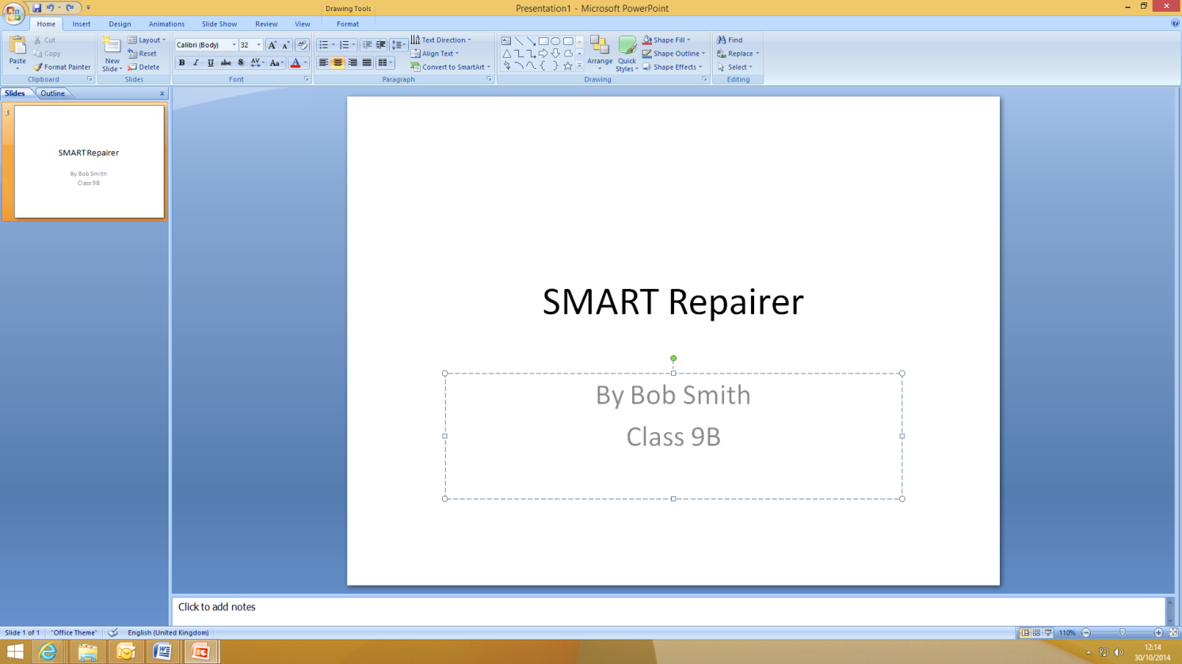

When you have done this click on ‘New Slide’ in the top toolbar to create the next slide:

This will appear like this:

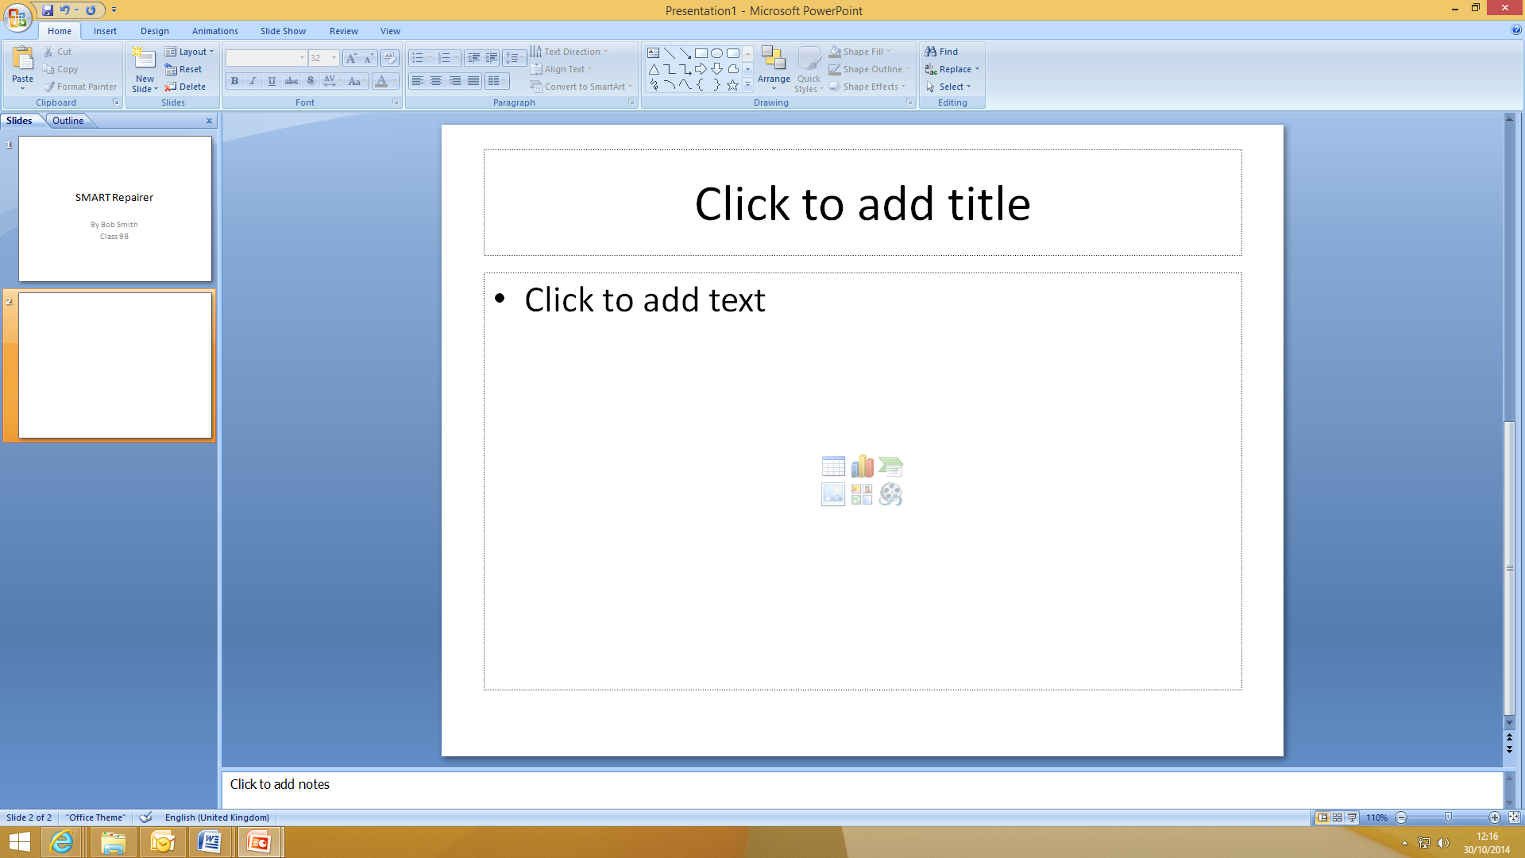

You can now create the slide using similar items to a Word document, add a title and text, you can use bullet points and change the font you use:

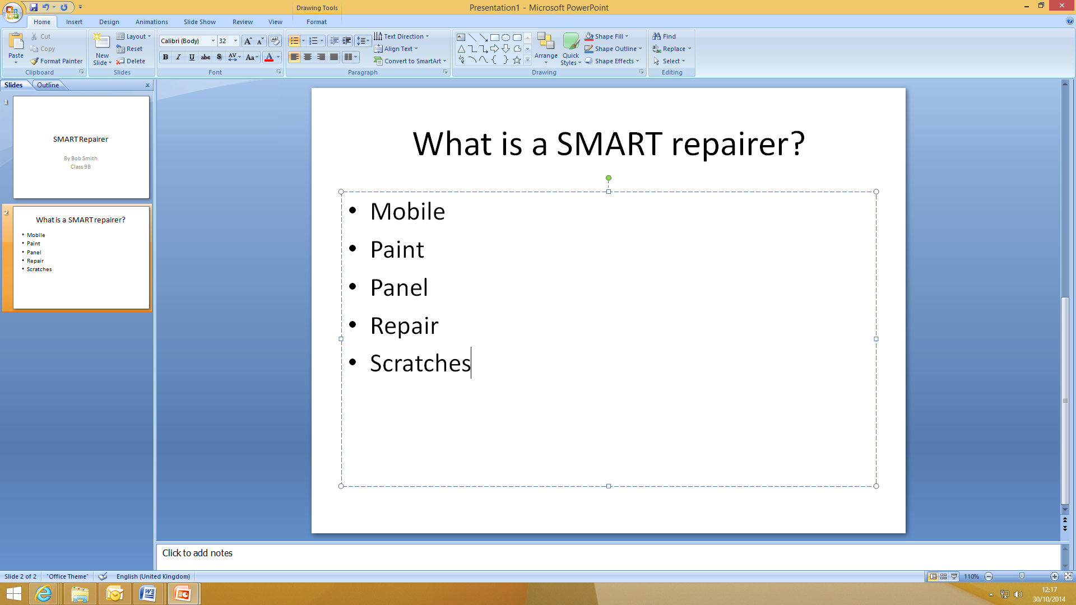

Repeat this process to add more slides to your presentation and put the information that you wish to include on your chosen job role.

You might want to include what qualifications you need, how much you can earn, where you work and what the best bits of the job are.

Keep going back to the information on the job role using www.autocity.org.uk/world-of-work to make sure you are including lots of relevant information.

Remember not to put everything onto the slides so you’ll just read off them, put key bots of information on the slide and then if you need to have notes in front of you to remind you about the detail of what you’re going to say.

Once you have finished your presentation save it by clicking on the Windows or File button and clicking ‘Save As’ and then ‘PowerPoint Presentation’:

Then save it where your teacher tells you to.

LESSON 11: ICT

Editing a Presentation

Learning objectives:
- Know: how to edit a Microsoft PowerPoint presentation
- Understand: what can be included in a PowerPoint presentation
- Be able to: add animations, backgrounds and images to a presentation.

Resources:
Student hand outs
026 | Editing a presentation | 027
028

Teacher’s resources
B | Automotive Family Fortunes_Slides | C | Automotive Family Fortunes_Questions

Misc.
COMPUTERS | Post-it notes (green, red, orange or yellow)
Smart board & Flip chart paper | Blue Tack, blank paper and marker pens

Pre-class preparation:

Task 1: Access to presentations form last lesson

Print out handout on editing a presentation

Lesson begins…
02

Starter Activity

Automotive Family Fortunes

Explain the rules if necessary (See Resource A Rules Automotive Family Fortunes)

- They will be split into two teams for this game (same teams over the 17 lessons).
- The winning team will receive a prize in the final lesson.
- Show example question and scoring on slides:
- Check everyone knows how to play.

Start the game:

Divide the class into two teams, ask the first player from each team to come to the front desk – and ask them both the first question.

- Name 5 car tyre brands … |  | - Name 5 petrol brands that you see out and about …
Continental  Michelin  Goodyear  Pirelli  Bridgestone | 31% said…  29%  22%  10%  8% | Shell  BP  Esso  Texaco  Total | 26% said…  24%  22%  17%  12%
- Name 5 different kinds of lights a car has … |  | - Name 5 safety features designed to protect passengers …
Headlight  Indicator  Fog light  Full beam  Reverse light | 34% said…  25%  21%  11%  9% | Seat belts  Airbags  Anti-lock braking system  Traction control  Safety cage | 39% said…  34%  15%  9%  3%

______________________________________________________________________________________

Lesson objective/aims:

(T) Explain the objectives.

Task 1:
02
(T) Review last lessons presentation skills

Task 2:
02

(ALL) Follow handouts on editing your presentation

Feedback to teacher

(T) Ask students if they feel the learning objective & aims have been met using Post-its.
Explain what the colours mean and give an example.

Give out Post-its. Green = YES Red = NO Amber OR Yellow = not sure

Ask students to give their reasons.

(ALL) Hold up a Post-it and volunteer reasons.

(T) Collect in Post-its held up/count no. of each colour and keep a written record.

Lesson ends
02
HANDOUT 028: Editing a Presentation

You are now going to edit your presentation.
Open Microsoft PowerPoint by clicking on the icon that looks like this:
(Yours might be another year)

Then click the Windows or File button, select Open and then open your presentation from where it was saved:

First change the background colour of your slides, to do this you can use a pre-set design, click on the ‘Design’ tab in the top menu and then select which colour scheme you would like to use:

Once you have selected a design you can change the colours of it by clicking the ‘Colours’ drop down menu:

Try out a few different designs and colours now.
Now you can add some images into your presentation, your teacher will tell you where the motor industry images are saved.

Simply left click the mouse to the place in a slide where you would like to put a picture and then click ‘Insert’ from the top Menu, and then ‘Picture’:

Select the picture you would like to put in your slide and click ‘Insert’:

The picture will then appear on the slide:

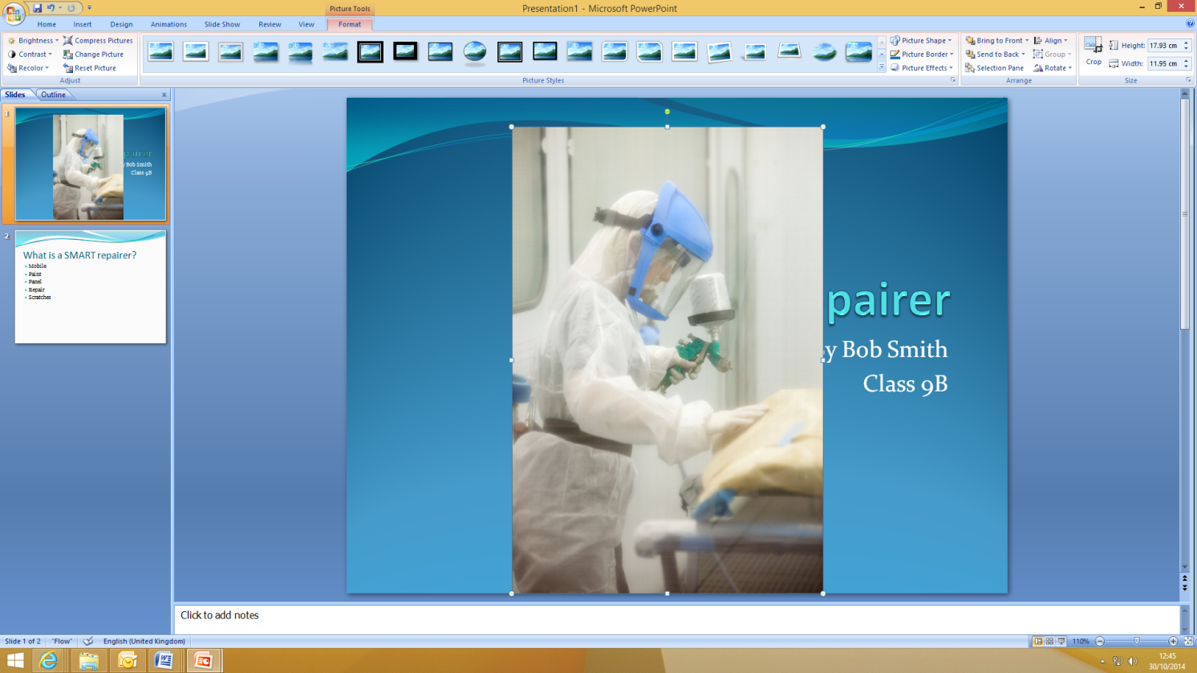

Obviously this picture is too big, so use the boxes on each corner of the picture to make it the size you want.

Then move it to where you want it on the slide by clicking in the middle of the picture and dragging it to where you want before letting go of the mouse button.

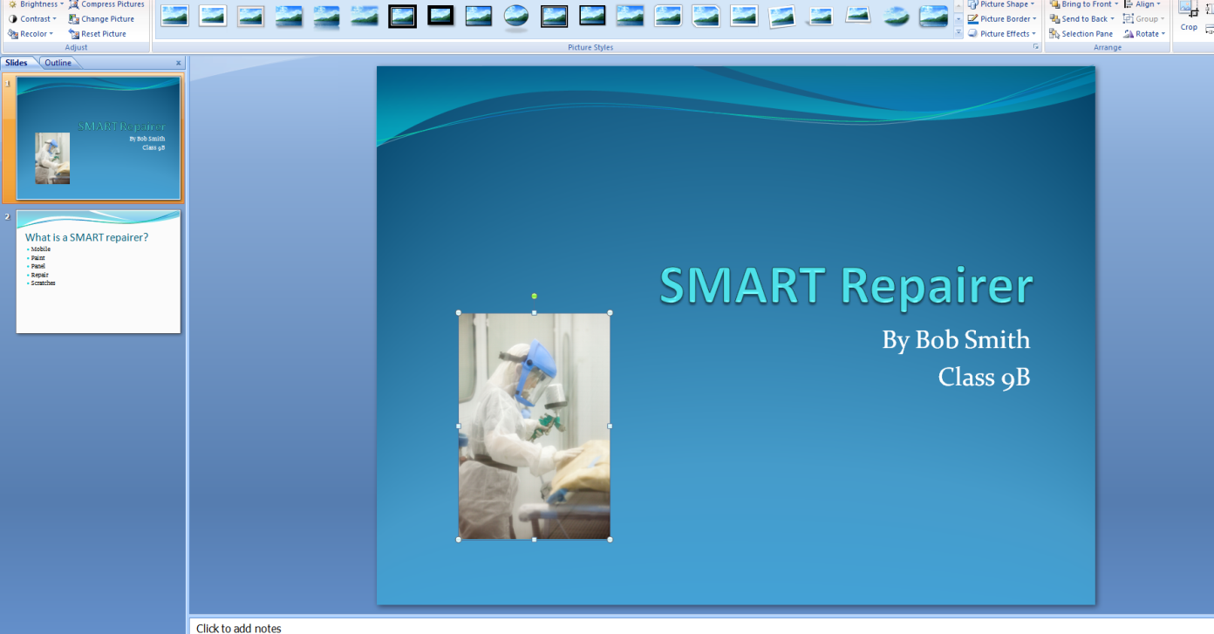

Repeat this process to put pictures anywhere you would like them in your presentation using the saved motor industry ones.

Now you can add in some animations, these make lines of text or pictures move / appear in different ways.

Highlight a word or sentence that you would like to animate, then click on the ‘Animations’ tab and then on the ‘Custom Animation’ button:

This will open a box on the right hand side of the screen.

Click on the ‘Add Effect’ drop down and this will give you the options relating to WHEN you want the animation to happen.

We are going to make the words move when they appear so chose ‘Entrance’ and then select the style you would like out of the options:

See what happens to the text you had highlighted. Try some different animations on some different words or lines of text until you decide on the ones you want to keep.

Remember not to use too many or it distracts your audience!

When you are happy with your presentation go back to the first slide and click the ‘Slideshow’ tab and select ‘From Beginning’; this will now play though your slideshow as it would when you are actually presenting (including all the animations):

Move from slide to slide by clicking the right arrow on your keyboard or the space bar and check you are happy with how the presentation looks and how all the animations work.

Press ‘Esc’ on your keyboard at any time to go back into PowerPoint and change anything you are not happy with.

Once you have finished your presentation save it by clicking on the Windows or File button and clicking ‘Save As’ and then ‘PowerPoint Presentation’:

Then save it where your teacher tells you to.
LESSON 12: ICT

Presentation Evaluation

Learning objectives:
- Know: how to give a presentation using PowerPoint
- Understand: how to present and move through the PowerPoint document
- Be able to: present their own PowerPoint presentation on a subject they have researched that includes text, images, animations and background designs / colours.

Resources:
Student hand outs
026 | Handout: Presentation evaluation | 027 | Additional Information : ICT

Teacher’s resources
B | Automotive Family Fortunes Slides | C | Automotive Family Fortunes Questions

Misc.
COMPUTERS | Post-it notes (green, red, orange or yellow)
Smart board & Flip chart paper | Blue Tack, blank paper and marker pens

Pre-class preparation:

Task 1: Print out feedback documents

Task 2: Access to a projector for the presentations

Task 4: Print out overall feedback on ICT lesson plans for The IMI

Lesson begins…
02

Starter Activity

Go to https://www.typingclub.com/typing-qwerty-en.html and practice your typing skills. Keep note of where you left off so as you can start at that point next lesson!

_________________________________________________________________________________________

Lesson objective/aims:

(T) Explain the objectives.

Task 1:
02

(T) Revise what we did last lesson with presentations, explain all students will have 5 mins each to present their PowerPoint and the rest of the class will fill in the feedback documents.

Task 2:
02

(ALL) Each student has 5mins to present their work

Students complete feedback document on each presentation

Task 3:
02

(ALL) Feedback form documents on good points from presentations

Task 4:
02

(ALL) Students fill in overall ICT Literacy feedback evaluation forms on all previous 12 lesson

(T) Sends feedback back to the Careers Team at The IMI careers@theimi.org.uk along with any particularly good presentations to showcase on IMI Autocity website www.theimi.org.uk/autocity

Feedback to teacher

(T) Ask students if they feel the learning objective & aims have been met using Post-its.
Explain what the colours mean and give an example.

Give out Post-its. Green = YES Red = NO Amber OR Yellow = not sure

Ask students to give their reasons.

(ALL) Hold up a Post-it and volunteer reasons.

(T) Collect in Post-its held up/count no. of each colour and keep a written record.

Lesson ends
02

HANDOUT 026: Presentation Evaluation

Speaker’s Name | Date
Title of presentation
What do you remember most?
What was good?
What was great?
What could have been better?
When you are assessing someone’s presentation, look for these success criteria:
Body Language | Voice and Clarity
- Eye contact  - Posture  - Gestures  - Poise | - Clear pronunciation  - Volume  - Good pace
Content and Research | Audience Appeal
- Main ideas  - Well-argued (makes sense)  - Well-organised (introduction-body-conclusion) | - Interesting  - Answers Questions  - Persuasive  - Confident
Additional comments:

HANDOUT: Additional Information: ICT
Course feedback – Student
The Institute of the Motor Industry is very interested to hear your thoughts and opinions on the ICT course
you have completed.

School or college name
Your name
Year group

Please tick one of these boxes:
 | Question | Strongly disagree | Disagree | Neither agree or disagree | Agree | Strongly agree
Course aims & objectives | Accurately described the content and propose
Resources | Useful online resources
 | Useful paper handouts
 | Useful presentation slides
Course topic | Interesting
 | Contained enough detail
Course activities | Useful and relevant
 | Fun and interesting
 | Enough time to complete each one
 | A good mix of group and individual activities
Homework | Relevant and achievable
Course speed | Appropriate
Difficulty level | Appropriate
My interest in ICT has increased
My ICT knowledge has increased
My increased ICT knowledge will help me in the future
Overall the ICT course has met my expectations
I would recommend the ICT course to other students

What was positive and or negative about the ICT course?

What suggestions do you have for improving the ICT course?

Thank you for your feedback! careers@theimi.org.uk
TEACHING RESOURCE: Automotive Family Fortunes – 36 Questions

We asked 100 people…

Lesson 1 – Understanding Hardware & Software

- Name an animal that would not fit into a Smart car |  | - Name the most popular car colours in the UK
Elephant  Lion  Hippo  Giraffe  Mouse | 43% said…  18%  16%  14%  9% | Silver  Black  Blue  Red  White | 41% said…  17%  16%  15%  11%
- What are the most crashed cars in the UK? |  | - What are the most popular cars of all time in the UK?
Renault Clio  Ford Fiesta  Alfa 147  Porsche Boxter  BMW Convertible | 38% said…  20%  18%  15%  9% | Ford Fiesta  Ford Escort  Vauxhall Astra  Ford Cortina  Vauxhall Corsa | 41% said…  17%  16%  15%  11%
- Name 5 of the most reliable cars |  | - Name 5 of the most unreliable cars
Honda  Toyota  Lexus  Suzuki  Subaru | 43% said…  28%  12%  11%  6% | Land Rover  BMW  Porsche  Volvo  Mercedes | 38% said…  20%  18%  15%  9%

Lesson 3 – Online Reputation

- Name 5 past and present Top Gear presenters |  | - Name the most popular (past and present) Top Gear presenter
Chris Evans  Jeremy Clarkson  Richard Hammond  James May  Matt Le Blanc | 43% said…  28%  12%  11%  6% | Jeremy Clarkson  James May  Chris Evans  Richard Hammond  Matt Le Blanc | 38% said…  20%  18%  15%  9%
- Name the oldest (past and present) Top Gear presenter |  | - Name the youngest (past and present) Top Gear presenter
Jeremy Clarkson (55)  James May (53)  Chris Evans (49)  Matt Le Blanc (48)  Richard Hammond (46) | 41% said…  17%  16%  15%  11% | Richard Hammond (46)  Matt Le Blanc (48)  Chris Evans (49)  James May (53)  Jeremy Clarkson (55) | 43% said…  28%  12%  11%  6%
- Name 5 of their most favourite cars featured on Top Gear so far |  | - Name 5 supercars
Audi  Lamborghini  Ferrari  BMW  Alfa Romeo | 41% said…  17%  16%  15%  11% | Bugatti  Ferrari  Aston Martin  Lamborghini  Porsche | 38% said…  20%  18%  15%  9%

Lesson 6 – Microsoft Excel

- Name 5 of the top selling motorbikes |  |  | - Name 5 major motorbike race circuits in the UK
Yamaha MT-09 Tracer  Honda CBF 125 M  BMW R 1200 S  BMW S1000 RR  Honda CBR 125 R | 38% said…  20%  18%  15%  9% |  | Brands Hatch (South West)  Silverstone (East Midlands)  Oulton Park (North West)  Donnington Park (East Midlands)  Anglesey (North Wales) |  | 41% said…  17%  16%  15%  11%
- Name 5 common reasons for motorbike accidents in the UK |  |  | - Name 5 of the most famous motorcycle racing World Champions
Bends on country roads  Collisions at junctions  Collisions while overtaking  Loss of control  Road surface conditions | 43% said…  28%  12%  11%  6% |  | Valentino Rossi  Jorge Lorenzo  Marc Marquez  Danni Pedrosa  Bradley Smith |  | 38% said…  20%  18%  15%  9%
- Name 5 commonly replaced motorbike parts – due to wear and tear |  |  | - Name 5 commonly modified motorbike parts
Tyres  Brake Pads  Oil filters  Air filters  Bulbs | 38% said…  20%  18%  15%  9% |  | Exhausts  Brake pads  Mirrors  Wind screens  Crash protection |  | 41% said…  17%  16%  15%  11%
- Name 5 job roles related to motorbikes |  |  |  | - Name 5 popular motorbike colours.
Service OR Parts adviser  Motorcycle technician  Motorcycle sales executive  Ignition component engineer  Mechanical / Restoration engineer |  | 43% said…  28%  12%  11%  6% |  | Black  Silver  Blue  Red  White | 38% said…  20%  18%  15%  9%

Lesson 7 – Microsoft Excel

- Name 4 cars from TV programmes |  | - Name 5 films featuring cars
Batmobile  Kit (Knight Rider)  The Mystery Machine  Transformers | 38% said…  22%  21%  19% | Transformers  The Fast and the Furious  Chitty Chitty Bang Bang  Mad Max / Gone in 60 secs  Italian Job | 41% said…  17%  16%  15%  11%
- Name 5 commonly misspelt car names |  | - Name 5 car manufacturers that often advertise on TV
Lamborghini  Ferrari  Subaru  Porsche  Mitsubishi | 43% said…  28%  12%  11%  6% | BMW  Toyota  Volkswagen  Seat  Skoda | 38% said…  20%  18%  15%  9%
- Name 5 car manufacturers |  | - Name 5 companies offering car insurance
BMW  Ford  Toyota  Audi  Vauxhall | 41% said…  17%  16%  15%  11% | Direct Line  Aviva  Tesco  RAC  AA | 38% said…  20%  18%  15%  9%

Lesson 8 – Microsoft Outlook

- Name 5 of the most expensive cars in the world |  | - Name 5 manufacturers beginning with the letter ‘m’
Ferrari  Bugatti  Mercedes Benz  Pagani  Aston Martin | 41% said…  17%  16%  15%  11% | Maserati  Mercedes-Benz  Mazda  Mini  Mitsubishi | 43% said…  28%  12%  11%  6%
- Name 5 car manufacturers beginning with the letter ‘s’ |  | - Name 5 German car manufacturers
Saab  Subaru  Skoda  Seat  Smart | 38% said…  20%  18%  15%  9% | Audi  Mercedes-Benz  BMW  Volkswagen  Porsche | 41% said…  17%  16%  15%  11%
- Name 5 car manufacturer’s logos featuring animals |  | - Name 5 completely silver car logos
Ferrari  Porsche  Lamborghini  Jaguar  Alfa Romeo | 43% said…  28%  12%  11%  6% | Audi  Mercedes-Benz  Renault  Toyota  Honda | 38% said…  20%  18%  15%  9%

Lesson 11 – Microsoft PowerPoint Further

- Name 5 car tyre brands |  | - Name 5 petrol brands visible on the roads
Continental  Michelin  Goodyear  Pirelli  Bridgestone | 38% said…  20%  18%  15%  9% | Shell  BP  Esso  Texaco  Total | 43% said…  28%  12%  11%  6%
- Name 5 different kinds of lights that a car has |  | - Name 5 safety features designed to protect passengers
Headlight  Indicator  Fog light  Full beam  Reverse light | 41% said…  17%  16%  15%  11% | Seat belts  Airbags  Anti-lock braking system  Traction control  Safety cage | 38% said…  20%  18%  15%  9%

We hope you have enjoyed using the ICT Lesson Plans.

If you have any feedback please get in touch with careers@theimi.org.uk

