ict lesson plans

Student Pack

Content

Introduction  About The IMI and IMI Autocity | Lesson 7  Microsoft Excel
Notes:  Curriculum Content | Lesson 8  Microsoft Outlook Basic
Lesson 1  Understanding Hardware and Software | Lesson 9  Microsoft Outlook Advanced
Lesson 2  Technology & Safety | Lesson 10  Microsoft PowerPoint
Lesson 3  Online Reputation | Lesson 11  Microsoft PowerPoint Advanced
Lesson 4  Microsoft Word Basic | Lesson 12  Presentation of PowerPoint
Lesson 5  Microsoft Word Advanced | Additional information:  Student Feedback
Lesson 6
Microsoft Excel

Introduction

The automotive industry influences everyone, from delivering goods on time to commuters travelling to work and emerging services being able to respond to crisis, the motor industry helps keep the country moving.

About The IMI

The Institute of The Motor Industry is the professional body for individuals working in the motor industry and the authoritative voice of the retail automotive sector. The IMI’s aim is to ensure that the automotive retail sector has a skilled, competent and professional workforce that is fully equipped to keep pace with the demands of new technology and changing markets. A key part of business for manufacturers and dealers is to encourage the best and brightest people to join their business in a variety of roles.

www.theimi.org.uk/autocity

IMI Autocity is the one-stop-shop for impartial careers information and advice on careers in the Retail Motor Industry. Whether you are an individual looking to start or progress your career, or a teacher or careers advisor who supports others in making their career choices, Autocity is the place to start. With over 150 #MotorCareers to choose from Autocity provides you with all things Automotive!
LESSON 1: ICT

Understanding Hardware & Software

Learning objectives:

- Know the difference between hardware and software.
- Understand what hardware and software are found in a home computer.
- Be able to label hardware and software correctly.

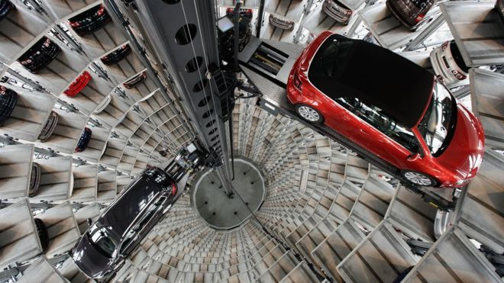
002 External Hardware Task 1

Label as many pieces of hardware as you can on this picture:

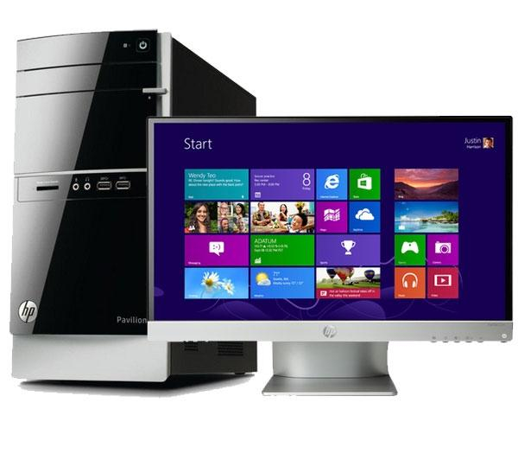
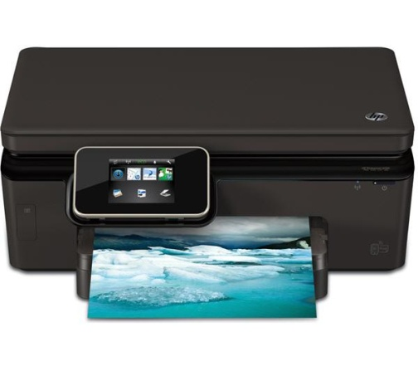

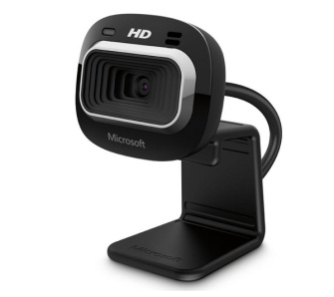
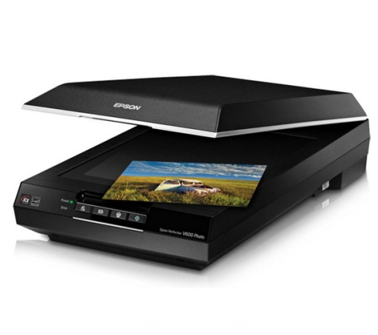
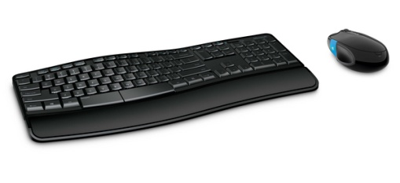
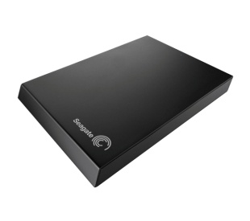
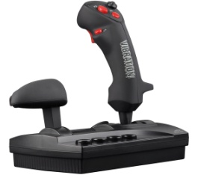
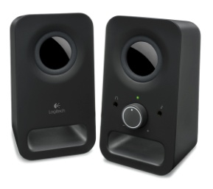
003 Internal Hardware Task 2

Label as many pieces of hardware as you can on this picture:

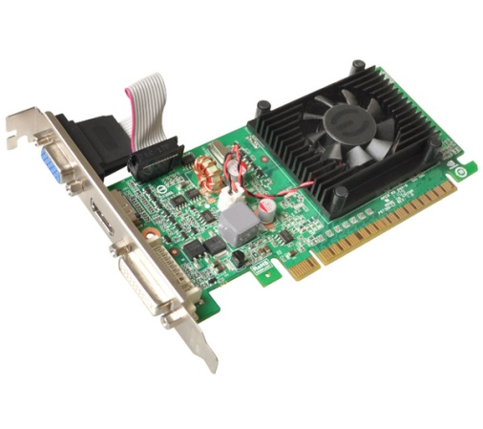
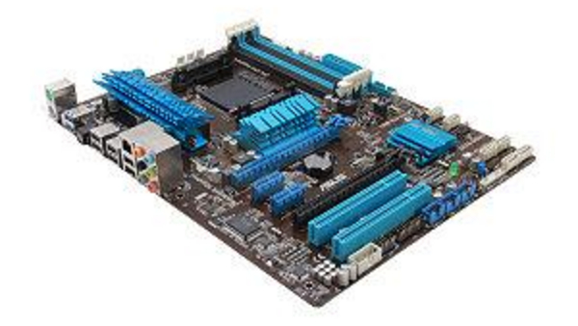
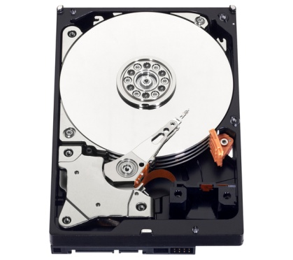
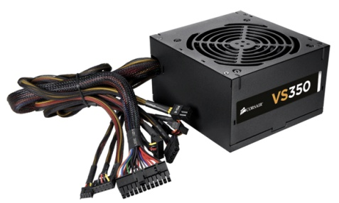

004 Hardware or Software Task 3
Hardware | Software

Graphics Card | Speakers
Microsoft Paint | Keyboard
Windows 8 | Driving Test Theory CDROM
Adobe Photoshop | Webcam
Microphone | Monitor
Windows Media Player | RAM
Power Supply | CPU
Sim City Game | Hard Disc Drive
Norton Anti-Virus | Microsoft Outlook
Assassin’s Creed 3 Download | Microsoft Word

LESSON 2: ICT

Technology & Safety

Learning objectives:
- Know how to use technology safely.
- Understand how to protect your online identity and privacy.
- Be able to recognise inappropriate content and know how to report it.

Lesson 2: Technology & Safety

Online Conversation Task 1

Read the following online conversation then answer the questions:
Chris: Hey you’re friends with Amy right? Saw you on her Facebook friends, are you in her class?

Sarah: Yeah, where do you know her from?

Chris: She lives near me, are you going Corn Exchange on Friday with her?

Sarah: Might do, dunno. You in our year? Which school?

Chris: Yeah, am at all boys

Sarah: Bugger! Lol. Do you know Tim Peters?
Chris: No, must be a different form – think my brother does. He’s away with our parents this week.
Chris: Maybe ;), they go away a lot. Do yours?
Sarah: So you’ve got a free house? Cool. Party?! ;)
Pretend you are Sarah:

QUESTION | ANSWER
What is the name of the person you are speaking to?
What year are they in?
How do they know you?

What school are they at?

Where do they live?

Are they male or female?

Do they have a family?

What would you reply to their last question?

007 Inappropriate Comments Task 2

Circle which comments you would find inappropriate if you saw them on Facebook or Twitter:

This is my video of my friend hitting a puppy, isn’t it funny?

Shut up you idiot!

Just hit a cyclist on way to work, oh well.

All Welsh people are dumb.

I wish I was Irish, the English are boring.
All French people eat frogs and snails.
I’m not racist, I just don’t like people from China.
Some people are really annoying!
I don’t talk to people from Scotland because I can’t understand them.
008 Privacy & Identity Theft Task 3

Work in groups and list 10 things you should never give out online.

1.

2.

3.

4.

5.

6.

7.

8.

9.

10.

Apart from Identity Theft, what other things could happen if you give out your personal information online?

1.

2.

3.

4.

5.

LESSON 3: ICT

Online Reputation

Learning objectives:
- Know what your online reputation is.
- Understand why it is important to protect your online reputation.
- Be able to manage online accounts safely, securely and appropriately.

010 Future You Task 1

You are now 40 years old, married and have 2 children. You own 4 car dealerships and are a respected member of your local Institute of the Motor Industry Members’ Association.

A local reporter is writing an article on you and decides to dig around online to see what he can find out about you when you were younger.

If you had posted any of the things below online the reporter will be able to find them and will use them in his article, which all your friends and family will see.

Knowing this, which of the following would you post online and which would you keep off the internet?

Information | Online or Offline?
A picture of you coming out of a party, drunk and wearing only underwear.
A picture of you and your friends at your university graduation.
A video of you singing karaoke in a nightclub in Ibiza.
A post where you have written that you think all people of a certain nationality shouldn’t be allowed in the UK.
A video of your dog.

A picture of you with your parents

A picture of you swearing at the camera.

Case Study

011 Kent youth PCC Paris Brown investigated over tweets (www.bbc.co.uk )

Paris Brown, an apprentice with Swale Borough Council, is due to start work as the UK’s first youth Police and Crime Commissioner job in the summer
Comments posted on Twitter by Britain's first youth police and crime commissioner are being investigated for possible criminal offences.
Paris Brown, 17, posted what could have been considered racist and anti-gay tweets from the ages of 14 to 16.
She was appointed to the £15,000-a-year post last week by Kent PCC Ann Barnes, who said she would stand by her.
Kent Police said it was investigating the circumstances to determine whether any offences had been committed.
The force said it had received on Monday a number of complaints about statements posted on social media.
Earlier, the teenager was urged to resign from the post. Two Kent MPs - Laura Sandys and Damian Collins - said Paris should step down.
Labour's home affairs select committee chairman Keith Vaz said he believed her views were "incompatible with holding office but at the end of the day it is a matter for the police and crime commissioner to decide".
The teenager, from Sheerness, made a tearful apology for the tweets after the Mail on Sunday reported she had boasted about her sex life, drug taking and drinking on her account @vilulabelle on the social networking website.
She said: "I deeply apologise for any offence caused by my use of inappropriate language and for any inference of inappropriate views.
"I am not homophobic, racist or violent and am against the taking of drugs.
"If I'm guilty of anything it's showing off and wildly exaggerating on Twitter and I am very ashamed of myself."
The Twitter page has since been removed.
Ms Barnes, 67, who is paying £5,000 of Paris's salary from her own pay, said her tweets or Facebook page were not vetted when she was offered the job.
"Perhaps that is a lesson for the future," she said. "We went through a perfectly normal recruitment process. We had her vetted by the force and nobody normally looks through anybody's Twitter feed."
Ms Barnes added: "A lot of young people use them and say the most horrible things. They don't even think about what they are saying and I think this is what's happened with Paris."
She said the teenager was one of 164 applicants for the job and was the best one and a "confident and articulate woman".
Paris, who is currently an apprentice at Swale Borough Council, is due to begin the one-year PCC post in July or August.
Paris resigned 2 days after this news story came out.

http://www.bbc.co.uk/news/uk-england-22083032

LESSON 4: ICT

Microsoft Word – The Basics

Learning objectives:
- Know what Microsoft Word is
- Understand what documents can be created in Microsoft Word
- Be able to create documents and use basic functions

HANDOUT 013: Microsoft Word

Type a Letter

You are going to write a letter to a local company applying for an apprenticeship that you have seen them advertising.

Go to http://jobs.theimi.org.uk/ and search for an apprenticeship.

Pick one vacancy that you are going to apply for.

Open Microsoft Word by clicking on the icon that looks like this:
(Yours might be 2007 or another year)

Letters should have certain information in them:
- Your address
- Your contact phone number and email address
- The company address
- The date
- The name of the person you are writing to or, if you do not know the name, put ‘Dear Sir or Madam’.
- The main section of the letter states why you are writing. In this case it will include the position that you want to apply for, where you saw it advertised and why you think you’d be good at the job
- Finish the letter with ‘Yours sincerely’ (or ‘Yours faithfully’ if you wrote to ‘Dear Sir or Madam’) and your full name

Now try writing a letter in Microsoft Word with all these things in it, an example is on the next page.

HANDOUT 014: Microsoft Word

EXAMPLE
Amy Beech
123 Road Avenue
Townland
Countyland
AB1 2CD
Contact no: 01234 567890
Email: amy.beech@email.co.uk

Mr B Jones
Motors Ltd
1 Road Way
Townland
Countyland
AB1 3EF

1st September 2017

Dear Mr Jones,

I would like to apply for the apprenticeship vacancy of Light Vehicle Maintenance and Repair Technician that I saw advertised on the IMI Jobs Website.

I have always been interested in fixing cars and would like to turn this hobby into a career. I can work as part of a team and have been volunteering at my local go-kart track at weekends.

I look forward to hearing from you.

Yours sincerely,

Amy Beech
HANDOUT: Notes on using Microsoft Word

Make sure that all the writing is in the same font. To change the font; select all the writing on the page and left click on the font box in the bar along the top, you can then select a different font by left clicking on it.

Change to font to Arial now using this box, then use the box next to it to make sure all your writing is the same size (12):

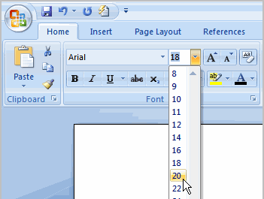

To make your address appear on the right hand side of the page you need to type it in normally, then select the writing you want to move and use the ‘alignment’ buttons on the right of the text box.

You can also use these to make sure the company’s address is aligned to the left hand side of the page.

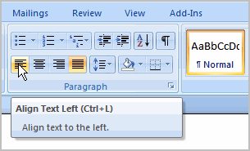

Once you have written your letter make sure you have no spelling mistakes by doing a spell check (you should do this on any document you create). Click ‘Review’ at the top of the page and then the first icon, Spelling and Grammar:

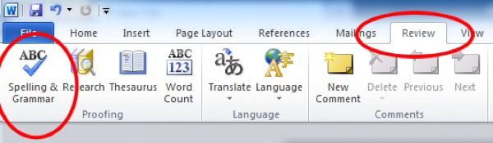

A box will appear that will change any words you have spelt wrong – remember do not just accept what it tells you, it might be changing the word. Make sure you read it carefully and think what you want to say.

You now need to save your document. Click the Windows Icon (or File), and select ‘Save As’ and ‘Word Document’:

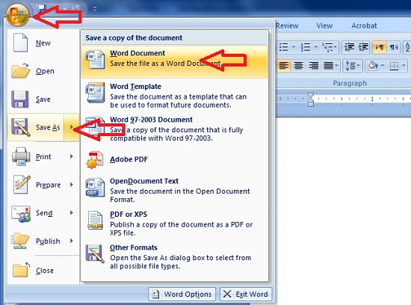

You can then select where you want to save the document (ask your teacher) and what to call it:

Now you need to make sure the letter prints properly. Go back to the Word document that is your letter and select the Windows Icon again, and hover your mouse over ‘Print’, the select ‘Print Preview’:

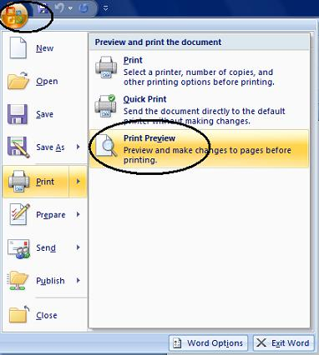

Once you have clicked Print Preview you will see your letter displayed in a preview screen:

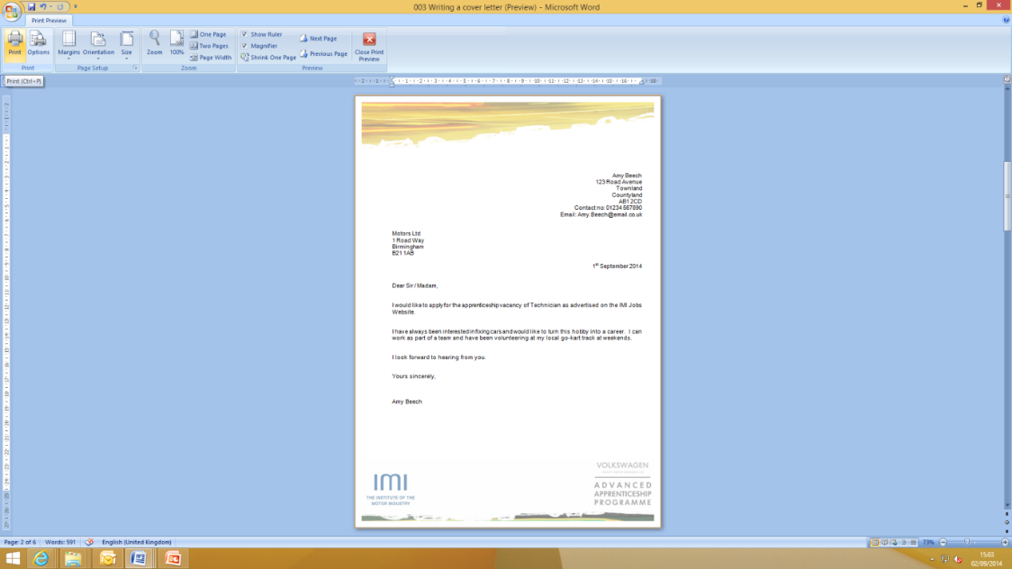
If you are happy with how your letter looks then press print in the top left corner.

When the print box comes up check that the right printer is selected (ask your teacher) and press ok.

Check your printed letter, if it is on more than one page, does not look right or has bits missing you need to change it in Microsoft Word, save it and re-print it.
LESSON 5: Microsoft Word

Document to Edit

Learning objectives:
- Know how to edit a Microsoft Word document
- Understand what you can display in a Microsoft Word document
- Be able to edit documents and add additional information into them

HANDOUT 016: Document to edit

Document to Edit

123 Garage
The Road
The Town
Countyland
AB1 1AB
01234 567890

Bob’s Parts
1 Road Street
The Town
Countyland
BA1 1AB

1st September 2017

Dear Bob,

I am trying to find an air filter for a Ford Focus. Please can you let me know if you have any?

Many Thanks

A. Garage

LESSON 6 & 7: ICT

Microsoft Excel

Learning objectives:
- Know what Microsoft Excel is
- Understand what documents can be created in Microsoft Excel
- Be able to create spreadsheets and use basic functions

HANDOUT 016: Production Methods

Now try creating a price list in Microsoft Excel with the following information in it:

Spreadsheet Title in Box 1A

Column Titles in Row 2: Part, Trade Price, VAT Amount, Retail Price

Put the following parts in Column A:
- Exhaust
- Wing Mirror
- Radiator
- Tyre
- Battery
- Headlight Bulb
- Windscreen Wiper

Make sure that you can read all of the words in each column by making the columns wider, put the mouse arrow over the line between two columns until you see the symbol below then left-click and drag until the column is the right size:

Put the following prices in the Trade Price column:
- Exhaust 40
- Wing Mirror 25
- Radiator 100
- Tyre 33
- Battery 27
- Headlight Bulb 2.50
- Windscreen Wiper 12.75

To make these numbers appear as pounds we need to turn them into currency.
Highlight the cells that have the numbers in by clicking on the top box and dragging the mouse down until they are all highlighted:

Then select the currency button at the top – it looks like notes and coins:

All the prices should now appear in this format: £40.00
To calculate the VAT amount we can use a formula. Formulas are the reason that Excel is used so much when any calculations need to be made to sets of numbers; the spreadsheet does it for you!
In this case we will need to work out 20% of the Trade Price, to do this you need to multiply the trade price by 0.2.

All formula’s in Excel start with the equals symbol =
Then add the cell that you want to apply the formula to, in this case B3
Then select the multiply symbol on your keyboard – this will show as *

Now type 0.2 and hit enter and the box should display the VAT amount of £8.00, you will still be able to see the formula in the top bar once the £8 is displayed:

To use the same formula on each price in this column you do not need to type it into each box, put your mouse arrow over the bottom right hand corner of cell C3 that shows the answer to your last formula (you can see a little box in the corner of the cell). Your arrow will change to a cross, when it does this left click and pull the box down until it covers all the cells you want the formula applied to:

When you let go of the mouse the correct VAT amounts should show in each cell:

Are yours correct? If not go back and work through the formula again.

To calculate the Retail Prices we are going to use another formula. This time we need to add together the Trade Price with it’s VAT and this will give the retail price.

Make sure you have clicked in the square where you want the answer to be, in this case D3
Start the formula as it always has to be with =

Now type the name of the cell with the trade price, B3and the add symbol + then the cell with the VAT amount, C3. As you do this the cells you are selected will be outlined in different colours:

Hit enter and the total should be shown:

Repeat the process to copy the formula down into all of the cells where you need to calculate the retail price. Does your spreadsheet look like this:

If not go back and start the formula process again.

Now you need to save your spreadsheet. Select the Windows icon, or File, and Save As, then select Excel Workbook:

You will then need to follow your teacher’s directions to save your spreadsheet in the right place.
The name of your Spreadsheet is not very easily read so we are going to edit Row 1 to make it look more like a heading.

Select cells A1 to D1, then we are going to merge the cells – this means turning them into one big cell:

Once you have clicked ‘Merge & center’ the heading should move into the middle of your table, leave the cell selected and make the text bold so it stands out:

You now need to put the list of parts into alphabetical order so it is easier to find what you are looking for – this might not seem important here but if you have 100 rows of parts you might find it useful.

To do this you need to select the column that you want to Sort, you do this by clicking on the ‘A’ button at the very top of the column:

You will then need to select the ‘Sort & Filter’ button from the right hand side of the top toolbar, and select ‘Sort A – Z’:

When you select this the spreadsheet will ask you if you want to expand your selection (so that all the prices stay in line with the parts) or continue with current selection (which will just change the order of the part names and leave the prices where they are).

You need to Expand the Selection as you want to keep all the right prices with the right part:

Click ‘Sort’, does your sheet now look like this:

If not go back to the beginning of the process to filter the Part names A-Z and try again.

Once it looks like this save your document by clicking the blue disk circled above.

You now need to print your spreadsheet, select the windows icon, or file, and Print, then select Print Preview – it is always a good idea to preview your print, especially when using Excel to make sure that it all shows on one page:

How do you think it looks in the Print Preview? Is it clear and easy to read?

With spreadsheets it is often easier to read if the gridlines between all the cells are shown when it is printed. To do this select Page Setup while still in the Print Preview:

Then the Sheet tab and tick the box marked Gridlines:

Then click ok and it should now look like this:

If you are happy with how it is shown, click Print and check that the correct printer is selected (check with your teacher), then select ‘ok’.

Make sure your name is on your work and hand in to your teacher.
LESSON 8: ICT

Creating an Email

Learning objectives:
- Know what Microsoft Outlook is
- Understand what Microsoft Outlook can do
- Be able to create emails, tasks and use basic functions

HANDOUT 020: Market Research

You are going to write an email to a local company, applying for an apprenticeship that you have seen them advertising.

Go to http://jobs.theimi.org.uk and search for an apprenticeship. Pick one vacancy that you are going to apply for.

Open Microsoft Outlook by clicking on the icon that looks like this:

(Yours might be 2007 or another year)

When you are applying for a job, the email is your cover letter and should always have certain things in:
- The email address of the person you are sending it to
- Your email address to send a copy of the email to
- A Subject
- It should be addressed to the correct person, if you do not know the name, put ‘Dear Sir or Madam’.
- The main section of the email will state why you are writing. In this case it will include the position that you want to apply for, where you saw it advertised and why you think you’d be good at the job
- Finish with ‘Yours sincerely’ (however if you don’t know the recipient’s name use ‘Yours faithfully’ instead) and your full name.
- Your CV will need to be attached to the email
When you open Microsoft Outlook you will need to create a new email:
Put the email address in of the person you want to send the email to (in this case the one your teacher has given you).

You then want to put your own email address into the ‘CC’ line, this stands for Carbon Copy and sends a copy of the email to yourself so you remember what you have applied for.

You also have the option of sending an email to someone ‘BCC’, this means Blind Carbon Copy and means that the person you send the email to cannot see that you also sent a copy to the BCC person.

You must always put a subject into an email; most companies have systems set up that will reject any email that comes in without a subject as ‘Junk’ or ‘Spam’, so to make sure your email gets through always put something in the subject box. This can be very simple and straight forward, in this case: ‘Application for Vacancy’ is all that is needed.

You then need to write your email, you MUST write something in the main body of the email or, again, many companies Spam filters will reject it. Plus – it looks strange if an employer receives an email with a CV attached but nothing written in the email how do they know why you have sent your CV?

The email is not very different to the cover letter that you created in Word except you do not need to put any postal addresses or the date at the top.

Do not think that because it is an email it can be informal; this is still you applying for an apprenticeship, or job role, and your first contact with an employer. If it’s badly written they will just delete it.

Now write your email.

Did yours look like this?

Make sure that all the writing is in the same font. To change the font; select all the writing on the page and left click on the font box in the bar along the top, you can then select a different font by left clicking on it.

Change to font to Arial now using this box, then use the box next to it to make sure all your writing is the same size (12):

Once you have written your email make sure you have no spelling mistakes by doing a spell check (you should do this on any email you create). Click ‘Spelling’ on the top menu:

A box will appear that will change any words you have spelt wrong – remember do not just accept what it tells you, it might be changing the word. Make sure you read it carefully and think what you want to say.

You now need to attach your CV to the email, using the file your teacher tells you, select the paper clip icon:

This will open a box and you need to find the file you are attaching then click insert:

The attachment will now show on your email:

Read over your email again and make sure you are happy with everything.

If you are, click Send.

LESSON 9: ICT

Creating a Meeting, Task and Contact

Learning objectives:
- Know: what Microsoft PowerPoint is
- Understand: what Microsoft PowerPoint can create and be used for
- Be able to: create a Presentation based on a researched subject

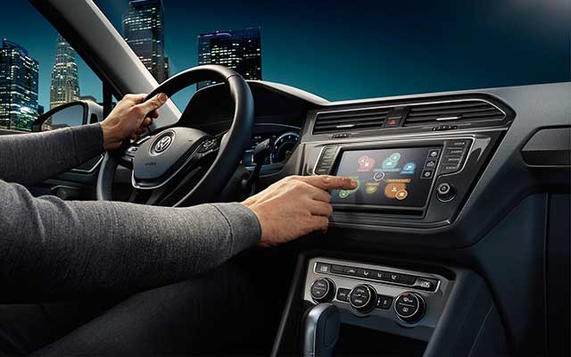
LESSON 10: ICT

Microsoft PowerPoint

Learning objectives:
- Know: what Microsoft PowerPoint is
- Understand: what Microsoft PowerPoint can create and be used for
- Be able to: create a Presentation based on a researched subject

HANDOUT 026: Creating a Presentation

You are going to create a 5 minute presentation to describe an automotive job role that you did not previously know existed.

Go to www.autocity.org.uk and choose Explore Job Roles from the menu. Decide which job role you are going to do your presentation on, research it and find some basic information that you will include in your slides.
Open Microsoft PowerPoint by clicking on the icon that looks like this:
(Yours might be 2007 or another year)

You can then start to put your information in the slides.

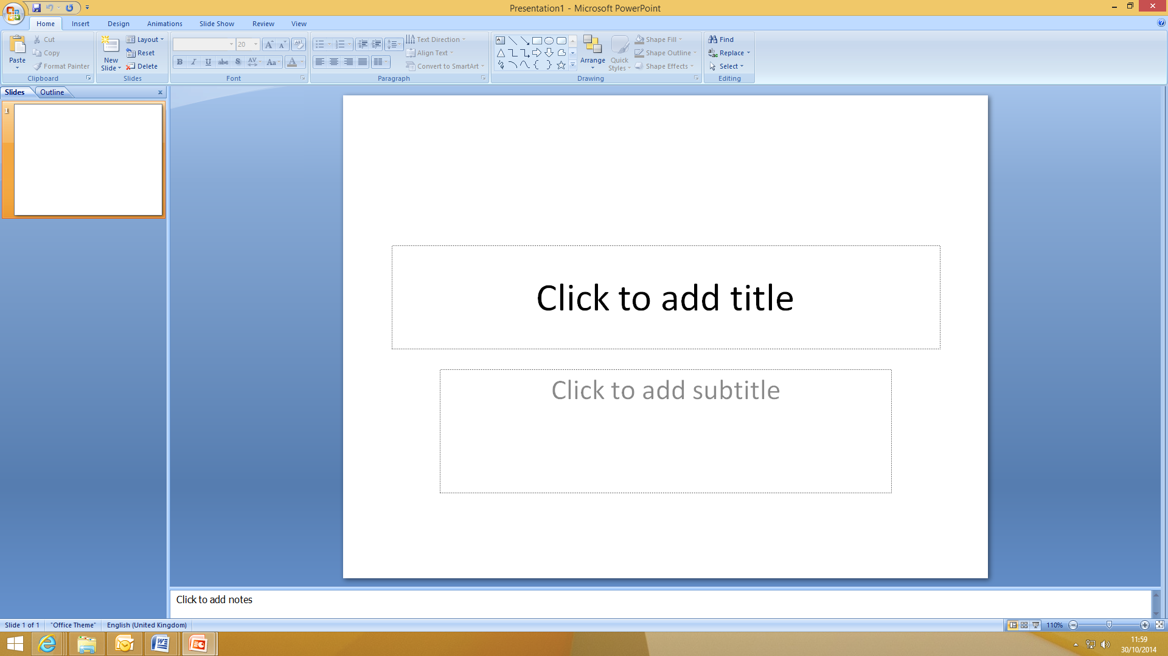

Follow the instructions to add a title and subtitle into your presentation:

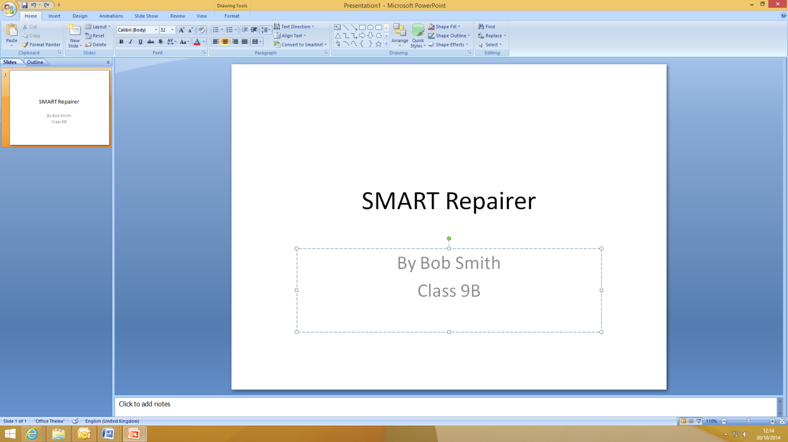

When you have done this click on ‘New Slide’ in the top toolbar to create the next slide:

This will appear like this:

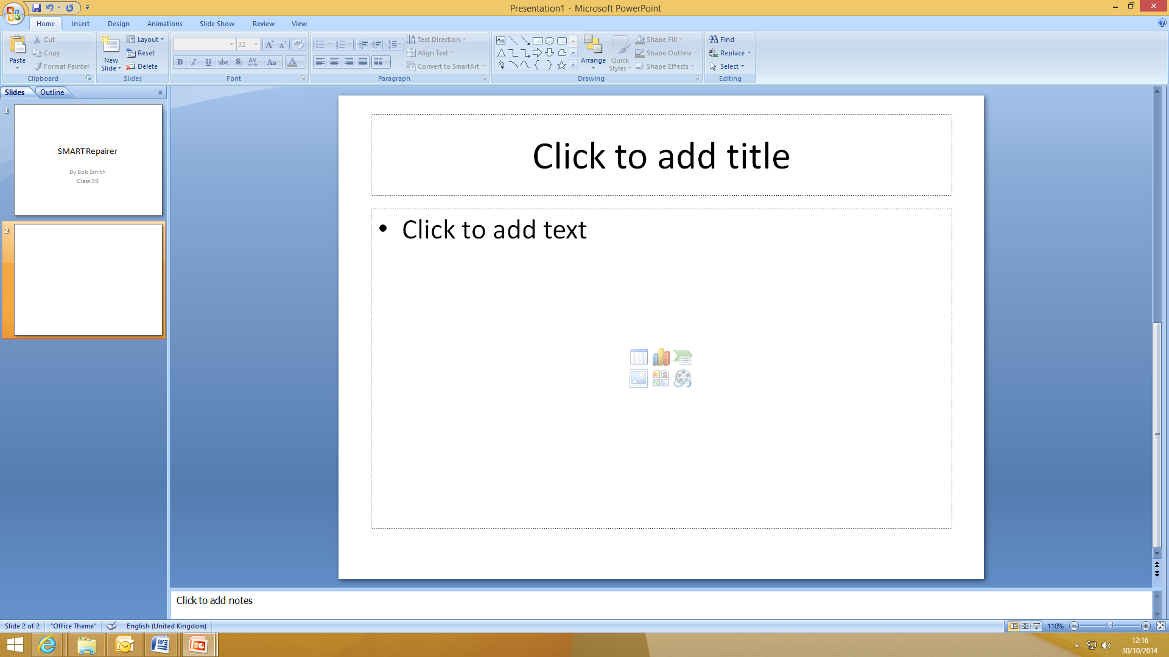

You can now create the slide using similar items to a Word document, add a title and text, you can use bullet points and change the font you use:

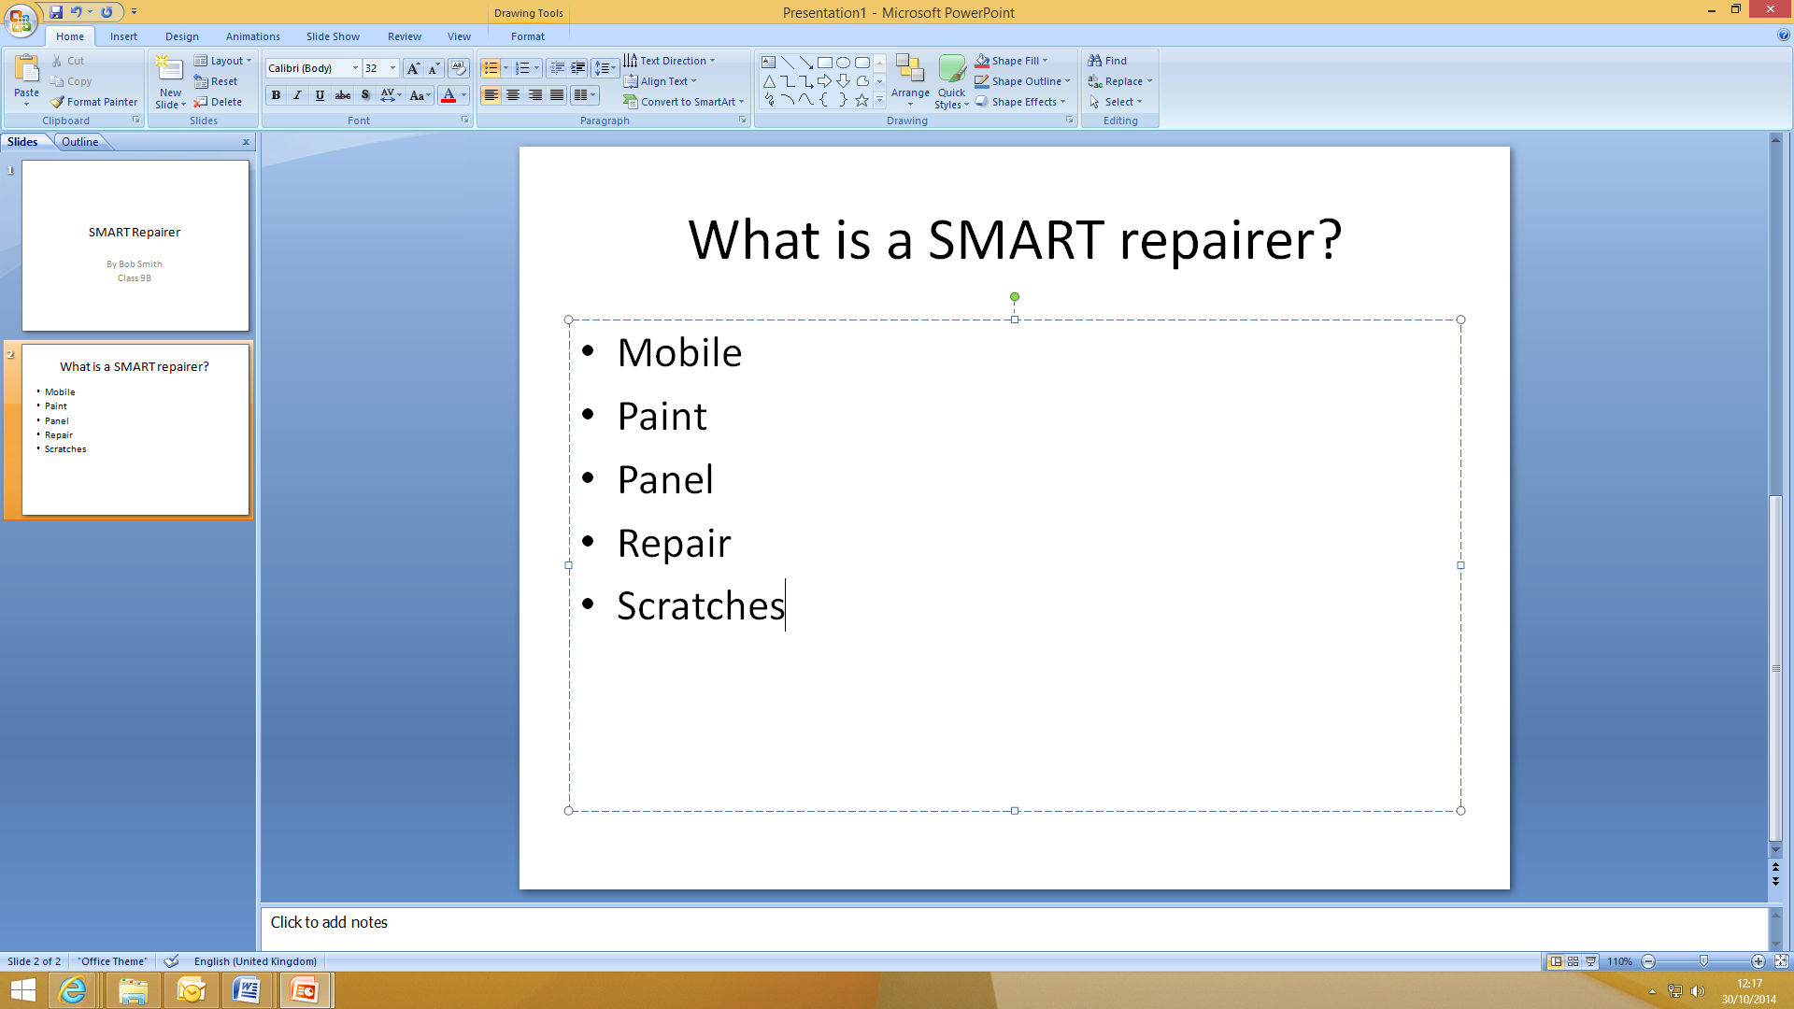
Repeat this process to add more slides to your presentation and put the information that you wish to include on your chosen job role.

You might want to include what qualifications you need, how much you can earn, where you work and what the best bits of the job are.

Keep going back to the information on the job role using www.autocity.org.uk to make sure you are including lots of relevant information.

Remember not to put everything onto the slides so you’ll just read off them, put key bots of information on the slide and then if you need to have notes in front of you to remind you about the detail of what you’re going to say.

Once you have finished your presentation save it by clicking on the Windows or File button and clicking ‘Save As’ and then ‘PowerPoint Presentation’:

Then save it where your teacher tells you to.

LESSON 11: ICT

Editing a Presentation

Learning objectives
- Know: how to edit a Microsoft PowerPoint presentation
- Understand: what can be included in a PowerPoint presentation
- Be able to: add animations, backgrounds and images to a presentation

HANDOUT 028: Editing a Presentation

You are now going to edit your presentation.
Open Microsoft PowerPoint by clicking on the icon that looks like this:
(Yours might be 2007 or another year)

Then click the Windows or File button, select Open and then open your presentation from where it was saved:

First change the background colour of your slides, to do this you can use a pre-set design, click on the ‘Design’ tab in the top menu and then select which colour scheme you would like to use:

Once you have selected a design you can change the colours of it by clicking the ‘Colours’ drop down menu:

Try out a few different designs and colours now.

Now you can add some images into your presentation, your teacher will tell you where the motor industry images are saved.

Simply left click the mouse to the place in a slide where you would like to put a picture and then click ‘Insert’ from the top Menu, and then ‘Picture’:

Select the picture you would like to put in your slide and click ‘Insert’:

The picture will then appear on the slide:

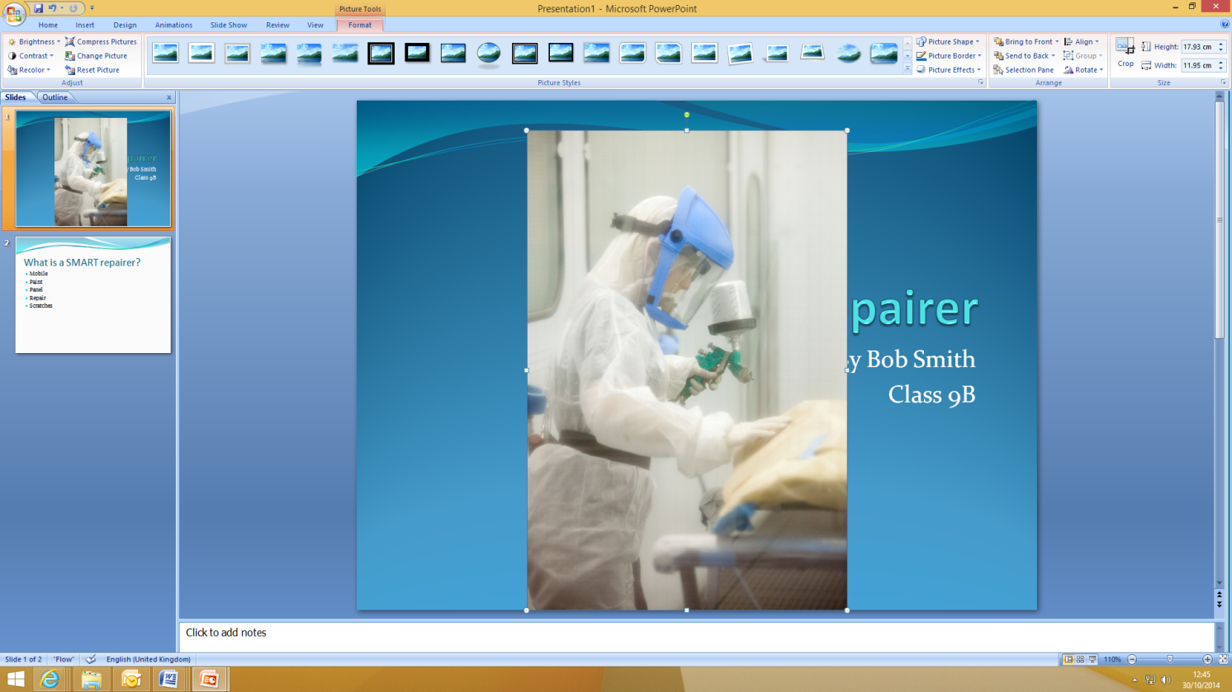

Obviously this picture is too big, so use the boxes on each corner of the picture to make it the size you want. Then move it to where you want it on the slide by clicking in the middle of the picture and dragging it to where you want before letting go of the mouse button.

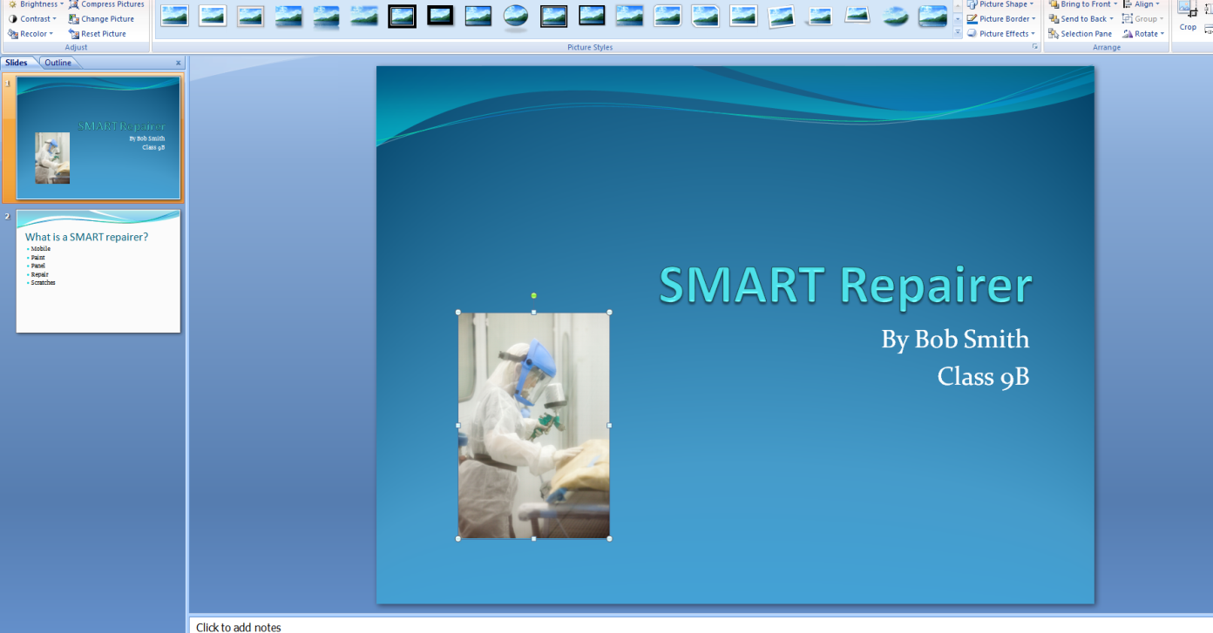

Repeat this process to put pictures anywhere you would like them in your presentation using the saved motor industry ones.

Now you can add in some animations, these make lines of text or pictures move / appear in different ways.

Highlight a word or sentence that you would like to animate, then click on the ‘Animations’ tab and then on the ‘Custom Animation’ button:

This will open a box on the right hand side of the screen.

Click on the ‘Add Effect’ drop down and this will give you the options relating to WHEN you want the animation to happen. We are going to make the words move when they appear so chose ‘Entrance’ and then select the style you would like out of the options:

See what happens to the text you had highlighted. Try some different animations on some different words or lines of text until you decide on the ones you want to keep.

Remember not to use too many or it distracts your audience!

When you are happy with your presentation go back to the first slide and click the ‘Slideshow’ tab and select ‘From Beginning’; this will now play though your slideshow as it would when you are actually presenting (including all the animations):

Move from slide to slide by clicking the right arrow on your keyboard or the space bar and check you are happy with how the presentation looks and how all the animations work.

Press ‘Esc’ on your keyboard at any time to go back into PowerPoint and change anything you are not happy with.

Once you have finished your presentation save it by clicking on the Windows or File button and clicking ‘Save As’ and then ‘PowerPoint Presentation’:

Then save it where your teacher tells you to.
LESSON 12: ICT

Presentation Evaluation

Learning objectives:
- Know: how to give a presentation using PowerPoint
- Understand: how to present and move through the PowerPoint document
- Be able to: present their own PowerPoint presentation on a subject they have researched that includes text, images, animations and background designs/colours

HANDOUT 026: Presentation Evaluation

Speaker’s Name | Date
Title of presentation
What do you remember most?
What was good?
What was great?
What could have been better?
When you are assessing someone’s presentation, look for these success criteria:
Body Language | Voice and Clarity
- Eye contact  - Posture  - Gestures  - Poise | - Clear pronunciation  - Volume  - Good pace
Content and Research | Audience Appeal
- Main ideas  - Well-argued (makes sense)  - Well-organised (introduction-body-conclusion) | - Interesting  - Answers Questions  - Persuasive  - Confident
Additional comments:

Additional Information: ICT

Course feedback – Student

The Institute of the Motor Industry is very interested to hear your thoughts and opinions on the ICT course you
have completed.

School or college name
Your name
Email address
Year group

Please tick one of these boxes:
 | Question | Strongly disagree | Disagree | Neither agree or disagree | Agree | Strongly agree
Course aims and objectives | Accurately described the content and propose
Resources | Useful online resources.
 | Useful paper handouts.
 | Useful presentation slides.
Course topic | Interesting.
 | Contained enough detail.
Course activities | Useful and relevant.
 | Fun and interesting.
 | Enough time to complete each one.
 | A good mix of group and individual activities.
Homework | Relevant and achievable.
Course speed | Appropriate
Difficulty level | Appropriate
My interest in ICT has increased.
My ICT knowledge has increased
My increased ICT knowledge will help me in the future
Overall the ICT course has met my expectations
I would recommend the ICT course to other students

What was positive and/or negative about the ICT course?

What suggestions do you have for improving the ICT course?

Thank you for your feedback! careers@theimi.org.uk

