# BUSINESS STUDIES LESSON PLANS

## Student Pack



C:\Users\joannah\AppData\Local\Microsoft\Windows\INetCache\Content.Word\sytner-careers[1].png

Sponsored by:

Content

|  |  |
| --- | --- |
| Introduction  About The IMI and IMI Autocity | Lesson 9  Market Research and the Marketing Mix |
| About Sytner Careers | Lesson 10  Product and Promotion |
| Notes:  Curriculum Content | Lesson 11  Product and Promotion |
| Lesson 1  Recruitment | Lesson 12  Price and Place |
| Lesson 2  Training | Lesson 13  Price and Place |
| Lesson 3  Choosing the right sources of finance | Lesson 14  Business Activity Sectors |
| Lesson 4  Beak-even Analysis | Lesson 15  Business Activity Sectors |
| Lesson 5  Cashflow | Lesson 16  Business Objectives |
| Lesson 6  Production Methods | Lesson 17  Business Organisation |
| Lesson 7  Quality Management and Production Efficiency | Additional Information:  Student Feedback |
| Lesson 8  Quality Management and Production Efficiency | Business Studies Competition:  Information and Brief |

Introduction

The automotive industry influences everyone, from delivering goods on time to commuters travelling to work and emerging services being able to respond to crisis, the motor industry helps keep the country moving.

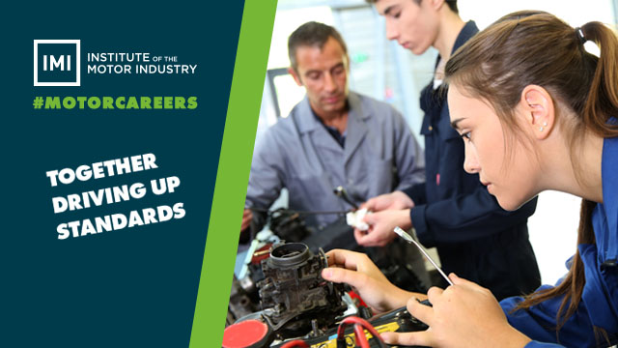

About The IMI

The Institute of The Motor Industry is the professional body for individuals working in the motor industry and the authoritative voice of the retail automotive sector. The IMI’s aim is to ensure that the automotive retail sector has a skilled, competent and professional workforce that is fully equipped to keep pace with the demands of new technology and changing markets. A key part of business for manufacturers and dealers is to encourage the best and brightest people to join their business in a variety of roles.

www.theimi.org.uk/autocity

IMI Autocity is the one-stop-shop for impartial careers information and advice on careers in the Retail Motor Industry.  Whether you are an individual looking to start or progress your career, or a teacher or careers advisor who supports others in making their career choices, Autocity is the place to start.  With over 150 #MotorCareers to choose from Autocity provides you with all things Automotive!

Sponsored by Sytner Group

Sytner Group represents 20 of the world's most desirable car manufacturers in over 100 dealerships across the UK. Last year Sytner sold over 135,000 cars and serviced a further 230,000 Cars.

[](http://www.bing.com/images/search?view=detailV2&ccid=5Rkxeyh0&id=7046E0193E28699BFA9A40830EE94F7E666C916F&thid=OIP.5Rkxeyh0W1IM9W8-AwUx_AEsCX&q=aston+martin+logo+sytner&simid=607993446168334245&selectedIndex=8)[Jaguar Careers](https://careers.sytner.co.uk/jaguar/)[Alpina Careers](https://careers.sytner.co.uk/alpina/)

[Maserati Careers](https://careers.sytner.co.uk/maserati/)[McLaren Careers](https://careers.sytner.co.uk/mclaren/)[Mercedes-Benz Careers](https://careers.sytner.co.uk/mercedes-benz/)[MINI Careers](https://careers.sytner.co.uk/mini/)[Porsche Careers](https://careers.sytner.co.uk/porsche/)[Rolls Royce Careers](https://careers.sytner.co.uk/rolls-royce/)[SEAT Careers](https://careers.sytner.co.uk/seat/)[smart Careers](https://careers.sytner.co.uk/smart/)[Volkswagen Careers](https://careers.sytner.co.uk/volkswagen/)[](http://www.sytner.co.uk/volvo/)[Audi Careers](https://careers.sytner.co.uk/audi/)[Bentley Careers](https://careers.sytner.co.uk/bentley/)[BMW Careers](https://careers.sytner.co.uk/bmw/)[Ferrari Careers](https://careers.sytner.co.uk/ferrari/)[Land Rover Careers](https://careers.sytner.co.uk/land-rover/)[Lamborghini Careers](https://careers.sytner.co.uk/lamborghini/)[Lexus Careers](https://careers.sytner.co.uk/lexus/)

Founded by British Touring Car Champion Frank Sytner and his brother Alan in 1968, Sytner Group celebrates a one team spirit and strives to follow Frank's uncompromising driving style by offering an uncompromised customer experience. In 2002 Sytner joined the Penske Motor Group who shared the Sytner passion for motorsport. CEO, Roger Penske, being the founder of Penske Racing, the most famous race team on a worldwide basis, featuring in the NASCAR and Indy Racing series as well as Formula 1 in the 1970’s.

Sytner recognises that unparalleled customer service can only be achieved by attracting, motivating and retaining the very best team members. With this in mind, Sytner puts their employees at the heart of everything they do by providing an outstanding working environment and exciting careers opportunities. Sytner are immensely proud to have been voted, by their employees, the Sunday Times No. 1 Best Big Company to Work for 2017 and have been in the top 5 for the last 8 years. In addition, for the 5th consecutive year, Sytner have also attained the highly prized 3 star accreditation for outstanding levels of employee engagement.

Sytner Group are committed to developing talent and building careers, working in partnership with the biggest car manufacturers in the world, leading training providers and industry specialists to offer comprehensive ‘on the job’ apprentice and trainee programmes. This offers future Sytner stars a progressive and consistently successful investment in their career and personal development.

Sytner welcome Apprentices and Trainees into a wide range of business areas to kick start their career, these areas include:

* Technicians
* [Sytner Careers](https://careers.sytner.co.uk/)Sales Executives
* Service Advisors
* Parts Advisors
* Administration

Due to success and demand for the Sytner Group apprentice and trainee programmes they look to support the most proactive students who are prepared to go that extra and most innovative mile to secure themselves a fantastic career opportunity. To find out more about the Sytner Apprenticeship and Trainee Programme: [**https://careers.sytner.co.uk/**](https://careers.sytner.co.uk/)

NOTES

Curriculum content

Please note: The following points are not covered on the Business Studies lessons.

Based on GCSE Business Studies 15370 (WJEC/CBAC) - Specifications for teaching from 2009.

|  |
| --- |
| **Candidates should be able to:**  2.1 The Business Framework   * Demonstrate understanding, in theory and practice of the following types of business organisations: sole traders, partnerships, private and public limited companies and social enterprises such as the co-operatives and charities.   2.2 Businesses and their customers   * Demonstrate an understanding of the product life cycle and the strategies that might be used to extend the life cycle of a product.   2.3 Producing goods and services   * Distinguish between goods and services that are provided through both the private sector and the public sector. * Explain the importance of international trade to business and identify the resulting problems, threats and opportunities that face businesses operating in the global market place.   2.5 The external environment   * Distinguish between goods and services that are provided through both the private sector and the public sector. * Have an understanding of Government legislation: including employment law; environmental law; health and safety law, consumer law, competition law and copyright law. (A broad understanding of the constraints and responsibilities that such legislation puts on business is required, not detailed knowledge of particular acts of parliament. * Understand the effects on business of unforeseen events e.g. natural disasters, adverse weather conditions and disease in livestock. |

LESSON 1: Business Studies

Recruitment

**Learning objectives:**

* To understand the stages and methods of recruitment.
* To be able to use and design recruitment documents.

**Key words and phrases:**

Needs Analysis Job Description Person Specification

Curriculum Vitae Application Form Interpersonal Skills

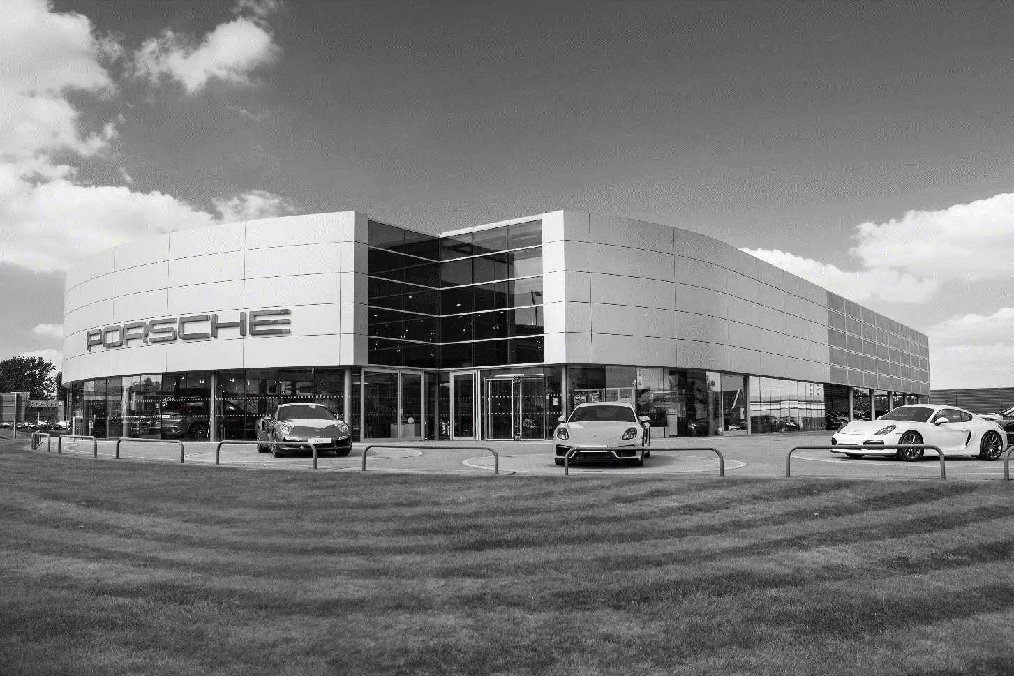

HANDOUT 003: Recruitment

Table to complete

Complete the table below:

|  |  |  |  |  |
| --- | --- | --- | --- | --- |
| Company & Role | Activity | Skills required | Qualifications required | Education required |
| *Example:*  Light Vehicle Diagnostic Technician | *Example:*  Diagnosing the cause of a problem | *Example:*  Excellent practical skills.  The ability to work quickly with attention to detail.  Good communication skills.  The ability to follow written and verbal instructions.  The ability to work without supervision. | *Example:*  Level 2 light vehicle service technician.  Level 3 diagnostic technician.  Advanced / modern apprenticeship in light vehicle maintenance and repair. | *Example:*  GCSE: English, Maths, DT, IT  BTEC/AS: Business Studies  Engineering, ICT  Degree: Engineering |
| 1. |  |  |  |  |
| 2. |  |  |  |  |
| 3 |  |  |  |  |
| 4. |  |  |  |  |
| 5. |  |  |  |  |

LESSON 2: Business Studies

Training

**Learning objectives:**

* To understand the importance of employee training.
* To be able to identify appropriate types of training for different circumstances.

**Key words and phrases:**

E-learning On-the-job training Off-the-job training Training needs

Technical skills Personal skills New workers Group working

Flexibility New training



HANDOUT 006: Training

Training Routes



|  |  |
| --- | --- |
| Vehicle Sales Executive | |
| **What is the work like?**   * Vehicle Sales Advisors, Executives or Vehicle Sales People are responsible for selling new and used vehicles, from cars, bikes and vans to commercials trucks. Duties may vary depending on the type and size of the organisation, but they will commonly include: * Greeting customers, discussing their needs and advising them on the most suitable vehicle * Arranging test drives * Negotiating sale and trade-in prices * Working out finance arrangements and packages, which may include organising registration plates, road tax and delivery of vehicles * Highlighting any additional products relevant to the customer * Processing orders and completing relevant paperwork, which may include carrying out stock checks using manufacturers’ databases * Updating customers on the progress of orders and contacting potential customers to update them about new vehicles and deals * Updating stock lists * Managing advertising and updating the website * Keeping the forecourt and cars clean and tidy * Providing potential customers with relevant literature and information * Inspecting vehicles pre- and post- sale * Attending auctions * In larger organisations you may work as part of a team, specialising in one aspect of selling. In smaller organisations you may be responsible for all aspects of vehicle sales | **Work environment**  Please note: These figures are meant as a guide only and may vary from employer to employer and may be dependent on the geographical area.  Vehicle Sales Advisors, Executives or Vehicle Sales People usually work around 40 hours per week, which will include some weekend and evening work to cover the busiest trading times. You may also be able to find part time work. Environments may vary depending on employers, but you would normally work in a showroom or an office, often venturing out onto the forecourt to show customers around.  **Salary**   * Starting salary for new entrants may be between £9,000 and £15,000 * A basic salary for experienced Sales Executives may start at £15,000, but with commission, bonuses and other benefits may reach £20,000 to £35,000 * Successful sales executives in senior roles may earn in excess of £35,000   Vehicle Sales Advisors/Executives usually receive a basic salary, plus commission on sales and bonuses for meeting sales targets. They may also receive a company car. There may be opportunities for shift and overtime pay depending on the employer. You may also be eligible for holiday entitlement, company pension and private healthcare schemes |
| **Qualifications and experience required**  Vehicle Sales Advisors, Executives or Vehicle Sales People do not need any formal qualifications for this job, although many employers will expect GCSEs/Standard Grades (A-C) in Maths and English.  IMI Awards [Level 2 Diploma in Vehicle Sales Principles](http://www.imiawards.org.uk/Qualifications/L2-Diploma-in-Vehicle-Sales-Principles)  [Edexcel Diploma in Vehicle Sales Competence](http://pearsonwbl.edexcel.com/i-am-a/parent-learner-btec-app/Pages/home.aspx) | **Skills Required**   * As a vehicle sales advisor, executive or vehicle sales person you will need to demonstrate: * A confident and outgoing personality * A smart appearance with a polite and professional approach * Good communication and listening skills * A high level of numeracy * Good negotiating skills * The ability to build and maintain good customer relations * Confidence in using IT software * A genuine interest in vehicles * The ability to explain technical information to people who are not experts * Good organisational skills and the ability to remain calm under pressure * The ability to work both as part of a team and alone, without supervision |
| **Entry routes**  There are several ways of starting your career as a sales advisor:   1. Train at work, in a dedicated training facility managed by the employer; many manufacturers offer apprenticeship programmes that involve training at specially equipped centres 2. Study on day release at local colleges or with training providers whilst in employment 3. Attend college, or a private training provider who will organise work placements 4. Study full time at college with practical exercises as well as classroom work 5. You may be able to get into this job via an apprentice/traineeship scheme. Apprentice/traineeships may differ from one place of work to the next but they work towards NVQ/SVQ level 2 or 3 in vehicle sales, and technical certificates in vehicle sales. To do this you may require GCSEs/Standard Grades in English, Maths, Science and IT or appropriate equivalents. For further information on apprentice/traineeships in England please visit [www.apprenticeships.org.uk](http://www.apprenticeships.org.uk/), for Wales please visit [www.careerswales.com](http://www.careerswales.com/) for Northern Ireland please visit [www.nidirect.gov.uk/careers](http://www.nidirect.gov.uk/careers) and for Scotland please visit [www.skillsdevelopmentscotland.co.uk](http://www.skillsdevelopmentscotland.co.uk/)   **Apprenticeships**  [Vehicle Sales (Intermediate- Sales Adviser)](http://www.apprenticeships.org.uk/Types-of-Apprenticeships/Retail-and-Commercial-Enterprise/Vehicle-Sales.aspx%20) As an apprentice, you’ll gain a broad range of skills used in a sales environment. You’ll learn how to identify a customer’s needs and interests; advise customers; promote the features and benefits of vehicles; appraise vehicles; and negotiate difficult sales. You’ll also learn how and when to make a successful compromise. | |

|  |
| --- |
| C:\Users\joannah\AppData\Local\Microsoft\Windows\INetCache\Content.Word\393775[1].jpg |

|  |  |
| --- | --- |
| Parts Advisor | |
| **What is the work like?**  Parts Advisors are also known as Vehicle Parts oOperatives. They are responsible for ordering, selling and managing stock control on a wide range of vehicle parts and accessories.  Duties may vary from employer to employer but will typically include:   * Advising customers on how to solve a problem with their vehicle * Taking orders from customers both face to face and over the phone * Maintaining an ordered stock room and finding parts from stock * Raising invoices for parts sold * Liaison with other members of staff   Customers may include members of the public, service departments of dealerships, and garages. | **Environment**  Please note: These figures are meant as a guide only and may vary from employer to employer and may be dependent on the geographical area.  Full time hours are typically around 40 hours a week; this may include some weekend and evening work, which may be on a rota system with other team members. You may be able to find part time work in this area. Working environments will differ, depending on where you work, but you may be based at a garage, shop or dealership.  **Salary**   * Trainees may earn between £6,000 and £8,000 a year * Fully trained operatives may earn between £10,000 and £15,000 a year * Senior operatives may earn £20,000 or more   There may be opportunities for shift and overtime pay depending on your employer. You may also be eligible for holiday entitlement, company pension and private healthcare schemes. |
| **Qualifications and experience**  Although there are no formal qualifications required for entry to this role, there are a range of qualifications in vehicle parts operations covering the underpinning knowledge useful in getting started, and the hands-on skills required to carry out the job.  Once working in parts you can complete your Automotive Technician Accreditation, this shows current competence and is valid for three years. To find out more please see [ATA Parts](http://ata.theimi.org.uk/ata-parts-route).  IMI Awards [Level 2 Diploma in Vehicle Parts Principles](http://www.imiawards.org.uk/Qualifications/L2-Diploma-in-Vehicle-Parts-Principles)  Edexcel [Level 2 Diploma in Vehicle Parts Competence / Principles](http://www.cityandguilds.com/1132.html%20)  City & Guilds [Vehicle Parts (VRQs) (4151)](http://www.cityandguilds.com/Courses-and-Qualifications/transport-maintenance/automotive/4151-vehicle-parts-vrqs) | **Skills**  As a Parts Advisor you will need to demonstrate:   * A good technical understanding and general knowledge of how motor vehicles work * Good communication skills * Willingness to keep technical knowledge updated in order to provide the most efficient service possible * Confidence in processing payments * The ability to work on your own initiative and as part of a team * Confidence in problem solving |
| **Entry Routes**  There are several ways of starting your career as a trainee in vehicle parts operations:   * Train at work, in a dedicated training facility managed by the employer; many manufacturers offer apprenticeship programmes that involve training at specially equipped centres * Study on day release at local colleges or with training providers whilst in employment * Attend college, or a private training provider who will organise work placements * Study full time at college with practical exercises as well as classroom work   Apprentice/traineeship schemes may vary from employer to employer but they will typically work towards an N/SVQ and will be on-the-job training. To do this you may require GCSEs/Standard Grades in English, Maths, Science and IT or appropriate equivalents. For further information on apprentice/traineeships in England please visit [www.apprenticeships.org.uk](http://www.apprenticeships.org.uk/), for Wales please visit [www.careerswales.com](http://www.careerswales.com/) for Northern Ireland please visit [www.nidirect.gov.uk/careers](http://www.nidirect.gov.uk/careers) and for Scotland please visit [www.skillsdevelopmentscotland.co.uk](http://www.skillsdevelopmentscotland.co.uk/)  **Apprenticeships**  [Vehicle Parts (Intermediate - Parts Sales Representative/Parts Telesales Representative)](http://www.apprenticeships.org.uk/Types-of-Apprenticeships/Engineering-and-Manufacturing-Technologies/Vehicle-Parts.aspx) This Apprenticeship covers the sale of motor parts for all kinds of vehicles. Vehicle parts operatives (or parts advisers) order, sell and manage stock control on a wide range of parts and accessories for all kinds of vehicles – from cars and motorcycles, to lorries, buses and coaches. | |

|  |  |
| --- | --- |
| Service Advisor | |
| **What is the work like?**  A customer Service Advisor deals directly with customers, scheduling service work to their vehicles and informing them of any additional repairs required. They will handle administrative and customer relations aspects of service department operations. Their duties may vary slightly from employer to employer depending on the size of the company, but they commonly include:   * Interpreting customer concerns and comments and liaising with technicians * Liaison with customers about any additional work required * Greeting customers and scheduling services * Estimating time and costs associated with repairs * Handling customer complaints * Responding to customer requests * Tracking the vehicle through the workshop | **Environment**  Please note: These figures are meant as a guide only and may vary from employer to employer and may be dependent on the geographical area. You will normally work around 37 hours a week Monday to Friday, and occasional Saturday work may be required. You will be office based and may be placed at the front of the business. You will conduct some of your work over the phone, communicating with customers and updating them on the progress of their vehicles.  **Salary**   * May range from £12,000 and £25,000 depending on experience   There may be opportunities for shift and overtime pay depending on your employer. You may also be eligible for holiday entitlement, company pension and private healthcare schemes. |
| **Qualifications and experience**  Employers may look for GCSEs/Standard Grades in English, Maths and IT or relevant equivalents, and may also prefer a qualification in customer service.  IMI Awards [Level 2 Certificate in Customer Service for the Automotive Industry](http://www.imiawards.org.uk/Qualifications/L2-Certificate-in-Customer-Service-for-the-Automotive-Industry)  City and Guilds [Level 2 Customer Service (VRQ)](http://www.cityandguilds.com/Courses-and-Qualifications/business-skills/customer-service-and-contact-centre/7014-customer-service)  Edexcel [NVQ and competence-based qualifications (QCF) Customer Service](http://www.edexcel.com/quals/NVQ-competence-based-qcf/Customer-service/Pages/default.aspx)  Automotive Technician Accreditation (An accreditation not a qualification) [ATA Customer Service](http://ata.theimi.org.uk/ata-customer-service-route) | **Skills required**  As a customer Service Advisor you will need to demonstrate:   * A professional manner * Good communication skills * Good organisational skills * The ability to gather technical information and relay it in a way that customers will understand |
| **Entry Routes**  There are no formal qualifications or entry routes for this role, although employers will look for a track record in customer service or customer facing roles. Some knowledge of, or a background in, a technical or service environment would be advantageous.  Employers may look for GCSEs/Standard Grades in English, Maths and IT or relevant equivalents, and may also prefer a qualification in customer service. For more information about automotive customer service qualifications, please see the Qualifications section.  **Apprenticeships**  [Customer Service Apprenticeship](http://www.apprenticeships.org.uk/Types-of-Apprenticeships/Business-Administration-and-Law/Customer-Service.aspx). This Apprenticeship teaches you the skills to provide excellent customer service, and can be applied to hundreds of job roles across many different sectors, from government to telecommunications.  [Business & Administration Apprenticeship](http://www.apprenticeships.org.uk/Types-of-Apprenticeships/Business-Administration-and-Law/Business-Administration.aspx). As a business and administration apprentice, your exact duties will depend on your employer. It's likely that you'll be working with a team or member of staff to handle various tasks.  To look at current Apprenticeship Vacancies please click [HERE.](https://www.findapprenticeship.service.gov.uk/apprenticeshipsearch)  Or for a full list of Recruitment and Training Websites please click [HERE](javascript:void(0)/*408*/). | |

|  |  |
| --- | --- |
| Light Vehicle Service Technician | |
| **What is the work like?**  Light Vehicle Service Technician’s service and repair vehicles such as cars, and vans up to 3.5 tonnes. Technicians are trained in all areas of vehicle mechanics and electronics, from engine and exhaust systems to air conditioning and security features.  The duties of a light vehicle service technician may include:   * Servicing vehicles – carrying out checks and maintenance according to the manufacturers’ guidelines * Repairing and replacing faulty parts and components * Advising the Service Receptionists about required repairs * Producing time estimates * Maintaining repair and service records | **Environment**  Please note: These figures are meant as a guide only and may vary from employer to employer and may be dependent on the geographical area.  Most Light Vehicle Service Technicians work 40 hours a week, from Monday to Saturday. This may include some shift and overtime work. Some tasks may be physically demanding although you will use lifting equipment to move heavy parts.  **Salary**   * As a trainee service technician you may expect to earn between £7,000 and £13,000 depending on your age and stage of training * Once you are qualified you may expect to earn between £22,000 and £26,000   As you gain more experience and complete further training you can expect this salary to rise. There may be opportunities for shift and overtime pay depending on your employer. You may also be eligible for holiday entitlement, company pension and private healthcare schemes. |
| **Qualifications and experience**  You will need to be trained in light vehicle maintenance and repair level 2 at this stage of your career. There are a range of qualifications in light vehicle maintenance and repair covering the underpinning knowledge you will need to get started and the hands-on skills required to carry out the job.  There are several ways of starting your career as a trainee light vehicle technician:   * Train at work, in a dedicated training facility managed by the employer; many manufacturers offer apprenticeship programmes that involve training at specially equipped centres * Study on day release at local colleges or with training providers whilst in employment * Attend college, or a private training provider who will organise work placements * Study full time at college with practical exercises as well as classroom work   If you have some experience and are currently working as a technician you can complete your Automotive Technician Accreditation, this demonstrates your current competence and is valid for three years. For more information see IMI Accreditation[Light Vehicle Maintenance & Repair.](http://accreditation.theimi.org.uk/light-vehicle-maintenance-repair-route)  IMI Awards [Level 2 Diploma in Light Vehicle Maintenance and Repair Principles (VRQ)](http://www.imiawards.org.uk/Qualifications/L2-Diploma-in-Light-Vehicle-Maintenance-and-Repair-Principles)  ABC Awards [ABC Level 2 Diploma in Motor Vehicle Studies (Light Vehicle)](http://www.abcawards.co.uk/archive-qualifications/1471/)  Edexcel [Edexcel BTEC Level 2 Diploma in Light Vehicle Maintenance and Repair Principles (QCF)](http://www.edexcel.com/quals/NVQ-competence-based-qcf/automotive/Pages/default.aspx%20)  [Edexcel Level 2 Diploma in Light Vehicle Maintenance and Repair Competence (QCF)](http://www.edexcel.com/quals/NVQ-competence-based-qcf/automotive/Pages/default.aspx%20)  City and Guilds [Advanced Auto Diagnostic Techniques (4121)](http://www.cityandguilds.com/Courses-and-Qualifications/transport-maintenance/automotive/4121-advanced-auto-diagnostic-techniques)  [Level 2 Certificate and Diploma in Light Vehicle Maintenance & Repair Principles (4290-12/17)](http://www.cityandguilds.com/qualifications-and-apprenticeships/transport-maintenance/automotive/4290-vehicle-maintenance-and-repair-vrqs#tab=information&acc=level2) | **Skills required**  As a Light Vehicle Service Technician you will need to demonstrate:   * Excellent practical skills * The ability to work quickly with attention to detail * The ability to work without supervision * Good communication skills * The ability to follow written and verbal instructions * A reasonable level of fitness |
| **Entry Routes**  Apprentice/traineeship schemes may vary from employer to employer but they will typically work towards an N/SVQ and will be on-the-job training. To do this you may require GCSEs/Standard Grades in English, Maths, Science and IT or appropriate equivalents. For further information on apprentice/traineeships in England please visit [www.apprenticeships.org.uk](http://www.apprenticeships.org.uk/), for Wales please visit [www.careerswales.com](http://www.careerswales.com/) for Northern Ireland please visit [www.nidirect.gov.uk/careers](http://www.nidirect.gov.uk/404) and for Scotland please visit [www.skillsdevelopmentscotland.co.uk](http://www.skillsdevelopmentscotland.co.uk/)  [Vehicle Maintenance and Repair (Intermediate Light Vehicle Service Technician)](http://vehicle-maintenance-and-repair-apprenticeships) In this qualification you’ll choose your area of specialisation, whether that’s motorcycles, cars, heavy vehicles or vehicle electrical systems. | |

HANDOUT 007: Training

SWOT Analysis

* Consider the skills, qualities and qualifications you are working towards
* Relate them to what you have discovered about the motor industry
* Indentify and write down your strengths and weaknesses, plus the opportunities and threats you see for yourself

|  |  |
| --- | --- |
| *Strengths* | *Weaknesses* |
| *Opportunities* | *Threats* |

LESSON 3: Business Studies

Choosing the Right Sources of Finance

**Learning objectives:**

* To consolidate your knowledge of the different types of business finance available.
* To be able to choose the right source of finance for different circumstances.

**Key words and phrases:**

Owner’s investment Sale of assets Retained profits Overdraft

Trade credit Factoring Bank loan Lease

Hire purchase Grants Mortgages Taking on a new partner

Depreciation



LESSON 4: Business Studies

Break-even Analysis

**Learning objectives:**

* To be able to calculate sales revenue and fixed, variable and total costs and profit.
* To be able to calculate the break-even point.
* To be able to plot fixed and variable costs on a chart (graph).
* To be able to construct a break-even chart.

**Key words and phrases:**

Break-even Fixed costs Variable costs Break-even graph

Total costs Sales revenue Selling price



HANDOUT 011: Break even analysis

Task 2 Break-even Graph

1. Create a break-even graph (using all the data below) and answer questions 2 to 7.

|  |  |  |  |  |
| --- | --- | --- | --- | --- |
| No of cars sold | Fixed cost | Variable cost | Total cost | Sales revenue |
| 0 | £100,000 | £0.00 | £100,000 | 0 |
| 5 | £100,000 | £150,000 | £250,000 | £200,000 |
| 10 | £100,000 | B | £400,000 | £400,000 |
| 15 | £100,000 | £450,000 | C | £600,000 |
| 20 | A | £600,000 | £700,000 | £800,000 |

* Audi Produces the Audi RS
* Fixed costs amount to £100,000
* The variable cost of each car is £30,000
* A brand new Audi currently sells at £40,000

**Plus**

1. What is the fixed cost of producing 20 cars?
2. What us the profit or loss made if 50 cars were sold?
3. What is the variable cost of producing 10 cars?
4. How many cars does Audi have to sell to break-even? Mark this on the graph.
5. What is the total cost of producing 15 cars?
6. Why is important that Audi takes care when using break-even forecasts like this?

HANDOUT 012: Break even analysis

Task 3 Fixed and Variable Costs

|  |  |  |
| --- | --- | --- |
| *Fixed Costs* | How could you reduce costs and be environmentally friendly at the same time? | *Variable Costs* |

LESSON 5: Business Studies

Cashflow

**Learning objectives:**

* To be able to prepare a cash flow forecast.
* To understand the importance of cash flow and how to improve it.

**Key words and phrases:**

Finance plan Repayments Cash-flow forecast



HANDOUT 014: Cashflow

*Cashflow Forecast*

**Task instructions:**

1. You are buying a 1.3 Fiesta on a finance plan for £5795.
2. Your parents are giving you the £2,000 deposit,
3. You must pay the rest of the money with your apprentice salary of £320 per month after tax and National Insurance.
4. Complete your cash flow forecast with the information from the table below

11

1. Use the blank rows to ADD OTHER PAYMENTS / MONEY IN AND OUT

|  |  |
| --- | --- |
| Money In | Money Out |
| Monthly car repayments = £96.20   * Starting form the second of the month * No payment during the first month   Birthday present in July =£100 cash  Christmas present in December = £200 cash | Car tax is due immediately =£130 for the year  Car insurance   * £185 = first moth * £85 per month for the rest of the year   Petrol = £40 per month  MOT due in July = £50  Car service in September = £15  New Tyre in November = £55  Engine problem in January   * Cost in January =£410 * Cost in February = £270 |

Q. What other expenses do you think you should include? EG rent, food, going out, tools, books, clothes, birthday and Christmas presents/cards…..

Q. Do you have any other expenses?

|  |  |  |  |  |  |  |  |  |  |  |  |  |
| --- | --- | --- | --- | --- | --- | --- | --- | --- | --- | --- | --- | --- |
|  | Months | | | | | | | | | | | |
|  | J | F | M | A | M | J | J | A | S | O | N | D |
| Money in/out | | | | | | | | | | | | |
| Income |  |  |  |  |  |  |  |  |  |  |  |  |
| Deposit from parents |  |  |  |  |  |  |  |  |  |  |  |  |
| Salary |  |  |  |  |  |  |  |  |  |  |  |  |
| Extra Cash |  |  |  |  |  |  |  |  |  |  |  |  |
| Total Income |  |  |  |  |  |  |  |  |  |  |  |  |
| Payments | | | | | | | | | | | | |
| Car deposit |  |  |  |  |  |  |  |  |  |  |  |  |
| Monthly car repayments |  |  |  |  |  |  |  |  |  |  |  |  |
| Car insurance |  |  |  |  |  |  |  |  |  |  |  |  |
| Car tax |  |  |  |  |  |  |  |  |  |  |  |  |
| Petrol |  |  |  |  |  |  |  |  |  |  |  |  |
| Car service |  |  |  |  |  |  |  |  |  |  |  |  |
|  |  |  |  |  |  |  |  |  |  |  |  |  |
|  |  |  |  |  |  |  |  |  |  |  |  |  |
|  |  |  |  |  |  |  |  |  |  |  |  |  |
|  |  |  |  |  |  |  |  |  |  |  |  |  |
|  |  |  |  |  |  |  |  |  |  |  |  |  |
|  |  |  |  |  |  |  |  |  |  |  |  |  |
|  |  |  |  |  |  |  |  |  |  |  |  |  |
|  |  |  |  |  |  |  |  |  |  |  |  |  |
|  |  |  |  |  |  |  |  |  |  |  |  |  |
|  |  |  |  |  |  |  |  |  |  |  |  |  |
|  |  |  |  |  |  |  |  |  |  |  |  |  |
| Total payments |  |  |  |  |  |  |  |  |  |  |  |  |
| Closing balance each month |  |  |  |  |  |  |  |  |  |  |  |  |

Your closing balance each month is your total income minus your total payments plus whatever is left in the bank from the month before.

LESSON 6: Business Studies

Production Methods

**Learning objectives:**

* Understand the factors that decide which production method is used.
* Understand the methods of production and be able to distinguish between them.
* Identify suitable methods for different products.
* Be able to analyse the advantages and disadvantages of each method.
* Understand the importance of technology in production.

**Key words and phrases:**

Job production Flow production Batch production Automation

CAD, CAM and CIM Lean production Just In Time (JIT) Total Quality Management (TQM)

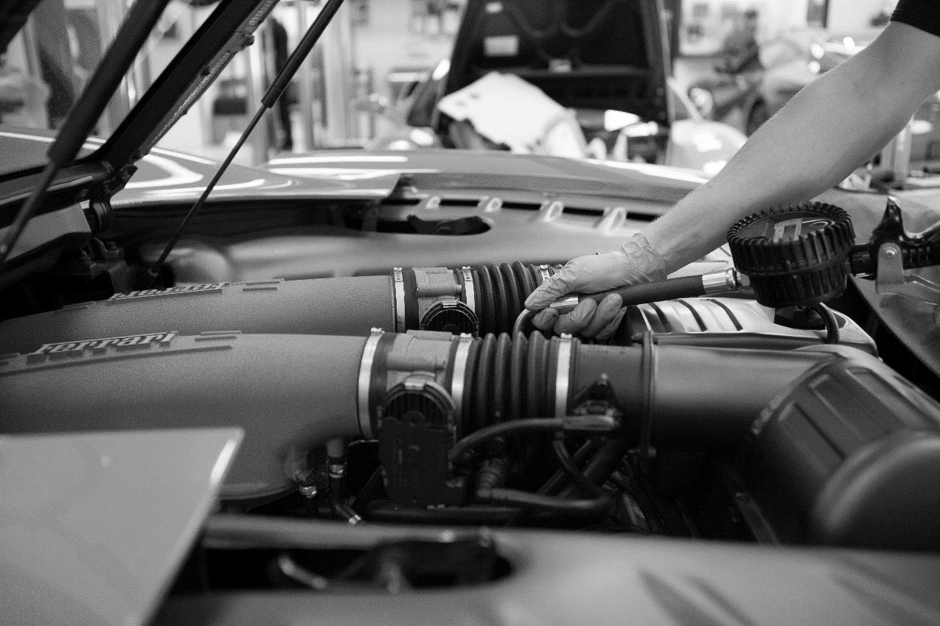

HANDOUT 016: Production Methods

Task 3: Terms

|  |  |
| --- | --- |
| Term |  |
| CAD | Computer Aided Design   * Automotive manufacturers worldwide depend on CAD as part of its design, engineering and manufacturing processes. |
| CAM | **Computer-aided manufacturing**   * The use of a computer to assist in all operations of a manufacturing plant, including planning, management, transportation and storage. * Main aim = to create a faster process and components and tooling with more precise dimensions and material consistency. * CAM is a subsequent computer-aided process after (CAD). |
| CIM | * A computer-automated system in which individual engineering, production, marketing, and support functions of a manufacturing enterprise are organized. * Functional areas such as design, analysis, planning, purchasing, cost accounting, inventory control, and distribution are linked through the computer with factory floor functions such as materials handling and management, providing direct control and monitoring of all process operations. |
| Lean production | A systematic method for the elimination of waste within a manufacturing system. |
| JIT | Just-in-time manufacturing   * A methodology aimed primarily at reducing flow times within production as well as response times from suppliers and to customers. |
| Lean production and JIT benefits: | JIT and Lean production will help companies to make cost savings especially because of the reduction in levels of storage space required. |
| TQM | Total quality management   * An organization’s-efforts to continuously improve its ability to deliver high-quality products and services to customers. |
| Quality Assurance | * 1. Maintaining a desired quality level for a service or product, by monitoring every stage of the process of delivery or production. |
| TQM and quality assurance benefits: | Both empower employees by involving them in the process and encouraging them to take more responsibility and care during production. This will lead to quality products and many new ideas. |
| Quality circle | * 1. A group of employees who meet regularly to consider ways of resolving problems and improving production in their organisation. |
| Quality circle info: | Do not guarantee honesty from employees and can be dominated by stronger characters giving a biased opinion.  Can be costly and time-consuming.  Avoid this by starting quality circles early so they do not disrupt production.  Ask more employees which will produce a fair answer. |

HANDOUT 017: Production methods

Task 4: Production Methods

|  |  |  |
| --- | --- | --- |
| Job production | Batch production | Flow / Continuous production |
| Order completion time is long. | Groups of items are made together and when required. | Production of thousands of identical, standardised products on an assembly line. |
| Each item is finished before the next one is started. | Less demand for highly skilled workers. | Workers have specialised jobs, for instance, fitting wheels. |
| Highly specialised or customised goods which means a premium price can be charged. | Equipment can be standardised to a certain extent, which lowers costs. | The assembly line runs continuously 24 hours a day, seven days a week to maximise production |
| Luxury products are built by just one highly trained and skilled employee. | Each batch is finished before starting the next batch of products. | The assembly line eliminates the extra costs of starting and stopping the production process. |
| Items are made **individually.** | Labour intensive. | Few employees are required. |
| Expensive for customers as highly skilled employees do not come cheap! | A high volume of stock may be held, tying up valuable cash. | Automated machinery can operate without breaks 24/7. |
|  | Machines are easily changed to produce different product batches. | Mass-production in large factories using conveyor belts and expensive machinery such as robot arms. |
|  | Jigs and templates are used to help production. | Vast orders can be met and large quantities produced. |
|  | Job repetition can de-motivate employees. | Standardisation of machinery can keep costs low |
|  |  | The process is highly automated. |
|  |  | Employees are unskilled. |
|  |  | Employees are highly de-motivated. |
|  |  | Customisation is difficult to meet and would increase costs. |
|  |  | Reebok are a famous example for taking standardisation to extremes by setting up factories to make just the left shoe of a trainer, and another factory in another country making the right trainer. |
|  |  | A large initial capital outlay is required. |

LESSON 7 & 8: Business Studies

Quality Management / Production Efficiency

This plan contains content to be delivered over two lessons.

**Learning objectives:**

To understand the importance of quality in meeting customers’ needs and desires

To distinguish between quality control, quality assurance and Total Quality Management

To understand the factors involved in Lean production

To gain greater knowledge of current manufacturing systems

**Key words and phrases:**

Quality control Quality assurance Total Quality Management (TQM)

Lean production Just In Time (JIT) Quality circles



LESSON 9: Business Studies

Market Research and the Marketing Mix

**Learning objectives:**

* To understand why businesses carry out market research.
* To be able to distinguish between primary and secondary research.
* To be able to design and use primary research methods.

**Key words and phrases:**

Market research Primary (field) research Secondary (desk) research



HANDOUT 020: Market research

Primary and Secondary Research

|  |  |  |  |
| --- | --- | --- | --- |
| Primary research | | Secondary research | |
| Information that comes directly from the source--that is, potential customers. You can compile this information yourself or hire someone else to gather it for you via surveys, focus groups and other methods. | | Market research that's already compiled and organized for you. Examples of secondary information include reports and studies by government agencies, trade associations or other businesses within your industry. | |
| Advantages | Disadvantages | Advantages | Disadvantages |
| The organistaion doing the research….. | | The organistaion doing the research….. | |
| Keep total data control | Pay more for the research | Time and cost effective | Confusing data definitions |
| Can focus on specific data | Spend time sorting the data as not specifically targeted | Extensiveness of data | Inaccurate data |
| Find very recent /accurate data | Find inaccurate/old data | Based on primary research | Out of date data |
| Own the data – with no need to share it | Require more resources:  money, people and time | Possibly non-specific |
| Copyright issues |

HANDOUT 021: Market research

Task 2: Cut Out Research Stages

|  |
| --- |
| Identifying your problem |
| Sales of your product are falling – why? |
| No repeat business from customers – why? |
| Understand competitor activities in the market better |
| Setting up a new business. |
| Setting objectives |
| To understand what customers want, now and in the future. |
| Level of customer service. |
| Success rates of advertising / sales promotion campaigns. |
| Available budget for carrying out the research. |
| Gathering data |
| Choose type of research - possible mix of both types. |
| Design questionnaire. |
| Carry out research, online / face-to-face. |
| Analysing data |
| Work through all information gathered through various forms of research to summarise where the problems are, why and what can be done to resolve them. |

LESSON 10: Business Studies

Intro to the Marketing Mix: Product, Price, Promotion and Place

This plan contains content to be delivered over two lessons.

**Learning objectives:**

* To understand the 4 Ps of the marketing mix.
* To understand the term target audience and characteristics which define different target audiences.
* To understand unique selling points (USPs), product features and promotional activities which can attract different target audiences.
* To understand and be aware of laws, costs and legal constraints that can affect advertising and promotion.
* To explore PR activities such as celebrity endorsement, sponsorship and tabloid press.
* (To create relevant questions for a market research questionnaire covering the 4 Ps.)
* To understand and explain reasons for choosing specific promotional activities.

**Key words and phrases:**

The marketing mix Product Price Place Promotion

Target audience Unique Selling Point (USP) Advertising Sales promotion

Sponsorship Public relations (PR)



HANDOUT 023: Intro to the Marketing Mix: Product, Price, Promotion and Place

Task 2 - Terms and Conditions

|  |  |
| --- | --- |
| *Term* |  |
| Marketing mix | * 1. A mixture of marketing techniques used to promote the sale of a product. |
| Product | An item or substance that is manufactured or created for selling. |
| Price | The amount of money expected, required or given for a product/service. |
| Place | A particular position, point, or area in space; a location/town/country. |
| Promotion | The publicizing of a product, organization, or venture so as to increase sales or public awareness |
| Target audience | A particular group at which a product such as a film or advertisement is aimed. |
| Unique Selling Point  (USP) | A factor that differentiates a product from its competitors, such as the lowest cost, the highest quality or the first-ever product of its kind.  A USP could be thought of as “what you have that competitors don’t.” |
| Advertising | The most widely used form of promotion.  E.g. TV adverts, radio, newspaper/magazine adverts, cinema or outdoor billboards |
| Sales promotion | Encourages new and repeat business from existing customers.  E.g. Loyalty cards, discount vouchers, free gifts and competitions. |
| Sponsorship | Sponsoring a sports team. |
| Public relations (PR) | using celebrity figures to endorse their products and improve their image |

HANDOUT 024: Intro to the Marketing Mix: Product, Price, Promotion and Place

Task 3 - Smart Car Info

**USP**

**Target Audience**

**Product Features**

HANDOUT 025: Intro to the Marketing Mix: Product, Price, Promotion and Place

Task 6: Ps Questions

Write three questions for each of the 4 Ps below, which will help you identify the best:

* Product: products , product features and services
* Promotion: ways to promote the opening, products and services
* Price: deals, leases and finance
* Place: location of dealership town/city

|  |  |
| --- | --- |
| *Product*  *Example: Give customers a list of the new Smart car’s features and ask them to rate them in order of importance to them.*  1  2  3 | *Promotion*  *Example: Give customers a list of advertising medium and ask them to indicate what type of advertising /promotion would impress/reach them in this situation.*  1  2  3 |
| *Price*  *Example: Give customers a list of price brackets and ask them to indicate which price bracket they would consider when buying a Volvo.*  1  2  3 | *Place*  *Example: Give customers a range of distances – to see if this is a factor when considering a top of the range model.*  1  2  3 |

LESSON 12&13: Business Studies

More on the Marketing Mix

This plan requires the use of computers and contains content to be delivered over two lessons.

**Learning objectives:**

* To demonstrate further understanding of the marketing mix by considering factors involved when planning to start or buy an existing dealership.
* To research and compare car selling prices on manufacturer and dealership websites.
* To demonstrate understanding and awareness of different pricing strategies.
* To demonstrate an understanding of VAT and duty.
* To use an understanding of pricing strategies and decide on a sale price for a car.
* To understand how geodemographic information (GDI), supply, demand, costs, competitors’ prices, market conditions and consumer perceptions affect an organisation’s different departments in preparation for a new product launch.

**Key words and phrases:**

VAT Duty Cost-plus pricing Penetration pricing

Price skimming Predatory pricing Competitor pricing Price discrimination

Psychological pricing



HANDOUT 027: More on the Marketing Mix

Task 1 Questions

Imagine that you are planning to start or buy an existing car dealership.

Use these questions as a guide and start making notes:

|  |  |
| --- | --- |
| 1. | Are you going to buy an existing business/start a new business/open a franchise? |
| 2. | Is the motor industry growing or declining? How will this affect your business? |
| 3. | What you need to start your business? eg premises/vehicles Why? |
| 4. | How do you propose to finance your business? |
| 5. | Key facts about your dealership: eg name/location Why? |
| 6. | What is your unique selling point? eg product features/after-sales Why? |
| 7. | What type of vehicle/s are you going to sell? Why? |
| 8. | What method of advertising/sales promotion will you use? Why? |
| 9. | Will you create a website? Why/Why not? |
| 10. | What are the advantages of the dealership’s location? |
| 11. | What are the disadvantages of the dealership’s location? |
| 12. | Focus on: proximity to the target market and a skilled workforce, price of land, ease of access and space to park. |

HANDOUT 027: More on the Marketing Mix

Task 2 Terms and Explanations

|  |  |
| --- | --- |
| *Term* |  |
| Supply | The total amount of a specific good or service that is available to consumers. |
| Demand | A customer’s willingness to go out and buy a certain product. |
| VAT (Value Added Tax) | A consumption tax applied at each stage of production - based on the value added to the product at that stage. |
| Duty | A payment applied to the import, export, manufacture, or sale of goods. |
| Geodemographic information (GDI) | This determines the type of product that will sell in an area and the price it can be sold at. |

*Business strategies used to set prices:*

|  |  |
| --- | --- |
| Cost-plus pricing | Setting a price by adding a fixed amount or percentage to the cost of making the product. |
| Penetration pricing | Setting a very low price to gain as many sales as possible. |
| Price skimming | Setting a high price before other competitors come into the market. |
| Predatory pricing | Setting a very low price to knock out the competition. |
| Competitor pricing | Setting a price based on competitors’ prices. |
| Price discrimination | Setting different prices for the same goods, but to different markets e.g. peak and off-peak mobile phone calls. |
| Psychological pricing | Setting a price just below a large number to make it seem smaller e.g. £9.99 not £10.00. |

LESSON 14: Business Studies

Business activity sectors - A

**Learning objectives:**

* To be able to classify business activity into primary, secondary or tertiary sector.
* To understand how the different sectors are interdependent.

**Key words and phrases:**

Primary production sector Secondary production sector Tertiary production sector Interdependence Just In Time production Lean production



HANDOUT 030: Business Activity Sectors - A

Task 1 – Primary, Secondary and Tertiary

**Car manufacturing activities**

|  |  |  |
| --- | --- | --- |
| Primary | Secondary | Tertiary |
|  |  |  |

HANDOUT 031: Business Activity Sectors - A

Terms and definitions

|  |  |
| --- | --- |
| *Term* |  |
| Primary production sector | Acquiring raw materials. Sometimes known as extractive production.  *E.g.* *Natural resources such as iron. Leather from cows.* |
| Secondary production sector | The manufacturing and assembly process. Converting raw materials into components assembling products.  *E.g.* *Combining natural resources such as iron with other elements to create steel for car production. Using leather from cows in the upholstery of car seats.* |
| Tertiary production sector | Commercial services supporting the production and distribution process.  *E.g.* *After-sales care, benefits such as peace of mind, transport distribution, advertising, selling, warehousing* |
| Interdependence | Organisations relying on other businesses in different sectors for raw materials, components or distribution. |
| Lean production | A systematic method for the elimination of waste within a manufacturing system. |
| Just-in-time production | Aimed primarily at reducing flow times within production, as well as response times from suppliers and to customers. |

HANDOUT 032: Business Activity Sectors - A

Task 2 & 3 – Blank form

|  |  |  |
| --- | --- | --- |
| Primary | Secondary | Tertiary |
|  |  |  |

LESSON 15: Business Studies

Business Activity Sectors - B

**Learning objectives:**

* To be able to define, explain and use the keywords and phrases listed below
* To understand the role of an environmental researcher within the Motor Industry
* To prepare a 5 minute group presentation which demonstrates understanding of the keywords and phrases below and how they affect job roles within the Motor Industry

**Key words and phrases:**

Social costs Social benefits Environment

Community Greenfield site Brownfield site

Ethical and merit goods



HANDOUT 034: Business Activity Sectors - B

Task 1: Terms and Definitions

|  |  |
| --- | --- |
| *Terms* |  |
| Social costs | Social cost is the total cost to society. It includes both private costs plus any external costs.  *E.g. air or water pollution.* |
| Social benefits | Business activities that have a positive impact on people and places.  *E.g. Creating new jobs* |
| Greenfield site | Sites which have not previously been built on. Includes the greenbelt land around cities. Cheaper to build on. Not favoured by environmentalists, as it encourages urban sprawl. |
| Brownfield site | Often on disused or derelict land.  More available in the North and Midlands, but most housing demand is in the South East.  Valuable as existing buildings can be split up into more homes on any one site.  The site has already been developed so it reduces urban sprawl.  Usually unsightly areas for building developments, so improve the urban environment.  More expensive to build on as often the land needs to be cleared first (especially if land is contaminated from previous industrial use). |
| Ethical goods | E.g. organic produce, fair trade, energy efficient light bulbs, electricity from renewable energy, recycled paper and wood . |
| Merit goods | Goods or services that the government feel people will under-consume.  These goods or services should be subsidised or provided free ‘at the point of use’ so that consumption does not depend primarily on the ability to pay for them. |

HANDOUT 035: Business Activity Sectors - B

Task 1: Dealership or a Plant

|  |  |  |  |
| --- | --- | --- | --- |
|  | Social costs |  | Social benefits |
| A large car manufacturing  plant |  |  |  |
| A large car  dealership |  |  |  |

LESSON 16: Business Studies

Business Objectives

**Learning objectives:**

* To be able to identify organisational objectives from car manufacturer’s websites
* To demonstrate an understanding of SMART objectives
* To be able to evaluate objectives using the SMART acronym
* To understand economic factors that affect organisations internally and externally
* To be able to create SMART objectives for a car dealership with clear reasons why

**Key words and phrases:**

Profit Growth Survival Service

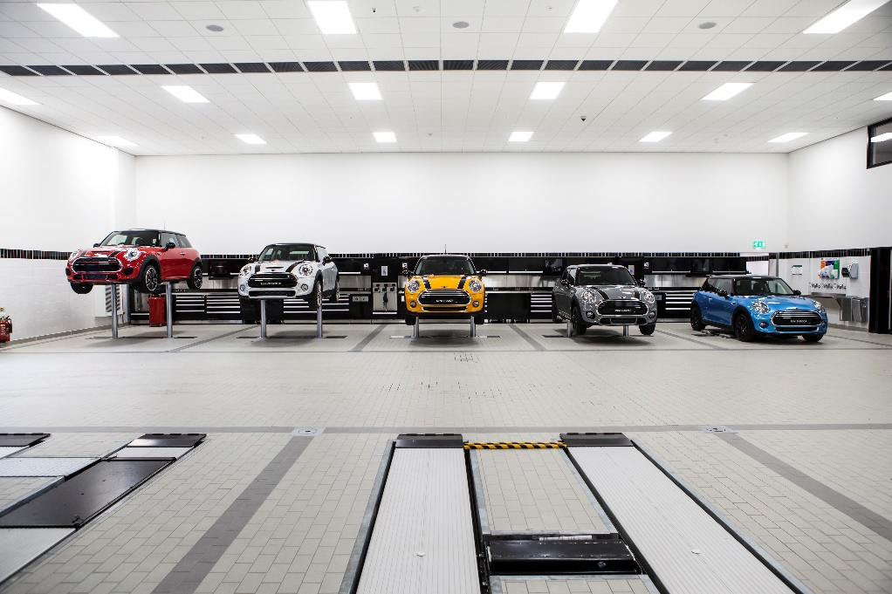

HANDOUT 037: Business Objectives

Task 2 – Your Dealership

|  |  |
| --- | --- |
| Imagine you and your colleagues are the owner of a small Bentley dealership in the local area.  The business has been up and running for the last 10 years and its profits have grown consistently until last year.  Discuss the 6 questions below and make detailed notes. | |
| Over the last three years:   1. What would your business aims have been? 2. What would your SMART business objectives have been?   Over the past year:   1. What are the possible reasons for a zero increase in profits? 2. How would the zero increase in profit affect the creation of new business objectives? 3. How AND why might your business aim now be different? 4. How AND why might your business objectives now be different? | |
| Inflation cost  Rising unemployment levels  Investors or shareholders  Maximising profit  Increase market share  Public relations  The local community |

LESSON 17: Business Studies

Business Organisation

**Learning objectives:**

* To be able to identify the different departments within a typical business
* To understand why the departments need to work with each other
* To be able to draw an organisation chart

**Key words and phrases:**

Administration Customer Services Distribution Finance

Human resources Chain of command Marketing Sales

Tall and flat structures Line management De-layering ICT

Span of control Accountability Authority Hierarchy

Organisation charts Functional organisation Formal groups Production

Research and Development (R&D)



**HANDOUT 039: Business Organisation**

Task 1 – Terms and Conditions

|  |  |
| --- | --- |
| Administration | The process or activity of running a business, organization, etc. |
| Customer services dept. | The provision of service to customers before, during and after a purchase. |
| Distribution dept. | Receives items ordered from organizations and directs them to the correct place/department. |
| Finance dept. | Manages the money: planning, organizing, auditing, accounting for and controlling finances. |
| Human resources dept. (HR) | Recruits, hires and trains new and existing employees. Deals with employee benefits and retention. |
| ICT dept. | Agrees and manages the most effective information technology and electronic communication. |
| Marketing dept. | Develops marketing goals/strategy, market research, monitors customer needs, promotion and advertisement. |
| Sales dept. | Sells the organisation’s products or services. |
| Production (manufacturing) dept. | [Manufactures](http://www.businessdictionary.com/definition/manufacturer.html) the [products](http://www.businessdictionary.com/definition/product.html) or [services](http://www.businessdictionary.com/definition/services.html). |
| Research & Development dept. | Discovers solutions to problems, creates new products and services, and seeks knowledge. |
| Organisation chart | Visual representation of an organisation’s structure – showing individual’s job titles and hierarchy. |
| Hierarchy | Refers to the levels of management in any **business**, from the highest to the lowest position and individual/s. |
| Span of control | The number of employees that a manager or supervisor can directly control. |
| Chain of command | The [order](http://www.businessdictionary.com/definition/order.html) in which [authority](http://www.businessdictionary.com/definition/authority.html) is held and is given, from the very top managers downwards. |
| Accountability | To be responsible or liable for, e.g. a task or situation. |
| De-layering | Reduces the size of a business hierarchy, (especially reducing management) creating a flatter structure. |
| Line management | Managers responsible for staff, the main activities or product/s in the organization. |
| Formal groups | Groups with common interests in an organization who easily identify with goals or independent activities. |
| Tall OR flat structures | Many levels of hierarchy OR few levels of hierarchy. |
| Functional organisation | Organizational structure: employees grouped hierarchically, clear lines of authority and report to one top person. |

Additional Information: Business Studies

Course Feedback – Student

The Institute of the Motor Industry is very interested to hear your thoughts and opinions on the Business

Studies course you have completed.

|  |  |
| --- | --- |
| School or college name |  |
| Your name |  |
| Email address |  |
| Year group |  |

Please tick one of these boxes:

|  |  |  |  |  |  |  |
| --- | --- | --- | --- | --- | --- | --- |
|  | Question | Strongly disagree | Disagree | Neither agree or disagree | Agree | Strongly agree |
| Course aims and objectives | Accurately described the content and propose |  |  |  |  |  |
| Resources | Useful online resources |  |  |  |  |  |
| Useful paper handouts |  |  |  |  |  |
| Useful presentation slides |  |  |  |  |  |
| Course topic | Interesting |  |  |  |  |  |
| Contained enough detail |  |  |  |  |  |
| Course activities | Useful and relevant |  |  |  |  |  |
| Fun and interesting |  |  |  |  |  |
| Enough time to complete each one |  |  |  |  |  |
| A good mix of group and individual activities |  |  |  |  |  |
| Homework | Relevant and achievable |  |  |  |  |  |
| Course speed | Appropriate |  |  |  |  |  |
| Difficulty level | Appropriate |  |  |  |  |  |
| My interest in business has increased | |  |  |  |  |  |
| My business studies knowledge has increased | |  |  |  |  |  |
| My increased business knowledge will help me in the future | |  |  |  |  |  |
| Overall the Business Studies course has met my expectations | |  |  |  |  |  |
| I would recommend the Business Studies course to other students | |  |  |  |  |  |

|  |
| --- |
| What was positive and or negative about the Business Studies course? |
| What suggestions do you have for improving the Business Studies course? |

Thank you for your feedback! [careers@theimi.org.uk](mailto:careers@theimi.org.uk)

# BUSINESS STUDIES & ENTERPRISE COMPETITION

## [Embedded image permalink](https://twitter.com/BoschAutoGrant/status/634332899215560705/photo/1)Sponsored by Sytner

About the Industry

The automotive industry influences everyone, from delivering goods on time to commuters travelling to work and emerging services being able to respond to crisis, the motor industry helps keep the country moving.

About the competition

The IMI’s teaching resources are now in their fifth year and are an initiative developed by the Institute of the Motor Industry (IMI)) that includes a series of creative curriculum-linked teacher and student resources, with the motor industry as the exciting backdrop. In addition we have developed this competition in conjunction with Sytner.

A key part of business success for manufacturers and dealers is to encourage people to buy their cars and as a result they spend much of their time and money ensuring their vehicles meet the ever growing needs of their customers, adding features to them that will attract and appeal to particular customers. In addition they develop promotional campaigns that help persuade, inform and increase awareness of their brand, whilst also building customer loyalty through positive buying experiences. It is these activities that help build the success of a business.

With this in mind we have developed this competition, where students put themselves in the position of launching a new vehicle of their own design, focusing on branding, product, target markets and promotion.

In all entries we are looking for creativity.

About the IMI

The Institute of The Motor Industry is the professional body for individuals working in the motor industry and the authoritative voice of the retail automotive sector. The IMI’s aim is to ensure that the automotive retail sector has a skilled, competent and professional workforce that is fully equipped to keep pace with the demands of new technology and changing markets. A key part of business for manufacturers and dealers is to encourage the best and brightest people to join their business in a variety of roles.

Sytner Group Trainee and Apprentice Programmes

Sytner Group represents 20 of the world's most desirable car manufacturers in over 100 dealerships across the UK. Last year we sold over 135,000 cars and we serviced a further 230,000 Cars.

[Alpina Careers](https://careers.sytner.co.uk/alpina/)[Audi Careers](https://careers.sytner.co.uk/audi/)[Bentley Careers](https://careers.sytner.co.uk/bentley/)[BMW Careers](https://careers.sytner.co.uk/bmw/)[Ferrari Careers](https://careers.sytner.co.uk/ferrari/)[Jaguar Careers](https://careers.sytner.co.uk/jaguar/)[Land Rover Careers](https://careers.sytner.co.uk/land-rover/)[Lamborghini Careers](https://careers.sytner.co.uk/lamborghini/)[Lexus Careers](https://careers.sytner.co.uk/lexus/)[Maserati Careers](https://careers.sytner.co.uk/maserati/)[McLaren Careers](https://careers.sytner.co.uk/mclaren/)[Mercedes-Benz Careers](https://careers.sytner.co.uk/mercedes-benz/)[MINI Careers](https://careers.sytner.co.uk/mini/)[Porsche Careers](https://careers.sytner.co.uk/porsche/)[Rolls Royce Careers](https://careers.sytner.co.uk/rolls-royce/)[SEAT Careers](https://careers.sytner.co.uk/seat/)[smart Careers](https://careers.sytner.co.uk/smart/)[Volkswagen Careers](https://careers.sytner.co.uk/volkswagen/)[Volvo Careers](https://careers.sytner.co.uk/volvo/) [TPS Careers](https://careers.sytner.co.uk/tps/)

Founded by British Touring Car Champion Frank Sytner and his brother Alan in 1968, Sytner Group celebrates a one team spirit and strives to follow Frank's uncompromising driving style by offering an uncompromised customer experience. In 2002 Sytner joined the Penske Motor Group who shared the Sytner passion for motorsport. CEO, Roger Penske, being the founder of Penske Racing, the most famous race team on a world wide basis, featuring in the NASCAR and Indy Racing series as well as Formula 1 in the 1970’s.

Sytner recognise that unparalleled customer service can only be achieved by attracting, motivating and retaining the very best team members. With this in mind, Sytner put their employees at the heart of everything we do and are proud to have achieved second place in the ‘Sunday Times Best Big Companies to Work For’ for the 2nd year in a row on and have been in the top 5 for the last 7 years.

Sytner Group are committed to developing talent and building careers, we work in partnership with the biggest car manufacturers in the world, leading training providers and industry specialists to offer comprehensive ‘on the job’ apprentice and trainee programmes. This offers the future Sytner stars a progressive and consistently successful investment in their career and personal development.

We welcome Apprentices and Trainees in to a wide range of business areas to kick start your career, these areas include:

* Technicians
* [Sytner Careers](https://careers.sytner.co.uk/)Sales Executives
* Service Advisors
* Parts Advisors
* Administration

Due to success and demand for the Sytner Group Apprentice and Trainee Programmes we look to support the most proactive students who are prepared to go that extra and most innovative mile to secure themselves a fantastic career opportunity.

To find out more about our Apprenticeship and Trainee Programme - <https://careers.sytner.co.uk/>

The Competition

You have been asked to design, brand and plan a lunch for your very own vehicle! Develop an outline of a logo, brand name and strapline for the business you are representing. We need to see clearly what your brand stands for, how you show this is entirely up to you. This competition aims for you to spend most of your time developing the launch of your vehicle and creating the entry to show how this will work. You could use video, social media, web design, PowerPoint, augmented reality or even virtual reality! In all areas of the entries we are looking for creativity.

The Brief

|  |
| --- |
| 1. Decide who the target market you want to develop your new car is for 2. Consider the type of vehicle (sports car, family saloon, 4x4 etc), the name and key product features that will be attractive to your chosen target audience 3. Design your vehicle 4. Plan a proposal for the launch for your new vehicle - you need to use modern technology and creative ideas to promote your vehicle to your target audience through this launch and attract media attention. Your launch could be done or shown through a website, an App or a social media campaign that you have created, a video you have filmed or any other electronic medium that you would like to use. |

Hints and Tips

Think about how Sytner brands launch their new vehicles and how it is reported in newspapers and magazines such as:

* AutoExpress <http://www.autoexpress.co.uk/>
* AutoCar <http://www.autocar.co.uk/>
* Sytner news <http://www.sytner.co.uk/news/>

Now think how you will get magazines to write about the launch of your car, what image do you want it to have? Brands think about the colours, music, video and location of the launch very carefully and you will need to as well. Will you have an official film or video and where will your launch be held?

Remember that the brand (logo, brand name and strapline) need to be visible at the launch - some brands use a # to promote it on social media.

Search the Sytner site to see how their range of brands launched their new vehicles <http://www.sytner.co.uk/>

The Prize

The winning team plus their teacher will be treated to a dream day out at Mercedes-Benz world located near Heathrow. Starting the day off with a fabulous breakfast in the AMG conference suite overlooking the track you will have a talk from the IMI and Sytner on careers in the industry before your VIP guided tour of the museum with special access to all of the attractions and exhibits. Not only that but you will also have your very own driving experience on the on or off road track depending on your age. There may also be some souvenirs heading your way as well!

Competition Guidelines

* Teams must represent their school or college
* Maximum of 6 students per team
* All entries are to be submitted electronically
* Areas to be covered – brand, product, target audience and promotional activities
* Entries must be submitted by the end of summer term to [careers@theimi.org.uk](mailto:careers@theimi.org.uk)

Contact us

If you have any questions, queries or feedback please contact the Careers Team on [careers@theimi.org.uk](mailto:careers@theimi.org.uk)

**GOOD LUCK!**

 