IMI Lesson Plans
Literacy
Students Pack

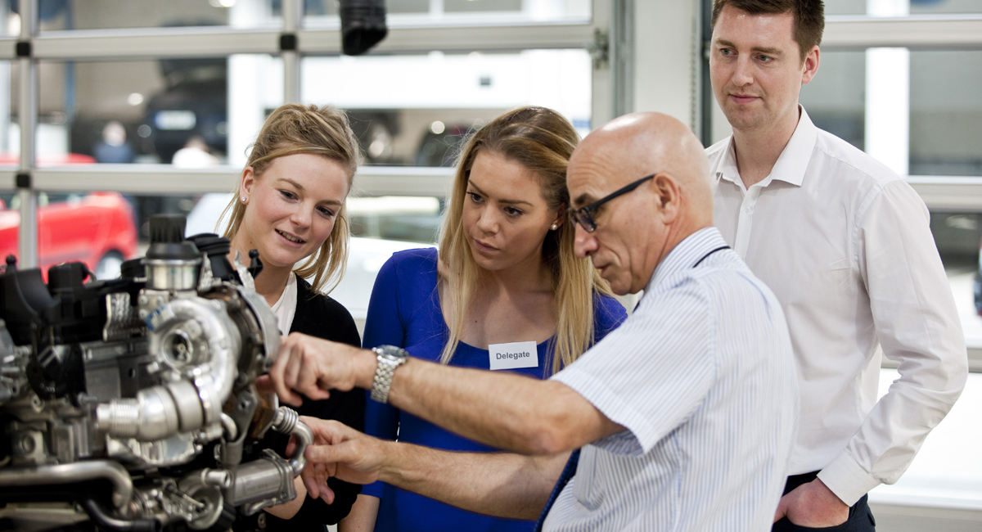

Contents
About The IMI and the automotive sector | Lesson Plan 6  Reports
Course summary | Lesson Plan 7  Reading - skimming and scanning
Lesson title and reference numbers | Lesson Plan 8  Debates
Lesson activities and key | Lesson Plan 9  CV’s part A
Lesson plan 1  Car reviews | Lesson Plan 10  CV’s part B
Lesson plan 2  Top Gear interviews – part A | Lesson Plan 11  Covering letters
Lesson plan 3  Top Gear interviews – part B | Lesson Plan 12  Interview skills
Lesson Plan 4  Magazine Articles | Additional information  Course feedback – student
Lesson Plan 5
Acrostic poems

The IMI and the Automotive Sector
Introduction
The automotive industry influences everyone, from delivering goods on time to commuters travelling to work and emerging services being able to respond to crisis, the motor industry helps keep the country moving.
About The IMI
The Institute of The Motor Industry is the professional body for individuals working in the motor industry and the authoritative voice of the retail automotive sector. The IMI’s aim is to ensure that the automotive retail sector has a skilled, competent and professional workforce that is fully equipped to keep pace with the demands of new technology and changing markets. A key part of business for manufacturers and dealers is to encourage the best and brightest people to join their business in a variety of roles.
IMI Autocity
Autocity is the one-stop-shop for impartial careers information and advice on careers in the Retail Motor Industry. Whether you are an individual looking to start or progress your career, or a teacher or careers advisor who supports others in making their career choices, Autocity is the place to start. With over 150 #MotorCareers to choose from Autocity provides you with all things Automotive! For information the job roles available in this exciting, highly skilled and fast paced industry please visit IMI Autocity.
www.theimi.org.uk/autocity
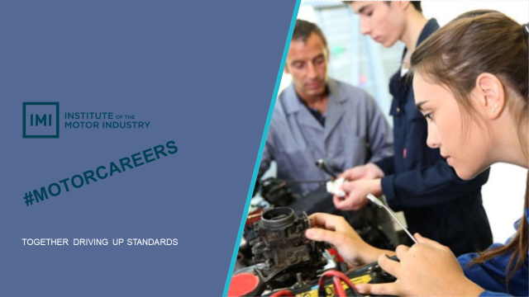

LESSON PLAN 1: Literacy
Car Reviews

Overall lesson objective:
To successfully write a car review, which includes appropriate language, register, your own opinions, facts, car specifications and other relevant details.

Aims:
- To demonstrate an understanding of Standard English and key differences between informal and formal registers.
- To understand and identify facts, opinions, relevant and irrelevant information.
- To write a car review which includes facts, opinions and relevant information.
- To evaluate the effectiveness and impact of a car review and identify improvement.

Language focus:
Reading Grammar and Vocabulary Writing Spoken English

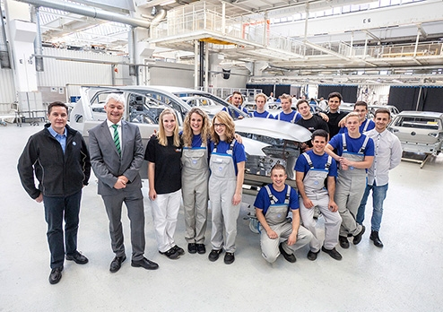
Student handout: Lesson 1 Literacy
005 Bentleys Golden era (The Sun)
Convertible ... Ken Gibson drives the new Bentley in San Francisco
By Nick Dimbleby
San Francisco sunshine, the world’s fastest four-seat convertible and a 1,000 mile drive... perfect.

Especially when you’ve just left England in the grip of an icy arctic freeze.

And my trip in the Bentley Continental GT Speed turned into a dream drive from San Francisco to Las Vegas in two glorious days of high-speed driving — roof down the whole way.

America is actually the ideal location for a Bentley — and not just because of the weather.

It’s the biggest sales market for the luxury brand and the GT convertible.

Mind you, Bentley are currently enjoying sales success across the world, as the British firm have once again established themselves as one of the favourite brands for the rich and famous.
And when you see the GT Speed convertible glistening in the early-morning sunshine, it’s easy to see why.
There may be more exotic convertibles than the Bentley but none can match its aristocratic grandeur.
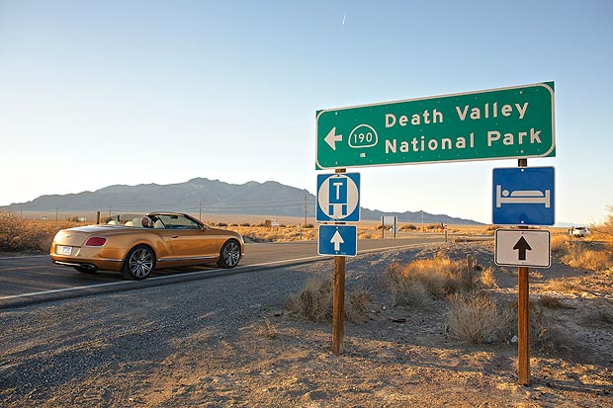
It’s the perfect mix of high-speed performance and unashamed luxury — a mobile testament to British craftsmanship at its very best.
It has to be the classiest way to get a sun tan — albeit a seriously expensive one as it carries a price tag of £167,900.
The GT Speed also happens to be the fastest way to experience wind-in-the-hair motoring for four people, living up to its name with a top marker of 202mph.
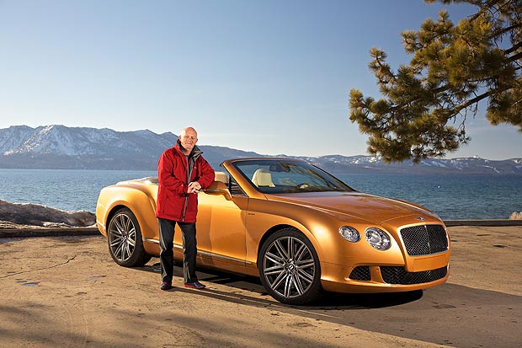
Floor the accelerator pedal and you are propelled forward in a wave of power. Forget about 0-60mph times — the GT Speed hits 100mph in just 9.7 seconds and continues relentlessly until you join the 200mph club.
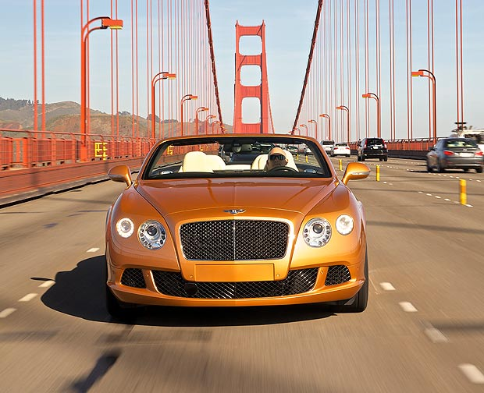
It should feel like a violent punch in the back but this is a Bentley and it does all the hard work in a ridiculously smooth and serene manner.
Clearly they are excessive speeds that will lose you your license and the reality is you won’t drive anywhere near the top speed in the UK.
But knowing the Bentley can do it is part of what makes it so special. What you will do constantly is flatten the accelerator pedal just so you can hear the velvety sound of the 6litre W12 cylinder engine.
In full cry, it is a motoring masterpiece — a deep rumble that erupts like a volcano.
There are other elements that take the driving experience to an added dimension of pure pleasure.
Things such as the brilliant eight-speed auto gearbox, which can switch to manual mode via F1-style paddles on the steering column or a beautifully crafted aluminium gearlever. The way the Bentley handles at speed is also truly remarkable, even more so when you think how big it is.
The grip at times seems to defy the laws of physics and it’s capable of doing it in any conditions — as I experienced in the snow-capped mountains of Nevada — because the GT Speed is equipped with all-wheel drive.
Lowered and self-levelling sports suspension that adapts instantly to the road also gives the GT a magic carpet ride at speeds which would see most cars careering off the road.
I could happily spend the rest of my driving days sitting in the glorious luxury of the Bentley, because this is British craftsmanship in wood and leather that no one can equal.
You can see, touch and feel the hours of painstaking expertise that have gone into crafting the Bentley cabin — the intricate hand-stitching of the leather work and wood that has been lovingly shaped like sculpted furniture.
And it’s the wonderful extras, such as the neck warmer fitted into the heated seats, which allow you to drive roof-down all year round. (The leather quilted seats can also massage you and be cooled in summer.)
Should you tire of the engine sound, there is a music and entertainment system that’s like having front-row seats at the Royal Albert Hall.
I also love the understated elegance of the GT Speed — the sculpted bodywork that ripples like the finely tuned muscles of an athlete.
The classic Bentley grille is finished in a subtle dark tint, while the twin LED headlights sparkle like jewellery and the 21in alloys look like a modern chariot’s wheels.
It’s all nicely finished off by an XL-sized double exhaust and a rear diffuser that, like the rest of the GT Speed, hints at something extra special.
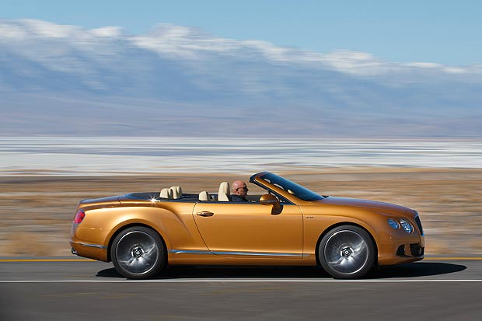
Which is exactly what it is — a showpiece of British craftsmanship and engineering excellence for lucky owners with the need for speed.

Student handout: Lesson 1 Literacy
006 Bentleys Continental GT Coupe (Parkers)
Reference: www.parkers.co.uk Other reviews: http://www.parkers.co.uk/cars/reviews/used/

By Simon Harris.

4.5 out of 5 overall
Opener
Any fears that new owner Volkswagen wasn't going to deliver a proper Bentley with its first model in charge were instantly dismissed with the arrival of the Continental GT. This opulent coupé offers real 200mph performance and room for four at a pinch for just over £100,000.

- Performance  - Handling | - Comfort  - Practicality | - Safety & Reliability  - Summary | - Equipment  - Running Costs
4.5 out of 5

Performance
Adding two turbos to an engine that already displaces six litres over 12 cylinders is a recipe for real fireworks. The GT punches out a huge 552bhp at 6100rpm to deliver a top speed of 198mph. But it's the pulling power available over such a broad range of revs that makes the GT feel effortlessly quick from any speed.

All the pulling power is on tap by 1600rpm meaning there's never any wait for the performance to arrive, unlike in some naturally aspirated rivals. Without a hint of slip the four-wheel drive traction rockets the Bentley to 60mph in just 4.6 seconds as the cabin fills with the deep murmur of the mighty engine up front, though the noise never becomes intrusive. The GT Speed is even faster, its 600bhp knocking three tenths off the 0-60mph sprint, delivering an even bigger kick in the back and making this the first Bentley to crack 200mph. The only available gearbox in both is a smooth six-speed automatic but paddles behind the wheel allow total control. The downside to all this performance and the sheer weight of the car deliver an abysmal 17 mpg though!
4 out of 5

Handling
This isn’t the kind of car you'd take to a track day. It weighs 2.3 tonnes and the four-wheel drive chassis isn't as playful as a supercar's. Even on a fast road, the Bentley isn't as exciting as it perhaps should be, preferring to be quietly capable. But back in the real world it does most things right.

The steering is well weighted and direct and in the speed version at least, offers useful feel about what's going on at the front wheels. Which for the most part is grip, grip, grip. Only outright clumsiness will unstick either end and even if that does happen there's the standard electronic stability system on hand to sort things out. Also standard are adjustable dampers that can be used to firm up the body control at the expense of some ride comfort by switching between various positions. But the standard or even the comfort settings are all that you need for most conditions.
4.5 out of 5

Equipment
You're not left wanting for goodies in a Bentley GT. Climate control, full leather trim, an automatic gearbox and satellite navigation are all part of the standard package. Cruise control is also standard but unlike the Mercedes and Jaguar systems, the Bentley's doesn't slow you automatically if the car in front reduces speed.

New owners can personalise the Bentley's trim by choosing various Mulliner options including different interior woods and leathers for the interior or even a sportier engine-turned metal dash trim.
4.5 out of 5

Comfort
Forget your low-slung supercars. If you want to enjoy 200mph performance without needing a twice weekly course of yoga to help you through it, the Bentley is the car you need. The beautifully trimmed front seats are incredibly comfortable for long trips and the cabin feels surprisingly spacious and suitably hushed even when you're using the performance.

The back seats are usable by adults providing the front occupants aren't overly tall. But it wouldn't be fair to call it a true four-seater as they're better suited to children and the tombstone front seats limit the view forward from the back, making it feel quite claustrophobic.
3.5 out of 5

Practicality
While a boot that's only just bigger than Volkswagen Golf's doesn’t sound huge in a car this large, it is big by the standard of the class and should carry all the luggage four people would want to take on the sort of long distance trip the Bentley was designed for. And many owners will treat the GT as a two-seater, leaving extra space behind the front seats. There's a storage cubby under the central armrest in the front, another cubby in the console between the rear seats and even storage space for sunglasses in an overhead console. Parking visibility isn't great although front and rear sensors are thankfully standard.

How does the boot space compare?
Mercedes-Benz CL AMG (07 on) | 490 litres | Aston Martin DB9 (04 on) | 172 litres
Bentley Continental GT Coupe (03-12) | 358 litres | Porsche 911 Coupé (04 on) | 105 litres

1.5 out of 5

Running costs
Compared to older Bentleys, the GT was comparatively affordable at launch and is even more so now used cars are available for the price of a more mainstream luxury coupé. The sheer number produced means residuals are strong but not rock solid. However any 200mph car is going to be expensive to run and the Bentley is no different, regardless of whether you bought it for £130,000 new or half that used. Group 20 insurance and a 17mpg thirst will put a dent in any pocket but at least the GT only requires servicing every 10,000 miles.
4 out of 5

Safety
The GT should be one of the safer cars in its class thanks to the standard front, side and curtain airbags, seatbelt pretensioners and the standard electronic stability control. We say should because in common with its rivals, the Bentley hasn't undergone Euro NCAP crash tests. But the grippy four-wheel drive chassis and standard stability control system should help prevent you causing a crash yourself while the expensive optional carbon ceramic brakes provide a noticeable improvement in stopping power and resistance to fade.

4 out of 5

Reliability
Being part of the same group as Audi and Volkswagen bodes well for the reliability of the Bentley GT and all current Bentley cars, just as it did for Lamborghini whose quality control received a massive shot in the arm when it became part of the family.
4.5 out of 5
Summary
So any fears that new owner Volkswagen wasn't going to deliver a proper Bentley with its first model in charge were instantly dismissed with the arrival of the Continental GT. This opulent coupé offers real 200mph performance and room for four at a pinch for just over £100,000. Not cheap, but less than half what Bentley had been asking for the old V8 Continental. The four-wheel drive chassis and W12 engine are actually shared with the Phaeton, Volkswagen’s attempt at a BMW 7-series rivalling saloon, but the two cars are certainly not clones and the Bentley is far more opulent, faster and more satisfying to drive. A four-door saloon version, the Flying Spur, appeared in 2005 and the GTC convertible a year later. Then in 2007 Bentley added the GT Speed, a more powerful version of the coupé, to combat the onslaught of more recent rivals, but the ordinary coupé continues also.
Overall:
Expensive to buy and run, but superb build quality, sophisticated image, refined driving experience and wonderful engine.

Student handout: Lesson 1 Literacy
007 Informal and formal registers
Informal register |  | Formal register
Spoken | Written | Spoken | Written
Regional breakfast radio  Top Gear TV presenter  Chat with a friend | Most blogs and reviews  Diaries and journals  Friendly letters and emails  Mobile texts  Short notes | Official speeches  National TV newsreader  Car insurance and tax documents  Some essays and reports | Email to HR Department  Announcements  Business and complaint letters
Language features
Slang and clichés  Abbreviations  Acronyms  Short sentences  Facts  Quotations  Jokes  Personal opinions  First, second and third person  e.g. I, you and he/she/it  Incomplete sentences |  | Longer, more complex and complete sentences.  Sentences beginning with:  ‘nevertheless’, ‘additionally’, ‘however’, ‘although’  Facts  Quotations
Extra punctuation e.g. (Hi Bob!!!!!)  Paragraphs or no paragraphs  Symbols |  | Avoid:  Slang, idioms, exaggeration (hyperbole) and clichés  Abbreviations and acronyms  – (unless you write it out in full the first time.)  Sentences starting with ‘like’, ‘and’, ‘so’, ‘but’, ‘also’  Contractions - unless quoting someone’s exact words

Definitions
Standard English | Generally the national, most formal version of the English language in the English speaking country you live in.  E.g.Standard English in England and Scottish Standard English in Scotland. There is a range of language registers.  - https://en.wikipedia.org/wiki/Standard_English
Language Registers | Used for a particular purpose OR a particular social setting.  E.g. Social occasion, purpose, and audience https://en.wikipedia.org/wiki/Register_(sociolinguistics)
Formal register | Appropriate for professional writing AND letters to a boss or a stranger.
Informal register | Conversational and appropriate when writing to friends and people you know very well.

Student handout: Lesson 1 Literacy
008 Informal and formal registers
Writing Frame

Main heading
(Opening statement) …

E.g. Sub-heading

E.g. Driving the Bentley is like …

E.g. It goes from 0 to 60 in 3.7 seconds, which is ….

E.g. Sub-heading

E.g. (Describe the Bentley’s comfort features) …

E.g. (Describe more of the Bentley’s specifications) …

(Closing statement) …

By ………………
Writing TIPS

Write a minimum of 4 and a maximum of 6 paragraphs:
Paragraphs: | Content
First | Opening statement introducing the review and including your own opinion.
Second, third, fourth and fifth | Include facts, your own opinions & relevant details from the Bentley reviews in each paragraph.
Final | Closing statement summarising the review and including your own opinion.

Think about and include:
Language features | Structural features
Informal language  Facts  Easy to understand  Details  Opinions  Relevant information  Accurate spelling, grammar and punctuation | A main heading  Sub-headings if required  Photographs  Diagrams  Short paragraphs

PLUS USE THE 2 Bentley car reviews

Student handout: Lesson 1 Literacy
008 Peer assessment writing

Group name ____________________________ Date: / /

Use the criteria below to assess the review:

Clear target audience  Clear purpose  Interesting  Opening statement - introducing the review and including the writer’s own opinion.  Closing statement - summarising the review and including the writer’s own opinion. | Language features | Structural features
 | Informal language  Facts  Easy to understand  Details  Opinions  Relevant information  Accurate spelling, grammar and punctuation | A main heading  Sub-headings if required  Photographs  Diagrams  Short paragraphs

What is good?

What is great?

- Do you have any constructive suggestions for the group?

LESSON PLAN 2: Literacy
Top Gear Interviews – part A

Overall objective:
To plan and practise a 3 minute Top Gear style interview.

Aims:
- To identify and understand why specific language features are used during the interview.
- To plan and write an interview script using appropriate content and language features.
- To create an interview storyboard, including camera angles and stage directions.
- To practise a Top Gear style interview.

Language focus:
Grammar and Vocabulary Writing Spoken English

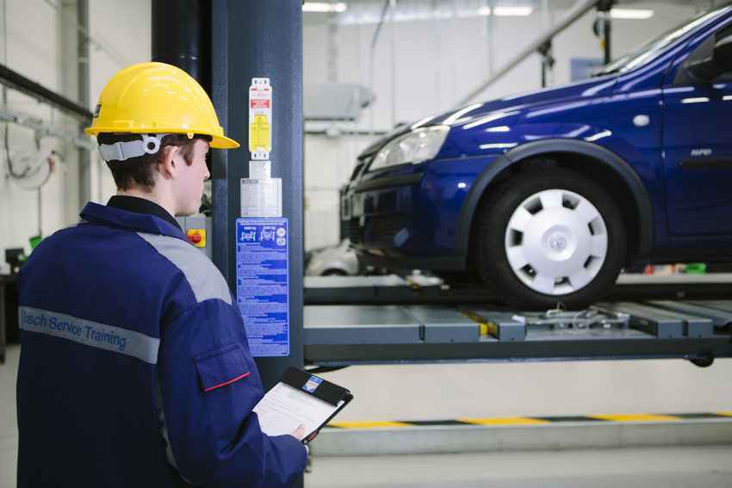
Student handout: Lesson 2 Literacy
014 You Tube clip analysis
 | Interviewer | Guest
Name:
Interview purpose: Argue, inform or entertain?
Body language:
Eye contact?
Posture?
Gestures?
Manner? relaxed/ uncomfortable
Voice and clarity
Pronunciation?
Intonation?
Volume?
Pace?
Language features: Vocabulary?
Grammar?
Sentence structure?
Question style? Yes/No or open
Formal/Informal register?
Content & Research:
Main ideas?
Well-argued (makes sense)?
Well-organised?
Audience appeal:
Interesting
Exclusive info. revealed
Persuasive
Confident
Stage directions:
E.g.
(Jeremy leans forward)
(Guest remains seated)
Camera angles:
E.g. Close up, wide/high/low angle, long shot, bird’s eye, extreme close up, eye level…
Student handout: Lesson 2 Literacy
015 Interview checklist
“Now it’s time to put a star in our reasonably priced car”

Interview Checklist

When completed
Interview roles
- Read the role descriptions.

Role | Description
Interviewer | Introduce the interview, the celebrity guest and ask the questions.
Celebrity guest | Prepare answers to the interviewer’s questions.
Researcher | Prepare interview questions, research the celebrity and find out the answers the celebrity will give.
Scriptwriter | Write the interview script, including stage directions.
Set designer | Design a set appropriate to Top Gear’s target audience.
Story-boarder | Create a story-board of the interview using story-board template.  Include camera angles, sound, lighting, etc.

- Choose a role for each group member.

Name of group member:
Interviewer
Celebrity guest
Researcher
Scriptwriter
Set designer
Story-boarder

(If there are less than 6 members in the group, choose an interviewer, a celebrity guest and work together to complete all the tasks within all the roles).

- Choose a celebrity guest to interview.

E.g. David Cameron, Barack Obama, Simon Cowell, Tinie Tempah, Professor Green, Keith Lemon,
Boris Johnson or your own idea.

Script and story-board

- Choose a style for your interviewer.

E.g. relaxed, informal, friendly, formal, probing or confrontational.

- Develop a range of ‘open’ questions beginning with who, what, why, where, when and how.
E.g. When did you start driving? What was the first car you ever bought?

- Create ‘closed’ questions which generate a yes or no answer.
E.g. Have you ever raced a car before? Did you expect to go that fast?

- Use the interview tips AND YouTube transcript hand outs.

- The script has a title.

- Interviewer/guest names are to be shown on the left when they are speak.
- Each scene is introduced and described.

- All names have a colon directly after them. E.g. Jeremy:

- There is a new line for every new speaker.

- Stage directions are in brackets ( )

- There are stage directions for how the interviewer/guest might speak.
- There are stage directions for how the interviewer/guest might move.
- Use the story-board template to plan everything.

- Every time the setting changes, a new scene starts.

- CAPITALS or italics are used to emphasise words.

- “There are NO speech marks.”

- REHEARSE the entire interview.

OPTIONS

- FILM the interview if there is time.

OR

- PRESENT the interview to the class next lesson.

Student handout: Lesson 2 Literacy
016 Interview preparation tips
DO
- Watch some examples of celebrity guest ‘Fastest Lap’ interviews on Top Gear:
Hugh Bonneville http://www.topgear.com/videos/top-gear-tv/hugh-bonneville-star-reasonably-priced-car-series-21-episode-1
Usain Bolt– part 2 of 2 http://www.topgear.com/videos/top-gear-tv/usain-bolt-star-reasonably-priced-car-part-22-series-13-episode-4
Rowan Atkinson http://www.topgear.com/videos/jeremy-clarkson/rowan-atkinson-star-reasonably-priced-car-series-17-episode-4
- Find out:
Who are you interviewing? What do you want to know about them?
Will it be a live or recorded interview? How will you film it?
What camera angles will be used? How long will the interview be?
How will the material be used (e.g. a short clip/longer feature)?
- Remember that Top Gear is pre-recorded and despite the hours of filming, only 8-10 mins of the footage may actually be broadcast.
- Create an outline of the main questions or topics the interview will cover.
- Write down your key messages - the most important things you want to communicate.
- Prepare your obvious questions, for example:
- Create some difficult and unusual questions. Here some topic ideas:
Future ambitions | New projects | Career choices | Defining moments | Personality traits
Route to fame/success | Fan stories | Directing | Producing | Auditions
Writing | Acting | Characters played | Celebrity friends | Advice to offer
Challenges | Surprises | Inspirations | Strengths, weaknesses | Funniest moments

- Create clear stage directions, for example:
Scene 1
(Jeremy stands up, steps forward and shakes Sting’s hand)
Jeremy: It’s great to you see you again. Please, take a seat.
(Jeremy gestures to the sofa behind Sting)
- Fix your gaze a couple of inches above the interviewer’s head.
- Practise out loud in front of a mirror to build your confidence.
What was your car history like? What is your favourite car?
Where is the best place your have ever driven? Who is your favourite racing driver?
How do you think you did on the Test Track?
DON’T
- Look directly at the camera, if you are nervous.
- Fidget or rock from side to side, as it can make you look nervous.

Student handout: Lesson 2 Literacy
017 Interview storyboard template

Student handout: Lesson 2 Literacy
018 YouTube clip transcript
TRANSCRIPT - including stage directions and camera angles
KEY: Stage directions ( ) CAPITALS = emphasis Examples of body language - camera angles

BEGINNING= 0:00
Scene description: Right of shot = Jeremy Clarkson seated. Left of shot, Hugh Bonneville seated.
Centre of shot = LCD monitor. Far right = fastest lap board. Background/edges = audience
Audience: (clap)
Jeremy: (Turn back from looking at audience and face Hugh)
- Head and shoulder shot of Jeremy facing Hugh
Anyway, the NEW FILM? Intonation rises expectantly on the last word and brushes face with left hand.
The Monuments Men. Tell me, what is that about?
- Head and shoulder shot of Hugh facing Jeremy
Hugh: It’s er, based on the true story of these rather sort of er…
Drops head slightly and adjusts glasses on his nose with his left hand.
unsung heroes of the Second World War , who, er… were art historians and museum curators, who were sent in after D-Day largely to try and locate the art and treasures that the Nazis were spiriting away – and also to try and
Tilts head to side and looks thoughtful.
persuade the allies not to try and blow up that particular church
Hugh throws right arm up in the air and gesticulates with both hands.

- Wide shot of both Hugh and Jeremy with audience behind
because there are Germans in it, because it does contain um, you know, part of our culture.
- Head and shoulder shot of Jeremy facing Hugh
Jeremy: Oh, REALLY? And that’s a true story?
- Head and shoulder shot of Hugh facing Jeremy
Hugh: It’s based on a true story. Looks down and nods head.
- Head and shoulder shot of Jeremy facing Hugh
Jeremy: Well, we’ve got a clip.
- Head and shoulder shot of Hugh facing Jeremy
Hugh: Ooh, I haven’t seen anything yet. Looks down slightly and scratches neck with right hand.

Jeremy: NO, NO, NO – well you can have a look at yourself on telly. Look, here we go.
- Wide angle shot of the seating area with Hugh and Jeremy sitting on chairs, a TV in the centre and the audience around them.
(Both look at the TV)
- PLAY FILM CLIP OF THE MONUMENT MEN Timing= 0.38 to 1.13
Audience: (clap)
- Wide angle shot of Hugh and Jeremy sitting on chairs with the TV in the centre of the screen and the audience around them. Hugh leans forward and looks at the TV
(Jeremy sit back in seat, face Hugh and clap)

- Close up shot of Hugh Hugh Looks down and touches face.
Jeremy: It looks like my sort of film. That is my sort of film.
(Clap and lean forward)
- Long shot of Hugh and Jeremy sitting on chairs with the TV in the centre of the screen, the fastest lap set and the audience all around them.
- Close up shot of Jeremy

Now. This is George Clooney – and he directed it as well, DIDN’T HE.
- Close up shot of Hugh

Hugh: George, er, directed it. He stars in it, he produced it, he co-wrote it…

- Close up shot of Jeremy

(Jeremy sit back in seat)
Jeremy: Look, well. Er, I have been wondering, looking at what you’re doing at the moment. Is, how on earth you are fitting it all in, because you are also working on – what is it called W1A.
- Close up shot of Hugh

Hugh: Yes, W1A is a spin-off of a show I did called 2012,

- Wide angle shot of Hugh and Jeremy sitting on chairs with the TV in the centre of the screen and the audience around them.

which is a sort of er, mockumentary about trying to organise the Olympics – and obviously my character made SUCH A SUCCESS of organising the Olympics, I am now the ‘go to’ man to sort out er corporate issues – so, what better place than to go into the BBC

- Close up shot of Jeremy

Jeremy: Cos I. When I heard that this was happening - and in fact I concealed er, the location signs around the BBC buildings where you were actually filming it. I was thinking how do you make FICTION about BBC management FUNNIER – than what actually happens?

Audience: (Laugh)
- Close up shot of Hugh
- Close up shot of Jeremy

Jeremy: Of course, Broadcasting House, the new BIG building on top of Regents Street, Portland Place. You are not allowed in there, even if you are BBC staff, unless you have been on a HALF HOUR HEALTH AND SAFETY COURSE

- Close up shot of Hugh
- Close up shot of Jeremy

Jeremy: …ON HOW TO OPERATE THE BUILDING
- Close up shot of Hugh

Hugh: Well, I started that course. A sort of 8 page document. A lady with an 8 page document arrived to talk me through it, and er page 1 was a picture of a fire alarm - in a red, red fire alarm box, she said this is a fire alarm…
Audience & Jeremy: (Laugh)
- Close up shot of Jeremy
- Close up shot of Hugh

Hugh: …and page 2 contained a graphic on a green side with a man running like this, with the word exit. That’s an emergency exit – and at that point I was taken off to do some filming and so I still haven’t gone through…
- Close up shot of Jeremy

Jeremy: You haven’t completed the course.
- Close up shot of Hugh

Hugh: …haven’t completed the course
- Close up shot of Jeremy

Jeremy: Oh I STILL HAVEN’T BEEN. I STILL HAVE to be escorted around Broadcasting House unless I …
- Close up shot of Hugh
- Close up shot of Jeremy

Jeremy: … am confused by a light fitting
Hugh: yeah
Jeremy: or something of that nature
- Shot facing Jeremy with Hugh side on.

Audience & Hugh: (Laugh)
Jeremy: It is STUPID and I am LONGING to see something that saturates it. AGAIN, how are you doing it? You must be the world’s busiest man. Presumably you drove VERY quickly around the lap, so you can get home more quickly.
Hugh: No, no. Erm, erm, I’m not a speed merchant. At the beginning, when the Stig took me round I was really terrified, er, being in the passenger seat and I thought I’ll never be able to do this – and by the end as your guys will tell you, you know, I refused to get out. I wanted to go again and again.
Jeremy: Who here, would like to see THE LAP?
(Look around at audience)
Audience: Yesssss
Jeremy: Play the tape, let’s have a look.
- PLAY CLIP OF HUGH DRIVING AROUND THE LAP Timing= 3:24 to 4.50
Jeremy: Wow, ahhh. I have just realised that’s the first ever wet lap we’ve had in that car. NOBODY ELSE has driven around in the rain.
Hugh: Hmmmm
Jeremy: So, bearing that in mind, WHERE DO YOU THINK you have come?
Hugh: Well, erm… I suspect it’s somewhere. I would think it’s somewhere between Ron Howard and Steven Tyler, bearing in mind it’s wet.
Jeremy: Right, so, somewhere between 1:50 and 1:51 is what you think you’ve done. Well, Hugh Bonneville, you did it IN…
(Lift up papers and look at notes. Take time to read and double check. Bring papers near to face, put papers down, adjust pen and clipboard. Look at Hugh with an expression designed to prolong the suspense)
Hugh: Laughs Looks pensive and rocks forward slightly
Jeremy: ONE
(Pause and look down at clipboard, start to write down the lap time)
Hugh: Oh! Screws up face in disappointment and then looks slightly impressed
FIFTY POINT ONE… which means…
Hugh: OH
Audience & Hugh: Laugh
(Pause and look down at clipboard. Start to write down the lap time on a piece of paper)
You are the first guest ever… to guess correctly… oh, wait, wait, wait, wait, wait,
Goes to the leader board and draws a symbol on Steven Tyler’s time - SPONTANEOUS
Audience: (Clap)
Jeremy: The first…
Hugh: You just put Steven Tyler Point to the leader board.

Jeremy: No – I will cross it out. Ooh – wrong, - very professional show. There. Look. Correct

Goes back to the leader board and crosses out the symbol he drew - SPONTANEOUS

Hugh: Laughs, picks up cup and drinks.
Audience: (Laugh)
Jeremy: To be brutally honest with you, the Stig did say that you have a natural talent and that if it’d been dry, you would have been very close to the top.
Holds head up and back slightly, with an impressed expression and emphasises his words as he looks at Hugh.
Hugh: Tilts head and looks impressed/surprised.
Hugh: Well, that’s, er, um, that’s an accolade then. I’ll take that, I’ll go away happy.
Looks down and smiles. Drinks again.

Jeremy: It is. Ladies and gentleman. THANK YOU SO MUCH. HUGH BONNEVILLE.
(Speak loudly - Sit with right shoulder and back to the audience, on the edge of seat, look at Hugh and holds out right arm and hand towards Hugh.)
Hugh: Thank you so much Looks to his right and holds up left hand, nodding his head in thanks to the audience.

Audience: (Clap)
END TIME= 6.10 Interview between Jeremy Clarkson and Hugh Bonneville, Top Gear Pub. 6 Nov 2014
http://www.topgear.com/videos/top-gear-tv/hugh-bonneville-star-reasonably-priced-car-series-21-episode-1

LESSON PLAN 3: Literacy
Top Gear Interviews – part B

Overall objective:
To perform a 3 minute Top Gear style interview with effective storyboarding and scriptwriting.

Aims:
- To practise performing a Top Gear style interview.
- To successfully perform a Top Gear style interview
- To evaluate each other’s performance of a Top Gear style interview.

Language focus:
Grammar and Vocabulary Writing Spoken English

Student handout: Lesson 3 Literacy
021 Interview check list
“Now it’s time to put a star in our reasonably priced car”

Interview Checklist
( when completed)
Interview roles
- Read the role descriptions.

Role | Description
Interviewer | Introduce the interview, the celebrity guest and ask the questions.
Celebrity guest | Prepare answers to the interviewer’s questions.
Researcher | Prepare interview questions, research the celebrity and find out the answers the celebrity will give.
Scriptwriter | Write the interview script, including stage directions.
Set designer | Design a set appropriate to Top Gear’s target audience.
Story-boarder | Create a story-board of the interview using story-board template.  Include camera angles, sound, lighting, etc.

- Choose a role for each group member.

Name of group member:
Interviewer
Celebrity guest
Researcher
Scriptwriter
Set designer
Story-boarder

(If there are less than 6 members in the group, choose an interviewer, a
celebrity guest and work together to complete all the tasks within all the roles).

- Choose a celebrity guest to interview.
E.g. David Cameron, Barack Obama, Simon Cowell, Tinie Tempah, Professor Green, Keith Lemon, Boris Johnson or your own idea.
Script and story-board:
- Choose a style for your interviewer.
E.g. relaxed, informal, friendly, formal, probing or confrontational.

- Develop a range of ‘open’ questions beginning with who, what, why, where, when and how.
E.g. When did you start driving? What was the first car you ever bought?

- Create ‘closed’ questions which generate a yes or no answer.
E.g. Have you ever raced a car before? Did you expect to go that fast?

- Use the interview tips AND YouTube transcript hand outs.

- The script has a title.

- Interviewer/guest names are to be shown on the left when they are speak.
- Each scene is introduced and described.

- All names have a colon directly after them. E.g. Jeremy:

- There is a new line for every new speaker.

- Stage directions are in brackets ( )

- There are stage directions for how the interviewer/guest might speak.
- There are stage directions for how the interviewer/guest might move.
- Use the story-board template to plan everything.

- Every time the setting changes, a new scene starts.

- CAPITALS or italics are used to emphasise words.

- “There are NO speech marks.”

- REHEARSE the entire interview.

OPTIONS

- FILM the interview if there is time.

OR

- PRESENT the interview to the class next lesson.

Student handout: Lesson 3 Literacy
022 Interview preparation tips
DO
- Watch some examples of celebrity guest ‘Fastest Lap’ interviews on Top Gear:
Hugh Bonneville http://www.topgear.com/videos/top-gear-tv/hugh-bonneville-star-reasonably-priced-car-series-21-episode-1
Usain Bolt– part 2 of 2 http://www.topgear.com/videos/top-gear-tv/usain-bolt-star-reasonably-priced-car-part-22-series-13-episode-4
Rowan Atkinson http://www.topgear.com/videos/jeremy-clarkson/rowan-atkinson-star-reasonably-priced-car-series-17-episode-4

- Find out: Who are you interviewing? What do you want to know about them?
Will it be a live or recorded interview? How will you film it? What camera angles will be used?
How long will the interview be? How will the material be used (e.g. a short clip/longer feature)?
- Remember that Top Gear is pre-recorded and despite the hours of filming, only 8-10 mins of the footage may actually be broadcast.
- Create an outline of the main questions or topics the interview will cover.
- Write down your key messages - the most important things you want to communicate.
- Prepare your obvious questions, for example:
- Create some difficult and unusual questions. Here some topic ideas:
Future ambitions | New projects | Career choices | Defining moments | Personality traits
Route to fame/success | Fan stories | Directing | Producing | Auditions
Writing | Acting | Characters played | Celebrity friends | Advice to offer
Challenges | Surprises | Inspirations | Strengths, weaknesses | Funniest moments

- Create clear stage directions, for example:
Scene 1
(Jeremy stands up, steps forward and shakes Sting’s hand)
Jeremy: It’s great to you see you again. Please, take a seat.
(Jeremy gestures to the sofa behind Sting)
- Fix your gaze a couple of inches above the interviewer’s head.
- Practise out loud in front of a mirror to build your confidence. What was your car history like? What is your favourite car? Where is the best place your have ever driven? Who is your favourite racing driver? How do you think you did on the Test Track?
DON’T
- Look directly at the camera, if you are nervous.
- Fidget or rock from side to side, as it can make you look nervous.

Student handout: Lesson 3 Literacy
023 Interview storyboard template

Student handout: Lesson 3 Literacy
024 YouTube transcript
TRANSCRIPT - including stage directions and camera angles
KEY: Stage directions ( ) CAPITALS = emphasis Examples of body language - camera angles

BEGINNING= 0:00
Scene description: Right of shot = Jeremy Clarkson seated. Left of shot, Hugh Bonneville seated.
Centre of shot = LCD monitor. Far right = fastest lap board. Background/edges = audience
Audience: (clap)
Jeremy: (Turn back from looking at audience and face Hugh)
- Head and shoulder shot of Jeremy facing Hugh
Anyway, the NEW FILM? Intonation rises expectantly on the last word and brushes face with left hand.
The Monuments Men. Tell me, what is that about?
- Head and shoulder shot of Hugh facing Jeremy
Hugh: It’s er, based on the true story of these rather sort of er…
Drops head slightly and adjusts glasses on his nose with his left hand.
unsung heroes of the Second World War , who, er… were art historians and museum curators, who were sent in after D-Day largely to try and locate the art and treasures that the Nazis were spiriting away – and also to try and
Tilts head to side and looks thoughtful.
persuade the allies not to try and blow up that particular church
Hugh throws right arm up in the air and gesticulates with both hands.

- Wide shot of both Hugh and Jeremy with audience behind
because there are Germans in it, because it does contain um, you know, part of our culture.
- Head and shoulder shot of Jeremy facing Hugh
Jeremy: Oh, REALLY? And that’s a true story?
- Head and shoulder shot of Hugh facing Jeremy
Hugh: It’s based on a true story. Looks down and nods head.
- Head and shoulder shot of Jeremy facing Hugh
Jeremy: Well, we’ve got a clip.
- Head and shoulder shot of Hugh facing Jeremy
Hugh: Ooh, I haven’t seen anything yet. Looks down slightly and scratches neck with right hand.

Jeremy: NO, NO, NO – well you can have a look at yourself on telly. Look, here we go.
- Wide angle shot of the seating area with Hugh and Jeremy sitting on chairs, a TV in the centre and the audience around them.
(Both look at the TV)
- PLAY FILM CLIP OF THE MONUMENT MEN Timing= 0.38 to 1.13
Audience: (clap)
- Wide angle shot of Hugh and Jeremy sitting on chairs with the TV in the centre of the screen and the audience around them. Hugh leans forward and looks at the TV
(Jeremy sit back in seat, face Hugh and clap)

- Close up shot of Hugh Hugh Looks down and touches face.
Jeremy: It looks like my sort of film. That is my sort of film.
(Clap and lean forward)
- Long shot of Hugh and Jeremy sitting on chairs with the TV in the centre of the screen, the fastest lap set and the audience all around them.
- Close up shot of Jeremy

Now. This is George Clooney – and he directed it as well, DIDN’T HE.
- Close up shot of Hugh

Hugh: George, er, directed it. He stars in it, he produced it, he co-wrote it…

- Close up shot of Jeremy

(Jeremy sit back in seat)
Jeremy: Look, well. Er, I have been wondering, looking at what you’re doing at the moment. Is, how on earth you are fitting it all in, because you are also working on – what is it called W1A.
- Close up shot of Hugh

Hugh: Yes, W1A is a spin-off of a show I did called 2012,

- Wide angle shot of Hugh and Jeremy sitting on chairs with the TV in the centre of the screen and the audience around them.

which is a sort of er, mockumentary about trying to organise the Olympics – and obviously my character made SUCH A SUCCESS of organising the Olympics, I am now the ‘go to’ man to sort out er corporate issues – so, what better place than to go into the BBC

- Close up shot of Jeremy

Jeremy: Cos I. When I heard that this was happening - and in fact I concealed er, the location signs around the BBC buildings where you were actually filming it. I was thinking how do you make FICTION about BBC management FUNNIER – than what actually happens?

Audience: (Laugh)
- Close up shot of Hugh
- Close up shot of Jeremy

Jeremy: Of course, Broadcasting House, the new BIG building on top of Regents Street, Portland Place. You are not allowed in there, even if you are BBC staff, unless you have been on a HALF HOUR HEALTH AND SAFETY COURSE

- Close up shot of Hugh
- Close up shot of Jeremy

Jeremy: …ON HOW TO OPERATE THE BUILDING
- Close up shot of Hugh

Hugh: Well, I started that course. A sort of 8 page document. A lady with an 8 page document arrived to talk me through it, and er page 1 was a picture of a fire alarm - in a red, red fire alarm box, she said this is a fire alarm…
Audience & Jeremy: (Laugh)
- Close up shot of Jeremy
- Close up shot of Hugh

Hugh: …and page 2 contained a graphic on a green side with a man running like this, with the word exit. That’s an emergency exit – and at that point I was taken off to do some filming and so I still haven’t gone through…
- Close up shot of Jeremy

Jeremy: You haven’t completed the course.
- Close up shot of Hugh

Hugh: …haven’t completed the course
- Close up shot of Jeremy

Jeremy: Oh I STILL HAVEN’T BEEN. I STILL HAVE to be escorted around Broadcasting House unless I …
- Close up shot of Hugh
- Close up shot of Jeremy

Jeremy: … am confused by a light fitting
Hugh: yeah
Jeremy: or something of that nature
- Shot facing Jeremy with Hugh side on.

Audience & Hugh: (Laugh)
Jeremy: It is STUPID and I am LONGING to see something that saturates it. AGAIN, how are you doing it? You must be the world’s busiest man. Presumably you drove VERY quickly around the lap, so you can get home more quickly.
Hugh: No, no. Erm, erm, I’m not a speed merchant. At the beginning, when the Stig took me round I was really terrified, er, being in the passenger seat and I thought I’ll never be able to do this – and by the end as your guys will tell you, you know, I refused to get out. I wanted to go again and again.
Jeremy: Who here, would like to see THE LAP?
(Look around at audience)
Audience: Yesssss
Jeremy: Play the tape, let’s have a look.
- PLAY CLIP OF HUGH DRIVING AROUND THE LAP Timing= 3:24 to 4.50
Jeremy: Wow, ahhh. I have just realised that’s the first ever wet lap we’ve had in that car. NOBODY ELSE has driven around in the rain.
Hugh: Hmmmm
Jeremy: So, bearing that in mind, WHERE DO YOU THINK you have come?
Hugh: Well, erm… I suspect it’s somewhere. I would think it’s somewhere between Ron Howard and Steven Tyler, bearing in mind it’s wet.
Jeremy: Right, so, somewhere between 1:50 and 1:51 is what you think you’ve done. Well, Hugh Bonneville, you did it IN…
(Lift up papers and look at notes. Take time to read and double check. Bring papers near to face, put papers down, adjust pen and clipboard. Look at Hugh with an expression designed to prolong the suspense)
Hugh: Laughs Looks pensive and rocks forward slightly
Jeremy: ONE
(Pause and look down at clipboard, start to write down the lap time)
Hugh: Oh! Screws up face in disappointment and then looks slightly impressed
FIFTY POINT ONE… which means…
Hugh: OH
Audience & Hugh: Laugh
(Pause and look down at clipboard. Start to write down the lap time on a piece of paper)
You are the first guest ever… to guess correctly… oh, wait, wait, wait, wait, wait,
Goes to the leader board and draws a symbol on Steven Tyler’s time - SPONTANEOUS
Audience: (Clap)
Jeremy: The first…
Hugh: You just put Steven Tyler Point to the leader board.

Jeremy: No – I will cross it out. Ooh – wrong, - very professional show. There. Look. Correct

Goes back to the leader board and crosses out the symbol he drew - SPONTANEOUS

Hugh: Laughs, picks up cup and drinks.
Audience: (Laugh)
Jeremy: To be brutally honest with you, the Stig did say that you have a natural talent and that if it’d been dry, you would have been very close to the top.
Holds head up and back slightly, with an impressed expression and emphasises his words as he looks at Hugh.
Hugh: Tilts head and looks impressed/surprised.
Hugh: Well, that’s, er, um, that’s an accolade then. I’ll take that, I’ll go away happy.
Looks down and smiles. Drinks again.

Jeremy: It is. Ladies and gentleman. THANK YOU SO MUCH. HUGH BONNEVILLE.
(Speak loudly - Sit with right shoulder and back to the audience, on the edge of seat, look at Hugh and holds out right arm and hand towards Hugh.)
Hugh: Thank you so much Looks to his right and holds up left hand, nodding his head in thanks to the audience.

Audience: (Clap)
END TIME= 6.10 Interview between Jeremy Clarkson and Hugh Bonneville, Top Gear Pub. 6 Nov 2014
http://www.topgear.com/videos/top-gear-tv/hugh-bonneville-star-reasonably-priced-car-series-21-episode-1

Student handout: Lesson 3 Literacy
025 Peer assessment - speaking

Group name ____________________________ Date: / /

What do you remember the most?

Use the criteria below to assess the Top Gear interview:

Body language | Voice and Clarity | Language features | Content & Research | Audience appeal
Eye contact?  Posture?  Gestures?  Manner? relaxed/ uncomfortable | Pronunciation?  Intonation?  Volume?  Pace? | Vocabulary? Grammar?  Sentence structure?  Question style? Yes/No or open  Formal/Informal register? | Main ideas?  Well-argued (makes sense)?  Well-organised? | Interesting?  Entertaining?  Informative?  Persuasive?  Confident?

What is good?

What is great?

What is different?

Group’s overall score: __ / 5
LESSON PLAN 4: Literacy
Magazine Articles

Overall objective;
To write a magazine article titled: ‘Why choose a career in the Retail Automotive Industry?’

Aims:
- To increase understanding of the Retail Automotive Industry and the IMI.
- To identify and understand the effects of key language, formatting and structural features in magazine articles.
- To effectively use language, formatting and structural features.
- To evaluate each other’s magazine articles.

Language focus:
Grammar and Vocabulary Writing

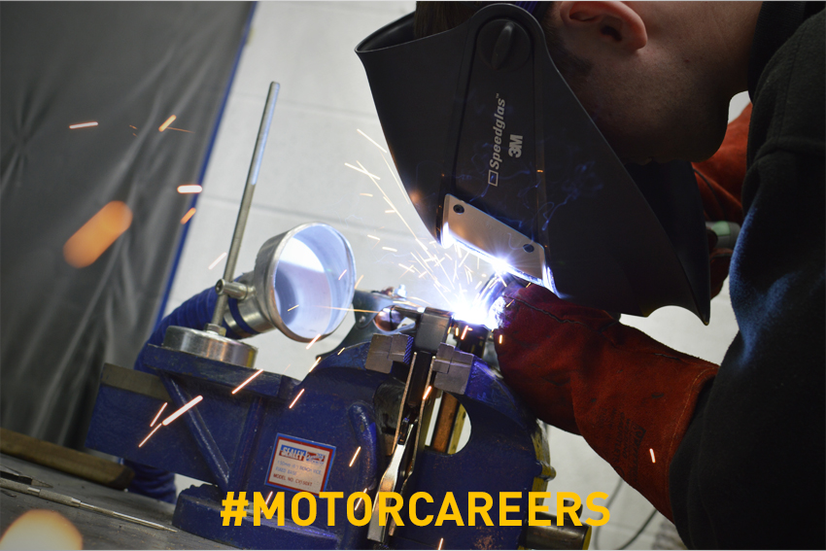
Student handout: Lesson 4 Literacy
028 The automotive industry and The IMI
What is the Retail Automotive Industry?
An exciting and innovative industry that covers a wide range of companies and organisations involved in the repair, servicing, selling and marketing of cars, motorcycles and trucks.
One of the world's most important economic sectors by revenue, which plays a significant role in the UK economy.
Benefits
- Gain quality training and qualifications
- Start a career with job prospects and development opportunities.
- An exciting, dynamic and constantly evolving sector.
- Join 536,000 people working in over 160 job roles.
- The forefront of modern technology.
- A demanding retail environment.
- Enter a professional profession!

History of the Automotive Industry: https://en.wikipedia.org/wiki/Automotive_industry

What is the Institute of the Motor Industry (IMI)?
www.theimi.org.uk
Also known as the IMI, this is the professional association for individuals working in the Automotive Industry.
- The governing body for the Automotive Technician Accreditation (ATA) Scheme.
- Attracts members of all ages, from across the industry.
- Recognises skills and experience gained.
- Encourages suitably qualified young people to join the industry.
- Equips young people for future success.

IMI Autocity is the IMI’s online careers portal:
www.autocity.org.uk
- Provides careers information, advice and guidance on:
- 160 different industry job roles
- CVs, cover letters and job interviews.
- Lists apprenticeship vacancies with Mercedes Benz, Ford, Daf, Scania, Kia and more.
Student handout: Lesson 4 Literacy
029 Article: New Porsche 911
Quentin Willson: New Porsche 911 is one of the best ever

This car will fly off the forecourt, with a top speed of around 200mph, and 0-60mph in an incredible, McLaren-beating three seconds.

Back in the 70s, the Porsche Turbo was one of the hottest rides on the road. By the 80s it had become the badge of rank of Gordon Gekko’s generation of grasping city traders.

If you got your name on the waiting list, you could sell your Porker for double what you paid in a heartbeat.

Wall St and London’s Square Mile echoed to the metallic drum roll of the flat six Porsche. Some dealers made £50k profit on every car sold, while canny owners enjoyed their cars for free.

Forty years on, there’s a sixth generation of Stuttgart’s fastest 911, and it kicks out twice the power of the 1974 screamer.

The twin-turbo, 3.8 litre flat six musters a massive 513bhp, hurling it to 60mph in a McLaren-beating three seconds. If you’re brave enough, you can also knock on the door of 200mph.

Lighter aluminium inner and outer bodies have helped cut weight and improve the power-to-weight ratio, plus 20in wheels, all-wheel drive, four-wheel steering with electro-mechanical assistance and three-stage front and rear spoilers improve down force and handling.

With the old ’74 you took your life in your hands at the limit – it was a wild and unpredictable banshee that could bite you big-time.

But the latest Turbo has dynamic chassis control, hydraulic anti-roll bars, carbon ceramic brakes and – here’s a first – no manual gearbox. All turbos will have a seven-speed dual-clutch auto.

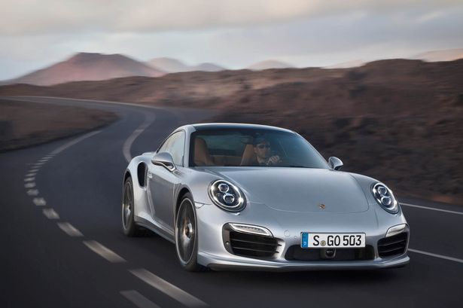
That makes it the easiest Turbo ever – good for epic, straight-line heave, millimetric corner control and finishing school docility for town trundling.

Prices start at £118,000, with deliveries scheduled for September. I won’t be surprised if the finest blown Porsche ever fills its order book very quickly, and we see 20 grand premiums for the first cars off the line.

Source: http://www.mirror.co.uk/lifestyle/motoring/car-reviews/quentin-willson-new-porsche-911-1869209 By Quentin Willson

The New Porsche 911

Student handout: Lesson 4 Literacy
029 Article feature check list
Included
Language features
Simple vocabulary
Simple sentences
Opening statement (grabs attention and introduces topic)
Closing statement
Language register: Informal
Language register: Formal
Connectives e.g. however, although, nevertheless etc
Exaggeration
Bias
Quotations
Statistics
Accurate spelling
Accurate grammar
Accurate details
Is the purpose clear?
Is the audience clear?
Formatting features
Colours
Fonts
Bold and italic
Tables
Underlined
Structural features
Headline
Sub headings
Pictures
Captions
Photographs

Student handout: Lesson 4 Literacy
032 Connectives

Connectives
and  also  as well as  moreover  too  furthermore  besides  in addition | however  although  unless  except  if  as long as  apart from  yet  despite

Student handout: Lesson 4 Literacy
033 Peer assessment – writing
Group name ____________________________ Date: / /

Use the criteria below to assess the review/article:

Language |  |  |  | Formatting | Structural
Simple vocabulary | Simple sentences | Exaggeration | Statistics | Colours | Headline
Opening statement | Is the audience clear? | Bias | Spelling | Fonts | Sub-headings
Concluding statement | Is the purpose clear? | Quotations | Grammar | Bold/italic | Pictures
Connectives | Language register: formal? or informal?) |  | Accuracy | Tables | Captions
Word count = 200 to 250 |  |  |  | Underlined | Paragraphs

What is good?

What is great?

- Do you have any constructive suggestions for the group?

LESSON PLAN 5: Literacy
Acrostic Poems

Overall objective:
To successfully write and perform an automotive themed acrostic poem, using similes, metaphors, the five senses and rhyme.

Aims:
- To understand and create similes and metaphors, related to the five senses.
- To create short sentences for an acrostic poem, including some rhyming words.
- To perform an acrostic poem using appropriate volume, pace, pronunciation, clarity and body language.
- To evaluate your peers’ poetry performance.

Language focus:
Reading Grammar and Vocabulary Writing Spoken English

Student handout: Lesson 5 Literacy
036A cut out definitions

an acrostic poem | A piece of writing containing letters in each line that form a word or words.
a verb | Describes an action, state, or occurrence.
a noun | Identifies a class of people, places, or things, OR names a particular one of these.
an adjective | Describes a noun. E.g. ‘sweet’, ‘red’, or ‘technical’.
a simile | Compares one thing with another ‘very different’ thing. Emphasizes something or makes it appear like something else very different.  E.g. ‘She is as brave as a lion’.
a metaphor | Something which represents or symbolizes something else. E.g. ‘You are the light of my life’.
to rhyme | A piece of writing that has or ends with a sound that corresponds to/sounds like another:

Student handout: Lesson 5 Literacy
037 Creating Similes and Metaphors

Write and or draw the name of a car, van, lorry or motorbike in the box below to inspire you!

Creating Similes

“A simile is a figure of speech involving the comparison of one thing with another thing of a different kind, used to make a description more emphatic or vivid.”

There are two different ways to create a simile

- Structure using as & as:

subject | + | verb | + | as | + | adjective | as | + | object
(The thing the subject
is being compared to)
Examples:

This car radio | + | sounds | + | as | + | awful | as | + | the last one did.
BMW’s i8 | + | is | + | as | + | cool | as | + | a cucumber.
Every Astra | + | drives | + | as | + | Good | As | + | the old model.

Create two automotive themed similes using as & as comparing vehicle/parts or related things - to ‘other things’, ‘ideas’, people’, ‘places’ etc.
- E.g. driving test

…………………………………………………………………………………………………………….

- E.g. tyre

…………………………………………………………………………………………………………….

- Structure using like:

subject | + | verb | + | like | + | noun
(The thing the subject
is being compared to)
Examples:
Her driving licence | + | was | + | like | + | an old rag
News about the fault | + | spread | + | like | + | wildfire.
Ferraris | + | soar | + | like | + | eagles.

Create two automotive themed similes using like:
- E.g. lorry

…………………………………………………………………………………………………………….

- E.g. motorbike

…………………………………………………………………………………………………………….

Creating Metaphors

“A metaphor is a figure of speech in which a word or phrase is applied to an object or action to which it is not literally applicable.”
The whole metaphor is created using a range of parts (there is no fixed order):

subject |  | ‘metaphorical’ object, adjective, verb or idea |  |  | object
verb |  |  | additional information

Examples:

Kia motors + broke into + the market place + a few years ago.

People + flocked + to + see + the new Jaguar.

His head + was + in a spin + after + 40 MOTs.

Reading that + F1 article + rekindled + my interest + in the sport.

Create four automotive themed metaphors using like, comparing vehicle/parts or related things - to ‘other things’, ‘ideas’, people’, ‘places’ etc.
- E.g. Ferrari

…………………………………………………………………………………………………………….

- E.g. Silverstone

…………………………………………………………………………………………………………….

- E.g. alloys

…………………………………………………………………………………………………………….

- E.g. speakers Glastonbury

…………………………………………………………………………………………………………….

Creating Similes and Metaphors using the Five Senses
Create five automotive themed similes and or metaphors, using the five senses:
E.g. Luk’s ESG system sounds like a bubbling brook. Jaguar looks to the future.

- E.g. exhaust fumes taste

…………………………………………………………………………………………………………….

- E.g. Dunlop tyres feel

…………………………………………………………………………………………………………….

- E.g. car look

…………………………………………………………………………………………………………….
- E.g. engine sound

…………………………………………………………………………………………………………….
- E.g. leather seats smell

…………………………………………………………………………………………………………….
Source of definitions: http://www.oxforddictionaries.com/definition/english/simile
http://www.oxforddictionaries.com/definition/english/metaphor

Please use the back of this hand out to practise creating similes and metaphors

Student handout: Lesson 5 Literacy
038 Creating an automotive acrostic poem

- Write one word (a make/model of car, van, lorry or motorbike) in capitals vertically down the page.
- Each capital letter is to be used as the start of each line in the poem.
- Use automotive vocabulary throughout.
- One simile AND one metaphor related to the five senses – (see, hear, touch, taste and smell).
- Two lines that end with words that rhyme.

EXAMPLE:
(The writer’s favourite car is a Vauxhall Astra. They have chosen to just use ‘Astra’.)

Again, I am driving at 50 mph along the M6.
Stopping almost every second like a bus.
The traffic looks like a fast-flowing stream.
Really, it feels as surreal as a dream.
At junction 10 the waters lessen, until junction 21 when it starts again…

Vocabulary ideas
LED lights | mouldings and trim | grills
spoilers | brakes | ignition systems
wheels | tyres | fuel pumps
seat covers | seat covers | pistons, rings and rods
floor mats | pads & shoes | exhaust
lighting | steering & suspension | door handles
fog lights | pedals & pads | door
headlights | headlight & taillight covers | GPS
filters | air systems | engine
brake lines | mirrors | sensors
Top Gear | Grand Prix | motorway
junction | parking ticket | speed camera
DVLA | MOT | tow-truck
speed | rally | track
driver | chauffeur | parking
jack-knife | overtake | passenger
under-cut | toll road | reverse
parallel park | swerve | back seat driver

Student handout: Lesson 5 Literacy
039 Peer assessment – speaking

Name of colleague _________________________________ Date: / /

What do you remember the most?

Use the criteria below to assess the acrostic poem performance:

Eye contact and body language | Voice | Understanding
Posture?  Confidence?  Eye contact?  Gestures? E.g. hands moving a lot.  Relaxed or uncomfortable | Pronunciation? Intonation?  Volume? Speed? | Subject/meaning unclear?  Any missing words?

- What is good?

- What is great?

- What is different?

LESSON PLAN 6: Literacy
Reports

Overall objective:
To write a formal report based on research, own opinions and relevant information.

Aims:
- To research a range of motorbikes using agreed search criteria.
- To make a decision using use the research and own opinions.
- To use relevant information and research findings to write a formal comparative report.
- To reflect on and evaluate your own research and decision process.

Language focus:
Writing Grammar and Vocabulary Spoken English

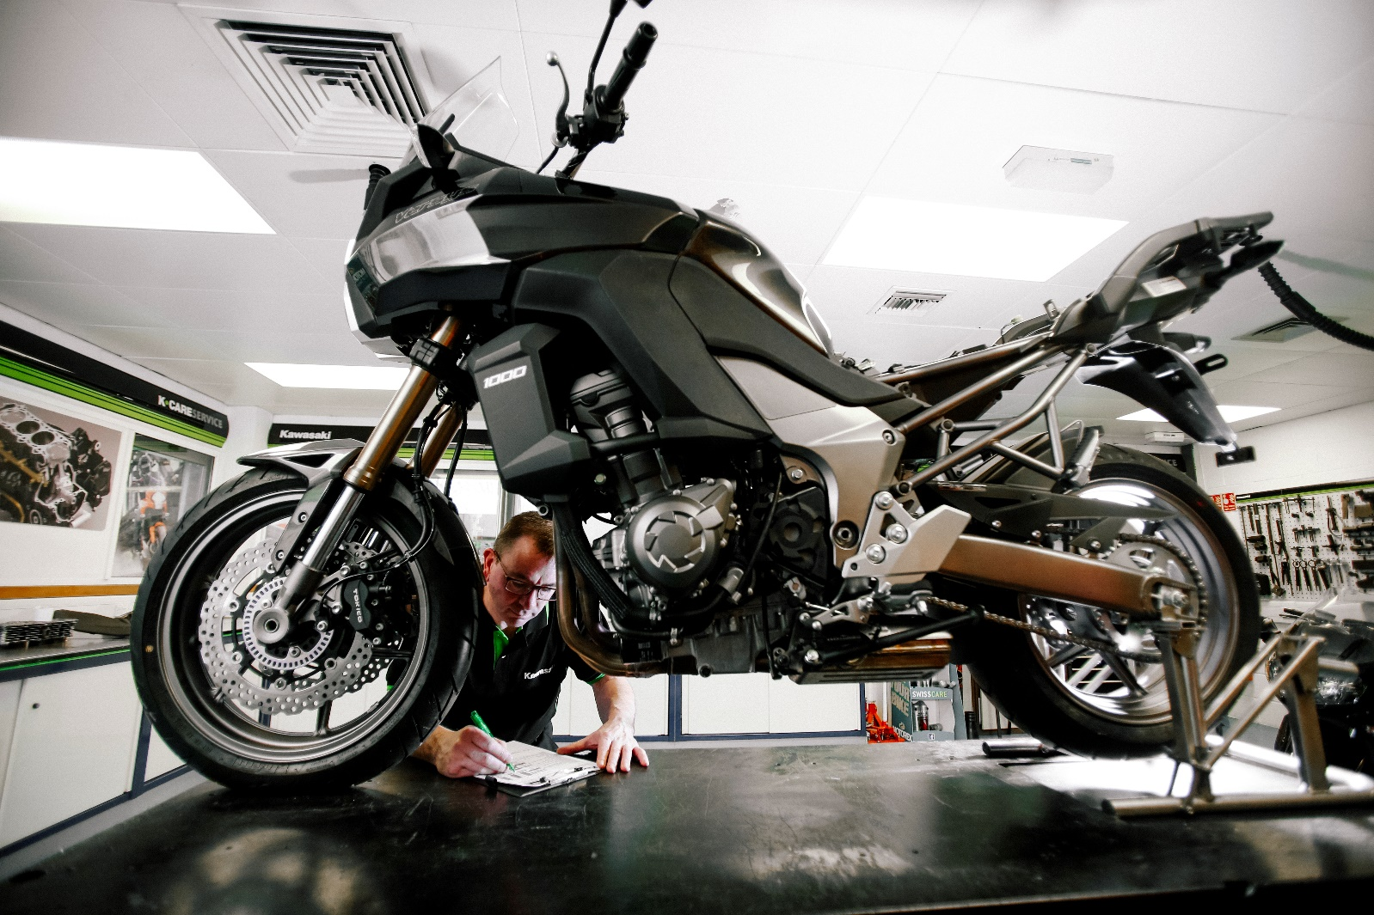
Student handout: Lesson 6 Literacy
041 Cut outs- Task 1 – Research and compare

Task 1 - Research and Compare

Imagine your managing director is planning to buy a used sports motorbike for her son.

She has given you some information from the Motor Cycle News (MCN) website.

She wants you to:

- Discuss and choose 3 of the Sports motorbikes, using your own opinions and this criteria:

- Maximum cost =£3,500

- sports motorbike

- used

- Write down all your thoughts and the reasons why you have chosen these 3.

- Compare the 3 sports motorbikes

- Write down all your thoughts, reasons and details related to the comparison.

Information from the MCN website

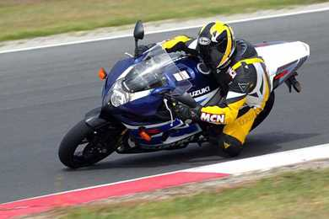
SUZUKI GSX-R1000 (2003-2004)

New price: N/A Used price: £2,900 to £4,000
- 988cc - 164 bhp
- 39 mpg - 150 miles range
- Medium seat height (830mm)

"Ultra fast, capable track missile that works far better on the road then you'd imagine"

 | Overall | Ride | Engine | Build | Value | Equipment
MCN ratings | 5 out of 5 | 4 out of 5 | 5 out of 5 | 4 out of 5 | 5 out of 5 | 5 out of 5
9 owners' ratings | 4.8 out of 5 | 4.8 out of 5 | 5 out of 5 | 4.3 out of 5 | 4.7 out of 5 | 4 out of 5
BMW S1000RR (2009-2011)

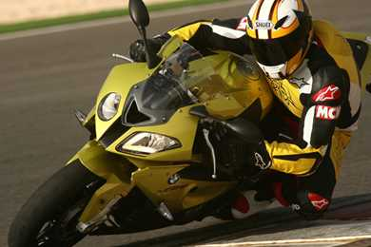
New price: N/A Used price: £8,300 to £10,000
- 999cc - 190 bhp
- 32 mpg - 147 miles range
- Medium seat height (820mm)

"BMW's first venture into modern superbike territory and hugely impressive"

 | Overall | Ride | Engine | Build | Value | Equipment
MCN ratings | 5 out of 5 | 5 out of 5 | 5 out of 5 | 4 out of 5 | 4 out of 5 | 4 out of 5
16 owners' ratings | 4 out of 5 | 4.5 out of 5 | 4.1 out of 5 | 3.7 out of 5 | 3.8 out of 5 | 4.4 out of 5

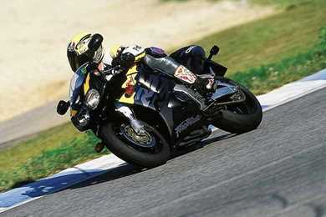

HONDA CBR900RR FIREBLADE (1992-1999)

New price: N/A Used price: £2,000 to £5,500
- 918cc - 128 bhp
- 41 mpg - 160 miles range
- Medium seat height (810mm)

"The motorcycle that changed how sports motorcycles were built."

 | Overall | Ride | Engine | Build | Value | Equipment
MCN ratings | 5 out of 5 | 4 out of 5 | 4 out of 5 | 5 out of 5 | 4 out of 5 | 4 out of 5
38 owners' ratings | 4.8 out of 5 | 4.7 out of 5 | 4.8 out of 5 | 4.3 out of 5 | 4.9 out of 5 | 4 out of 5

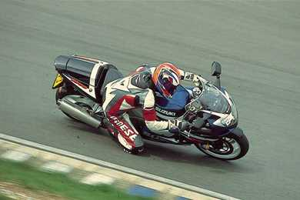
SUZUKI GSX-R1000 (2001-2002)

New price: N/A Used price: £3,000 to £3,500
- 988cc - 160 bhp
- 32 mpg - 125 miles range
- Medium seat height (830mm)

"Original Suzuki GSX-R1000 K1 and K2 models are still supremely competent sports bikes"

 | Overall | Ride | Engine | Build | Value | Equipment
MCN ratings | 4 out of 5 | 4 out of 5 | 5 out of 5 | 3 out of 5 | 4 out of 5 | 4 out of 5
12 owners' ratings | 4.9 out of 5 | 4.9 out of 5 | 5 out of 5 | 4.7 out of 5 | 4.8 out of 5 | 4.1 out of 5

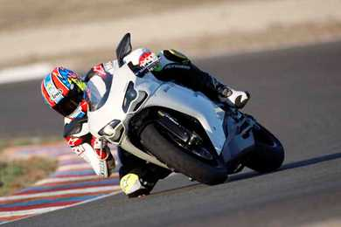

DUCATI 848 (2007-2013)

New price: N/A Used price: £6,000 to £9,500
- 848cc - 122 bhp
- 27 mpg - 93 miles range
- Medium seat height (800mm)

"The Ducati 848 isn't just a small 1098, it's much more than that"

 | Overall | Ride | Engine | Build | Value | Equipment
MCN ratings | 5 out of 5 | 5 out of 5 | 5 out of 5 | 5 out of 5 | 4 out of 5 | 4 out of 5
5 owners' ratings | 4.6 out of 5 | 4.6 out of 5 | 5 out of 5 | 4.6 out of 5 | 4 out of 5 | 4.4 out of 5

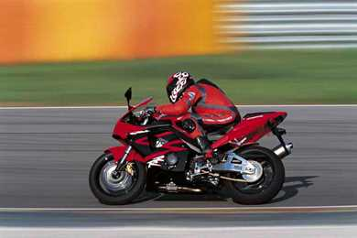

HONDA CBR900RR FIREBLADE (2002-2003)

New price: N/A Used price: £2,500 to £12,000
- 954cc - 149 bhp
- 39 mpg - 150 miles range
- Medium seat height (815mm)

"The last Blade by Tadao Baba is the most exciting to ride and lighter than its successors"

 | Overall | Ride | Engine | Build | Value | Equipment
MCN ratings | 5 out of 5 | 4 out of 5 | 4 out of 5 | 4 out of 5 | 4 out of 5 | 4 out of 5
13 owners' ratings | 4.9 out of 5 | 4.8 out of 5 | 4.8 out of 5 | 4.8 out of 5 | 4.6 out of 5 | 4.2 out of 5

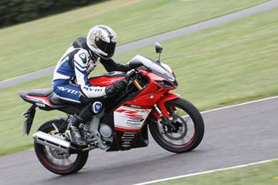

RIEJU RS3 125 (2013-on)

New price: £3,399 Used price: £2,600 to £3,500
- 124cc - 15 bhp
- 66 mpg - 176 miles range
- Medium seat height (845mm)

"Fast engine and good looks let down by poor build quality and bad handling"

 | Overall | Ride | Engine | Build | Value | Equipment
MCN ratings | 3 out of 5 | 2 out of 5 | 4 out of 5 | 3 out of 5 | 3 out of 5 | 3 out of 5
7 owners' ratings | 4.3 out of 5 | 4 out of 5 | 4.7 out of 5 | 3.6 out of 5 | 4.3 out of 5 | 3.9 out of 5

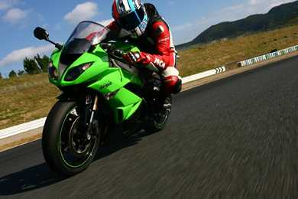

KAWASAKI ZX-6R (2009-2012)

New price: N/A Used price: £4,200 to £6,500
- 599cc - 115 bhp
- 39 mpg - 144 miles range
- Medium seat height (815mm)
"New big piston forks use MotoGP technology"

 | Overall | Ride | Engine | Build | Value | Equipment
MCN ratings | 5 out of 5 | 5 out of 5 | 5 out of 5 | 5 out of 5 | 5 out of 5 | 5 out of 5
9 owners' ratings | 4.9 out of 5 | 4.8 out of 5 | 5 out of 5 | 4.4 out of 5 | 4.9 out of 5 | 4.6 out of 5

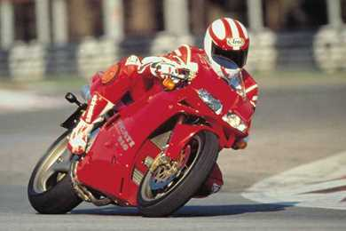

DUCATI 998 (1994-2005)

New price: N/A Used price: £7,000 to £16,000
- 998cc - 123 bhp
- 37 mpg - 145 miles range
- Medium seat height (790mm)
"Always makes the rider feel special - whether out on a blast or just staring at it in the garage"

 | Overall | Ride | Engine | Build | Value | Equipment
MCN ratings | 4 out of 5 | 4 out of 5 | 4 out of 5 | 2 out of 5 | 4 out of 5 | 4 out of 5
4 owners' ratings | 4.5 out of 5 | 5 out of 5 | 5 out of 5 | 4 out of 5 | 5 out of 5 | 4 out of 5

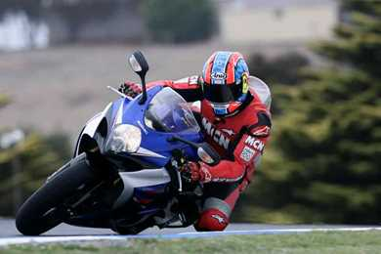

SUZUKI GSX-R1000 (2007-2008)

New price: N/A Used price: £5,200 to £6,500
- 999cc - 185 bhp
- 38 mpg - 146 miles range
- Medium seat height (810mm)
"Now thanks to a three-way power switch you can choose how much power you need"

 | Overall | Ride | Engine | Build | Value | Equipment
MCN ratings | 5 out of 5 | 4 out of 5 | 5 out of 5 | 4 out of 5 | 5 out of 5 | 5 out of 5
17 owners' ratings | 4.6 out of 5 | 4.6 out of 5 | 4.6 out of 5 | 4.2 out of 5 | 4.7 out of 5 | 4.4 out of 5

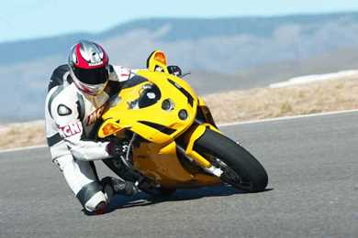

DUCATI 749 (2003-2007)

New price: N/A Used price: £3,000 to £8,800
- 748cc - 116 bhp
- 43 mpg - 148 miles range
- Medium seat height (780mm)
Preferred by some to the larger 999 series – and for good reason

 | Overall | Ride | Engine | Build | Value | Equipment
MCN ratings | 4 out of 5 | 4 out of 5 | 3 out of 5 | 3 out of 5 | 3 out of 5 | 3 out of 5
13 owners' ratings | 4.3 out of 5 | 4.5 out of 5 | 4.5 out of 5 | 3.9 out of 5 | 4.1 out of 5 | 3.7 out of 5

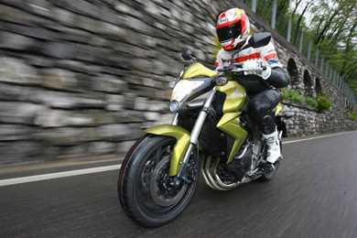

HONDA CB1000R (2008-on)

New price: £9,299 Used price: £4,100 to £10,000
- 998cc - 130 bhp
- 38 mpg - 209 miles range
- Medium seat height (825mm)
"The only thing the CB1000R lacks is a bit of soul"

 | Overall | Ride | Engine | Build | Value | Equipment
MCN ratings | 4 out of 5 | 4 out of 5 | 4 out of 5 | 5 out of 5 | 4 out of 5 | 4 out of 5
23 owners' ratings | 4.4 out of 5 | 4.6 out of 5 | 4.5 out of 5 | 4.5 out of 5 | 4.5 out of 5 | 4.2 out of 5

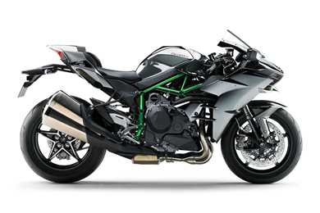

KAWASAKI NINJA H2 (2015-on)

New price: £22,000 Used price: £20,000 to £22,000
- 998cc - 210 bhp
- Medium seat height (825mm)
The Ninja H2 redefines superbike acceleration

 | Overall | Ride | Engine | Build | Value | Equipment
MCN ratings | 5 out of 5 | 4 out of 5 | 5 out of 5 | 5 out of 5 | 3 out of 5 | 3 out of 5
1 owner ratings | 5 out of 5 | 5 out of 5 | 5 out of 5 | 5 out of 5 | 4 out of 5 | 5 out of 5

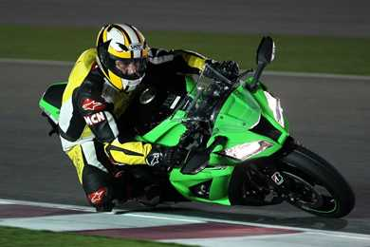

KAWASAKI ZX-10R (2011-on)

New price: £12,999 Used price: £6,000 to £20,000
- 998cc - 197.3 bhp
- 34 mpg - 128 miles range
- Medium seat height (813mm)
"At 198kg fully gassed, the ZX-10R has the best power to weight ratio, and it isn't as intense to ride as the BMW and so will suit a lot more riders. Good one, Kawasaki"

 | Overall | Ride | Engine | Build | Value | Equipment
MCN ratings | 4 out of 5 | 4 out of 5 | 4 out of 5 | 4 out of 5 | 4 out of 5 | 4 out of 5
11 owners' ratings | 3.8 out of 5 | 4.4 out of 5 | 4.3 out of 5 | 3.6 out of 5 | 3.5 out of 5 | 4.3 out of 5

Student handout: Lesson 5 Literacy
024 Writing frame
Remember to consider:

Language |  |  |  | Structural
Formal language |  | Simple sentences | Comparisons | Heading | Sub-headings | Pictures
Opinions |  | Facts & details | Informative | Paragraphs including:
Relevant info | Descriptive |  |  | Introduction | Conclusion |  | Recommendation
Did you plan? | Spelling/Grammar/Punctuation

Main heading to describe the report

(Subheading – e.g. Introduction)
First paragraph - to introduce the report, state the aim and what you are going to include in the report.

(Subheading – e.g. the make and model of motorbike 1)
Paragraph to introduce/describe this motorbike and explain why this has been chosen.

(Subheading – e.g. the make and model of motorbike 2)
Paragraph to introduce/describe this motorbike and explain why this has been chosen.

(Subheading – e.g. the make and model of motorbike 3)
Paragraph to introduce/describe this motorbike and explain why this has been chosen.

(Subheading – e.g. Comparison)
Paragraph to compare the three motorbikes using: the criteria you used, your research notes and your opinions.

(Subheading – e.g. Conclusion)
Paragraph:
“The conclusion that I can draw from the research carried out on the MCN website and based on (insert the criteria you used) is therefore:
(Motorbike 1) is ……….
(Motorbike 2) is ……….
(Motorbike 3) is ……….”

(Subheading – e.g. Recommendation)
Paragraph:
“Based on the above conclusions, I would recommend that (my tutor/my sister/John etc.) should buy the (motorbike make and model) because……………………………………………………………………………”

Student handout: Lesson 5 Literacy
025 Peer assessment – writing
Your group name ____________________________ Date: / /

Use the criteria below to assess your report:

Language |  |  |  | Structural
Formal language |  | Simple sentences | Comparisons | Heading | Sub-headings | Pictures
Opinions |  | Facts & details | Informative | Paragraphs including:
Relevant info | Descriptive |  |  | Introduction | Conclusion | Recommendation
Did you plan? | Spelling/Grammar/Punctuation

What is good?

What is great?

- Do you have any constructive suggestions for the group?

LESSON PLAN 7: Literacy
Skimming and scanning

Overall objective:
To use, understand and develop effective skimming and scanning techniques.

Aims:
- To understand and use skimming to identify the gist of a text.
- To understand and use scanning to identify details from a text.
- To identify answers to reading comprehension questions.

Language focus:
Reading Grammar and Vocabulary

Student handout: Lesson 7 Literacy
046 Task 1 - Reading
L1 Certificate in Motorcycle Maintenance

Who is it suitable for?
This Vocationally Related Qualification (VRQ) is primarily designed to engage and motivate aged 14 to 19 year olds who are interested in learning about the maintenance of motorcycles, the various roles that are available in the retail motor industry, and would therefore like a qualification that will support their progress into the retail motor vehicle industry.

There are no formal entry requirements for this qualification. However selection criteria for entry should take into account each applicant's existing academic/vocational qualifications, experience, and interest in working in the industry sectors.

About
This qualification has a predominately practical approach to assessment, and includes many visual questioning techniques, which will stimulate and interest the learner.

The qualification’s combination of units provides learners with the flexibility in the choice of the areas they wish to develop their knowledge and skills in.

All learners will develop their knowledge and skills in:
- health and safety practices in vehicle maintenance and good housekeeping in the automotive environment
- tools, equipment and materials for vehicle maintenance

Learners have the opportunity develop their knowledge and skills in a wide variety of areas, and also the option to achieve Level 2 units, which will support the learner’s progression to an IMI Level 2 Certificate (VRQ) in the appropriate career route. Examples of some of the unit options available follow:
- introduction to the retail automotive maintenance and repair industry
- motorcycle construction
- routine maintenance motorcycle chassis systems
- motorcycle engines
- motorcycle transmission systems
- motorcycle electrical and electronic systems
- motorcycle fuel, ignition, air and exhaust system units and components
- introduction to low carbon technologies in the automotive industry
Progression
This Certificate is ideal for those learners who wish to undertake a qualification which will support their progress into the retail motor vehicle industry. It can also supplement their progress to GCSEs and other appropriate destinations, such as the Institute of the Motor Industry Sector Skills Council (IMI SSC) Intermediate Apprenticeship at Level 3, or employment.

Assessment
The assessments for this qualification have a practical focus and combine various assessment styles/methodologies in order to suit the subject and levels of units contained within it.

Want to know more? Please contact an IMI approved centre.

Student handout: Lesson 7 Literacy
046 Task 1 - Reading

Task 1 – Reading (Questions)
L1 Certificate in Motorcycle Maintenance (IMI course summary)
Skim read the extract.
No. | Question | / | /
1 | Explain the gist/main idea: |  | 1
Scan read and answer the following questions:
2 | Give three of the unit options available on the level 1 certificate: |  | 3
3 | How are learners assessed on this course? |  | 2
4 | Give two benefits for learners who take these courses: |  | 2
5 | What do the initials IMI stand for? |  | 1
6 | What are the possible next steps after this course? |  | 2
7 | Which language register has been used to write this course overview? |  | 1
8 | Give three structural features included in this overview: What effect does each have? |  | 6
9 | Who are the target audience for this course overview? |  | 2
10 | What impact has this overview had on you? What impact could it have on others? |  | 2
11 | What is your opinion of this course? Why do you think this? |  | 2
12 | What is the purpose of this article? |  | 2
Overall score |  |  | 26
Student handout: Lesson 7 Literacy
047 Task 2 – Reading and questions

Chitty Chitty Bang Bang: Information
Background

Best known as the creator of James Bond, Ian Fleming is the surprise author of "Chitty Chitty Bang Bang", the children's book which later became such a hit at the Box Office.
In 1964 Ian Fleming had a major heart attack. It was during his convalescence that he decided to turn the bedtime stories he had been telling his little son Casper, into a book for children. This book became Chitty Chitty Bang Bang: the story of the adventures of inventor Commander Caractacus Potts, his wife Mimsie, their two children Jeremy and Jemima and the wonderful Chitty Bang Bang car which could float on water and even fly!

The story

The family acquire a broken down old car and the Commander sets to work to repair it. Once mended it is clear that this is no ordinary car... and so begins an adventure for the Potts Family involving a trip across the Channel, a kidnapping and a run in with a mob of gangsters.
http://www.chittybangbang.com/chittybangbang-book.html

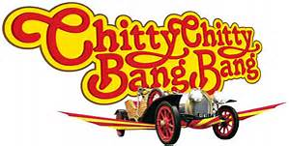

The text is an extract taken from: Fleming, I. and Burningham, J. (n.d.). Chitty chitty bang bang.

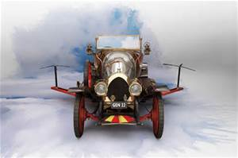
EXTRACT FROM CHAPTER FIVE
A New Member of the Family

OVER CANTERBURY, Commander Pott insisted on circling the tall tower of the cathedral, so that the jackdaws and pigeons flew out of their nooks and crannies squawking and cooing with fright and excitement, and then they headed on over the trees and woods, taking a short cut away from the Dover road, towards the distant majesty of Dover Castle, with its Union Jack flying from the topmost tower.
And of course, at that speed, in minutes they were over the castle, and again Commander Pott insisted on circling round so that the family (and CHITTY-CHITTY-BANG-BANG for the matter of that) could have a good look, and all the soldiers drilling on the square inside the castle walls looked up, much to the rage of their sergeant-major, and the sentries too, and between you and me, I think CHITTY-CHITTY-BANG-BANG was lucky to get away without being shot at by the soldiers, because after all she had no proper aircraft markings, only her GEN II registration plates, and for all the soldiers knew, she might have been some kind of foreign aeroplane come to attack the castle, or even a flying bomb, which was really quite what she looked like.
But all went well, and they flew up the coast looking for a place to land to have their picnic beside the sparkling blue sea. But everywhere – St. Margaret’s Bay, Walmer, Deal, Sandwich, Ramsgate – all the beaches were crowded with families who had had the same idea as the Pott family, and CHITTY-CHITTY-BANG-BANG’s passengers became more and more gloomy as they saw the beautiful sands with their bathers and paddlers and shrimpers, and the rock-pools that were certainly crawling with excited crabs and eels and valuable shells, all crowded with rival holidaymakers. And they all longed for a bathe and to unpack the bulging picnic basket full of Mimsie’s delicious goodies.
Then a curious thing happened. The steering wheel twisted, actually twisted in Commander Pott’s hands, as if CHITTY-CHITTY-BANG-BANG realised their disappointment and was taking control herself and do you know what? CHITTY-CHITTY-BANG-BANG turned away from the coast and soared away over the English Channel straight out to sea.
The family held their breath with excitement and Commander Pott wrestled with the wheel and began to look rather nervous. But then the green light started to blink on the dashboard, and now instead of saying PULL DOWN, as it had said before, it said PUSH UP. And gently Commander Potts pushed up the little silver lever and gently CHITTY-CHITTY-BANG-BANG began to lose height and plane softly downwards.
“Heavens!” cried Mimsie. “She’s going to drop us in the sea! Now we are in a real mess! Get ready to swim, everyone. The cushions will float! Each one hang on to a cushion! The Deal lifeboat will see us and if we keep afloat we’ll be alright!”
“Don’t worry, Mimsie darling,” shouted Commander Pott against the roar of the wind. “It’ll be alright. I think I know what CHITTY-CHITTY-BANG-BANG has got in mind. Look there where we’re heading for. Those are the Goodwin Sands – acres of beautiful sand that get uncovered during a low tide like this. Why, in summer they even have a football match on the sands. Dover and Deal play each other and get the game over before the tide comes in. Then they row away in boats. And there’s the…”
While Commander Pott had been telling these exciting things, CHITTY-CHITTY-BANG-BANG had been planing gently down towards the big expanse of beautiful golden sand lapped by the soft blue ripples of the English Channel and fringed by the masts and the half sunken hulls of the wrecks that show up at low tide. The crew of the bright-red painted lightship came up on deck and waved excitedly to them as they soared low overhead and then, as the green light on the dashboard went on winking and Commander Pott gently took his foot of the accelerator, the wheels automatically lowered themselves into position again and they came in to land on the hard flat golden surface. The aerocar ran a little way on the sand and then, as Commander Pott put on the brakes, CHITTY-CHITTY-BANG-BANG came to a gentle stop at the edge of the sea. At once the red light on the dashboard showed again, and now it said PUSH UP (no IDIOT this time).
Commander Pott pushed up the little silver lever, and there came the same low hum as the front and back wings slowly folded back to become mudguards again, and the propeller and generator out front slipped back until the two halves of the radiator closed over them. CHITTY-CHITTY-BANG-BANG gave a last two big sneezes and two soft bangs, then Commander Pott switched off the engine and there was a perfectly good, gleaming, green car sitting quietly on the huge sandbank in the middle of the sea.
The whole family let out a big “Pouff” of relief and excitement and piled out of the magical car onto the warm sand.

No. | Questions | / | /
 | Skim read the extract
1 | Explain the gist/main idea of the extract: |  | 1
 | Scan read the extract and answer the following questions:
2 | How many characters speak or give their opinion within the extract? |  | 2
3 | Give your opinion and why you think this, for one character: |  | 2
4 | Why does the author think CCBB was lucky not to have been shot? |  | 2
5 | How is this text different to the text in Task 1? Consider its target audience and purpose. |  | 3
6 | Find 10 nouns in the extract related to the motor industry: |  | 10
7 | How does the extract compare to the CCBB film you may have seen on television or books about CCBB you may have read before? |  | 1
8 | Which language register has been used? |  | 1
9 | What structural & formatting features have been used? How do they affect the reader? |  | 4
10 | Who is the target audience? |  | 1
11 | What impact has the extract had on you? |  | 1
12 | What is your opinion of the story? |  | 1
13 | What is the purpose of the story? |  | 1
Overall score |  |  | /30

Student handout: Lesson 7 Literacy
048 Task 3 – Reading and questions
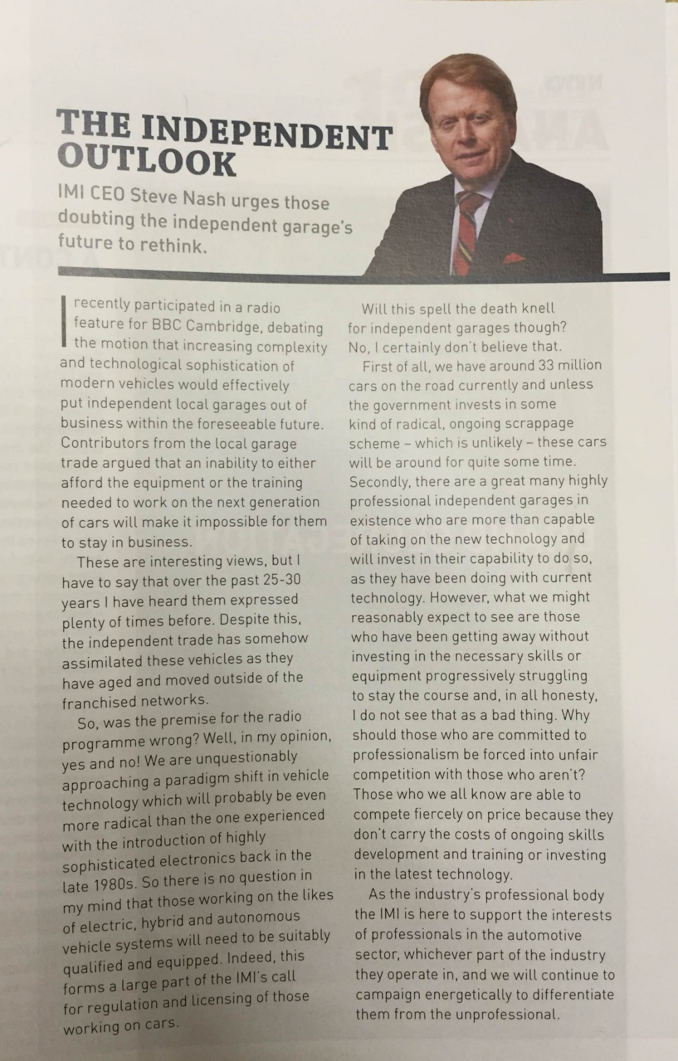

No. | Question |  | /
Skim read the text
1 | What is the overall gist of the article? |  | 1
Scan read and answer the following questions:
2 | What has happened over the past 25 to 30 years according to Steve Nash? |  | 1
3 | Steve Nash agrees that ‘those working on electric, hybrid and autonomous vehicle systems will need to be suitably qualified and equipped’. Why does he believe this? |  | 2
4 | What is your opinion on the future of independent garages? |  | 1
5 | What issue can dramatically affect an independent garage’s ability to compete in the industry? |  | 1
6 | Whose industry presence offers support to professionals in the automotive industry? |  | 1
7 | What is the name of this grammar feature used in the article: ‘Will this spell the death knell for independent garages though?’ |  | 1
8 | Identify 3 facts from this article: |  | 3
9 | What structural features have been used? How do they affect you as the reader? |  | 4
10 | What industry data does Steve Nash give that backs up his opinion that independent garages will not disappear? |  | 1
11 | Identify an opinion from the article that is not backed up by fact or information: |  | 1
12 | Where would you expect to find this type of article? |  | 1
13 | What is the purpose of this article? |  | 1
14 | What impact has this article had on you? What impact could it have on other readers? |  | 1
Overall score |  |  | 20

LESSON PLAN 8: Literacy
Debate

Overall objective:
To effectively plan for and participate in a structured formal debate, giving reasoned arguments.

Aims:
- To help prepare a formal 2 minute speech using specified language features and a clear beginning, middle and end.
- To listen to and consider different opinions.
- To confidently express your opinions with well-thought out and structured reasons.
- To participate in a structured debate.

Language focus:
Writing Grammar and Vocabulary Spoken English

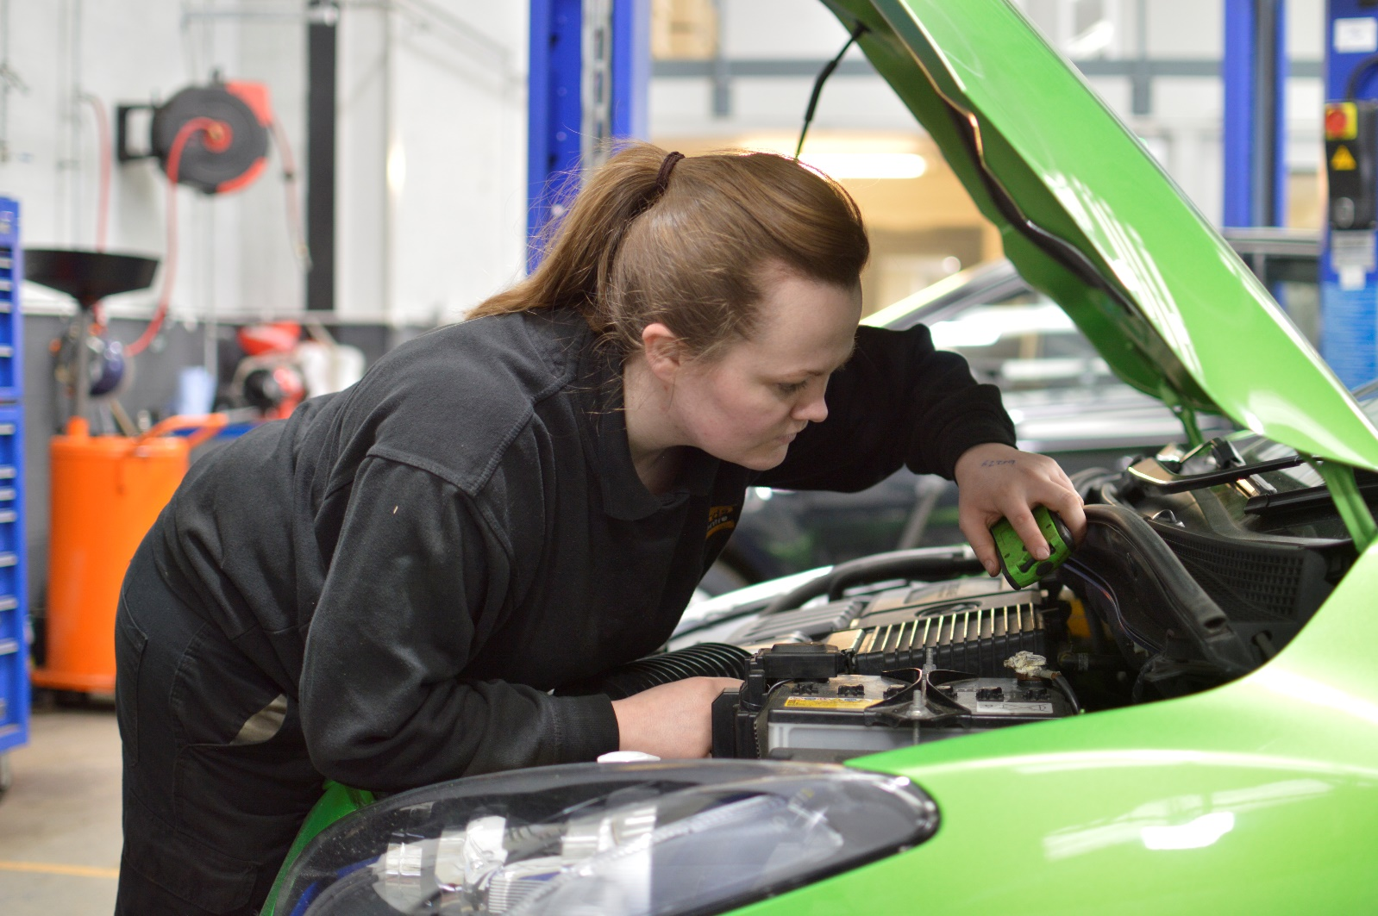
Student Handout: Lesson 8
051: Assessment record
Debate: Assessment Checklist

 | *For / Against |  |  |  |  | Name:
 | More than 2 minutes |  |  |  |  |  |  |  |  | Less than 2 minutes
 | *delete as appropriate |  |  |  |  |  |  | / | Any comments
 | Introduced themselves
 | Stated ‘for’ or ‘against’
 | Clear reasons supporting view
 | Clear conclusion
 | Sentence openers
 | Repetition
 | Rhetorical question
 | Present tense
 | Interesting / persuasive
 | Confident |  | Formal language
 | Eye contact
 | Posture
 | Gestures
 | Pronunciation
 | Intonation
 | Volume
 | Speed

Debate: Assessment Checklist

*For / Against |  |  | Name:
More than 2 minutes |  |  |  |  |  |  |  | Less than 2 minutes
*delete as appropriate |  |  |  |  |  | / | Any comments
Introduced themselves
Stated ‘for’ or ‘against’
Clear reasons supporting view
Clear conclusion
Sentence openers
Repetition
Rhetorical question
Present tense
Interesting / persuasive
Confident |  | Formal language
Eye contact
Posture
Gestures
Pronunciation
Intonation
Volume
Speed

Student Handout: Lesson 8
052: Pros and Cons – Flying Cars

 | Pros | Cons
1. | Could solve the problem regarding the lack of parking spaces. | Installing traffic lights and road signs could be difficult.
2. | Could solve congestion problems. | Could be a high risk of accidents around high buildings, wildlife and aircraft.
3. | Could reduce the need for congestion charges. | Could cause issues regarding a country’s borders and airspace regulations.
4. | Emergency service vehicles could be designated to use the sky speeding up journeys to save lives and protect people. | People could stop using public transport as they believe there is more space up there.
5. | HGVS could be designated to the sky to reduce the dangers they pose to drivers of smaller vehicles. | Public transport companies and airlines could lose a lot of money.
6. | Less pollution close to the ground for people and nature. | Weather could cause problems and accidents.
7. | Access to remote areas of the country, otherwise cut off from amenities and emergency services. | Exhaust emissions could damage cloud formation (and reduce our protection from the sun etc.) through their close proximity.
8. | Increased speed of postal and delivery services. | Accidents would affect those in the air and those on the ground below.
9. | The Motor Industry would grow and benefit from the increased revenue paid to the DVLA and car insurance providers | Increased number of cases of health problems like deep vein thrombosis.
10. | Cyclists would be safer on the roads. | Existing drivers would likely have to pay out money again for flying driving lessons and the tests.
11. | There may be less road traffic accidents. | Running out of fuel mid-air would be catastrophic.
12. | Bus services would be faster. | Drink-driving would be even harder to monitor and would be catastrophic.

Student Handout: Lesson 8
053: Speech check list
Basic structure: 2 minutes

Beginning Introduce yourself.
State the idea to be debated and whether you are ‘for’ or ‘against’.

Middle Clearly explain each reasons you have supporting your view.

End A clear conclusion to why you have this view.

Language features

Sentence openers
E.g. Firstly In addition Moreover Due to Although However On the other hand In conclusion Finally As a result

Rhetorical questions
Asked without needing or intending for it to be answered.
Used to create an emotional response or affect someone’s opinion.
E.g. How could you (we) allow this to happen? Do you really think…
What would happen if…… Is it really worth….
Could your conscience cope with…. Do you want to be part of…….

Present tense Formal language Repetition

Persuasive language: Put forward a point of view and try to get others to agree.

Emotive language: Adjectives e.g. fantastic idea
Adverbs e.g. cruelly done

Body Language

Eye contact Posture Gestures

Speaking

Pronunciation Intonation Volume Speed

BE INTERESTING AND CONFIDENT
LESSON PLAN 9: Literacy
CV’s part A

Overall objective:
To start completing a CV Builder in preparation for creating an effective targeted CV.

Aims:
- To become more familiar with skills and qualifications needed for Motor Industry apprenticeships.
- To identify which employability skills you have and which you would like to develop.
- To decide which of your skills and experience should be included on a CV builder.
- To begin writing suitable sentences and collecting information.

Language focus:
Writing Grammar and Vocabulary

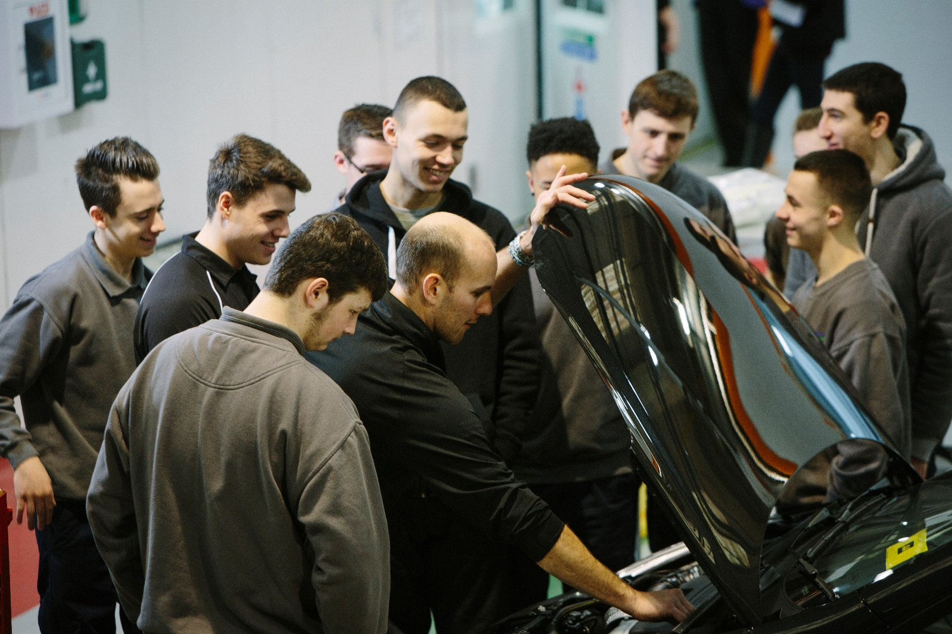
Student handout: Lesson 9 A
062: Targeted CV builder

What is the aim?

To gather relevant information and sentences to include on your targeted CV.

Personal details

The details below will not be in a table and will look slightly different on a real CV.

Example: Adam Bowers
109a Any Road, Rotherham, South Yorkshire, S63 3AB
adam-bowers@email.co.uk 07787 9159938

Name
Address 1
Address 2
Address 3
Address 4
Address 5
Post code
Mobile telephone number?
Home telephone number?
Email address

Personal Profile

The boxes below are to help you create different parts of the profile.

Key Skills

The tables below are to help you create sentences for your CV.

- Technical OR Motor Industry related skill | Sentences

- Interpersonal quality | Sentence

- IT / Computer software | Sentence

- Achievements

- Education

Start with the college, school or training centre you are at now and work backwards.

- Date started | Date left | Name of school/college | Where
20 | Still there
Full name of qualification or training course |  |  |  | Grade or score

- Date started | Date left | Name of school/college | Where
20 | 20
Full name of qualification or training course |  |  |  | Grade or score

- Date started | Date left | Name of school/college | Where
20 | 20
Full name of qualification or training course |  |  |  | Grade or score

Continue on a separate piece of paper.

Employment (paid)

Write down details of any work you have done – where you have been paid.

- Date started | Date left | Job title, Name of organisation / who for | Where
20 | 20
Tasks

- Date started | Date left | Job title, Name of organisation / who for | Where
20 | 20
Tasks

- Date started | Date left | Job title, Name of organisation / who for | Where
20 | 20
Tasks

Continue on a separate piece of paper.

Work experience (unpaid)

Write down details of any work experience you have done:

- Date started | Date left | Job title | Organisation name, Where
20 | 20
Tasks

- Date started | Date left | Job title | Organisation name, Where
20 | 20
Tasks

3. Date started | Date left | Job title | Organisation name, Where
20 | 20
Tasks

Continue on a separate piece of paper.

Voluntary experience (unpaid)

Write down details of any unpaid work you have done:

- Date started | Date left | Job title | Organisation name, Where
20 | 20
Tasks

- Date started | Date left | Job title | Organisation name, Where
20 | 20
Tasks

- Date started | Date left | Job title | Organisation name, Where
20 | 20
Tasks

Continue on a separate piece of paper.

Hobbies and Interests

The table below is to help you organise and write down your hobbies and interests.
It will be set out differently on your real CV.

i. During school, college or work time: | ii. After school, college or work:
iii. At the weekend:

Referees

Referee 1

Referee’s full name
Referee’s job title
Organisation name where the referee works
Organisation address 1
Organisation address 2
Organisation address 3
Organisation post code
Referee’s mobile or landline telephone number
Referee’s email address

Referee 2

Referee’s full name
Referee’s job title
Organisation name where the referee works
Organisation address 1
Organisation address 2
Organisation address 3
Organisation post code
Referee’s mobile or landline telephone number
Referee’s email address

If you are running out of space, you can just write:

Referees are available on request.

EXAMPLE CV

Carrie Vauxhall
30 The Road, Braketown, Padshire, AA10 1AA
Home: 00123 456789 Mobile: 07777 777777
Email: carrievauxhall7@carmail.com

Personal Profile

An extremely hard working and motivated individual. An effective and organised team player, also extremely capable of working alone using my own initiative. Possess ……………. years’ experience with/in …………………………..Currently employed as a / studying …………..…………………… / Recently completed the……………………………...……………………………… Seeking a/n ………… apprenticeship in the Motor Industry to start a career as an ………………………………………………..

Key Skills

Technical
Tyre fitting Tyre removal Tyre inflation and deflation

Interpersonal
Dedicated Versatile Responsible Reliable Confident
Approachable Motivated Organised Initiative Energetic

IT & Computers
Email Database MS Word Telephone

OR if you have space create sentences for each:

Email - Manage emails/calendars using MS Outlook and web-based email.
Database - Check stock levels and customer details using the CRM / parts database.
MS Word - Create assignments incl. formatting: tables, bullets, bold and images.
Telephone - Answering, making, holding, retrieving and transferring calls.

Achievements

- First prize at the 2013 North West AutoCar Competition – I designed an electric car.
- Student of the Month at Windscreen High for three consecutive months.

Education

Sep. 2011 to date Windscreen High Gearville, Wipershire
GCSE Design Technology, Double Science, Ongoing
English Language and English Literature Maths, PE and RE.

Level 2 Diploma in Light Vehicle Maintenance and Repair Competence Passed

Employment

Jun. 2012 to date General Assistant, Auto Autos Ltd Clutchton, Wipershire
- Use specialist equipment to remove wheels, remove tyres and release air.
- Fit new tyres and inflate them to the correct pressure for the vehicle.
- Check tyres carefully for nails and cracks and report findings to my manager.
- Liaise with my manager and my colleagues daily to prioritise and identify new tasks.
- Deliver customer service on the reception in person and on the telephone.
- Print, scan and photocopy customer invoices, records of work completed and job lists.
- Check levels of printer paper/office supplies and tidy reception and my work area.

Apr. 2010 - Jun. 2012 Customer Service Asst. Frozen World Clutchton, Wipershire
- Worked in the Customer Service Team stocking and tidying shelves and work area.
- Used a touch screen cash till, handling money, credit card transactions and refunds.
- Packed customer’s shopping bags and helped them carry it to their car, if required.
- Assisted my supervisor with new customer service staff training.
- Answered customer’s product and service enquiries and dealt with complaints.
- Liaised with the management team and my supervisor in person and on the phone.

Work experience

Feb to Mar. 2009 Mr Tomkinson Clutchton, Wipershire
- Assisted my uncle repairing broken down cars at customers’ homes and workplace.
- Followed direct instructions and requests for tools and equipment.
- Gained knowledge about various car parts and recognised problems to be resolved.
- Kept detailed paper records of products and equipment to be replaced/purchased.
- Tidied tools away and ensured the work area was clean and safe before leaving.

Voluntary Experience

Apr. 2009 Cancer Research UK Clutchton, Wipershire
- Worked at weekends in a charity shop and supported staff at fundraising events.
- Answered customer enquiries and helped them find specific products.
- Sorted and steamed clothing donations and recycled items unsuitable for sale.
- Used a touch screen cash till, handling money and credit card transactions.
- Merchandised stock in the shop window, on mannequins, rails and display shelving.

Hobbies and Interests

Regularly ride and fix my motocross bike.
Go to a gym and play for my local football team.
Enjoy mixing my own music and DJ-ing at a local venue.

Referees

Jennifer Toyota | Paul Mercedes-Benz
Chief Executive | Project Manager
Electric Cars Ltd | Hybrid Plc.
27 Some House Lane | 1 Place Street
Sometown | Middle
Someshire ZR00 0ZZ | Middleham XB99 0WW
00000 000000 | 11111 111111
jennifert@brakes.com | paulmb@tyre.co.uk

LESSON PLAN 10: Literacy
CV’s part B

Overall objectives:
- To continue completing a CV Builder.
- Students who ‘haven’t finished’ their CV Builders
Use a CV Builder to start creating an effective targeted CV.
- Students who ‘have finished’ their CV Builders
To decide which of your skills and experience should be included on a CV builder.
To write suitable sentences and collect relevant information.
To select relevant information from a CV Builder and create a targeted CV.
To select suitable formatting options for a CV.
Everyone
- To evaluate the effectiveness and potential impact of a peer’s CV.

Language focus:
Writing Grammar and Vocabulary

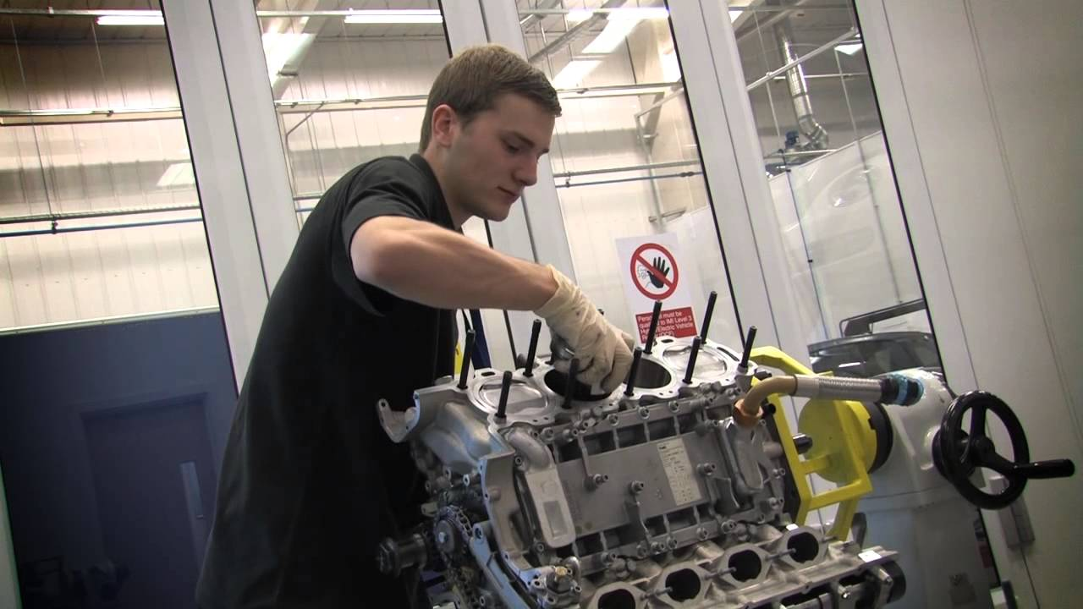
Student handout: Lesson 10
066 Peer assessment – writing

Name ___________________________________ Date: / /

Use the criteria below to help you assess the CV:

Bullet points | Clear information | Lists | Short paragraphs
Spelling | Punctuation | Grammar | Relevant
Date order (starting in the present) |  | Interesting | Headings
A sensible email address |  | Post paid / unpaid experience = past tense
Formal language |  | What will the employer think?
Use of bold italics and underlining

What is good?

What is great?

Do you have any constructive suggestions?

LESSON PLAN 11: Literacy
Covering letters

Overall objective:
To write a targeted covering letter.

Aims:
- To understand which details should be included on a covering letter.
- To analyse and identify features of good and bad covering letters.
- To create an effective covering letter using a checklist.
- To evaluate the effectiveness of a peer’s covering letter and recognise your own mistakes.

Language focus:
Writing Grammar and Vocabulary

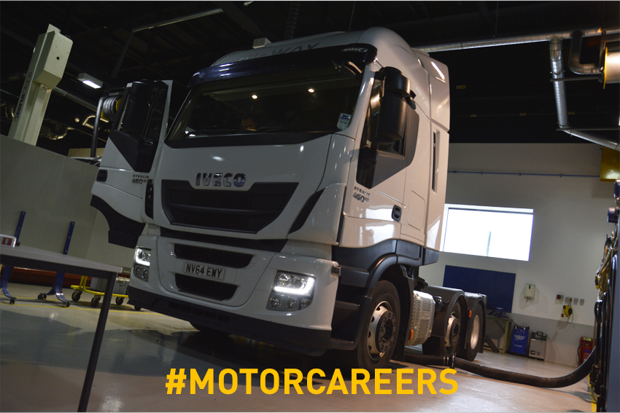
Student handout: Lesson 11
069 Cut out – include and do not include

Include | Do not include
- Use a computer | - Write in pencil
- Just rearrange and restructure it to fit the specific details of the job opportunity. | - Rewrite the entire letter for every new job.
- Notice the keywords, qualifications emphasised and the order that the desired skills are in. Follow this order. | - Ignore the keywords, qualifications and desired skills in the job description.
- Don’t forget to change the title of the position, the name of the company, and the name and title of the contact person for each job! | - Write as much as you need to.
- Explain any gaps in your CV, when you weren’t at school or working. | - Don’t worry about any gaps in your experience.
- Spell the person’s name correctly. | - Choose a font and text size you feel comfortable with.
- Use clear, business-like language. | - If you don’t understand any words or language on the job vacancy, just look at the ones that you do understand.
- Keep it short and to the point. (Maximum of five short paragraphs on one single side. | - Include everything you have done.
- Check for spelling and grammatical errors.
- Use the same font and text size on your covering letter and your CV.
- Push your strengths and draw attention to your most relevant skills and achievements.
- Use the right language and tone
- Research the company using their website.
- Check any words or language you don’t understand on the job vacancy and website.

- Look again at the job to find out which are the main skills the employer needs.

- What personal qualities, experience, qualifications, and skills do you have to impress them?

Reduce the number of times you use the word ‘I’ and increase the number of times you use ‘you’ and ‘your company’.
Consider providing information about your disability: You’re not legally obliged to mention your disability and it’s your choice on how open you decide to be in your covering letter about it. Deciding to disclose your disability at the application stage can give you an opportunity to talk about the transferable skills you've developed and how you will bring those skills to the workplace.
Student handout: Lesson 11
070 Include on a targeted covering letter

- Use a computer | - Research the company using their website.
- You don't have to rewrite your entire letter every time; just rearrange and restructure it to fit the specific details of the job opportunity. | - Check any words or language you don’t understand on the job vacancy and website.
- Notice the keywords, qualifications emphasised and the order that the desired skills are in. Follow this order. | - Look again at the job to find out which are the main skills the employer needs.
- Don’t forget to change the title of the position, the name of the company, and the name and title of the contact person for each job! | - What personal qualities, experience, qualifications, and skills do you have to impress them?
- Explain any gaps in your CV, when you weren’t at school or working. | - Push your strengths and draw attention to your most relevant skills and achievements.
- Spell their name correctly. | - Use the right language and tone
- Use clear, business-like language. | - Check for spelling and grammatical errors.
- Keep it short and to the point. (Maximum of five short paragraphs on one single side. | - Use the same font and text size on your covering letter and your CV.
- Reduce the number of times you use the word ‘I’ and increase the number of times you use ‘you’ and ‘your company’.
- Consider providing information about your disability

You’re not legally obliged to mention your disability and it’s your choice on how open you decide to be in your covering letter about it.

Deciding to disclose your disability at the application stage can give you an opportunity to talk about the transferable skills you've developed and how you will bring those skills to the workplace.

STARTING THE LETTER
Add the full name and work address of the person named in the job advert to the left hand side of the letter.
Use their title: Mr, Mrs, Ms, Miss or Dr, etc.
Include the full job title.
Include the job reference number (if you have it).
Include where you saw it advertised.
Add your full name and address to the top right hand corner of the letter.

THE OPENING PARAGRAPH
Be enthusiastic.
Show how much you want this job and want to work for them.
Impress them with how much you know about their organisation.
Show you're familiar with their products, services and recent news.

THE MIDDLE PARAGRAPHS
Convince them that you know about the job and you are the right person.
Provide examples and evidence of your personal qualities, experience, qualifications, and skills.
Highlight your achievements e.g. completing training courses, promotions, company awards, or any other praise or recognition.
Be positive and push your strengths in and out of work/college.

THE LAST PARAGRAPH
Tell the reader they can get more details about you from the enclosed CV.
Say you're looking forward to hearing from them.
Explain how they can contact you e.g. by phone, email or post.

Student handout: Lesson 11
071 Good example of a covering letter

David Gray
34 Hammond Road
Manchester
M34 2AA

Telephone: 0161 237 4658
Email address: dgray@msn.com

23rd October 2020

Mrs Lucy Watts
Personnel Officer
Smart Vehicles UK
Manchester
M17 1BB

Dear Mrs Watts

Re: Bodyshop Reception Manager, ref 234brm

Please find enclosed a copy of my CV in response to the advert for the vacancy advertised in the Manchester Evening News on 21st October 2020.

As you will notice from my CV, I am currently working as Receptionist at The Car Centre in Manchester. I have seven years’ experience within the motor industry at various levels, including four years in supervisory roles.

This allowed me to develop my skills in a range of areas including food and beverage operations; accommodation management; marketing; conference and event management; financial management; food safety and human resources. This experience, combined with my Foundation Degree in Retail Management, has provided me with broad-ranging skills.

As Smart Vehicles UK is a new venture, I feel that my experience of customer service would be a valuable asset in this role. Building up the client base of The Car Centre in Chester taught me about the particular importance of effective marketing in making a success of a new business. I hope this experience can help Smart Vehicles UK become one of Manchester’s leading organisations.

I am now looking to use these skills and progress to a more senior role.

Thank you very much for your time. I look forward to hearing from you in the near future.

Yours sincerely

David Gray

Student handout: Lesson 11
072 Bad example of a covering letter

David Gray
34 Hammond Road
Manchester
M34 2AA

Telephone: 0161 237 4658
Email address: dgray@msn.com
23rd October 2020

Mrs Lucy Watts
Smart Vehicles UK

Dear Lucy

Re: Reception Job

Please find enclosed a copy of my CV in response to your advert. I am currently
working as Receptionist at The Car Centre in Manchester.

My job there involves:
Managing staff
Dealing with customer complaints and comments
Making sure the garage follows MOT regulations
Coming with up creative ideas to improve reception processes
Preparing invoices and quotations for the work
Mediating in any differences of opinion about details
Keeping detailed records to make sure that costs stay within budget
Dealing with paperwork, phone calls, emails and letters
Being there on the day of the event to make sure everything goes to plan.

My skills are:
Organisational skills
Good communication skills
Creative skills
Attention to detail
Ability to work under pressure
Sales skills
Admin and IT skills
Teem work skills
Bussiness skills

My qualifications are:
Foundation Degree in Retail Management
5 GCSEs – ENGLISH (C) Maths (C) Science (D) French (B)

I really believe I can do this job and hope my CV and covering letter shows this.

Thanks
David Gar

Student handout: Lesson 11
073 Good and bad answers

ANSWERS – GOOD CV
David’s now included the full name, job title and address of the person he’s writing to. | By using the recruiter’s full name and preferred title (Mrs) David’s created a polite and business-like tone.
All the job details are correct: the job title, where David saw the job advertised and the reference number in the advert. The employer knows exactly which job David is applying for. | David summarises his recent experience.  This is a management vacancy, so it’s a good idea for him to push his management experience.
The covering letter is neatly presented in paragraphs and it’s all in the same font and text size. | David signs off in the correct way. His letter is to a named person (Lucy Watts) so he uses ‘Yours sincerely’ instead of ‘Yours faithfully’.
The paragraph summarises what David’s looking for (promotion and a challenge) and states what he would like to happen next. | This shows David has read up on the company.  He’s thought about what the employer is likely to want. He’s related his experience to the job, and given specific examples of how he can contribute.
The advert asked for someone with a range of hospitality experience. Listing these skills shows how they fit the employer’s requirements.

ANSWERS – BAD CV
David’s not included enough details of the recruiter. As well as their name and company name, he should also include their job title and full address. | Using just the first name is too informal and familiar.
This isn’t specific enough. A large company may be recruiting for a number of different jobs and David needs to say which one he’s applying for. | David includes a lot of detail about his current job rather than describing what he could offer the new employer.
There’s more than one text style used here. If David kept one text style throughout it would look a lot neater. | There are spelling mistakes, which don’t create a good impression. David could have used a spell checker and asked somebody else to proofread.
The skills and qualifications section seems to repeat the information you would get in David’s CV. It doesn’t add anything to strengthen his application. He needs to expand on his CV and explain why he’s the person for this job. | The letter could be finished in a more formal way:  ‘Yours sincerely’ if you’re writing to a named person or ‘Yours faithfully’ if your letter is addressed to Dear Sir/Madam.
The final paragraph could also state what David hopes to happen next, such as to be contacted by the employer.

Student handout: Lesson 11
074 Structure

STARTING THE LETTER
Add your full name, address, telephone number and email address to the top right hand corner of the letter.
Add the full name, job title and work address of the person named in the job advert to the left hand side of the letter.
Use their title: Mr, Mrs, Ms, Miss or Dr, etc.
Use the greeting ‘Dear’, their title and their surname.
On a separate line, add the job title and job reference number (if you have it).

THE OPENING PARAGRAPH
Start off with ‘Please’ and tell them where they can find your CV.
Say where and when you saw the job advertised.

THE MIDDLE PARAGRAPHS
Refer to your CV.
Provide examples and evidence of your personal qualities, experience, qualifications, and skills.
Highlight your achievements e.g. completing training courses, promotions, company awards, or any other praise or recognition.
Highlight your strengths in and out of work/college.
Show that you know about the job and you are the right person.
Show you're familiar with their products, services and recent news.
Show how much you want this job and want to work for them.

FINISHING THE LETTER
Thank them for their time.
Say you're looking forward to hearing from them.
Use ‘Yours sincerely’ because you know the name of the person.
(If you didn’t know the person’s name, you would use ‘Yours faithfully’.)

Student handout: Lesson 11
075 Peer assessment - writing

Name ___________________________________ Date: / /

Use the criteria below to help you assess the covering letter:

Bullet points | Clear information | Lists | Short paragraphs
Spelling | Punctuation | Grammar | Relevant
Date order (starting in the present) |  | Interesting | Headings
A sensible email address |  | Post paid / unpaid experience = past tense
Formal language |  | What will the employer think?
Use of bold italics and underlining

What is good?

What is great?

Do you have any constructive suggestions?

LESSON PLAN 12: Literacy
Interview skills

Overall objective:
To create effective answers to common interview questions.

Aims:
- To gain an awareness of and reasons behind common interview questions.
- To gain an understanding of the criteria needed to answer interview questions.
- To actively participate in group discussions and offer ideas, in order to produce answers to interview questions.
- To evaluate the effectiveness of own and peers’ interview question answers.

Language focus:
Writing Grammar and Vocabulary Spoken English

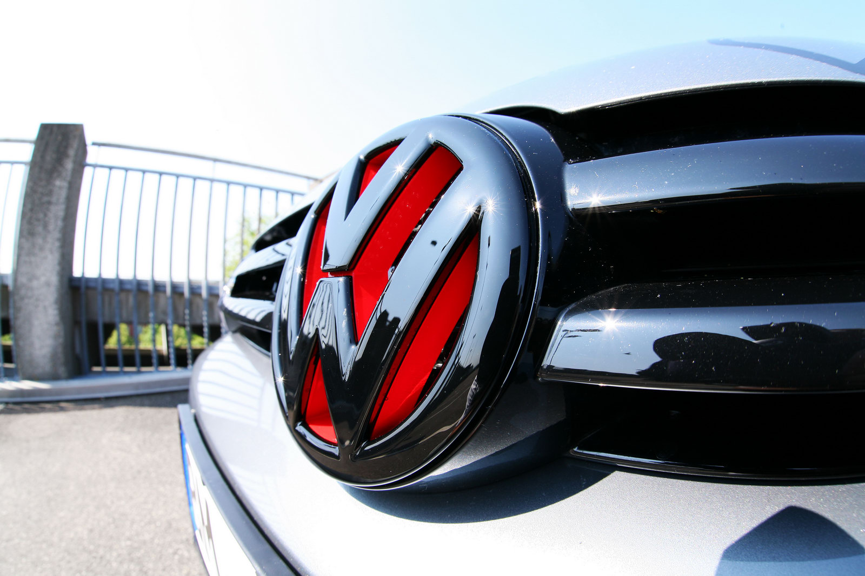
Student handout: Lesson 12
079 Cut out top 10 interview questions and tips

Tell me about yourself?  - Don’t talk about your personal life.  - Highlight your strengths, by talking about specific past work, school or college experiences. | Why did you leave your last job?  - If you left voluntarily, - in your reason give a characteristic about this organisation that is attractive to you AND one that your previous employer didn’t have.  - If you were asked to leave - explain why and take responsibility. Explain what you learnt from the experience and how this has changed your behaviour in the present. (The interviewer knows you are human and make mistakes and wants to see that you have grown from the experience.)
Why should we hire you?  - Be specific.  - Highlight a strength that is specifically related to what the organisation is looking for. | What is your greatest accomplishment?  - Be specific.  - Talk about a past work accomplishment/achievement.  - Choose an achievement that shows how valuable you will be as an apprentice.
What is your greatest strength?  - Be specific.  - Give a brief work related example showing your greatest strength.  - Choose a strength related to the specific knowledge they are looking for. | Describe a difficult work situation and what you did to overcome it?  - Be specific.  - Look back to a problem that you were faced with.  - Define the problem, the expected outcome, and possible solutions.  - Talk about any people who were also involved and how you communicated with them to reach your goal.
What is your greatest weakness?  - Be honest.  - Show you are taking steps to deal with this weakness.  - Turn a negative into a positive.  - Don’t mention a weakness related to skills or abilities that are essential to the apprenticeship. | Where do you see yourself in 5 years?  - Show you have a clear direction and goals.  - Describe a realistic goal that you have related to the apprenticeship and the organisation.
Why do you want to work here?  - Be specific.  - Say things about the organisation that you admire.  - Describe your strengths and abilities that make you perfect for the apprenticeship. | Do you have any questions?  - Say yes – and ask two or three questions.  - Show that you have researched the organisation by asking questions on topics that you know are important to them.

Student handout: Lesson 12
080 Example interview answers

Tell me about yourself
‘I have been … for the past five years. My most recent experience has been … One reason I particularly enjoy this industry, and the challenges that go along with it, is the opportunity to… . In my last job / qualification I… . My real strength is.. I pride myself on,,, What I am looking for now is… where I can join a string team and have a positive impact on… and… .
Why should we hire you?
As a fast growing organisation like… must be a dynamic place to work. A company that has outstripped its revenue expectations five quarters in a row provides the challenge and opportunity I’m looking for.

What is your greatest strength?
- I have extremely strong writing skills. Having worked / studied as a copy editor for five years I have a strong attention to detail when it comes to writing. I have also written for a variety of publications, so I know how to shape my writing style to fir the tasks and audience. As a marketing assistant I will be able to effectively write and edit press releases and update web content with accuracy and ease.
- I also have strong communication skills which helps me work well with customers, team members and executives. I am known for being an effective team member with a talent for giving presentations.

What is your greatest weakness?
- I used to wait until the lat minute to set appointments for the coming week but I realised that scheduling in advance makes much more sense.
- I had difficulty with maths during school but I persevered with tutoring assistance and extra effort and completed my GCSE’s with a B minus.
- I used to like to work on one project to its completion before starting another but I’ve learned to work on many projects at the same time and I think it allows me to be more creative and effective in each one.

Why do you want to work here?
Based on the research I’ve done this company is an industry leader. When I visited your website I found some impressive information about future projects you have planned. I was also impressed with the founders' backgrounds and the current financial statements. This is the company I've been looking for, a place where my background, experience and skills can be put to use and make things happen."
Why did you leave your last job?
If you left voluntarily…
- I’m relocating to this area due to family circumstances and left my previous position in order to make the move.
- After several years in my last position, I'm looking for a company where I can contribute and grow in a team-oriented environment.
- I am interested in a new challenge and an opportunity to use my technical skills and experience in a different capacity than I have in the past.
- I recently received my degree and I want to utilize my educational background in my next position.
- I am interested in a job with more responsibility, and I am very ready for a new challenge.

What is your greatest accomplishment?
- My team designed an idea for an electric car and we won first prize at the 2015 North West AutoCar Competition.
- I was Student of the Month at Windscreen High for three consecutive months, due to my attendance, punctuality and helpfulness to my classmates.

Describe a difficult work situation and what you did to overcome it?
I was asked to find a band to perform at the bar I worked in at short notice, and with little money. We had an event on with a headline band and one of the other bands broke up after we had paid in advance. We didn’t have any money left to hire another, so I decided to ask on Facebook if there were any local bands who might be interested in playing, and offered them a “showcase” spot. The band I found were thrilled to be part of a large event with a well-known headline act, and all it cost us was the price of a few drinks for the band members after their performance.

Where do you see yourself in 5 years time?
- I hope that in five years I’ll be managing my own team and helping to expand my department.”
- Do you have any questions?
- How would you describe a typical week / day in this position?
- How many people work in the office / department?
- How much travel is expected?
- What are the prospects for growth and advancement?
- If I am offered the job how soon would you like me to start?
http://career-advice.monster.com/job-interview/Interview-Questions http://jobsearch.about.com/od/interviewquestionsanswers http://interviewarea.com/interview-questions/

Student handout: Lesson 12
078 Peer / Group assessment – speaking

Group name ___________________________________ Date: / /

Use the following assessment criteria:
- The question has been answered properly.
- There is enough detail
- It is created using formal language.
- The answer makes sense.
- The answer is relevant

What is good?

What I great?

Do you have any constructive suggestions?

Additional Information: Literacy
Course feedback – Student
The Institute of the Motor Industry is very interested to hear your thoughts and opinions on the literacy course you have completed.

School or college name
Your name
Email address
Year group

Please tick one of these boxes:
 | Question | Strongly disagree | Disagree | Neither agree or disagree | Agree | Strongly agree
Course aims and objectives | Accurately described the content and propose
Resources | Useful online resources.
 | Useful paper handouts.
 | Useful presentation slides.
Course topic | Interesting.
 | Contained enough detail.
Course activities | Useful and relevant.
 | Fun and interesting.
 | Enough time to complete each one.
 | A good mix of group and individual activities.
Homework | Relevant and achievable.
Course speed | Appropriate
Difficulty level | Appropriate
My interest in literacy has increased.
My literacy knowledge has increased
My increased literacy knowledge has helped me in other subjects
Overall the literacy course has met my expectations
I would recommend the literacy course to other students

What was positive and or negative about the literacy course?

What suggestions do you have for improving the literacy course?

Thank you for your feedback! careers@theimi.org.uk

We hope you have enjoyed using the IMI Business Studies Lesson Plans.
If you have any feedback please get in touch with careers@theimi.org.uk

We also have an associated competition with amazing prizes!

IMI Literacy competition
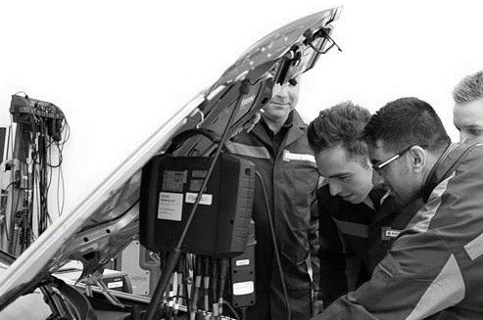
About the Industry
The automotive industry influences everyone, from delivering goods on time to commuters travelling to work and emerging services being able to respond to crisis, the motor industry helps keep the country moving.

About the competition
The IMI’s teaching and learning resources are now in their sixth year and are an initiative developed by the IMI that includes a series of creative curriculum linked teacher and student resources using the motor industry as the exciting backdrop. To complement these resources we have developed this competition.

A key part of business success for manufacturers and dealers is to encourage the best and brightest people to join their business in a variety of roles. Based on Lesson 3 of the Literacy teaching resources this competition aims to promote various job roles and training opportunities and is designed to encourage students to consider the retail motor industry as a career choice. This competition and related resource aims to deliver the literacy curriculum in an applied and engaging manner and encourage students to think about career option.

Curriculum areas to be covered:-
- Arranging information and ideas in a sensible order, maintaining a consistent point of view, avoiding ambiguity and using organizational features (such as paragraphs) to improve clarity and coherence.
- Plan, draft, edit and proof read confidently and effectively

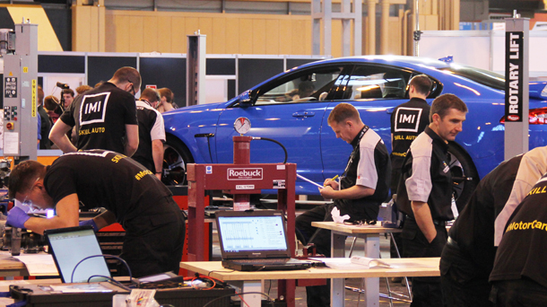
About the IMI
The Institute of The Motor Industry is the professional body for individuals working in the motor industry and the authoritative voice of the retail automotive sector. The IMI’s aim is to ensure that the automotive retail sector has a skilled, competent and professional workforce that is fully equipped to keep pace with the demands of new technology and changing markets. A key part of business for manufacturers and dealers is to encourage the best and brightest people to join their business in a variety of roles.

The Competition
This competition can be linked to Lesson 3 of the Literacy Teaching Resources or as a stand-alone lesson. http://www.autocity.org.uk/hubcap/resources?nid=15807

The Brief
You have been commissioned by the Institute of the Motor Industry Magazine to write a 500 word article entitled ‘Why choose a career in Automotive?’ They have specified that your article must include information on job roles in the industry. You are able to use images, videos, quotations, statistics and interviews but you must end the article by choosing what your ideal job would be if you were to work in the industry and why.

The magazine editor has given you some leads on the Retail Automotive Industry to get you started. Some manufacturers who have apprenticeship programmes include:
- Audi https://www.audi-ap.co.uk/
- VW Passenger Cars http://www.volkswagen-apprentice.co.uk/
- Mazda https://www.mazdaapprenticeships.co.uk/
- DAF Trucks https://www.daf-apprenticeships.co.uk/
- Body and Paint http://www.vwgroup-paintandbodyaap.co.uk/
- Lookers https://www.lookers.co.uk/careers/lookers-apprenticeships
- Jaguar Landrover https://www.jaguarlandrovercareers.com/go/Advanced-Apprenticeship/4027601/

Details on the different job roles in the motor industry http://www.autocity.org.uk

Competition Guidelines
- Maximum of 1 student per entry (there will be a total of 5 winning entries)
- Students must be aged 14-16 years old
- All entries must be submitted by 30th May to careers@theimmi.org.uk or to: The Careers Team, The IMI, Fanshaws, Brickendon, Hertfropdshire, SG13 8PQ
- In all entries we are looking for creativity.

The prize
The winning article, judged by a team of industry experts, will be published in The Institute of the Motor Industry Magazine with a reach of over 25k members receiving the magazine and appear on the IMI magazines online channel http://magazine.theimi.org.uk/ The winners will also receive a scalextric.

GOOD LUCK!

