Art Lesson Plan
Student pack
Contents-
1. Introduction to the automotive industry. – Page 2
2. Teaching guidance – Page 3 -4
3. Student pack – Page 5-8
4. Power point pages Introduction (extra download on autocity.org.uk)

Introduction

The automotive industry influences everyone, from delivering goods on time to commuters travelling to work and emerging services being able to respond to crisis, the motor industry helps keep the country moving.

About The IMI

The Institute of The Motor Industry is the professional body for individuals working in the motor industry and the authoritative voice of the retail automotive sector. The IMI’s aim is to ensure that the automotive retail sector has a skilled, competent and professional workforce that is fully equipped to keep pace with the demands of new technology and changing markets. A key part of business for manufacturers and dealers is to encourage the best and brightest people to join their business in a variety of roles.

www.theimi.org.uk/autocity
IMI Autocity is the one-stop-shop for impartial careers information and advice on careers in the Retail Motor Industry. Whether you are an individual looking to start or progress your career, or a teacher or careers advisor who supports others in making their career choices, Autocity is the place to start. With over 150 #MotorCareers to choose from Autocity provides you with all things Automotive!

Teachers Pack

This lesson plan is intended to teach the basic sketching of a vehicle and the importance of using frames in order to keep the correct dimensions. By the end of the lesson your students should be able to draw a 2D image of a car and implement this into changing the shapes and curve to consider new designs.

Learning objectives:
- Know why art is important in the automotive industry and identify ways in which it is used.
- Learn the steps to draw a 2D image of a car.
- Use creativity to design their own vehicle.

Why is art relevant
The automotive industry is vast and encompassed a variety of roles. Within this there are manufacturing, body repair and refinishing. Thinking about the way art impacts on the industry it can be a big influence on sales and the reason people pick a specific brand. There is science behind the shapes of vehicle but there is also the aesthetic appeal that will affect its popularity. On top of this business and races rely on artists to spray and design the logos and images for their vehicles, so it’s safe to say that if is a vital part of the industry we know today.

Task 1 - What jobs in the automotive industry use art?

This can be done as a classroom task, in small groups or individually.
You want to get them thinking about the types of jobs there are like in the example below. This can be extended and will benefit from them writing down examples.

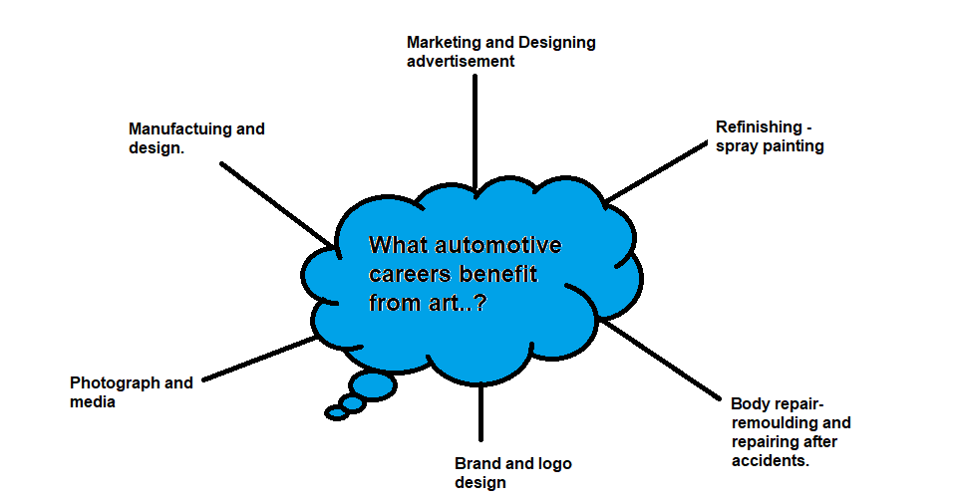

Task 2 – Step by step how to draw a car.

Use the student pack or powerpoint to guide the students through each stage of the drawing.
For this task they will need:

- 1 x A4 paper (others will also work)
- 1 x Pencil
- 1 x Ruler
- 1 x Black Pen
- (coloured pencils and pencil sharpener can be incorporated)

Task 3 – Present your vehicle to the class or teacher and describe who you think would buy your vehicle.

Student Pack

Here is your step by step guide to drawing a 2D car by Drawforall.net. For this you will need to start with a pencil and ruler. Keep all lines in pencil until Step 8

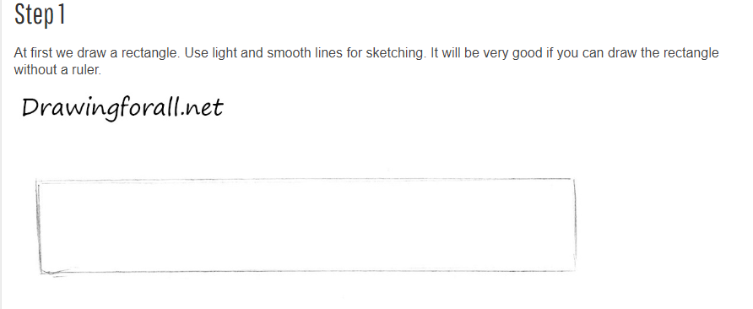
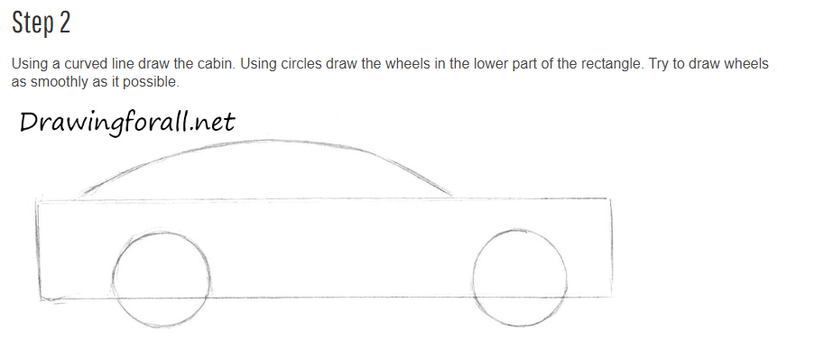
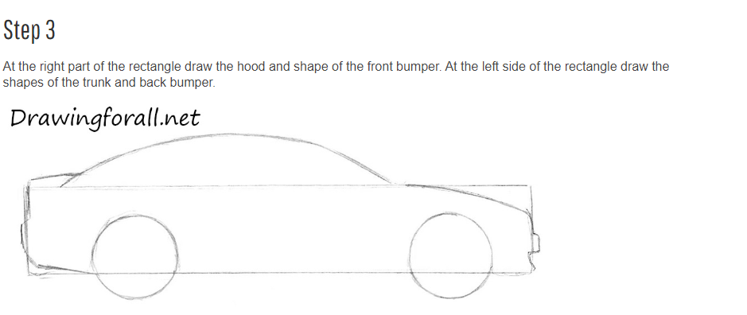
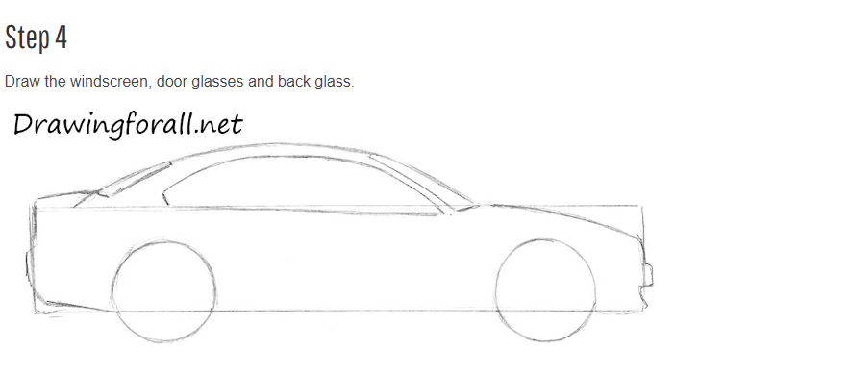
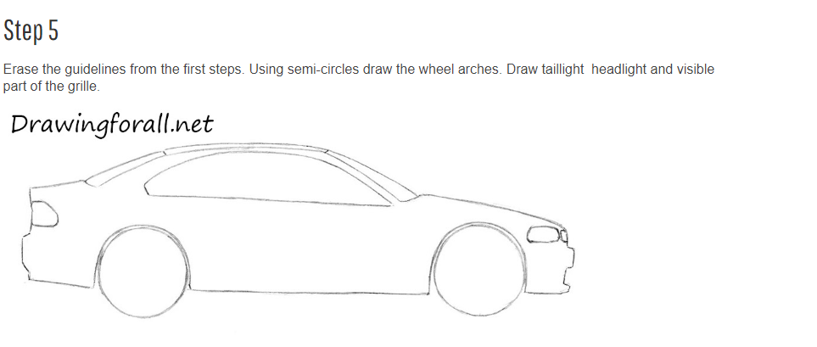
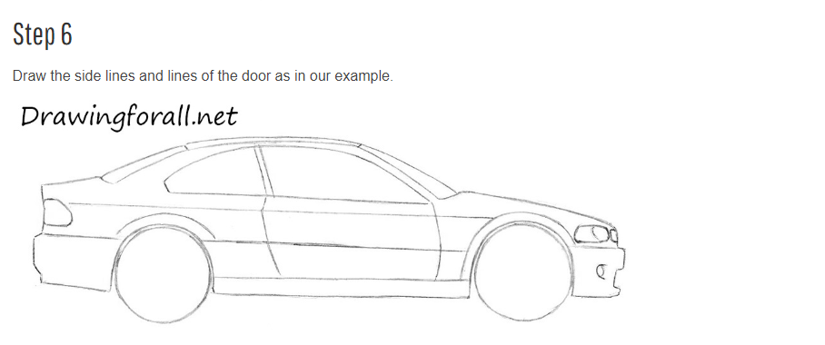
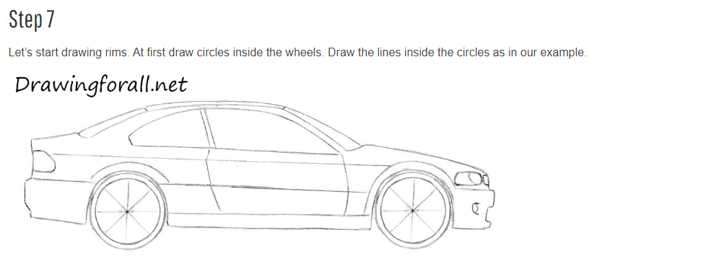
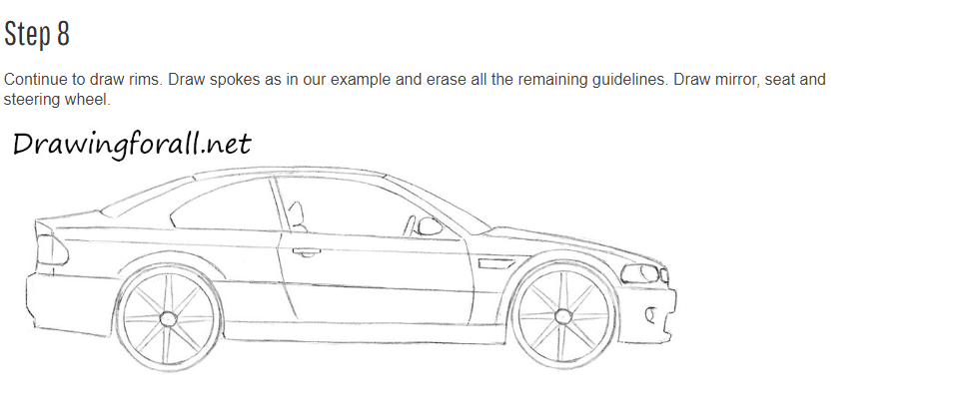

Once you have completed your car you may decide to change a few shapes. Maybe the lights maybe add a spoiler, you might prefer different wheels? When your picture is final Draw over your design in black pen, make sure its dry and rub out any excess pencil.

If you want why not add some colour?

Now we cant you to think about who this car could be for.

Who do you think would drive it?
What kind of job do they have?
Do they have a family or pets?
How much do you think it would cost?

Write down your description of who the car belongs to below. Consider some of the questions above and be ready to explain to your teacher the reasons you have chosen this person to drive this car.

If you found this fun and usefu,l why not challenge yourself to go further. We have a business enterprise competition to design a car of the future which is a 2 hour business and marketing based lesson plan. All you have to do is deliver the lesson and send us in the student packs via email or post, for more information visit: http://www.autocity.org.uk/index.php/competitions-events/

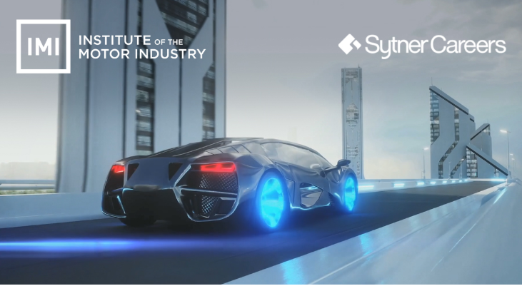

For different drawing tutorials just like this one visit Drawingforall.org

