Automotive labour market baseline report

Profile 2018

# Introduction

This report seeks to give an overview of the current automotive labour market. Using EMSI data it allows a view of industry, occupation and job postings over England, Scotland and Wales.

The data gives us a full, contextualised view of the labour market. The industry data comprises all 563 industry and 369 occupation classifications across all regions of the country. This means that we are able to drill down to the most specific (SIC and SOC), at national, Government Office Region, County/Unitary Authority and Local Authority levels. In addition, staffing patterns allow us to see the occupational make up of any industry for any area, whilst inverse staffing patterns allow us to pick any occupation and identify the industries that employ people in this role. The data is created from a collection of nine Government sources, which EMSI combine to provide multi-layered cross-checking. The data is updated annually to give more than 20 million data points describing labour market conditions across Britain. EMSI data includes data from England, Wales and Scotland but not Northern Ireland. For the purposes of this report, regional analysis, we have used government office region.

Data is updated annually and so the most recent full year is 2018. Predications are forecast up to 2027. For the purposes of this report a number of level 4 SOC (the lowest level available) industries are grouped to establish the Automotive Retail subsector and an estimate of the automotive industry as a whole. These are outlined in each of the tables. Job Postings data is updated monthly when EMSIE reviews job advertisements across the 3 nations. It enables us to examine trends in job titles, skills and churn in industries and occupations.

# Industry view

## Industry Breakdown

**Automotive Industry Breakdown - England, Scotland, Wales [2018]**



* In 2018 there were 92,603 establishments in the automotive industry providing 725,383 jobs. Of this, 86,107 establishments were within the automotive retail sub sector industries providing 552,113 jobs.
* The average wage for a job in the automotive industry is £29,768.
* The highest average earnings of the individual automotive industries are those working in the Manufacture of Motor vehicles, at £45,278.
* Those in the Maintenance & Repair of Motor Vehicles average wage is £24,605.
* The automotive industry contributes £30 billion Gross Value Added (GVA), 2.5%, to the 3 nations (England, Scotland, and Wales) economy.

**Automotive Industry Breakdown - % changes**

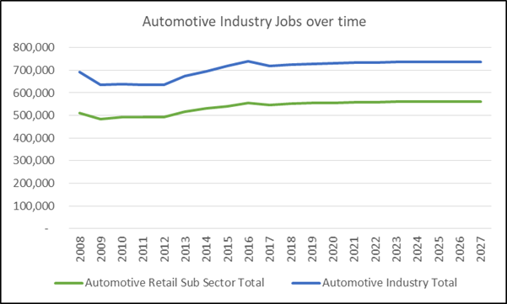

* Over the past 10 years, the automotive industry has seen an increase of 34,500 jobs - a percentage increase of 4.8%. In the past year it increased by 1%. It is predicted to continue to grow with an additional 12,166 jobs by 2027 – an increase of 1.6%.
* Over the past 10 years, the automotive retail sub sector has seen an increase of 41,493 jobs – a percentage increase of 7.5%. In the past year it increased by 0.9%. It is predicted to continue to grow with an additional 9,844 jobs by 2027 – an increase of 1.8%.
* Maintenance & Repair of Motor Vehicles and Manufacture of Motor Vehicles industries have seen the largest increase in jobs over the past 10 year period with an increase of 15.4%.
* Sale of Other Motor Vehicles saw the largest increase in the past year, in job terms an increase of 2.6%.
* Manufacture of Electrical & Electronic Equipment for Motor Vehicles has seen the largest decrease in jobs in the past 10 years, with jobs more than halved. This decreasing trend is predicted to continue until 2027.
* Sale of Other Motor Vehicles is predicted to see the largest % increase until 2027, with an increase of 8.3%.

## Industry Profile

**Age Profile**

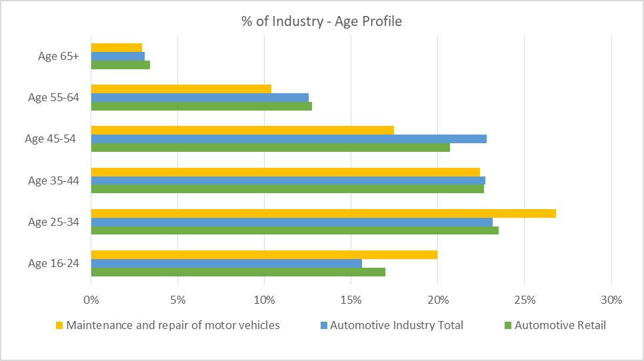

* 39% of the automotive industry is aged 34 and under, with 16% aged 16 to 24. The largest age bracket in the industry is that of 25 to 34 year olds.
* The automotive retail subsector has a similar age profile to the automotive industry as a whole.
* The Maintenance & Repair of Motor Vehicles industry has the youngest profile of the automotive industries.

**Gender Profile**

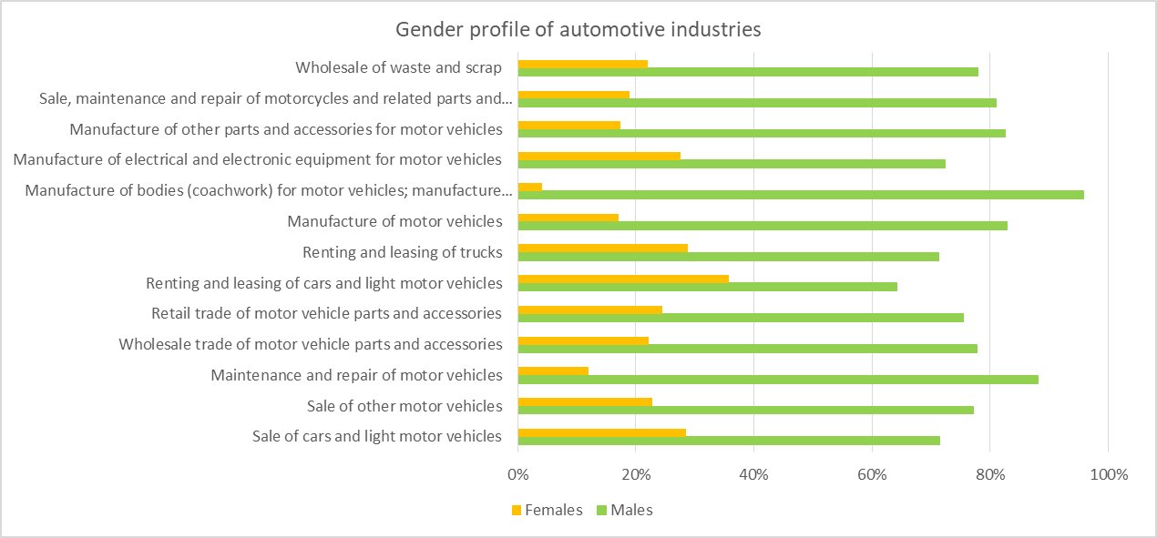

* 80% of the automotive industry are male and 20% are female. Although predominantly male dominated, there are differences across individual automotive industries.
* The largest proportion of females is in the Renting & Leasing of Cars & Light Motor Vehicles industry, with 36%.
* The largest proportion of males is in the Manufacture of Bodies (coachwork) for Motor Vehicles industry [percentage here?]

**Regional Profile – All Automotive Industry**

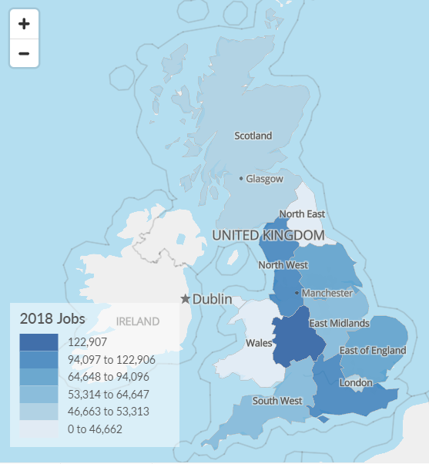

* The largest proportion of jobs in the automotive industry is in the West Midlands (17%).
* West Midlands also has the highest average wage.
* The South East has the largest amount of Establishments.

**Regional Profile – Retail Automotive Industry**

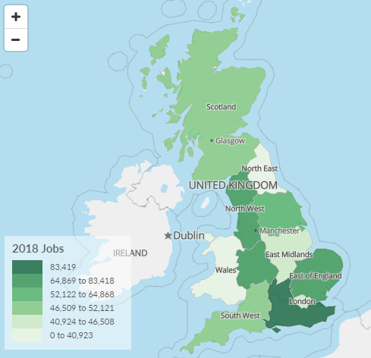

* The largest proportion of jobs in the automotive retail industries is in the South East (15%).
* The South East also has the highest average wage and the largest number of establishments.

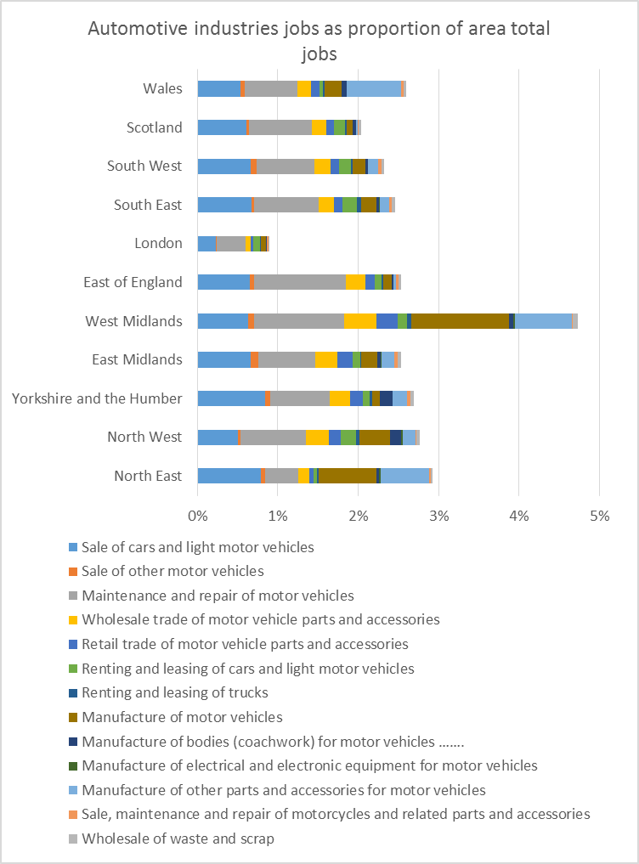

* There are significant regional differences in terms of automotive industries.

* Automotive jobs in the West Midlands makes up 5% of all jobs in the region.
* Maintenance & Repair of Motor Vehicles has the highest proportions in the 7 of the 11 regional areas (North West, East Midlands, East of England, London, South East, South West, and Scotland).
* The Sale of Cars & Light Motor Vehicles has the highest proportions in the North East and Yorkshire and the Humber.
* In the West Midlands, Manufacture of Motor Vehicles has the highest proportion.
* In Wales, the Manufacture of other parts and accessories for motor vehicles has the highest proportion.

# Occupation view

**Top 20 Occupations in the Automotive Industry**



* The top 20 occupations make up 67% of the automotive industry, demonstrating the varied occupations in the industry. In fact, in 2018 there were 204 registered occupations in the industry.
* The most popular occupations in the automotive industry are: Vehicle Technicians, Mechanics & Electricians, employing 129,932, which equates to 17.9% of the industry.
* Of the top 20, the highest paid (on average) were Sales Accounts & Business Development Managers.

**Focus on Vehicle Technicians, Mechanics & Electricians**



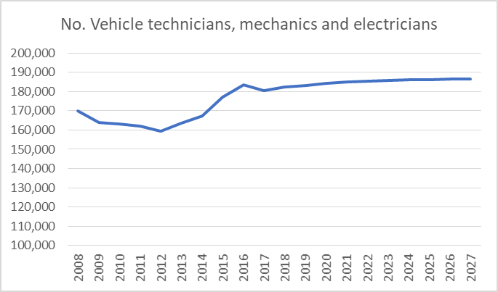

* There were 183,302 Vehicle Technicians, Mechanics and Electricians employed across all industries.
* 129,932 were employed in automotive industries. 52,371 were employed outside of the Automotive Industry. The most significant industries being:
  + Service activities incidental to land transportation
  + Freight transport by road
  + Urban and suburban passenger land transport
  + Technical testing and analysis
  + Repair of machinery
* Over the past 10 years the Vehicle Technicians, Mechanics and Electricians occupation roles have increased by 6.9%, last year increasing by 1%.
* They are predicted to increase by a further 4170 (2.2%) by 2027.

**Age and Gender Profile**

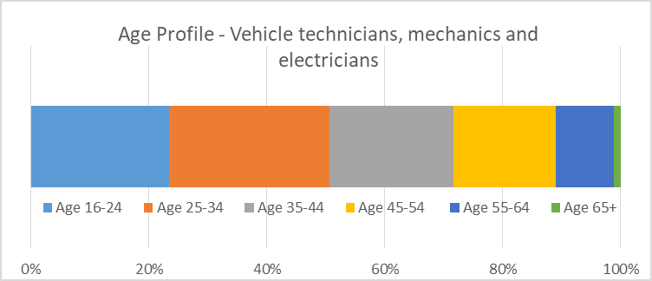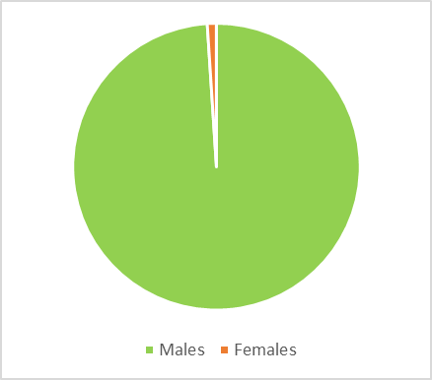

* 51% of Vehicle Technicians, Mechanics and Electricians are aged 34 and under, with 23% aged 16 to 24.
* The largest age bracket in the industry is that of 25 to 34 year olds.
* It is a younger profile than the automotive industry as a whole.
* It is a significantly male dominated occupation - 99%.

# Job postings

**Top posted job titles and skills requested when advertising for Vehicle Technicians, Mechanics & Electricians**

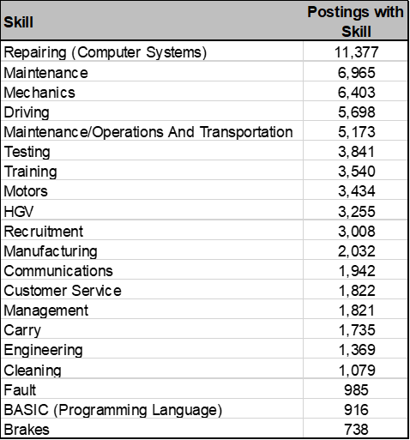

* There were 27,216 Vehicle Technicians, Mechanics & Electricians job postings since Jan 2019.
* Vehicle Technician is the most popular job title for jobs posted since Jan 2019.
* Software tester was the third most popular job title.
* Repairing (Computer Systems) is the most requested skill in job postings.

**Top 20 companies advertising for vehicle technicians, mechanics and electricians (excluding recruitment organisations)**

* Goodyear posted the most job postings for vehicle technicians, mechanics and electricians in 2019.